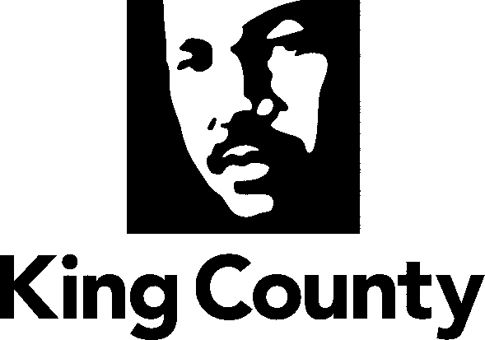

Checklist and Summary of Changes for the attached
Collective Bargaining Agreement

Name of Agreement
Washington State Council of County and City Employees, Council 2, Local 1652R (Industrial and Hazardous Waste)

Labor Negotiator
James J. Johnson

Prosecuting Attorney’s Review | Yes
Legislative Review Form; Motion or Ordinance | Yes
Executive Letter | Yes
Fiscal Note | Yes
Six Point Summary | Yes
King County Council Adopted Labor Policies Consistency | Yes
Ordinance | Yes
Original Signed Agreement(s) | Yes
Does transmittal include MOU/MOA? | N/A

Six Point Summary of changes to the attached agreement:
1. Changes to effective dates.

2. Changes that reflect the terms of the “Total Compensation” Coalition Memorandum of Agreement, ratified by King County Council Ordinance 17916.

3.

4.

5.

6.

