Lease Property Summary

Photo of Property
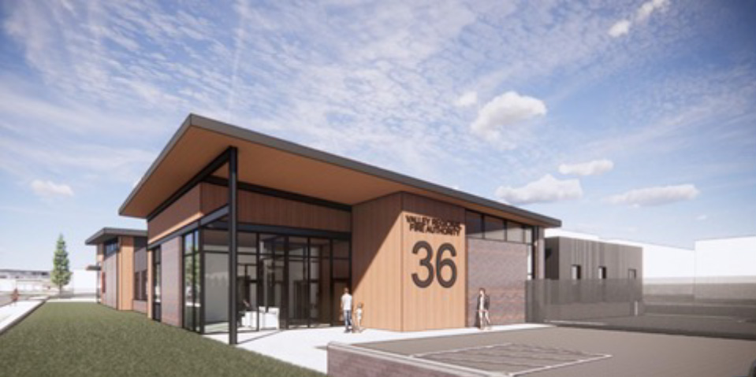
Temporary Premises of Station 36 shown above. Rendering of the Permanent Premises at Station 31 not available.

Property Owner: Valley Regional Fire Authority
Address: 1101 D Street NE, Auburn, WA
Cost Per Sq. Ft.: $3.78 per year
Operational Costs: $0
Term: Five years and three, five-year options to extend
Square Footage: 2,019 square feet (SF) exclusive space and 3,020 SF shared space
Template: County
Council District: Seven
Funding Source: Levy, Ordinance 19950
Previous Location: N/A, new facility at a previous location
Offer Expiration: Proposed Ordinance to be passed by November 30, 2026, per the terms of the lease agreement.

Lease Synopsis:
The property is currently owned by Valley Regional Fire Authority (VRFA) and used by King County Medic One (KCM1), a division within Public Health-Seattle King County (PHSKC), to provide emergency medical services to Algona, Auburn and Pacific. KCM1 has been leasing space at VRFA’s Fire Station 31 since 2017. VRFA is demolishing its existing fire station and building a new one at this location. During the demolition and construction of the new facility, VRFA will provide equivalent space to KCM1 at the nearby Fire Station 36, also located in Auburn, on a temporary basis. This new lease has a total term of up to 20 years if all options are exercised and includes the temporary space during the initial term.

The new Station 31 is in the City of Auburn with convenient access to the cities of Auburn, Algona, Pacific, and other South County communities via arterial roads. The lease includes the exclusive use of approximately 2,019 square feet, 27 square feet of outdoor storage for oxygen tanks and shared use of approximately 3,020 square feet. The exclusive space includes a storage room, two sleeping rooms with connecting anterooms, one ADA bathroom, and an ambulance bay that can house two ambulances. The shared space includes a laundry room, designated clean room, Personal Protective Equipment (PPE) storage room, decontamination room, medical waste disposal bin, kitchen/dining room, day room, fitness room, and an office room for drop in workspace. In addition to the interior space, outdoor space to store medical oxygen tanks and two parking spaces are included in the lease.
The temporary premises at Station 36 contains substantially the same spaces and square footage. The proposed lease agreement will allow KCM1 to continue to operate on an uninterrupted basis out of VRFA Station 31 on a long-term basis and out of VRFA Station 36 on a temporary basis.

Context
Rationale for transaction: The proposed lease agreement would allow KCM1 to continue to provide first responder service to the South King County area from an advantageous location. At this location, operating out of an old mobile building, this medic unit has responded to 2,461 incidents per year on average over the eight-year period from 2017-2024. This equates to an average of nearly seven incident responses per day. Response times from this location to the surrounding community are within the targeted length of time needed to respond to emergency calls from the public. In 2024 the Median Unit Response Time was eight and a half minutes, ninety-two percent of responses were less than fourteen minutes, approximately eighty-three percent were less than twelve minutes, sixty seven percent were less than ten minutes, and forty three percent were less than eight minutes.

Policy considerations: This lease agreement supports Medic One’s mission to provide Advanced Life Support (ALS) and other first response services to Auburn, Algona, Pacific and surrounding areas.

Political considerations: N/A

Community considerations
or partnerships: This new lease agreement allows KCM1 and VRFA to continue their partnership to provide Advanced Life Support (ALS) and Basic Life Support (BLS) services to Auburn, Algona, Pacific and surrounding areas.

Fiscal considerations: The annual cost to lease the facility is $19,032 inclusive of operating costs. King County is not responsible for grounds or maintenance costs.

Other considerations: N/A

CIP/operational impacts: The location of the leased property provides easy access to major roads and highways and public transit facilitating the provision of KCM1’s services to the surrounding area.

King County Strategic Plan impact: N/A

Equity and Social Justice impact: In accordance with Real Property Asset Management Plan (RAMP) policies, the Facilities Management Division and the PHSKC reviewed this proposed legislation for Equity and Social Justice impacts. The Medic One program is the only provider of ALS emergency medical services to the communities of Auburn, Algona and Pacific. No negative ESJ impacts are anticipated with this agreement.

Energy Efficiency impact: N/A

Lease Agreement Alternatives Analysis
Summary: King County conducted a facility search prior to securing this location. Fire Station 31 meets the needs of the cities of Auburn, Algona, Pacific and King County EMS.

Vicinity View Map
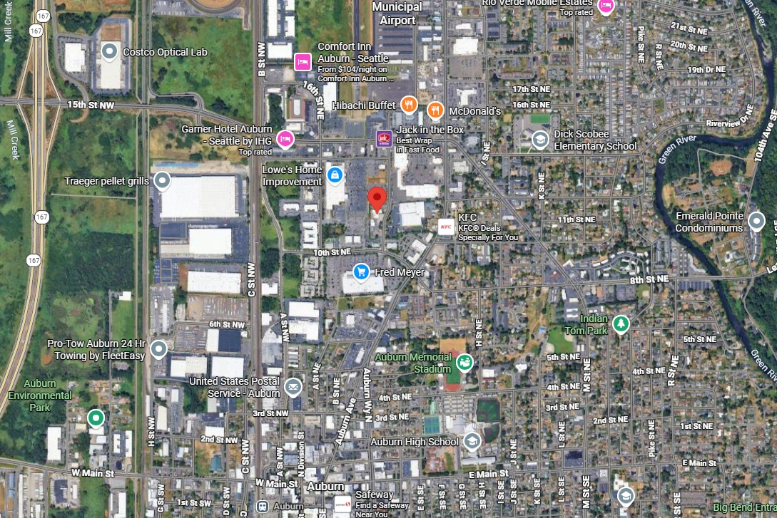

Parcel Map
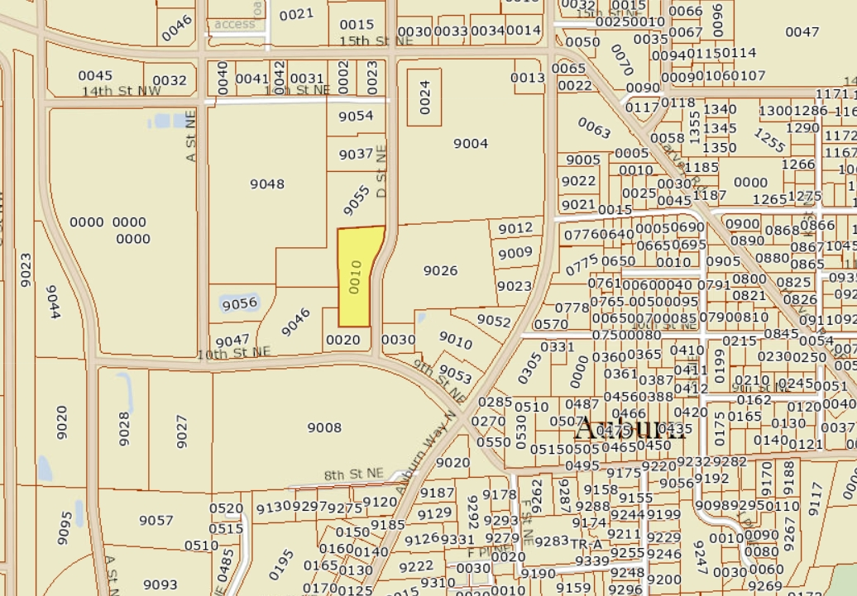

King County Ordinance 19950 [LINK]

