Metropolitan King County Council
Committee of the Whole

STAFF REPORT

Agenda Item: |  | Name: | Mike Reed
Proposed No.: | 2005-0208 | Date: | October 3, 2005
Attending: | Christie True, Manager, Major Capital Projects, Wastewater Treatment Division  Pam Elardo, Right-of-Way/Permitting Supervisor, Wastewater Treatment Division  Verna Bromley, Deputy Prosecuting Attorney, Prosecuting Attorney’s Office

SUBJECT: An ORDINANCE authorizing the condemnation of property interests for the Brightwater Wastewater Treatment Facility outfall.

BACKGROUND
Proposed Ordinance 2005-0208 authorizes condemnation proceedings for parcels necessary for the construction of the wastewater outfall associated with the Brightwater Regional Wastewater Treatment Facility. This outfall would channel the treated wastewater effluent of the Brightwater facility into Puget Sound utilizing effluent diffuser technology, extending offshore approximately 5200 feet beyond the shoreline.

The Council has earlier authorized condemnation of properties associated with the Route 9 Brightwater site itself, for properties along the conveyance route, and for ‘portals’ (sites intended to facilitate construction staging and support maintenance and operations) along the conveyance route.

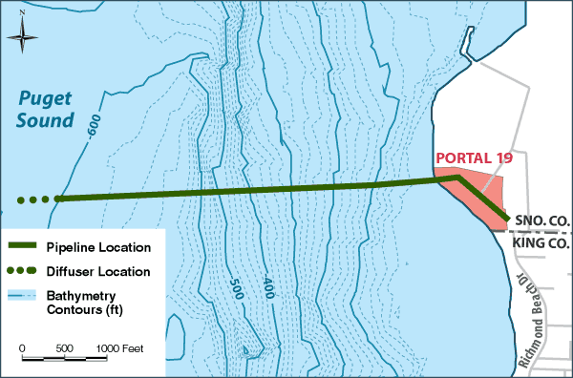
The remaining condemnation authority needed in support of the construction process is for the site intended to facilitate construction and operation of the outfall location, known as the ‘Point Wells’ site, or Portal 19. This site is located in Snohomish County where the King-Snohomish county line intersects the Puget Sound shoreline. The site is on a 26-acre parcel acquired in March, 2005 by Paramount Petroleum of Paramount, California; that property had historically been used as an asphalt-processing facility by the previous owners, Chevron Corporation, and continues in that use today under Paramount’s ownership. The acreage needed by the Wastewater Treatment Division for the outfall is a small portion of that parcel; 1.5 acres is needed for continuing operations and maintenance on a permanent basis, and 8 acres is needed temporarily for staging and construction. The property is listed by the state’s Model Toxics Control Act program as in need of site remediation associated with toxic wastes.

The county, through the Wastewater Treatment Division and the Prosecuting Attorney’s Office, has been negotiating with Paramount Petroleum since that company acquired the property in March, 2005; they had expended several years in negotiations with Chevron prior to the property sale.

The county is faced with some urgency with regards to the need to gain access this property for purposes of project development; the planning and construction timeline requires the county to go to bid for outfall construction in June, 2006.

State Condemnation Authorization
State law (RCW 8.12.030) authorizes condemnation proceedings; it indicates, in part,

Every city and town …is hereby authorized and empowered to condemn land and property… for streets, avenues, alleys… either within or without the limits of such city for public parks, drives and boulevards, hospitals, pesthouses, drains and sewers,… after just compensation having been first made or paid into court for the owner in the manner prescribed by this chapter.

Chapter 35.58.320 gives Metropolitan Municipal Corporations the same power as those of cities, described above, with regards to eminent domain:

A metropolitan municipal corporation shall have power to acquire by purchase and condemnation all lands and property rights, both within and without the metropolitan area, which are necessary for its purposes. Such right of eminent domain shall be exercised by the metropolitan council in the same manner and by the same procedure as is or may be provided by law for cities, except insofar as such laws may be inconsistent with the provisions of this chapter.

RCW 8.12 further describes the condemnation process, including the following key provisions:
- Petition for condemnation to superior court
- Judicial determination as to whether the proposed use is really a public use
- Determination of compensation through judicial procedure

RCW 8.25 provides that a condemning party can take possession of a property before final decrees are entered if the property owner stipulates to ‘immediate possession and use’.

SUMMARY
Proposed Ordinance 2005-0208 provides
- a finding that, to acquire needed land or necessary easements for the treatment system, including conveyance and outfall, it is necessary to condemn certain lands, property rights and rights in property;

- the county council deems it necessary that lands specified be condemned, for the purpose of constructing the Brightwater plant outfall facilities, subject to the payment of just compensation;

- prior to condemnation proceedings, the county will arrange for an independent appraisal of the property’s value, and enter voluntary negotiations with property owners; only when the department determines that voluntary negotiations have failed to reach agreement will condemnation proceedings be undertaken;

- Condemnation proceedings are authorized, and the county’s attorneys are authorized and directed to begin to prosecute necessary proceedings.

The proposed ordinance speaks to the need for condemnation authority for processes leading up to construction of the outfall facility, as well as construction; however, it is silent on the operations and maintenance of the outfall facility. As noted above, eight acres addressed in the legal description is intended to support construction and related activities on a temporary basis; 1.5 acres will be retained permanently for operations and maintenance. Staff has prepared an amendment to clarify that the condemnation authority is for properties needed for operations and maintenance, in addition to construction and construction-related activities, for the Council’s consideration.

Attachments:
- Proposed Ordinance 2005-0208 and attachments
  - Legal Description, Portal 19
b. Transmittal Letter dated April 26, 2005

