STAFF REPORT

Agenda Item: | 8 | Name: | Mary Bourguignon
Proposed No.: | 2025-B0136 | Date: | September 17, 2025

SUBJECT

Today’s briefing will provide an update on several of Metro’s flexible mobility services, focusing on the Vanpool Program, Community Van, and Metro Flex.

SUMMARY

Vanpool Program. Metro operates a Vanpool Program as an alternative mobility service for individuals who don’t have convenient transit service between home and work. As of December 2024, the Vanpool Program has 992 groups, with the goal of increasing to 1,098 by 2026.

Community Van Program. Metro’s Community Van Program operates in Algona-Pacific, Bothell-Woodinville, Kenmore/Kirkland, Redmond, Sammamish, Shoreline/Lake Forest Park, Skyway, Snoqualmie Valley, Tukwila, and Vashon. It offers a van for pre-scheduled trips as a driver or passenger. The cost to ride is the same as bus fare.

Metro Flex. Metro Flex is an on-demand mobility service through which riders can request a ride using a phone app or through Metro’s call center or web site. The rider provides a start/end to their trip within the service area and receives a pick-up location and estimated arrival time. Metro Flex currently operates in Delridge/South Park, Issaquah/Sammamish, Juanita, Kent, Northshore, Othello, Overlake/Crossroads, Rainier Beach/Skyway, Renton Highlands, and Tukwila. The cost to ride is the same as a bus fare.

Metro’s states that it is working to ensure its flexible services are unified and complementary to fixed-route services; are simple and easy for customers to use; provide more equitable and efficient use of resources; and promote stronger, more sustainable partnerships. Today’s briefing from Metro will provide more information on each of these services.

BACKGROUND

Flexible services. Metro’s flexible services are defined in its adopted policy documents as transportation services tailored to meet specific community needs that operate without a fixed route. Flexible services may or may not serve designated stops or hubs, depending on service design. They are typically deployed in communities that lack the infrastructure, density, or land use to support fixed-route bus service.

Flexible services are one of the types of service Metro offers. Service types, which are defined based on the level of service a route provides, are Very frequent/RapidRide, Peak Frequent, Local, Hourly, Peak-only, and Flexible services.

Flexible services are planned and implemented by Metro following criteria outlined in the adopted Service Guidelines to plan, add, evaluate, or reduce flexible services.

Figure 1, below, which is from the adopted Service Guidelines, outlines the process that is used to identify, develop, pilot, and evaluate a flexible service.

Figure 1.
Life Cycle of a Pilot Project

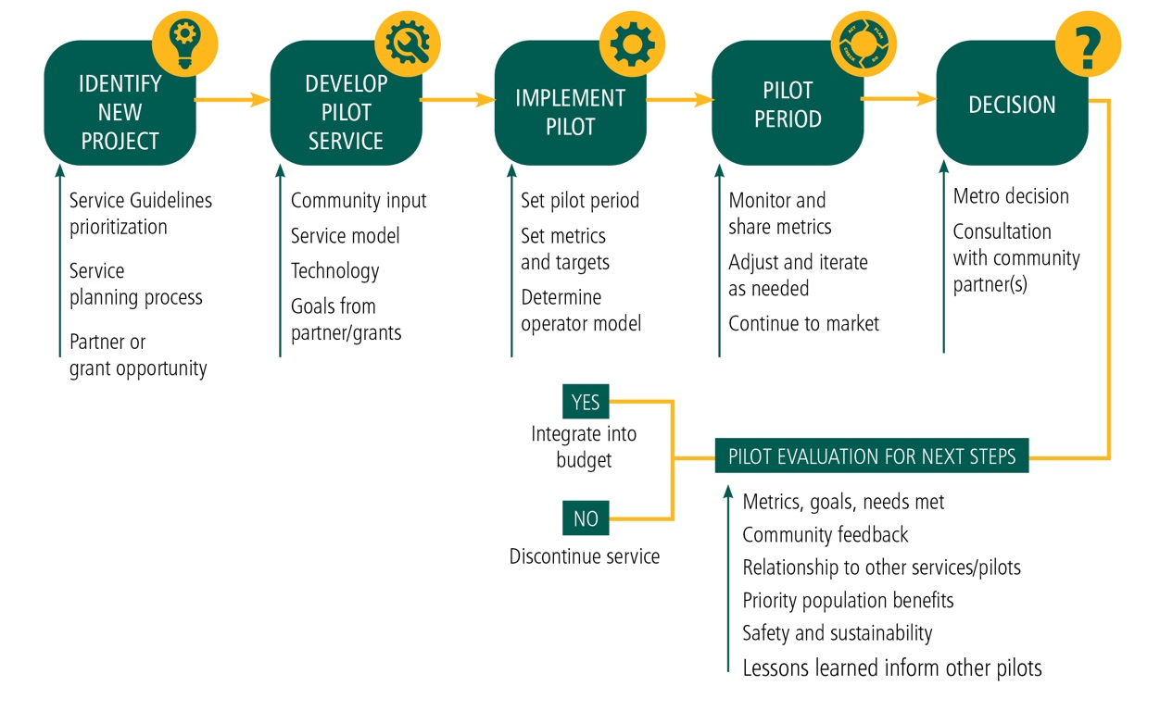

Metro notes that flexible services are prioritized based on:

- Equity, to serve those who need access the most
- Partnership, in response to opportunities to leverage resources
- Access, to reach jobs and community assets
- Density, to serve areas with adequate ridership and without high quality fixed-route service

After the pilot process for a flexible service shown in Figure 1, above, Metro conducts an evaluation, which measures:

- Equity, productivity, efficiency
- Community feedback
- Alignment with Metro’s priorities, goals, and plans
- Other mobility solutions in the area
- Available resources, including staff capacity

Vanpool Program. Metro operates a commuter Vanpool Program as an alternative mobility service for individuals who don’t have convenient transit service between home and work. Vanpools range in size, with five or more members required to start a Vanpool group. Each group has a volunteer driver plus a bookkeeper to track mileage, ridership, and fares. Fares are based on mileage, number of riders, and size of van. Vans are kept at the driver’s house and riders usually meet at a Park & Ride lot, with each group determining their own route, parking, and operating rules.

Metro sets fares for the program (which are often subsidized by employers) to recover 100% of direct costs and at least 25% of indirect and administrative costs, as required by the King County Code. Fares are based on the number of commuting days, trip mileage, vehicle size, and the number of people in the Vanpool.

The Vanpool Program had 1,649 Vanpool groups operating in 2019 prior to the pandemic. Membership fell to 395 groups in 2021, then grew to 992 by the end of 2024.

As of the end of 2024, the Vanpool Program had a fleet of 1,308 vehicles that included 1,221 active and 97 retired vehicles. Metro retires Vanpool vehicles at their end of their life cycle. Lower-mileage retired Vanpool vehicles are repurposed for other rideshare uses, including Vanshare, Job Access Reverse Commute, Community Van, and the Council’s van grant program. Higher-mileage retired Vanpool vehicles are sold, with proceeds used to support the Vanpool Program’s cost recovery requirements.

Vanshares are available for commuters who need to share the ride to or from another public transit mode such as a park-and-ride, train station or transit hub. A Vanshare provides first/last mile connections for commuters who share a van to link to public transportation (such as a train, bus, ferry, or longer-distance Vanpool). Each Vanshare must have five or more riders and a daily commute of 20 miles or less. Vanshare costs a flat $200/month, which is split by the group or covered by an employer.

Community Van. Metro’s Community Van Program operates in Algona-Pacific, Bothell-Woodinville, Kenmore/Kirkland, Redmond, Sammamish, Shoreline/Lake Forest Park, Skyway, Snoqualmie Valley, Tukwila, and Vashon. It offers a van for pre-scheduled trips as a driver or passenger. The cost to ride is the same as bus fare.

Each Community Van program has a Community Transportation Coordinator who recruits volunteer drivers, manages trips and vehicles, and promotes and maintains an info hub about the van. Metro provides vehicles, fuel, maintenance, insurance, staff funding, and monitoring. Community Vans are available 24/7, with flexibility to meet community needs.

All trips are driven by volunteer drivers and are dependent on volunteer availability. Passengers wishing to request a ride are asked to contact the coordinator for Community Van in their service area, with Metro requesting two business days’ advance notice. Metro notes that Community Van programs provide a way to organize local group trips to events and activities, and also support medical appointments, food bank trips, meal deliveries, and youth trips.

Metro Flex. In March 2023, Metro’s Community Ride, Ride Pingo to Transit, and Via to Transit services were consolidated into Metro Flex. Metro Flex currently operates in Delridge/South Park, Issaquah/Sammamish, Juanita, Kent, Northshore, Othello, Overlake/Crossroads, Rainier Beach/Skyway, Renton Highlands, and Tukwila. The cost to ride is the same as a bus fare.

Metro Flex is open to the general public. Riders can request a ride on-demand using a phone app or through Metro’s call center or web site. The rider provides a start/end to their trip within the service area and receives a pick-up location and estimated arrival time. The rider then walks to the pick-up location and joins a shared ride with a 15-minute estimated time of arrival for the ride on average. Metro Flex services have the same fare as a Metro bus and provide free transfers to fixed-route buses, Link light rail, or Sounder commuter rail using an ORCA card.

Metro states that Metro Flex, as currently configured:

- Provides operational efficiencies
- Builds on innovations from previous services, while preserving the innovations achieved by previous services
- Streamlines branding and reduces customer confusion
- Reduces staff demands
- Achieves cost savings

Service times for Metro Flex are shown in Table 1.

Table 1. Metro Flex Service Times (September 2025)

Service Area | Weekdays | Saturdays | Sundays
Delridge/South Park | 6am-11pm | 6am-11pm | 6am-11pm
Issaquah/Sammamish | 7am-6pm | 9am-6pm | --
Juanita | 7am-7pm | -- | --
Kent | 5am-7pm | 7am-7pm | 7am-7pm
Northshore | 7am-7-m | -- | --
Othello, Rainier Beach, Skyway | 5am-1am | 5am-1am | 6am-12am
Overlake/Crossroads | 7am-7pm | 8am-6pm | 8am-6pm
Renton Highlands | 5am-1am | 5am-1am | 6am-12am
Tukwila | 5am-1am | 5am-1am | 6am-12am

During today’s briefing, Metro staff will provide updated information about Metro’s existing flexible services, as well as how flexible services are planned, piloted, marketed, and evaluated.

INVITED

- Chris O’Claire, Mobility Division Director, Metro Transit Department
- Melisa Allan, Transportation Planner, Metro Transit Department
- Brian Henry, Transportation Planner, Metro Transit Department
- Victoria Tobin, Rideshare Coordinator, Metro Transit Department
- Julie Paone, Transportation Planner, Metro Transit Department

ATTACHMENTS

- Metro flexible services presentation

2025-RPT0092 (link)
Community Van Program (link)
Current Metro bus fares: free for children and youth, $3.00 for adults, $1.00 for ORCA LIFT (low-income), and $1.00 for seniors or people with disabilities with a Regional Reduced Fare Permit ORCA.
Metro Flex (link)
Service in the Overlake/Crossroads neighborhoods in Bellevue began September 15, 2025.
King County Metro Policy Updates, Technical Report A, July 2021 (transmitted as ancillary material to the policy documents adopted through Ordinance 19367) (link)
Ordinance 19367
Ordinance 19367, Attachment B
Ordinance 19367, Attachment B, p. 30
Metro Vanpool Program (link)
KCC 4A.700.130
2025-RPT0092 (link)
The Job Access Reverse Commute Program partners with social service organizations, local jurisdictions, and employers to assist with transportation for low-income people, specifically for job training and placement programs.
The Community Van Program (link) is being piloted in several communities. It offers a van for pre-scheduled trips as a driver or passenger.
Most years, the Council grants retired vanpool vans to non-profit organizations and local governments to meet the mobility needs of seniors, youth, low-income people, and people with disabilities (KCC 4.56.100.E). The program has granted more than 775 retired vans since it began in the 1990s.
KCC 4.56.195
KCC 4A.700.130 requires that the vanpool program must cover 100% of direct costs and 25% of indirect costs.
Vanshare (link)
Community Van Program (link)
Current Metro bus fares: free for children and youth, $3.00 for adults, $1.00 for ORCA LIFT (low-income), and $1.00 for seniors or people with disabilities with a Regional Reduced Fare Permit ORCA.
Metro Flex web site (link)
Service in the Overlake/Crossroads neighborhoods in Bellevue began September 15, 2025.

