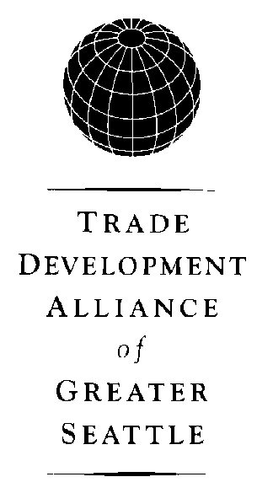

William B. Stafford

Bill Stafford is president of the Trade Development Alliance of Greater Seattle. Between 1971 and 1990, he was employed with the City of Seattle in a number of positions, including Deputy Mayor to Charles Royer and Director of the Office of Intergovernmental Relations, where he was responsible for the national, state, regional and international relations of the city. He has been involved in a number of national urban advisory committees, chairing the National Urban Consortium in 1980 and is currently a member of the Citistates Associates. Prior to joining the City of Seattle, he was with Ford Motor Company. He has been an affiliate professor at the Graduate School of Public Administration of the University of Washington. He is a graduate of Colorado College and has an MBA from Columbia University. He was selected “Outstanding Public Employee” by the Municipal League of Seattle-King County in 1986.

Bill Stafford has been active in the Seattle area community for many years. He is a member of the United States Department of Commerce’s District Export Council and the International Advisory Board of the University of Washington’s Center for International Education and Research. He also chairs the Seattle Sister City Coordinating Council, and serves on several boards including the Advisory Board of the Burke Museum, the Museum of History and Industry (MOHAI), Sister Cities International, Port Jobs, and the Economic Development District. In the past, Stafford served as executive board member of the Japan America Conference of Mayors and Chamber of Commerce Presidents. In addition, he served as a board member for the Woodland Park Zoological Society and Oversight Board, Seattle Children’s Museum, and the Public Defender Association. Furthermore, he was a member of the National Advisory Committee of Small Business Administration

The Trade Development Alliance of Greater Seattle is comprised of the Port of Seattle, Port of Tacoma, Metropolitan King County Government, Snohomish County Government, Pierce County Government, the City of Seattle, the City of Everett, the Greater Seattle Chamber of Commerce and organized labor representatives. The Trade Alliance exists to promote the Greater Seattle region as one of North America’s premier international gateways and commercial centers.

