STAFF REPORT

Agenda Item: | 10 | Name: | Mike Reed
Proposed No.: | 2020-B0071 | Date: | September 2, 2020

SUBJECT

RWQC Engagement process preliminary to the 2022 wastewater rate setting effort.

SUMMARY

The Regional Water Quality Committee is briefed annually on recommended sewer rates and capacity charges, prior to adoption by Council. In the 2021 rate setting process, significant projected rate increases in coming years became a point of discussion, and Asset Management emerged as a key element in those discussions. For the 2022 rate setting process, the Wastewater Treatment Division has committed to engaging key participants, including the Regional Water Quality Committee, in framework discussions to inform that rate setting effort. The Division has conducted several briefings for the Metropolitan Water Pollution Abatement Advisory Committee (MWPAAC); today’s briefing will initiate that engagement process for RWQC.

BACKGROUND

The regional wastewater rate-setting process for 2021 rates, which occurred at the MWPAAC and Council level in the spring of 2020, resulted in a heightened regional recognition of significant upward pressure on sewer rates, that are projected to result in recommendations for substantial rate increases in coming years. Table 1 below depicts the rate history of recent years, and projected rates for coming years.

Table 1. Sewer Rates (2009-2020 Actual; 2021 Proposed; 2022-2025 Projected)
Year(s) | Rate  ($/RCE/ Month) | % Increase
2009 – 2010 | 31.90 | 14.1%
2011 – 2012 | 36.10 | 13.2%
2013 – 2014 | 39.79 | 10.4%
2015 – 2016 | 42.03 | 5.6%
2017 | 44.22 | 5.2%
2018 | 44.22 | 0.0%
2019 | 45.33 | 2.5%
2020 | 45.33 | 0.0%
2021 | 47.37 | 4.5%
2022 | 47.37 | 0.0%
2023 | 52.23 | 10.25%
2024 | 52.23 | 0.0%
2025 | 57.58 | 10.25%

It is important to note that, while the 2022 rate is projected to hold constant in the table above, that projection was included as a “placeholder” after initial indications of significantly greater rate recommendations for the 2021-2022 period; it was inserted pending a robust engagement process leading to the development of a 2022 rate recommendation.

There are a number of rate “drivers” that are often discussed as shaping the emerging rate picture. These include:

  - The requirement for establishment of Combined Sewer Overflow facilities to control discharge of untreated wastes during periods of high stormflow, resulting from the CSO Consent Decree between King County, the Washington Department of Ecology, the federal Environmental Protection Agency and the federal Department of Justice.
  - The Washington Department of Ecology is moving forward with development of a regulatory project that is expected to result in a limitation on the level of nutrients that can be discharged in the effluent of wastewater plants discharging into Puget Sound. Response to those regulations may have significant capital cost implications for King County wastewater processing facilities.
  - Regional population growth, requiring assessment of the capacity of the existing system to effectively capture and process anticipated wastewater volumes; the Division has completed a wastewater Flows and Loads study which should help inform the discussion regarding growth-driven capacity needs.
  - The need for system resilience, which was dramatically illustrated by the West Point system failure in 2017, and which resulted in a third-party analysis that emphasized system resilience as a key means of preventing recurrence of similar events
  - Aging of the physical plant. The primary elements of the wastewater conveyance and processing system, including the interceptor pipelines and West Point and South treatment plants, were constructed in the 1960s and 1970s. Those facilities are now approaching or exceeding 50 years old, and to a greater or lesser extent, experiencing the challenges of an aging system. The Wastewater Treatment Division is addressing the need to evaluate, rehabilitate and replace aging segments of the conveyance system through the Conveyance System Improvement project, which identifies segments in need of upgrade to assure conveyance capacity capable of handling a 20-year peak flood through the year 2060. The urgency of the need to address conveyance system needs was highlighted in the 2021 rate discussion. Figure 1 below illustrates the age of various interceptor system segments:

Chart 1 Interceptors By Age

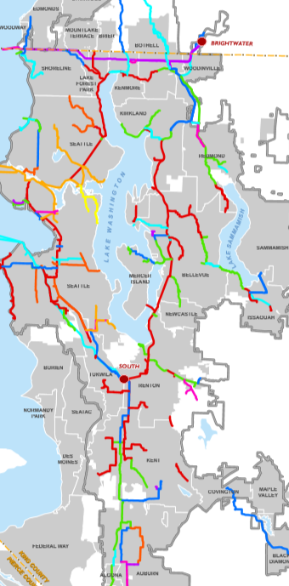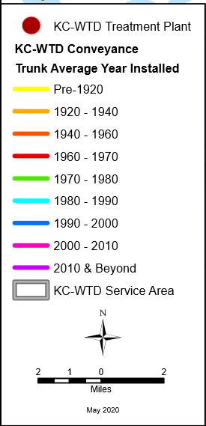

These aging wastewater facilities, or system “assets”, are the subject of the agency Asset Management project. Asset Management is the systematic evaluation, project development, costing, and scheduling of projects intended to address the functioning and reliability of the wastewater physical plant.

Asset Management is emerging as a key element in discussions regarding rate drivers. The Wastewater Treatment Division is presenting a series of briefings to city and sewer district participants in the wastewater system, through the Metropolitan Water Pollution Abatement Advisory Committee.

Today’s briefing will introduce the Regional Water Quality Committee to this topic, as a means of engaging the Committee with the specifics of the framework that will define the development of the projected sewer rate proposal for 2022 and beyond.

INVITED

- Bruce Kessler, Deputy Division Director, Wastewater Treatment Division

ATTACHMENTS

- Wastewater Treatment Division’s Asset Management Overview Presentation

Map produced by Shari Cross of the GIS program of the Wastewater Treatment Division

