STAFF REPORT

Agenda Item: | 6 | Name: | Brandi Paribello
Proposed No.: | 2025-0204 | Date: | August 20, 2025

SUBJECT

Proposed Motion 2025-0204 would accept the King County 30-Year Forest Plan, which has been transmitted in accordance with the requirements of the adopted 2024 Comprehensive Plan Update.

SUMMARY

King County developed a 30-Year Forest Plan as required in the adopted 2015 Strategic Climate Action Plan; it was finalized in 2021. The adopted 2024 Comprehensive Plan Update required that it be transmitted in 2025, along with a motion accepting the plan.

The 30-Year Forest Plan contains sections on seven priority areas and goals for each, strategies within each of those priority areas, and details regarding implementation actions for each of those strategies. Additionally, within each of the priority area sections, the 30-Year Forest Plan describes how goals and strategies are aligned to other King County plans and initiatives, including Clean Water Healthy Habitat, the Land Conservation Initiative, the 2025 Strategic Climate Action Plan, and the Equity and Social Justice Strategic Plan.

BACKGROUND

In 2015, the King County Council adopted the Strategic Climate Action Plan (SCAP) which included the 1 Million Trees initiative, a commitment to plant at least one million trees with county partners in King County by 2020. The SCAP also included a commitment to work with partners to develop a 30-Year Forest Plan (the Plan) to guide efforts to maintain and enhance the county’s forest cover from 2020-2050.

In 2019, the County began to solicit input on priorities, goals, and strategies for the Plan by beginning outreach efforts with nonprofits, Indian tribes, and city governments that also participated in the 1 Million Trees initiative. Outreach was conducted through one-on-one meetings, workshops, community events, and email correspondence. Additionally, an online public input survey was distributed to other stakeholders, including forest landowners and managers. The Plan was ultimately finalized by the Executive in 2021; however, the adopted 2024 Comprehensive Plan Update requires that the Plan be transmitted in 2025, along with a motion.

Ordinance 19881, Section 377 states:

No later than June 30, 2025, the executive shall transmit the thirty-year forest plan, clean water healthy habitat strategic plan, and wildfire risk reduction strategy to the council, along with motions accepting each document. The documents and motions required by this section shall be filed with the clerk of the council, who shall retain an electronic copy and provide an electronic copy to all councilmembers, the council chief of staff, and the lead staff to the transportation, economy, and environment committee or its successor.

The Chairs of the Transportation, Economy, and Environment (TrEE) and Local Services and Land Use (LSLU) committees agreed that the Plan and proposed motion should be referred to LSLU.

ANALYSIS

Priority Areas and Goals. The Plan identifies seven priority areas relating to the value and benefits of forests. Within each priority area, the Plan identifies goals that relate to forests and tree cover, including specific goals related to cultural resources and equity. The identified priorities and goals include:

- Climate: Contribute to climate change mitigation by increasing carbon sequestration and storage in King County forests and increase resilience and preparedness for climate change effects on forests.
  - Increase the amount of carbon stored in forests in King County to the greatest extent practicable while protecting biodiversity and improving forest health.
  - Increase the resilience of existing forests and newly planted trees to the effects of climate change.
  - Improve the preparedness of communities near forests for any potential increase in fire risk caused by climate change.
  - Equity and cultural resources: Maintain western red cedar, which may be susceptible to drought stress associated with climate change, and other species of cultural significance that provide cultural resources and values to area Indian tribes.
- Forest Health: Improve and restore forest health, including increasing resilience to disease, invasive species, drought, and climate change; sustaining biodiversity, improving wildlife habitat, and restoring connectivity; and maintaining or improving ecological functions.
  - Increase the area of healthy and resilient forestland.
  - Increase connectivity of protected forestland to improve wildlife habitat.
  - Equity and cultural resources: Create a broader public understanding of pre-settlement forest stewardship by the Coast Salish peoples and the resulting forest conditions as a baseline for healthy, complex, and biodiverse forests; improve forest conditions that support the ability of Indian tribes to exercise treaty rights and cultural practices; and improve forest health in forests close to under-served communities.
- Urban Forest Canopy: Increase tree canopy in urban areas, with a focus on areas with the lowest canopy cover and maintain and improve the health of existing urban forests.
  - Maintain and increase existing tree canopy in urban areas, prioritizing areas with low canopy cover.
  - Maintain urban trees and improve urban forest health.
  - Equity and cultural resources: Increase tree canopy above current baseline in urban unincorporated areas with low canopy cover and support urban forest projects as a foundation for youth training to develop tomorrow’s forestry leaders.
- Human Health: Prioritize tree canopy improvements and increased access to forested spaces to improve human health outcomes and advance health equity.
  - Increase tree canopy with improvements focused in geographic areas and communities with residential areas subject to high levels of summer heat and/or pollution, or other human health disparities.
  - Improve access to forested spaces, prioritize communities where the needs are greatest, and support outdoor recreation opportunities that can provide physical and mental health benefits.
  - Equity and cultural resources: Increase use, engagement, and sense of belonging in forested parks where access to or use of parks and green space is below the regional average
- Salmon Habitat: Increase and improve forest cover and condition in areas where it can enhance salmon habitat.
  - Protect, increase, and improve the extent and health of riparian forests.
  - Protect, increase, and improve the extent and forest health in the headwaters of salmon streams to improve ecological function and protect water quality and quantity.
  - Equity and cultural resources: Align salmon habitat restoration with Indian tribal priorities and use culturally important plant species in salmon habitat restoration.
- Water Quality and Quantity: Maintain and expand forest canopy where it provides the most benefit for improving water quality and quantity, reducing stormwater runoff, and reducing flooding.
  - Maintain and expand forest cover in areas identified as having poor water quality or high pollutant loads to streams and rivers, where forest cover improvement can provide benefits.
  - Maintain and expand forest cover to improve water quantity conditions in areas identified as having high potential to mitigate flooding or where protecting groundwater is a priority.
  - Equity and cultural resources: Integrate equity considerations into prioritization of stormwater projects involving forest cover.
- Sustainable Timber: Support an ecologically sustainable and economically viable timber industry that promotes maintenance of ecological functions in working forests and local economic development.
  - Maintain healthy working forests and prevent forest fragmentation and the conversion of working forests to non-forested uses.
  - Increase the use of forestry practices that improve ecological functions (such as carbon sequestration, fish and wildlife habitat, and hydrologic cycling) in working forests.
  - Improve access to and condition of infrastructure and markets that support sustainable forestry practices.
  - Equity and cultural resources: Increase equity in the timber industry and diversity of forestry professionals, particularly those trained in ecological forest management practices and the cultural importance of forests.

Strategies. The Plan provides tables under each priority and goals that set out strategies to achieve those goals, as well as the DNRP action required to implement the strategies. The tables additionally indicate whether any other priorities within the Plan or other countywide strategic plans are related to each strategy. Figure 1 below is an example of these tables within the Plan, specifically related to Priority 1, Climate, Goals 1-3 and 1-4.

Figure 1. Strategy Table Example

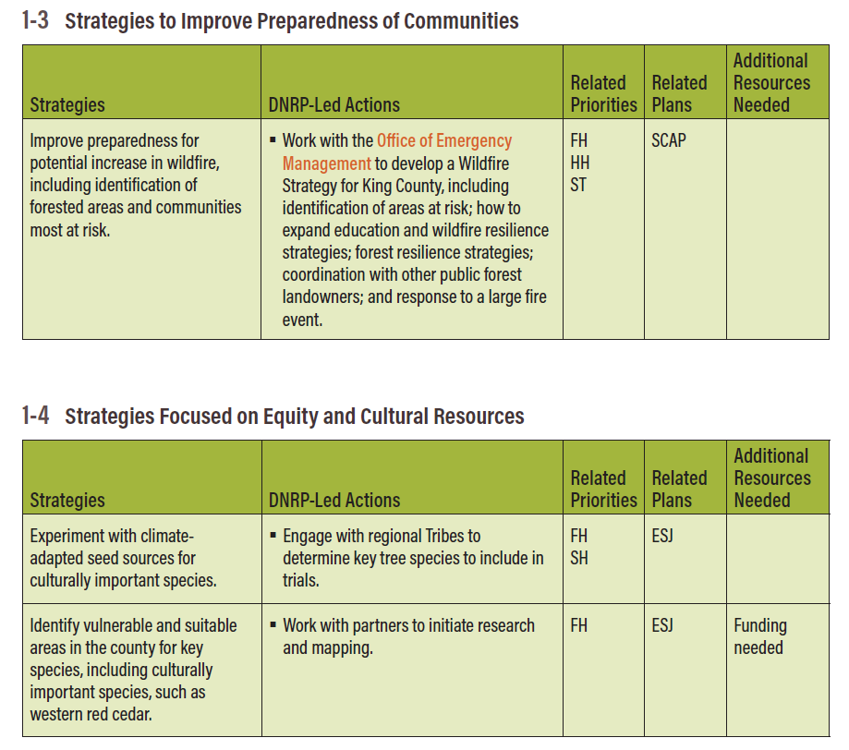
Implementation. The Plan includes information on actions DNRP will take in implementing the strategies laid out in the Plan. The implementation period is from 2021 through 2026 and includes actions such as:

- A set of pilot projects, all of which will be initiated in the first year of the plan. According to Executive staff, six pilot projects were planned and initiated. As of transmittal, four were completed (forest health assessment, climate-adapted planting, tree giveaway, and urban tree planting using City Forest Credits), one is in progress (demonstration forest at Taylor Mountain), and one has been discontinued (the riparian planting project using City Forest Credits). Staff state the last project was discontinued because “changes to the carbon credit rules meant the credits would be based on future tree growth, not actual carbon already removed from the air. Present day crediting for offsets potentially generated in the future is not allowed under policies that govern the County's forest carbon program, so there was no longer a valid way to use the credits for small tree planting projects.”
- A set of actions that directly align with the 2020 SCAP. The document indicates these will be completed by the end of 2025. Connections to the SCAP are noted within each of the priority sections within the Plan.
- A set of DNRP-led actions to be initiated in the next five years. Actions identified in the plan will be prioritized based on the following criteria: ability to provide multiple benefits (i.e. contribute to multiple priorities); contribution to other plans and initiatives; and availability of funding. Executive staff state the following actions have been advanced and a full progress report will be available in 2026:
- Wildfire Strategy: released in 2022; Community Wildfire Protection Plan in development.
- Climate-Adapted Planting Trial: implemented and monitored.
- Assisted Migration Paper: published in 2024.
- Forest Health: 1,000 acres treated; prioritization and stewardship planning underway.
- Urban Forestry Forum and Street Tree Working Group: launched.
- Tree Planting Projects: completed in Skyway and White Center.
- Youth Engagement and community programming expanded.
- Multiple Actions Underway spanning climate resilience, urban canopy, water quality, and sustainable forestry.

The document states that the Plan will be revisited every five years to evaluate progress and identify priority actions for the next five-year period.

Alignment with Other County Initiatives or Plans. The Plan describes the ways in which it aligns with the following County initiatives and plans in each of the priority sections. In general, the Plan aligns with the following:
- Clean Water Healthy Habitat: aligns by highlighting healthy forests and more green space as one of its six goal areas.
- Land Conservation Initiative (LCI): aligns with the LCI goals of protecting additional forests and providing more equitable access to forested areas.
- 2025 Strategic Climate Action Plan: aligns by incorporating all the forestry-related SCAP actions.
- Equity and Social Justice Strategic Plan: aligns by using the ESJ goal that “All county residents should have equitable access to clean air and water, and the health and recreation benefits of King County’s extensive network of regional trails, open spaces, and working farms and forests” to inform the Plan.

Policymaker Input on the Plan. Executive staff indicate that a progress report on implementation of the contents of the Plan will be available in the second quarter of 2026. Should Council wish to provide input on the next phase of five-year action identification and implementation, it may make sense to wait to provide that direction until after it receives the report.

INVITED

- Josh Baldi, Division Director, Water and Land Resources Division, Department of Natural Resources and Parks

ATTACHMENTS

- Proposed Motion 2025-0204 and its attachment
- Transmittal Letter
- Fiscal Note

Motion 14419
Ordinance 19881, Section 377
King County 30-Year Forest Plan, page 27.
According to Executive staff, these projects are: - Forest Health: Parks forestlands assessed and prioritized; 977 acres high priority. - Urban Canopy & Human Health: Tree planting project evaluated via Impact Certification; useful for funders, but time intensive. - Water Quality: Tree giveaway piloted in White Center and Skyway with community partnerships; 200 trees distributed in 2024. - Climate: Trial plantings of climate-adapted seedlings at four sites; monitoring underway. - Sustainable Timber: Taylor Mountain selected as demonstration site; interpretive signage and tours planned. - Salmon Habitat: City Forest Credits project deemed infeasible due to carbon credit protocol issues.
According to the transmittal letter accompanying the Plan and motion, “Although finalized in 2021, the Forest Plan is being transmitted now as called for in the 2024 Comprehensive Plan Update. Developed to implement the 2015 Strategic Climate Action Plan (SCAP), the Forest Plan responded to SCAP directives to plant at least one million trees by 2020 and to create a 30-year strategy for expanding tree canopy in urban and rural areas while supporting growth, agriculture, wildfire resilience, and working forests. A new SCAP has since been transmitted to the Council, and the Forest Plan’s objectives remain aligned with the updated SCAP.”
The ESJ Strategic Plan is an Executive initiative not adopted by the Council. The ESJ Strategic Plan expired in 2022.

