Questions and Answers on WTD’s Capital Program

Council Staff QUESTION #1. Please explain the processes in place within WTD and within the Executive branch (this could include PSB monitoring) to successfully manage and deliver the capital program and the accountability and oversight mechanisms that are in place.

WTD Response: WTD Portfolio Management provides financial stewardship by performing coordinated, balanced, and transparent management of portfolios and portfolio categories of capital projects and programs to better achieve the organization’s strategic objectives through prioritization, resource balancing, and continuous improvement. Portfolio, Program, and Project oversight is conducted through a tiered internal governance structure shown below.

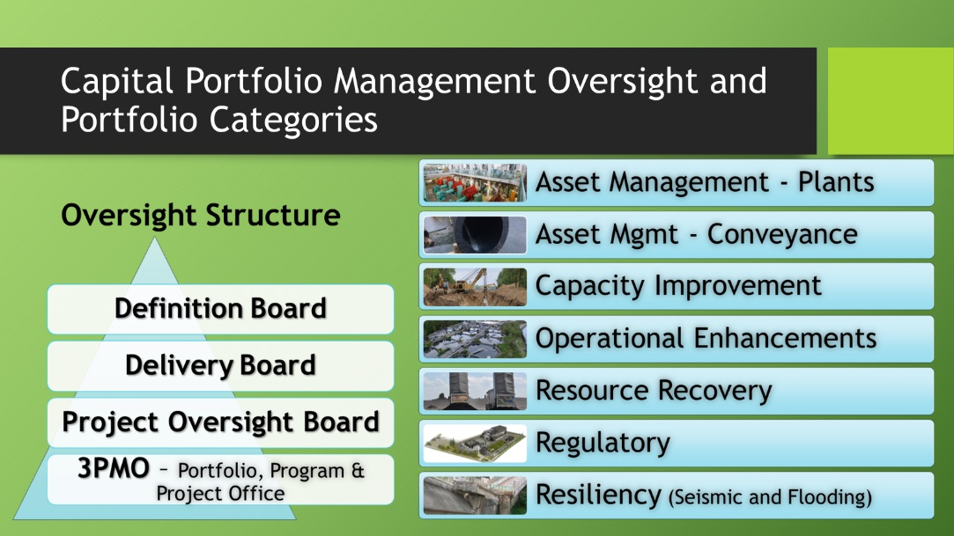

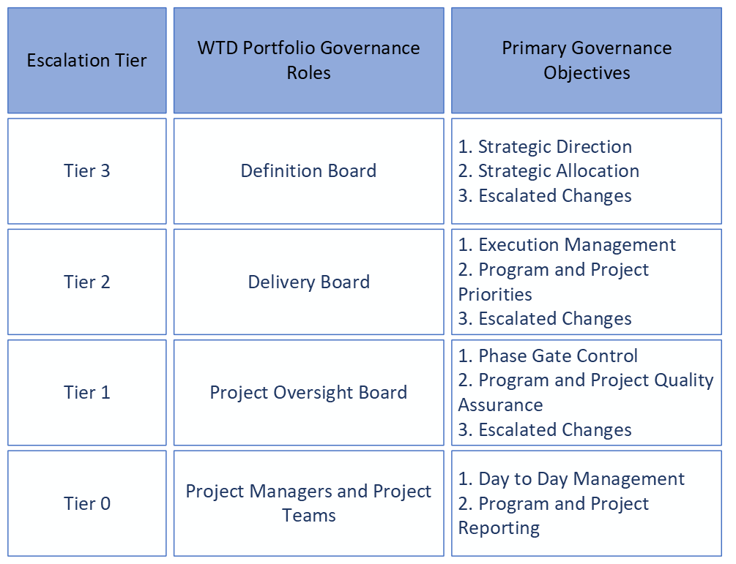

WTD Capital Portfolio Governance Objectives
- Clearly defined strategic direction for the capital portfolio comprised of programs and projects
- Demonstrate the value added to the public by the capital investments to the system
- Evaluation and prioritization of capital project requests, concepts, opportunities and existing programs and projects in development and delivery
- The transparent, balanced, and efficient management of limited resources
- Regular data-driven monitoring and reporting
- To establish and maintain strategic and rigorous parameters, weighted multi-attribute criteria, and well documented assumptions
- Develop and deliver the right projects and programs at the right time for the right reasons

The Definition Board (tier 3) makes decisions regarding the budget strategic direction in execution and delivery of capital projects to:
- Provide financial accountability.
- Promote governance that understands stakeholder needs and timelines.
- Seek to identify measures to manage risk.
- Provide direction for timely delivery of the organization’s programs and projects that maximizes the value of the investments for stakeholders through the allocation of capital to portfolio categories.
- Provide strategic direction to the management and oversight actions of the capital portfolio.

The Delivery Board (tier 2) is organized and chartered to inform and make decisions and recommendations regarding the execution and delivery of capital projects to:
- Establish the capital portfolio prioritization.
- Manage adjustments to the planned capital portfolio, including adjustments to individual portfolio categories.
- Provide oversight and direction for timely delivery of the organization’s programs and projects that maximizes the value of the investments for stakeholders by balancing the WTD capital portfolio through project prioritization, validation, and resource management.
- Adjust to changing conditions over time to deliver projects and programs that align with WTD strategic objectives.
The Project Oversight Board (POB) (tier 1) makes decisions regarding the execution and delivery of programs and projects to:
- Provide oversight and direction for timely delivery of the organization’s programs and projects.
- Adjust to changing conditions over time to deliver projects and programs that align with WTD strategic objectives.

Additionally, PSB oversight mechanisms include quarterly baseline reporting, annual spending report, and financial monitoring.

Council Staff QUESTION #2. What metrics are used to manage the capital program, who are the metrics reported to, what happens when projects are “off-track”, etc.

WTD Response. PRISM is WTD’s Project Information System Management. All capital contracts, projects, programs and portfolios are organized to monitor and manage the entirety of the capital program. Metrics include:
- PRISM dashboards and PRISM Project Health use real time project information, schedule forecasts, status, and financials for monitoring performance.
- Real-time Quarterly reporting: daylights quarterly progress, quarterly key activities (current and upcoming quarter), closely monitored Issues and Key Risks, Contract Change, and variance on scope, cost, and schedule versus last approved plan

Typical WTD Capital Key Performance Indicators (KPIs) applied are:
- Annual spending Accomplishment Rate vs plan
- Engineers Estimate vs Bid Amount review
- Allied Cost Ratio review
- Variance form Cost Model review
- Milestones achieved by Quarter monitoring
- Contract statistics such as change orders, and contingency usage.
- Capital $ per FTE analysis

Council Staff QUESTION #3. What happens when projects are “off-track”?

WTD Response. See question 2 above on how oversight of projects and programs are governed via the Project Oversight Board, Delivery Board and Definition Board. Project Management supervisors and unit managers also work daily/weekly/monthly with Project Managers and project teams to mentor, coach and address “off track” issues expeditiously.

Council Staff QUESTION #4. Have there been consultant reports or other WTD initiated reports which discuss capital project management/delivery? If so, please provide links and whether WTD has adopted any of the recommendations in the reports.

WTD Response. WTD has been adhering to Project Management Institute (PMI) project management standards since 2006. WTD has had more than 100 certified Project Management Professionals (PMP) by PMI. Our comprehensive Project Management Manual aligns with PMI standards and our business needs, serving as a key resource for our team. WTD is an active member and a co-chair of the Capital Project Management Working Group (CPMWG) focused on standardizing project management processes across all departments. CPMWG engaged a consultant in 2020 to review all the project management manuals and process and that report can be found here.

Council Staff QUESTION #5. Does WTD maintain a listing of projects with significantly changed scope, schedules or budgets when comparing to the prior appropriation? I defer to you on how define “significant”. For context, I have reviewed the CAP summary table and there are many projects descriptions which note the cost at completion has changed but in most cases, there’s no way to know from reading the description how significant the change is.
WTD Response. Below are projects with significant scope and/or cost changes. We are defining as significant those projects with Estimate at Completion (EAC) changes that are both large in overall cost and percentage increases over EACs included in the last budget.
Name | 2023-2024 Budget EAC and Classification | 2025 Budget EAC and Classification | Driver
1139043 Elliott West Wet Weather Treatment Station | $12M  Not applicable, no construction included | $492M  AACEi Class 4* | Previous scope included only scope to complete the facility plan. Current scope and EAC includes final design and construction phases per the issued West Point NPDES permit which accelerated project completion.
1141134 West Point Electrical Improvements | $131M  AACEi Class 10 | $410M  AACEi Class 4* | Added scope in preliminary design to include assets aging out of expected life during the 10-year program horizon. The cost estimate was also updated per recent electrical equipment prices and include allowances for additional cost uncertainty.
1143830 WPTP Critical Gate Refurbishment | $29M  Rough order of magnitude based on similar historical projects | $154M  AACEi Class 5* | Developed conceptual scope during project formulation.
1143834 West Point Digestion Capacity Expansion | $84M  AACEi Class 10 | $330M  AACEi Class 5* | Updated program assumptions during problem definition, includes a longer program horizon and future phases of expansion not included in the estimate submitted in the last budget.
1143865 Black Diamond Trunk Capacity Upgrade | $57M  AACEi Class 5 | $167M  AACEi Class 5* | 2023-2024 Budget submittal included only first phase of capacity improvements. Updated population growth estimates and changed assumptions accelerated second phase of improvements into the project scope.

*For reference, the table below describes the cost estimate classifications, the level of typical scope definition, and the expected accuracy ranges for estimates based on the level of scope definition.
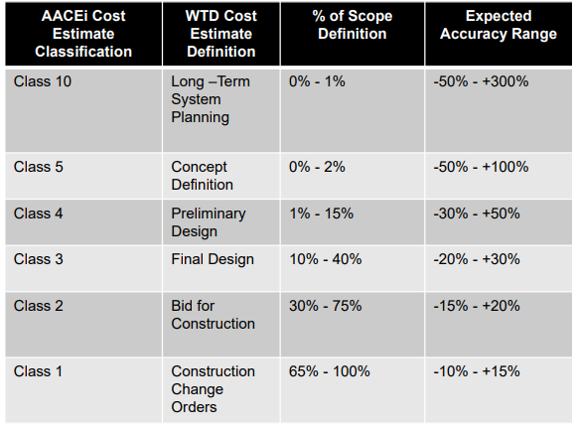

Council Staff QUESTION #6. How can I quickly identify projects which have had significant scope, schedule or budget changes and some level of detail on those changes?
WTD Response. Each quarter PSB transmits a budget management report to the clerk of the council. One element of this report is a listing of all baselined projects with current estimate scope, schedule, and cost information and a comparison to the baseline estimate as well as detailed updates on projects that have been designated for additional risk monitoring. Within the Project Information Center (PIC), comparisons can also be made between reporting cycles using the “Baseline Quarterly Comparison Report.” In addition, the description of budget request in the CAP form within PIC notes when the Estimate at Completion changes due to a change in scope, schedule or budget. WTD can provide this information upon request.

