Lease Property Summary
Photo of Property:

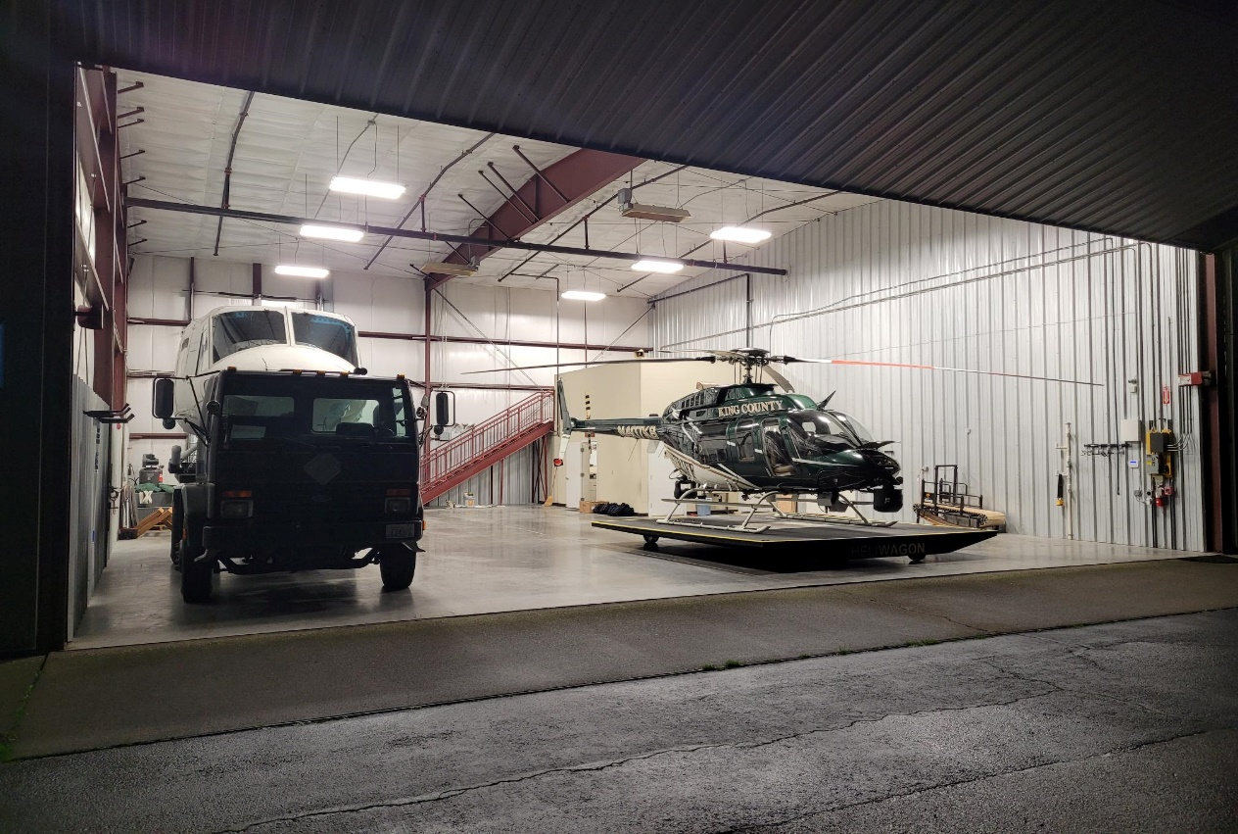

Property Owner: RNT 750 LLC
Address: 750 West Perimeter Road, Renton, WA 98057 – Renton Municipal Airport
Cost Per Sq. Ft.: $31.33 per rentable square foot per year
Operational Costs: $5.14 per rentable square foot per year
Term: 10 years plus two five year options to renew
Square Footage: 10,505 rentable square feet
Template: Landlord Template with County edits
Council District: Council District Five
Funding Source: Long Term Lease Fund
Previous Location: N/A – Existing Location Renewal
Offer Expiration: Current lease term expires May 31, 2025

Lease Synopsis:
The proposed Ordinance would approve an amendment to a lease that has been in effect since 2011. The current lease expires May 31, 2025 and does not have additional options to renew. This amendment extends the term for ten years until May 31, 2035 (extended term) and provides two five-year options to renew (option terms).
Context
Rationale for transaction: This lease supports the King County Sheriff’s Office (KCSO) Special Operations Division. KCSO utilizes the premises to house $25,000,000 of County equipment, such as a newly purchased helicopter for KCSO’s Air Support Unit (ASU). The areas of this lease include Hangars B, G, and H which are occupied by KCSO Special Operations.

This lease also supports new office space for the K9 Unit administration that provides services such as general police service and narcotics and explosives detection. In addition, this lease renewal supports additional large vehicle storage for the Tac 30/SWAT Unit.

The amendment to this lease renewal is for an existing location that has supported KCSO since this lease commenced in 2011.

Policy considerations: The equipment stored at this leased location requires easy and quick access to the runway at Renton Municipal Airport, as it is utilized for life-saving operations. The equipment cannot be left outside as exposure to the elements could cause damage.

Political considerations: N/A

Community considerations
or partnerships: N/A

Fiscal considerations: The monthly base rent for year one of the extension term will be $27,410.57 which represents a three percent increase over the current monthly base rent of $26,612.20. Annual base rent shall increase by the amount of three percent over the previous year’s monthly base rent for years 2-10 of the extension term. In addition to the monthly base rent, King County is responsible for the monthly operating costs, which is currently in the amount of $4,498.07. Annual base rent for year one of each option term shall be at fair market value with annual increases of three percent for years 2-5 of each option term.

Other considerations: N/A

CIP/operational impacts: N/A

Equity and Social Justice impact: In accordance with Real Property Asset Management Plan (RAMP) policy, the Facilities Management Division and the King County Sheriff’s Office reviewed this legislation for Equity and Social Justice (ESJ) impacts. This location is in Renton south of Lake Washington at the Renton Municipal Airport. This program has been occupying this location since 2011 and is not expected to negatively impact low-income communities, communities of color, or limited English-proficient communities by continuing to occupy this location. The community and public safety determinant of equity includes services such as fire, police, and emergency medical services and code enforcement that are responsive to all residents so that everyone feels safe to live, work, and play in any neighborhood of King County.

Energy Efficiency impact: The landlord is currently in the planning phase to upgrade the campus exterior lighting to LED this year and upgrade/replace hangar heaters with high efficiency units.

Lease Alternatives Analysis
Summary: No alternatives analysis was done. This location is the existing location and meets the operational needs of KCSO. The location provides easy access and quick access to the runway at Renton Municipal Airport that is utilized for life-saving operations.

Vicinity View Map

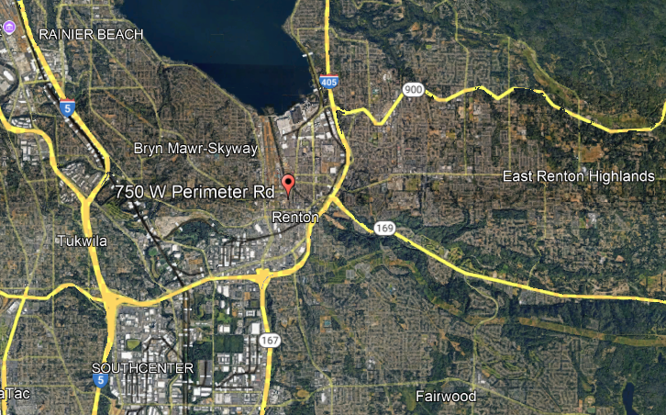

Parcel Map
