DRAFT Scoping Document for Updating the Regional Wastewater Services Plan

Draft Prepared by WTD for Discussion at RWQC Workshop 9/4/24

- Introduction

This draft scoping document describes the overall approach that will be used and some of the major policy issues that will be analyzed to update King County’s Regional Wastewater Services Plan (RWSP).

This draft document was produced to solicit input and feedback on the scope of the RWSP Update from members of the Regional Water Quality Committee (RWQC) and members of the Metropolitan Water Pollution Abatement Advisory Committee (MWPAAC). This scoping document will be discussed at the August 28 MWPAAC general meeting and the September 4 RWQC workshop, and possibly at future meetings and workshops. WTD is interested in hearing about the scope elements and major policy issues that RWQC and MWPAAC would like analyzed as part of the RWSP Update. WTD drafted this document based on initial verbal and written input heard to date from RWQC members and staff, MWPAAC members, and based on feedback obtained during and after the Clean Water Plan process. The draft document is designed to spark discussion and conversation. A revised version of this document will be presented after receiving feedback from MWPAAC and RWQC.

More detailed scopes of work for specific tasks will be developed as needed.

Background

The RWSP, a supplement to the King County Comprehensive Water Pollution Abatement Plan, was adopted by the King County Council in November 1999 by Ordinance 13680, and the RWSP policies were subsequently codified in King County Code (KCC) chapter 28.86. The RWSP identifies projects and programs needed to provide wastewater capacity for homes and businesses in the wastewater service area through 2030 and provides policy direction for the operation and continued development of the wastewater system. The RWSP has largely been implemented, and it is now time to update the plan to guide future investments and actions. Changed conditions also justify another major update, including population growth, climate change, aging assets, regulatory requirements, and rate affordability.

An update to the RWSP will support the extension of local agency sewage disposal contracts, many of which expire in 2036, and continue to strengthen King County Wastewater Treatment Division’s (WTD) relationship with local agencies. An update to the RWSP will also help make the case for additional state and federal funding and meet the requirements for a General Sewer Plan update for approval by Ecology.

The planning process started in 2019 as the Clean Water Plan and was paused at the end of 2021 to fully consider and address feedback received during the planning process. The pause in the Clean Water Plan process also provided an opportunity for more regulatory certainty regarding Combined Sewer Overflow (CSO) obligations and nutrient reduction obligations. The planning process restarted in 2024 as the RWSP Update planning effort and includes important adjustments intended to address feedback received during the Clean Water Plan process. The current RWSP update planning process is generally similar to the process used to develop the 1999 RWSP.

Project Objectives

The overall project objectives are to develop a vision for WTD’s future, to develop an update to the RWSP, and to update the policies in King County Code 28.86. The project will define a future vision for the utility that is consistent with WTD’s mission – “We protect public health and the environment by collecting and cleaning wastewater while recovering valuable resources for a healthy and resilient Puget Sound.” The vision will inform policies and investments that are included in the final RWSP Update. The planning process will produce an RWSP update that will guide future investments, ensures the core mission to protect water quality; seeks to achieve affordable wastewater utility rates into the future; meets regulatory and legal obligations; and reflects County initiatives including equity, race and social justice; strategic climate action planning; and clean water, healthy habitat.

The resulting RWSP Update document will include the Vision for clean water, a capital investment plan, and policy updates to King County Code for Council review and approval. Once adopted by the Council, the document will be transmitted to the Washington State Department of Ecology for review and approval.

Scope for the Effort

The planning process tasks are shown in Figure 1 and described below with the associated deliverables.

Figure 1. Overall Schedule for Completing the Update to King County’s Wastewater Plan
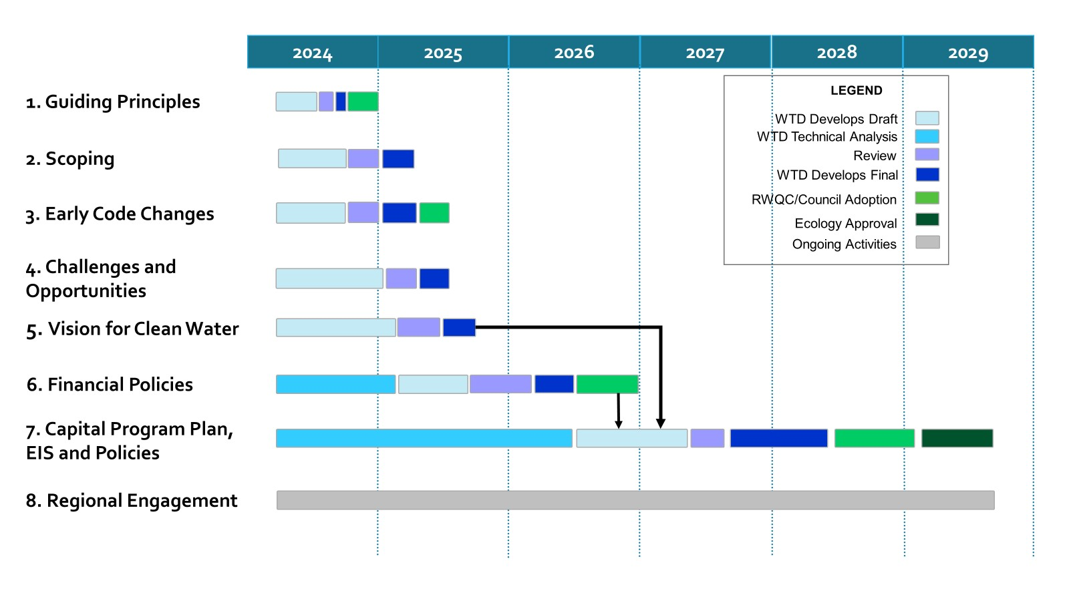

Tasks/Deliverables
- Guiding Principles – The guiding principles will direct the process to update the RWSP and associated policies. The work includes:
- Reviewing feedback from RWQC, component agencies, and interested parties received during the Clean Water Plan outreach process.
- Developing draft guiding principles.
- Soliciting feedback on draft guiding principles.
- Finalizing guiding principles in the form of a resolution for RWQC consideration
- Timeline: Final Completed in 4th Quarter 2024

- Scoping – Scoping will identify the major issues that will be addressed and the process to address those issues in the effort. The work will include:
  - Developing a draft scoping document.
  - Soliciting feedback on the draft scoping document.
  - Finalizing the scoping document.
  - Timeline: Final Completed in 1st Quarter 2025

- Early Code Changes – There are a small number of policies that are outdated because the work is complete. The early code changes will update the policies to reflect completed work. The early code changes are anticipated to be straightforward and do not require extensive analysis. The work will include:
  - Developing a list of policies for early code changes.
  - Drafting redline/strikeout edits to the identified policies.
  - Having MWPAAC review the redline/strikeout edits.
  - Finalizing the edits.
  - Developing and transmitting to Council an ordinance proposing the early code changes for adoption.
  - Timeline: Final Completed in 2nd Quarter 2025

- Challenges and opportunities – This document will summarize the status of major challenges affecting the future of WTD’s wastewater system, projected trends for those challenges in the coming decades, emerging trends and potential opportunities for the future of water-sector utilities, and key questions to be explored in future regional discussions. Challenges and opportunities will inform the scope of work, policy analysis, investment plans and financial strategies. The work will include:
  - Reviewing relevant materials developed during the previous Clean Water Plan process.
  - Reviewing industry research on drivers and trends.
  - Updating information on the regional wastewater system.
  - Interviewing national water utility experts and thought leaders.
  - Listening sessions with interested and potentially affected parties.
  - Developing a draft challenges and opportunities document.
  - Soliciting feedback on the draft challenges and opportunities document.
  - Finalizing the challenges and opportunities document.
  - Timeline: Final Completed in 1st Quarter 2025.

- Vision for Clean Water – The Vision for clean water will articulate the future of wastewater services and will inform policies and investments that are included in the final RWSP Update. The work will include:
  - Reviewing existing documentation of regional priorities and feedback.
  - Conducting interviews and listening sessions to confirm and refresh feedback as well as hear new ideas.
  - Drafting several initial vision concepts.
  - Conducting broad outreach and engagement to gather feedback on the initial vision concepts and the accompanying challenges and opportunities document.
  - Finalizing the vision to be adopted with the RWSP Update.
  - Timeline: Final Completed in 3rd Quarter 2025.

- Financial Policies – Technical analysis will be performed to provide information to support proposed changes to the financial policies in King County Code 28.86.160. The analysis will look at cost structure and equity (including the capacity charge); capital financing and debt management; and financial planning and revenue sufficiency. The work will include:
  - Studying peer utility agency financial policy structures and evaluating them within a WTD specific context.
  - Developing draft policy revisions and seeking review from MWPAAC and stakeholders.
  - Finalizing financial policy revisions and developing a proposed ordinance for Council review and approval.
  - Timeline: Final Completed in 4th Quarter 2026

- Capital Program Plan, Environmental Impact Statement (EIS), and Policies – Technical analysis will provide the information to support proposed policy changes and WTD’s future capital program. The information will be used to develop a draft and final RWSP Update, draft and final EIS, and draft and final policy revisions. The work will include:
Technical analysis
  - Identifying current/existing conditions in our service area in terms of demographics, the economy, water quality, and wastewater infrastructure.
  - Gathering background information on current policies.
  - Developing a range of options/strategies for policy questions. All options/strategies will meet legal obligations.
    - Stay the Course: Under this strategy, WTD would largely maintain current policies while investing as needed to meet current and future regulatory obligations with as little disruption as possible.
    - Strategic Enhancement: Under this strategy, WTD would largely maintain current policies but look to enhance or proactively invest in key areas that may include asset management, resource recovery (biosolids, recycled water), and additional treatment capacity.
    - Pioneering Utility: Under this strategy, WTD would shift to an even more innovative, future-focused utility, including but not limited to investing earlier in upgraded treatment levels to meet all future legal obligations, eliminating Puget Sound discharges, maximizing resource recovery, proactively managing assets, and actively managing infiltration/inflow (I/I) into the system.
  - Evaluating possible policy revisions.
  - Identifying the capital projects, including timelines, costs, and rate impacts, associated with the options/strategies.
Draft Plan and EIS
  - Conducting State Environmental Policy Act (SEPA) scoping.
  - Writing a Draft RWSP Update that includes draft projects and policies, along with a draft EIS that describes the environmental impacts associated with the Draft RWSP Update.
  - Conducting broad outreach and engagement to gather feedback on the Draft Plan and EIS.
Final Plan and EIS
  - Responding to comments and feedback on the draft RWSP Update and draft EIS.
  - Selecting among the options/strategies to create a proposed strategy that includes a list of capital projects, timelines, and policy revisions.
  - Identifying outcome measures to evaluate progress and measure success.
  - Identifying future update schedules and/or triggers.
  - Preparing a Proposed RWSP Update and final EIS.
  - Developing and transmitting to Council an ordinance to adopt the Proposed RWSP Update.
  - Developing and submitting to Ecology the adopted RWSP Update as a proposed amendment to King County’s General Sewer Plan.
Approvals
  - Council adopting the RWSP Update.
  - Ecology approving the RWSP Update satisfying WTD’s regulatory obligation for an amended general sewer plan.
  - Timeline: Final Completed in 3rd Quarter 2029

- Regional Engagement – Regional engagement throughout the planning process ensures that interested and affected parties are informed and involved with the project. In addition to RWQC and the Metropolitan Water Pollution Abatement Advisory Committee (MWPAAC), the following categories of interested and potentially affected parties may be engaged in the process. More detailed audience lists will be developed along with work plans and supporting outreach or event plans in each phase.
  - Local Jurisdictions and Local Sewer Utilities
  - Wastewater Professionals and industry peers
  - Community-Based Organizations (ESJ, Immigrant and Refugee, Environmental Justice)
  - Environmental Organizations /Non-Governmental Organizations (NGOs)
  - Regulators and Resource Managers
  - Neighborhood Groups
  - Public Health Community-Based Organizations
  - Ratepayers
  - Youth and Students
  - Business community
  - Faith-Based Organizations
  - Homeowner Associations
  - Labor Unions
  - Thought leaders and experts from inside and outside the region.
  - Timeline: Final Completed in 3rd Quarter 2029
A specific plan and approach will be developed to engage with Tribal Governments. Figure 2 below shows RWQC engagement during the RWSP Update planning effort. RWQC will have an opportunity to give input before drafts are produced, to provide feedback once drafts are available, and to receive status briefings along the way before they are asked to take action.

Figure 2. Summary of RWQC Engagement During Effort to Update King County’s Wastewater Plan.
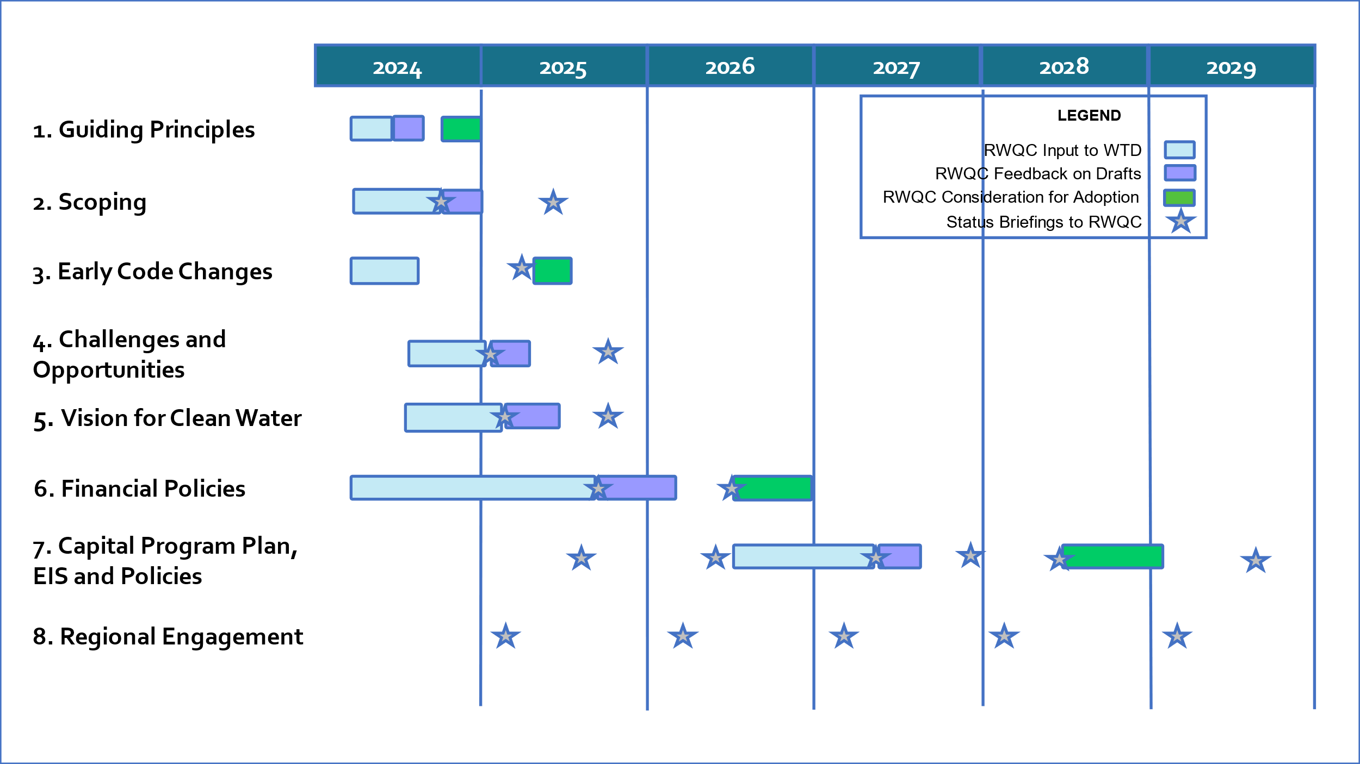

Major Policy Issues and Questions

King County has identified several major decisions regarding the future of our regional wastewater system that will need to be made in this process. To build and operate the large regional system, WTD has a long and growing capital project list in the coming decades, with significant forecasted costs. In making these investments, King County needs to consider many issues like our aging wastewater system, population growth, future regulations, water quality goals, energy and resource conservation and recovery, affordability, and climate change. The update to the RWSP does not include stormwater planning for the region but will instead include how to address stormwater entering the wastewater system.

The policy questions shown in the table below have been grouped into major topics/themes that WTD has identified as known challenges and opportunities for the wastewater sector. Though a question is identified under one topic, it may also intersect with other topics in the table.

Challenges and Opportunities – Topics/Themes | Major Policy Questions to be Analyzed in RWSP Update
Regulatory Landscape  CSO, nutrients, per- and polyfluoroalkyl substances (PFAS) and other contaminants of emerging concern (CECs), current and existing requirements, new and anticipated requirements, opportunities for larger regional partnerships to address water concerns,  requirement to comply with future Total Maximum Daily Load (TMDLs) | What types and levels of treatment should be planned for?  What assumptions should be made about future nutrient permit requirements, regulations related to CECs such as PFAS, or other future regulatory changes?  What upstream or source control actions should the region undertake to prevent contaminants and reduce cost?
Capacity Demands  Infiltration and Inflow (I/I), population growth, conveyance and treatment capacity demand, including onsite septic systems in urban areas, | What is the future capacity needed for growth and when, where and how should we address that need?  Beyond the required capacity needed to meet current regulatory and contractual obligations, what level of capacity should be planned for?  When addressing capacity, should capacity increases within existing facilities be maximized over acquiring new sites, where possible? Should the region continue to provide a centralized approach or consider decentralized options?  How should I/I be managed? How much of the additional projected flow is coming from I/I versus population growth? Should I/I policy change to reduce the capacity needed for I/I?  How should the conversion of onsite septic systems to sewers in the service area be managed and what planning assumption should WTD use about the conversion rate?
Infrastructure Resiliency  Asset management, maintenance, improvements, renewal, replacement, labor and supply chain disruptions, natural hazard resiliency. | How and when should WTD decide to refurbish or replace aging infrastructure?  What level of resiliency should WTD plan for regarding seismic and other natural hazards? What level of risk tolerance should WTD accept?  What level of redundancy of critical systems should WTD have?
Equity and Social Justice  Distributional equity, WTD role in safeguarding public health | What actions should WTD take to increase equity and social justice for the regional wastewater system (Should include definition of equity and social justice).
Climate Change  Mitigation - green building, eliminating/reducing fossil fuel use, energy and water efficiency, renewable energy, materials management, tree planting, etc.  Adaptation – sea level rise, more extreme heat, increased storm intensities, wildfire smoke, increased river flooding, etc. | What climate experts and data should WTD use to inform planning?  How should WTD reduce energy use and reduce greenhouse gas emissions?  How should WTD prepare and adapt to climate impacts in line with the Strategic Climate Action Plan? What level of climate impact risk tolerance should WTD plan for?
Resource Recovery  Recycled water, biosolids, energy capture | Energy production and heat recovery – Should WTD be expanding its efforts to capture energy and heat? If so, at what level of effort?  Biosolids – Should WTD further expand its efforts to develop Class A biosolids? What changes are needed to biosolid recovery policies and processes?  Recycled water – Under what circumstances should the region expand the use of reclaimed water? Which uses (e.g., environmental benefits, groundwater recharge, industrial uses, irrigation) are most appropriate?
Finance / Affordability  Cost structure and equity, capital financing and debt management, financial planning and revenue sufficiency | Is there a better rate structure for the sewer rate? (Note WTD has identified a work plan to further evaluate the residential customer equivalent conversion factor of 750 cubic feet per month.)  Will WTD maintain a single uniform sewer rate per RCE (Robinswood “one for all, all for one”), or consider alternative cost recovery rate structures to reflect other system impacts?  Should WTD update the rate structure for the capacity charge to align with current industry standards? (Note the capacity charge rate structure was updated in 2021. A capacity charge methodology study is in progress.)  What other rate relief approaches should WTD implement to improve affordability for those who may struggle to pay their sewer bill?

