STAFF REPORT

Agenda Item: | 10 | Name: | Jake Tracy
Proposed No.: | 2026-0023 | Date: | June 17, 2026

SUBJECT

Proposed Ordinance 2026-0023 would adopt and ratify amendments to the 2021 King County Countywide Planning Policies to modify growth targets for the Black Diamond Potential Annexation Area and the Unaffiliated Urban Unincorporated area.

SUMMARY

Proposed Ordinance 2026-0023 would amend the 2021 King County Countywide Planning Policies (CPPs) to address a mismatch in housing unit allocation within urban unincorporated King County. Specifically, the proposed ordinance would modify growth targets for the Black Diamond Potential Annexation Area (PAA) and the Unaffiliated Urban Unincorporated area.

The CPPs were adopted in 2021. Subsequent analysis supporting the 2024 King County Comprehensive Plan (KCCP) found that, while urban unincorporated King County had sufficient overall housing capacity, the capacity of the Black Diamond PAA specifically was limited to 200 housing units, creating a 128-unit deficit from its originally allocated target of 328 units in CPP Table DP-1. In response to this identified capacity mismatch, the King County Executive's Office committed to working with the Growth Management Planning Council (GMPC) to reallocate the targets. The GMPC subsequently passed Motion 25-3, recommending the redistribution of the 128 housing units from the Black Diamond PAA to the Unaffiliated Urban Unincorporated area, which was found to have the necessary residential capacity under current zoning.

Proposed Ordinance 2026-0023 would implement this recommendation by formally approving amendments to CPP Table DP-1, reducing the Black Diamond PAA's target by 128 units and increasing the Unaffiliated Urban Unincorporated area's target by the same amount. If adopted by the Council, the amendments to the CPPs become effective when the Ordinance is ratified by at least 30% of the city and county governments representing at least 70% of the population of King County. A city is deemed to have ratified an amendment to the CPPs unless the city disapproves it by legislative action within 90 days of adoption by King County.

BACKGROUND

Growth Management Planning Council (GMPC). The GMPC is a formal body comprised of elected officials from King County, Seattle, Bellevue, other cities and towns in King County, and special purpose districts. The GMPC was created in 1992 by an interlocal agreement in response to a provision in the Washington State Growth Management Act (GMA) requiring cities and counties to work together to adopt CPPs.

The CPPs are a series of policies that address growth management issues in King County. The CPPs present the shared vision of King County and the 39 cities within King County to guide jurisdictions as they develop and amend their comprehensive plans. For King County government specifically, the CPPs relate to the KCCP and its implementing development regulations.

As provided for in the GMPC interlocal agreement, the GMPC developed and recommended the original CPPs, which were adopted by the King County Council and ratified by the cities in 1992.

2021 Countywide Planning Policies and Growth Allocation Process. The CPPs were comprehensively reviewed and updated in 2021 in Ordinance 19384. The 2021 CPPs established 2019-2044 growth targets for King County jurisdictions in Table DP-1. The growth targets were amended in 2023 in Ordinance 19660 to establish jurisdictional housing need values commensurate to growth targets. Policy DP-13 of the CPPs tasks GMPC with updating housing and employment growth targets and housing needs periodically to provide jurisdictions with up-to-date growth allocations to be used as the land use assumption in state-mandated comprehensive plan updates.

Allocations are made to both cities and urban unincorporated areas. In urban unincorporated areas, growth is allocated to specific cities' PAAs, as well as to the "Unaffiliated Urban Unincorporated" area – that is, urban unincorporated areas that have not been identified for future annexation. These areas are shown in Attachment 4 to this staff report, with teal areas representing cities' PAAs and orange areas representing Unaffiliated Urban Unincorporated.

Updated Growth Targets and Identification of Capacity Mismatch. The growth targets in the CPPs were informed by the 2021 Urban Growth Capacity Report (Attachment 5). A subsequent report (Attachment 6) developed in support of the 2024 KCCP confirmed that urban unincorporated King County had sufficient residential capacity between the PAAs and Unaffiliated Urban Unincorporated areas to accommodate its growth targets. However, further analysis undertaken by the Executive into the capacity of each individual PAA indicated that the Black Diamond PAA only had capacity for 200 units, not 328 as identified in Table DP-1 of the CPPs. The 2024 KCCP identified this issue and stated that "King County continues to work with the Growth Management Planning Council to reallocate targets within urban unincorporated King County to address this deficit, in a manner consistent with planning goals and the VISION 2050 Regional Growth Strategy." PSRC, in its certification report, encouraged King County to "promptly follow through with this commitment."

GMPC Recommendation. In 2025, The King County Interjurisdictional Team, which advises the GMPC, analyzed this issue and recommended that the GMPC resolve the capacity mismatch by redistributing 128 housing units of urban unincorporated King County growth from the Black Diamond PAA to the Unaffiliated Urban Unincorporated area, noting that the Unaffiliated Urban Unincorporated area has "the greatest share of residential capacity within urban unincorporated King County and have capacity to accommodate the target increase, particularly in southern King County, maintaining 45 growth allocated to that portion of the Urban Growth Area in the growth targets." GMPC Passed Motion 25-3 (Attachment A to the proposed ordinance), which recommended this redistribution, in its November 19, 2025 meeting. GMPC Motions are a recommendation to the King County Council.

Amendments to the CPPs become effective when the County adopts an Ordinance and when the Ordinance is ratified by at least 30% of the city and county governments representing at least 70% of the population of King County. A city is deemed to have ratified an amendment to the CPPs unless the city disapproves it by legislative action within 90 days of adoption by King County.

ANALYSIS

Proposed Ordinance 2026-0023 would approve amendments to the King County Countywide Planning Policies to redistribute 128 housing units of urban unincorporated King County growth from the Black Diamond PAA to the Unaffiliated Urban Unincorporated area. To achieve this, Table DP-1 of the CPPs would be changed as follows:

Table 1. Proposed Changes to CPP Table DP-1
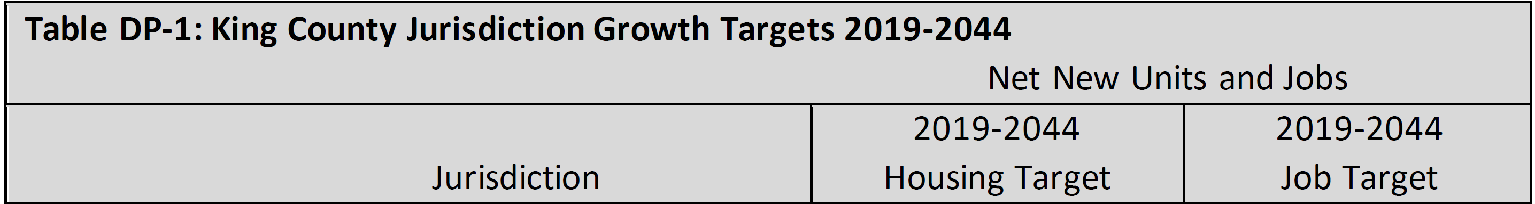
…

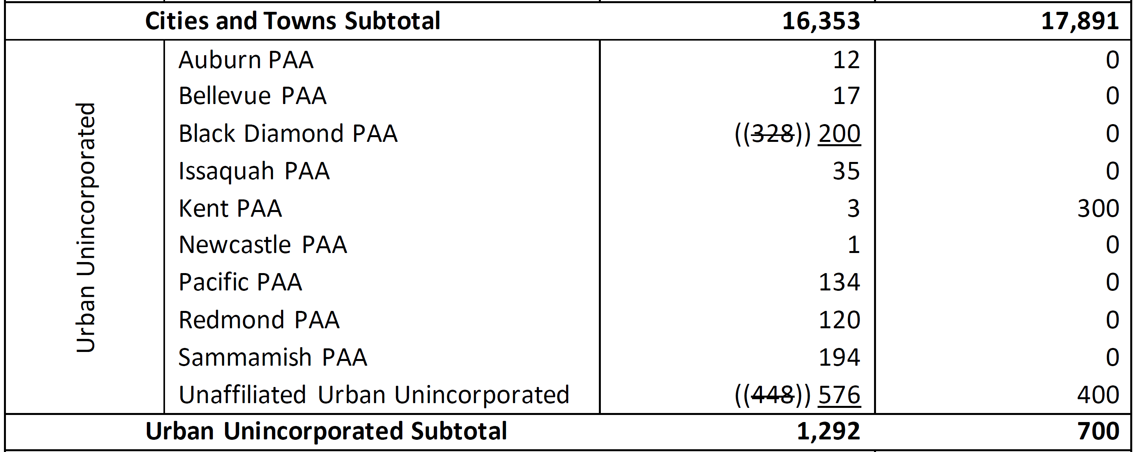

As the Executive's analysis has determined that the extra 128-unit capacity already exists in the Unaffiliated Urban Unincorporated area under current zoning, this change would not require any zoning changes; it would simply bring Table DP-1 into alignment with the capacity of the area as it exists today.

INVITED

- Erin Auzins, Regional Planning Lead, King County Executive's Office

ATTACHMENTS

- Proposed Motion 2026-0023 (and its attachment)
- Transmittal Letter
- Fiscal Note
- Potential Annexation Areas Map
- 2021 Urban Growth Capacity Report
- 2024 KCCP Appendix D1 – Growth Targets and the Urban Growth Area

Per the 2024 King County Comprehensive Plan, a Potential Annexation Area is an area in unincorporated King County adjacent to a city that is expected to annex to the city and to which that city will be expected to provide services and utilities within the next two decades.
https://www.psrc.org/sites/default/files/2025-07/king-county-compplan-2024-certification.pdf
GMPC Motion 25-3.

