HARBORVIEW 2020 PROP 1 CAPITAL FUND
Analyst: Sam Porter

 |  | 2026-2027 Proposed |  | 2028-2029 Projected |  | 2030-2031 Projected
Revenues |  | $219,720,655 |  | $745,048,859 |  | $656,491,028
Appropriations |  | $219,720,655 |  | $745,048,859 |  | $656,491,028
Major Revenue Sources: Harborview 2020 Proposition 1 Bond revenue

Description

This fund accounts for revenue from the 2020 Harborview Proposition 1 bond to fund projects at Harborview Medical Center. Harborview Medical Center is a 413-bed hospital and Level 1 trauma center serving Washington, Alaska, Montana, and Idaho. The hospital is owned by King County, governed by the County-appointed Board of Trustees, and operated by the University of Washington. A $1.74 billion capital bond was approved by voters after being placed on the November 2020 ballot by King County Ordinance 19117. A revised program plan for the 2020 Harborview Bond was approved by Motion 16435, known as the Ordinance Workgroup (OWG) report.

Summary of Proposed Budget and Changes

The proposed budget would make a total appropriation of over $219.7 million to support final design [$173.9 million] and implementation [$45.8 million] of the new bed tower project, however the tower construction phase of the project is not expected to begin until the 2028-2029 biennium. Table 1 below shows the planned project phasing and costs according to documents provided with the budget.

Table 1.
Bed Tower Planned Project Phasing

Phase | Budget through June 2025 | FY26-27 | FY28-29 | FY30-31 | Total
Planning | $143,060,620 | $0 | $0 | $0 | $143,060,620
Final Design | $0 | $173,944,970 | $591,970,064 | $591,970,064 | $1,229,715,813
Implementation | $0 | $45,775,685
Total Budget | $143,060,620 | $219,720,655 | $591,970,064 | $591,970,064 | $1,546,721,403

The $219.7 million allocation would support administrative costs, a co-location space, space renovations through 2031, and 1% for Art at the Harborview Campus.
- Administrative costs include paying a share of consultant and contractor costs for project management, design, and other services; permitting and legal costs; and a combination of County and Harborview staffing.
- Co-location workspace will be modular trailers serving as a collaborative work environment for Harborview and King County staff, as well as contractors, and consultants.
- Space renovations include site improvements, utility connections, and early site work required to support the expansion of the hospital campus and the construction of the new tower.
- 1% for Art includes $13,467,554 in 2026 managed by 4Culture consistent with the County Code and led by a public art committee.

Executive staff provided a visual timeline of the Tower Project in Table 2.

Table 2. Visual Timeline of the Tower Project
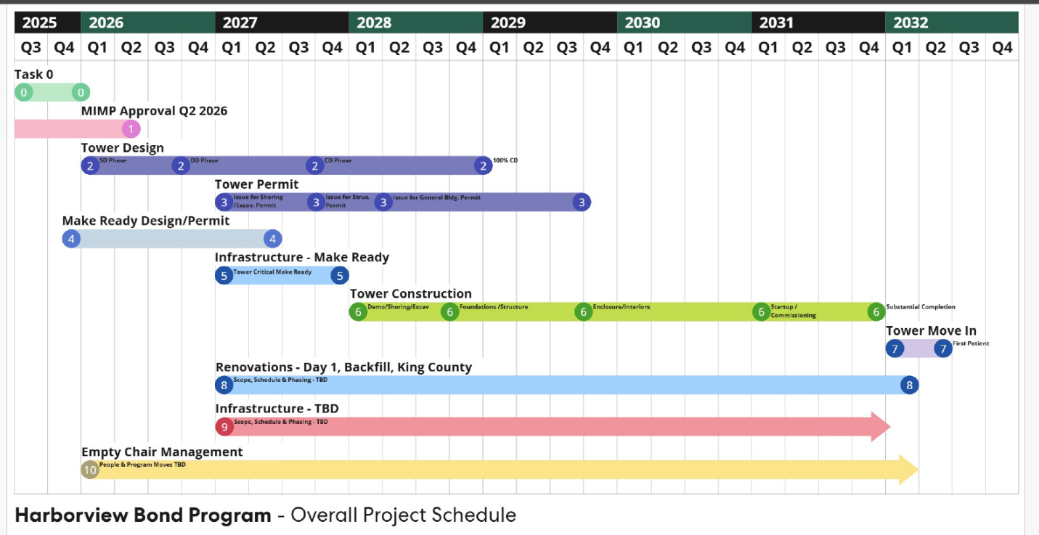

Key Issues

Issue 1 – Uncertainty About Whether Moneys to Construct OWG Scope are Sufficient

Executive staff indicate that the tower construction program is in the validation phase including an updated cost analysis to construct the OWG scope for the bed tower project as described beginning on page 10 of the September HMC Bond Program Monthly Status Report. Executive staff state that until the costing assessment is completed they are unsure if there are sufficient moneys to construct every element of the tower recommended by the OWG. Councilmembers may wish to request a briefing or report back to Council when the cost assessment is complete in early 2026.

This is approximately 88% of the 2020 Harborview Bond projected revenue of $1.74 billion.
Executive staff state that this facility will be roughly 20,000 sq. ft. modular office and conference facility necessary to support the project, constructed on the site of the old construction trailer located at 319 Terry Street.
Harborview Bond Program Monthly Status Report, September 2025, https://mkcclegisearch.kingcounty.gov/LegislationDetail.aspx?ID=7685997&GUID=A559D015-B7BB-48F3-A06A-E4C41E010878&Options=Advanced&Search=

