Attachment A

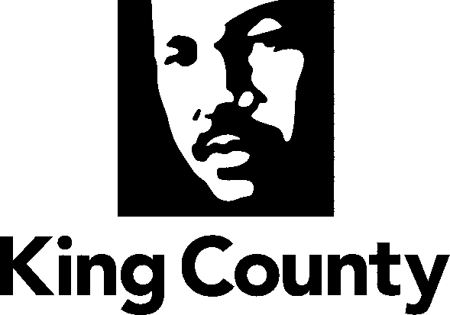

Metropolitan King County Council

Regional Policy Committee 2025 Work Program

I. Subject matters for mandatory referral of legislation:

- Solid Waste

2. Veterans, Seniors, and Human Services Renewal Levy (VSHSL)

3. Crisis Care Centers Levy (CCC)

4. Homelessness, including the King County Regional Homeless Authority and Health through Housing

5. Mental Illness and Drug Dependency (MIDD)

6. Regional Transportation (not including transit)

7. Affordable Housing

8. Best Starts for Kids (BSK) Levy

9. Cultural/Sports/Tourism Resources and Access

10. King County Doors Open Program and Implementation Plan

11. Proposed new and renewal levies and bonds to be imposed countywide

12. Implementation Plans for levies and bonds imposed countywide
13. EMS Levy Renewal
14. Parks Levy Renewal

lI. Briefings on subject matters that would benefit from interjurisdictional discussion

- RPC Acting in its capacity as the Solid Waste Interlocal Forum
  - Potential briefings - Planning, Recycling, Composting, Collection, Disposal, Transfer, Finance
  - Next disposal option
  - King County Solid Waste Comprehensive Plan
  - RePlus+ implementation and the economy

- Veterans, Seniors, and Human Services Renewal Levy (VSHSL)
VSHSL Annual Report

- Land Conservation
- Parks, Recreation, and Sports

- Homelessness
- Health through Housing
a. Health through Housing Annual Report
- Public Health
  - Opioid and fentanyl crisis response
  - Winding down of federal ARPA funds
- Regional Affordable Housing Strategies

- Mental Illness and Drug Dependency (MIDD)
- MIDD Annual Report

- Best Starts for Kids (BSK)
- BSK Annual Report

- Pre-Apprenticeship and Apprenticeship Programs

- Regional Transportation
  - Briefings on county-wide road needs: conditions, bridges, funding and traffic
  - Traffic safety

- Elections

- Natural Disasters
  - Briefing from Office of Emergency Management on community outreach and preparedness for natural and human-caused disasters
  - Evacuation planning and shelter planning

- Flood Control
  - Briefing from the King County Flood Control District
- King County International Airport Expansion and Regional Airport Needs
  - Briefing on the impacts of siting a new airport in King County
  - Briefing on the regional importance of KCIA
- State of Agriculture in King County
- Regional Approach to Public Safety
  - Briefing on Restorative Community Pathways
  - Briefing from the King County Sheriff's Office
  - Briefing from the King County Prosecuting Attorney's Office
  - Briefing from the King County Regional Office of Gun Violence Prevention
- King County's Regional Wastewater Services Plan
- Climate Change and Response to Motion 16463

- Doors Open Program
a. Doors Open Annual Report
- Briefing on World Cup Preparations

For the purpose of determining a subject matter for mandatory referral pursuant to the King County Charter Section 270 and KCC 1.24.065, the numbered topics should be liberally construed.
RPC acting in its capacity as the Solid Waste Interlocal Forum
Legislation relative to the lettered topics included in this Section II shall not be subject to mandatory referral.

