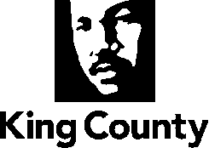

Critical Areas Comprehensive Plan Update

2025 Update to 2024 King County Comprehensive Plan

December 2024

In Chapter 5 Environment, on page 5-51, amend as follows:

((E-412 A small Category IV wetland that is less than 2,500 square feet and that is not part of a wetland complex may be altered to move functions to another wetland as part of an approved mitigation plan that is consistent with E-413 and E-414.))

