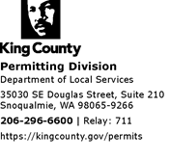

DATE: June 26, 2020

TO: Melani Pedroza, Clerk of the Council
King County Council

FM: Tracy Cui, AICP, Senior Planner – Urban Product Line
Department of Local Services – Permitting Division

RE: Introductory Ordinances for Preliminary Plats

Attached are Introductory Ordinance(s) for the Hearing Examiner’s agenda scheduled for public hearing, as follows:

File No.: PLAT19-0002 Mason Heights Preliminary Plat scheduled to be heard on August 25, 2020 10:00 a.m. via ZOOM video conferencing.

A copy of the hearing agenda for each item is also attached for your information.

If you have any questions or need additional information. Please contact Tracy Cui 206-263-8720 tracy.cui@kingcounty.gov

Attachments

