STAFF REPORT

Agenda Item: | 5 | Name: | Mike Reed
Proposed No.: | 2022-0172 | Date: | May 25, 2022

SUBJECT:

The Executive Proposed 2023 Sewer Rate and Capacity Charge.

SUMMARY:

King County's sewer rates are set for the following year by July 1 of each year, pursuant to contract with participating utilities. The Executive has transmitted Proposed Ordinance 2022-0172 setting the sewer rate and capacity charge for 2023. The Proposed Ordinance would:

- Increase the monthly sewer rate effective in 2023 by 5.75% to $52.11 per residential customer equivalent (RCE) per month; and
- Set the monthly capacity charge for new connections to the regional system occurring in 2023 at $72.50 per RCE per month, which is a 3.0% increase over the 2022 rate of $70.39.

By contract with partner cities and sewer districts, the county is to complete its consideration of the sewer rate for the following year by July 1 of each year. (Note: partner city and sewer districts act after the county sets the sewer rate to establish their local rates, all of which go into effect on January 1, 2023)

BACKGROUND

Monthly Sewer Rate. King County provides wastewater treatment services for 18 municipalities and 15 sewer districts and the Muckleshoot Tribe in King County, southern Snohomish County, and the northern tip of Pierce County. The county provides sewer interceptor lines that receive wastewater collected from residences and businesses by the cities and sewer districts, who bill their customers directly for both county and local utility charges. The sewer rate is charged by the county to the utilities to deliver, treat and discharge wastewater.

The monthly sewer rate collected by the county goes to support all Wastewater Treatment Division (WTD) expenses, including operating costs, debt service, and capital expenses. The monthly sewer rate for both residential and commercial customers is calculated based on Residential Customer Equivalents (“RCEs”).

Table 1.
Sewer Rate (2009-2022 Actual; 2023 Proposed; 2024-2025 Projected)

Year(s) | Rate  ($/RCE/ Month) | % Increase
2009 – 2010 | $31.90 | 14.1%
2011 – 2012 | $36.10 | 13.2%
2013 – 2014 | $39.79 | 10.4%
2015 – 2016 | $42.03 | 5.6%
2017 | $44.22 | 5.2%
2018 | $44.22 | 0.0%
2019 | $45.33 | 2.5%
2020 | $45.33 | 0.0%
2021 | $47.37 | 4.5%
2022 | $49.27 | 4.0%
2023 | $52.11 | 5.75%
2024 | $55.11 | 5.75%
2025 | $58.28 | 5.75%

Table 1 above depicts the anticipated sewer rates through 2025 according to the transmittal. Increases have historically been structured effectively as biennial rates, with rate adjustments in alternating years. In 2021, after engagement with cities and sewer districts through the Metropolitan Water Pollution Abatement Advisory Committee (MWPAAC), the Executive recommended annual, rather than biennial adjustments to sewer rates.

Rate Drivers. The Executive transmittal has referenced several rate drivers that impact this 2023 proposal:

- Economic Conditions.
  - The impacts of Covid 19: Agency projections regarding the impact of the Covid 19 pandemic on revenues have been revised to indicate an expectation of continuing revenue impacts for an additional year, noting that the agency billing structure bills for past services in the current quarter.

  - Project capital costs are heavily dependent on interest rates, noting that the sale of bonds provide the primary support for capital projects, and that capital expenditures make up the largest part of the agency budget. Interest rate changes can impact agency costs in a variety of ways, including payments on the portfolio of variable rate bonds that are managed for wastewater purposes. Table 2 below depicts the cost impacts to the agency of interest rate changes on the variable rate bond portfolio.

Table 2.
Interest Rate-Impacted Payments on Variable Rate Bonds

Year | Total Principal Outstanding | Monthly Payment in March | Annual Payment
2020 | $546,910,000 | $748,641 | $7,620,132
2021 | $538,685,000 | $160,815 | $2,957,016
2022 | $538,685,000 | $188,958 | $8,310,625

  - Labor market constraints have complicated efforts to staff capital construction projects. In addition, supply chain challenges could also impact project delivery.

- West Point Treatment Plant power reliability investments. Power reliability investments at the West Point Treatment Plant are required by a Department of Ecology administrative order, to respond to a February 2021 emergency discharge at the plant that was driven by power reliability constraints. WTD began work on a joint project with Seattle City Light in 2021.

- Critical Asset Management Projects. WTD has rated an index of infrastructure repair/replacement projects according to the system risk they represent; Tier 1 projects are highest risk. The proposed 2023 sewer rate would support $1.6 billion in Tier 1 projects, to be completed by 2033, including 19 updated or newly identified projects that scored as Tier 1 priority since the 2022 sewer rate adoption.

- Combined Sewer Overflow Consent Decree. The CSO Consent Decree requires completion of mandated CSO projects by 2030; King County, by letter to the Environmental Protection Agency in 2019, requested schedule relief, and opened negotiations on the Consent Decree. Previous sewer rate transmittals have assumed a 2040 completion date for remaining CSO projects. In light of project timelines, the proposed rate includes almost 40% of total CSO costs ($1.68 billion), with the remaining $2.6 billion of costs assumed for the following decade and future rate plans. This results in an increase of $1.2 billion through 2032 from the $486 million currently in the adopted 2022 rate plan.

- Puget Sound Nutrients General Permit. In December 2021, Washington Department of Ecology issued a requirement for a General Permit limiting discharges of nutrients into Puget Sound. The Executive is seeking a partial stay of the permit requirements; however, initial costs for controlling nutrient discharges pursuant to the permit requirements are included in the proposed 2023 rate, including nitrogen reduction planning, evaluation, monitoring, and plant optimization, totaling $50 million.

- Operations Investments. New investments in operations, totaling $11 million, are assumed in the 2023 Rate Plan. According to the Plan, staffing for support of new combined sewer overflow treatment and storage facilities, nutrient sampling, corrective and preventative maintenance and services on HVAC and electrical systems, and conveyance inspection and flow monitoring, would be included, totaling 96 new FTEs.

- Flows and Loadings. The Flows and Loadings Study and Treatment Planning Program has identified capacity improvement needs at the three regional treatment plants. Some of the critical projects have been prioritized in the 2023 sewer rate planning assumptions, to assure compliance with permit requirements and adequate treatment capacity.

- Conveyance System Improvement Plan (CSI). The 2017 update to the Conveyance System Improvement Plan, which plans for upgraded conveyance projects needed to meet capacity requirements, identified high priority conveyance system projects. These are considered urgent projects; sewer overflows have occurred at several project locations. These projects are supported by the 2023 sewer rate.

- Climate Change. The 2023 rate plan would support $256 million in climate change mitigation investments, including the South Plant Biogas project, the West Point Biogas Optimization project, and three Digester Circulation Pump Replacement projects.

- Co-Digestion. $10 million in initial investments in this project, which would make more efficient use of food waste and process gases, is included in the 2023 rate. Coordination on the project with the Solid Waste Division is underway.

Capacity Charge. New connections to the regional wastewater system are assessed a capacity charge, based on the policy of “growth pays for growth”. Payment may be made in a lump sum or paid over a 15 year period. Table 3 presents the proposed charge as the monthly payment over 15 years.

Table 3.
Capacity Charge (2012-2022 Actual; 2023 Proposed; 2024-2025 Projected)

Year | Rate/Month/RCE  15-yr. duration | % Increase
2012 | $51.95 | 3.0%
2013 | $53.50 | 3.0%
2014 | $55.35 | 3.5%
2015 | $57.00 | 3.0%
2016 | $58.72 | 3.0%
2017 | $60.80 | 3.6%
2018 | $62.60 | 3.0%
2019 | $64.50 | 3.0%
2020 | $66.35 | 2.9%
2021 | $68.34 | 3.0%
2022 | $70.39 | 3.0%
2023 | $72.50 | 3.0%
2024 | $74.68 | 3.0%
2025 | $76.92 | 3.0%

Consistent with the Regional Wastewater Services Plan policies, the capacity charge is based on the estimated costs of the 30-year Regional Wastewater Services Plan (RWSP). The capacity charge is set at a level to recover the designated, growth-related costs that are not covered by the monthly rate payments of newly connecting customers. Over the planning period of RWSP (2003 – 2030), the capacity charge and monthly rate payments of newly connecting customers are structured to cover 95% of growth-related costs.
Unlike the monthly sewer rate, the capacity charge is directly billed by and paid to King County. Based on information provided by the cities and sewer districts, King County notifies new connecting customers of the option to pay over time (15 years) or in a lump sum. The lump sum payment is less than the total dollar value of the 15 year option since the cost of financing the long-term payment is deducted.

The Council approved revisions to the capacity charge rate structure in 2020, in recognition of emerging housing options like Accessory Dwelling Units and microhousing; and in acknowledgement of the imbalance of a charge that assessed the same amount for small and large single-family dwellings. The revisions are tied to the average number of persons per household by housing type. Smaller single-family homes—under 1500 square feet (s.f.) are assessed at 0.81 RCE; mid-sized homes—1,500 s.f. to 2,999 s.f.-- are assessed at 1.00 RCE; and large homes, over 3,000 s.f., are assessed at 1.16 RCE. Accessory Dwelling Units are assessed at 0.59 RCE, and there were small changes to the rates charged for multifamily units.

Local Jurisdiction Sewer Rates. As noted, cities and sewer districts are responsible for collecting wastewater from homes and businesses within their jurisdictions; they assess a separate charge in addition to the county sewer rate and capacity charge described here. To provide a sense of the total wastewater charges a residential ratepayer might pay, staff has reviewed the rates of several jurisdictions to identify the sewer charge they assess. Local charges vary substantially; some are fixed rates monthly, while some are variable based on water consumption. Most do not include a local separate connection charge tied to local system growth costs. Some local jurisdictions may also provide a discount to low-income ratepayers—those discounts are not addressed in this summary.

The five jurisdictions referenced in Table 4 below are randomly selected, and may or may not be representative of the 34 city and sewer district jurisdictions that partner with the Wastewater Treatment Division in delivery of wastewater services. These are 2022 rates. 2023 rates will be established following the county’s determination of its rate through Proposed Ordinance 2022-0172.

Table 4.
2022 Sewer Rate (per month) — Selected Local Partner Jurisdictions

Northshore Utility District | Renton | Redmond | Sammamish Plateau WSD | Soos Creek WSD
$14.69 | $31.12 | $14.15 | $39.29 | $21.22

A given ratepayer, depending on jurisdiction, water usage, application or non-application of a local connection charge, may pay a local sewer rate that varies substantially from case to case. For illustrative purposes, if the $31.12 Renton local charge identified above were added to the county’s 2022 rate of $49.27, the ratepayer would be paying $80.39/mo. (collected by the city; county’s portion is passed through to the county). In addition, if that ratepayer connected to the system in 2022, and selected to pay the monthly rate rather than the full up-front cost of the capacity charge, that ratepayer would be paying an additional $70.39/mo. for the capacity charge which would be paid directly to the county. The total cost for the Renton ratepayer would be $150.78/mo. for both the sewer rate and capacity charge.

ANALYSIS

Operating Revenues. According to the Financial Plan accompanying the transmittal (Attachment A), 2023 revenues are projected at $600.9 million, $37.07 million (6.6%) more than 2022 operating revenues. Increases in sewer rate revenue of $33.4 million are associated with the proposed 2023 sewer rate increase of 5.75%, and with RCE forecasts. Table 5 provides a summary of all revenues to support Wastewater operations and capital.
Table 5.
Revenues Supporting Wastewater Operations and Capital (in $ millions)

 | 2022 Adopted | 2023 Proposal | Difference | % Change | 2024 Projected | % Change
Sewer Rate | $441.7 | $475.1 | $33.4 | 7.5% | $513.4 | 8.0%
Capacity Charge | $93.6 | $96.4 | $2.8 | 2.9% | $99.3 | 3.0%
Other Income | $28.5 | $29.4 | $.9 | 3.1% | $31.1 | 5.7%
Rate Stabilization | - | - | - | 0.0% | - | 0.0%
Totals | $ 563.8 | $ 600.9 | $ 37.1 | 6.6% | $ 643.8 | 7.1%

Operating revenues reflect both the rate charged, and the numbers of residential and commercial accounts and their flow volumes—translated into Residential Customer Equivalents (the sewer rate and capacity charge rate are assessed per monthly RCE). As RCE’s increase or decrease based on population growth and economic conditions, corresponding changes are reflected in total operating revenues. RCE counts in the commercial/multifamily sector have been impacted by the economic slowdown associated with the COVID-19 pandemic, as businesses and industrial plants reduced operations. The table below depicts the projected impacts of these RCE reductions on revenues, in terms of proportionate reductions in RCE counts and associated revenue impacts.

Table 6.
Impact of COVID-19 Economic Slowdown on RCEs and Revenues
Commercial and Multifamily RCE’s—Percent Change from 2019

 | Quarter 1 | Quarter 2 | Quarter 3 | Quarter 4
2020 | 1.9% | (15.1%) | (13.5%) | (8.6%)
2021 | (12.3%) | (8.1%) | (6.4%) | (10.0%)
2022 | (7.0%) | (7.0%) | (5.0%) | (5.0%)
2023 | (3.0%) | (3.0%) | (1.0%) | (1.0%)
2024 | 0.0 | 0.0 | 0.0 | 0.0

Operating Expenses. For 2022 and 2023, operating expenses are projected at $175.5 million and $193.3 million respectively. Table 7 compares the forecast of operating expenses from the 2023 Proposed Rate to the 2022 Adopted Rate.

Table 7.
Operating Expenses — 2023 Proposed Rate, 2022 Adopted Forecast (in millions)

 | 2022 (adopted) | 2023 (rate proposal) | 2024 | 2025 | 2026 | 2027
2023 Proposed Rate | (175.5) | ($193.3) | (198.9) | ($210.6) | ($220.9) | ($231.4)
2022 Adopted Rate Forecast | ($177.1) | ($182.8) | ($192.2) | ($202.7) | ($211.4) | ($220.6)
Difference | ($1.6) | $10.5 | $6.6 | $7.9 | $9.5 | $10.8

Capital Revenue. Revenue support for capital expenditures is derived from both rate-supported cash transfers to capital accounts, and from borrowing, including bond sales, state and federal loans and other debt instruments. Cash transfers are intended to provide 40% of the cost of capital projects in cash, over time. This cash-funded capital helps to assure sufficient “debt coverage”—the amount of revenue available to pay regular debt obligations, described as, for example, “1.5x” (one-and-a-half times the amount of revenue available compared to that needed to pay debt payments due). Table 8 below illustrates the various standards for debt coverage, and the wastewater system’s debt coverage level.

Table 8.
Debt Coverage Standards

Minimum Requirements of Debt Covenants and Code | Minimum for Rate Setting—Debt Review Recommendations | 2021 Actual | Moody’s Recc. for Aa Rating | S&P Recc. for Aa Rating | 2018 Median for Aa Sewer Utilities
1.15x | 1.40x | 1.64x | 1.70x | 1.40x | 2.20x

Table 9 below describes the recent debt rating history of WTD debt instruments, and the debt coverage ratio history.
Table 9.
WTD Debt Coverage Ratios and Rating History

 | 2010 | 2011 | 2012 | 2013 | 2014 | 2015 | 2016 | 2017 | 2018 | 2019 | 2020 | 2021
WTD Debt Ratio | 1.30x | 1.32x | 1.28x | 1.33x | 1.33x | 1.36x | 1.41x | 1.51x | 1.49x | 1.58x | 1.52x | 1.64x
S&P Rating | AA+ | AA+ | AA+ | AA+ | AA+ | AA+ | AA+ | AA+ | AA+ | AA+ | AA+ | AA+
Moody’s Rating | Aa2 | Aa2 | Aa2 | Aa2 | Aa2 | Aa2 | Aa2 | Aa1 | Aa1 | Aa1 | Aa1 | Aa1

Bond sales and loans result in outstanding debt that is repaid by regular debt payments, supported by the sewer rate. Chart 1 below illustrates the declining amount of overall existing debt principal, from approximately $3.4 billion currently to approximately $2.1 billion in 2032. That decline, however, is expected to be offset by increasing amounts of new debt, with totals amounting to approximately $5.5 billion by 2032.

Chart 1.
Outstanding Debt – Existing and New

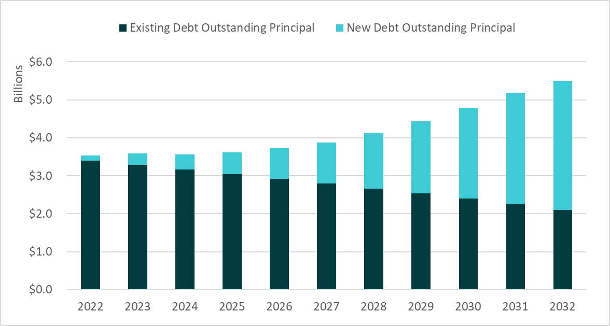

Capital Expenditures. Chart 2 below shows the differences in WTD's proposed Capital Spending Plan compared to the capital spending projections made in the adopted 2022 rate. While expenditure expectations for 2023 are less than initially projected, projections for 2025 and beyond anticipate significantly higher expenditure levels for capital projects than had been forecast in the 2022 rate forecast.

Chart 2.
WTD Capital Spending Plan (in $ millions)
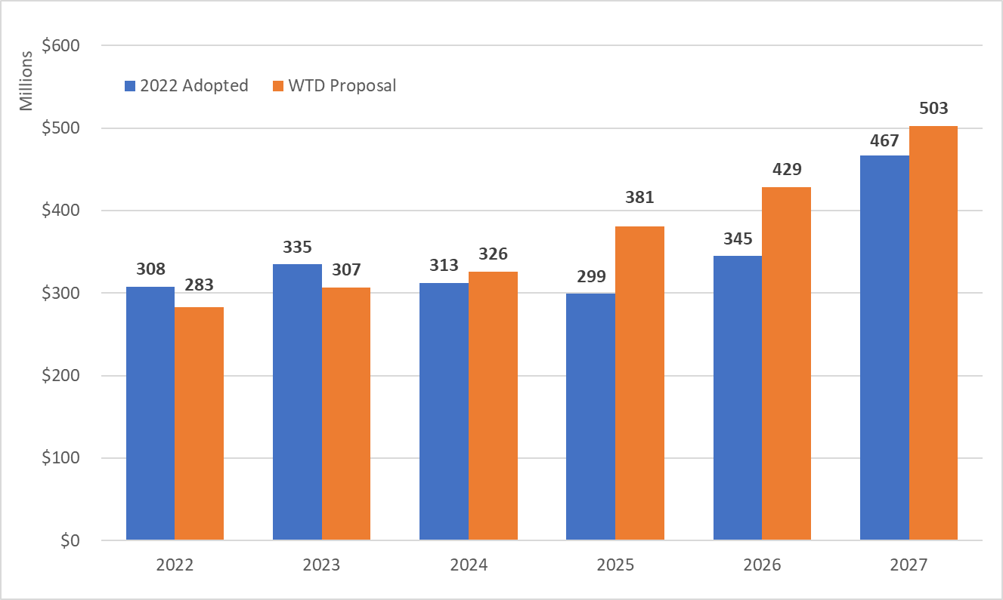

As a means of illustrating the purposes that the capital budget supports, the agency has categorized its capital expenditures according to major functional areas, or “portfolios”. The portfolios include:
- Regulatory – Projects and programs that respond to regulatory, permit, or consent decree legal deadlines
- Asset Management: Plants and Conveyance – Rehabilitation or replacement of critical assets at treatment plants or in wastewater conveyance network
- Resiliency – Improve the survivability and operability of core assets against natural disasters by addressing known deficiencies
- Operational Enhancements – Reduce operating costs at treatment plants through projects that create efficiencies
- Capacity Improvement – Increase capacity at WTD facilities to accommodate growth
- Resource Recovery – Projects that reduce energy use or recover resources with value from wastewater such as methane gas or reclaimed water

Chart 3 below depicts the anticipated proportional growth in expenditures in the portfolios, as well as substantial growth in projected total capital expenditures. Asset management at treatment plants, responding to the aging of the system, and regulatory projects required by federal or state regulatory entities, show the greatest expenditure growth through 2031, with projects to increase the capacity of treatment plants and pipelines, associated with population growth, also showing major increases.

Chart 3.
Capital Expenditure Growth by Portfolio

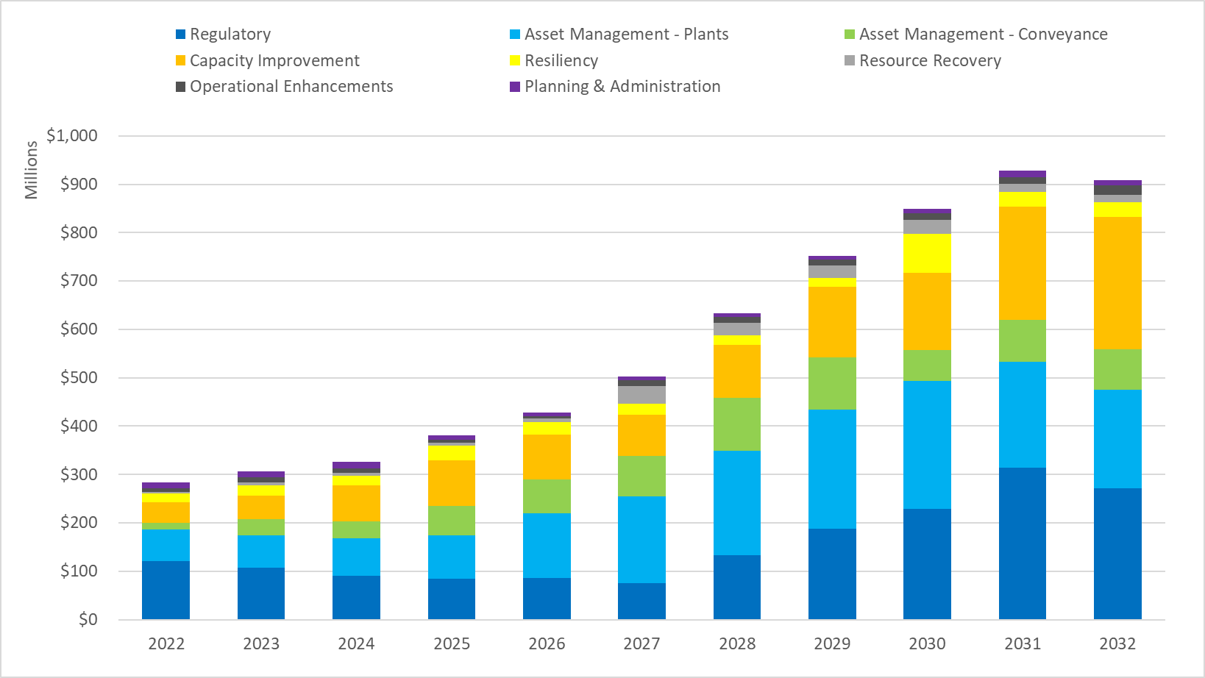

As noted above, upgrades the wastewater conveyance system is one of the major capital expenditures required to manage the system. Chart 4 below illustrates the age range of interceptor conveyance lines throughout the system.

Chart 4.
Interceptors By Age

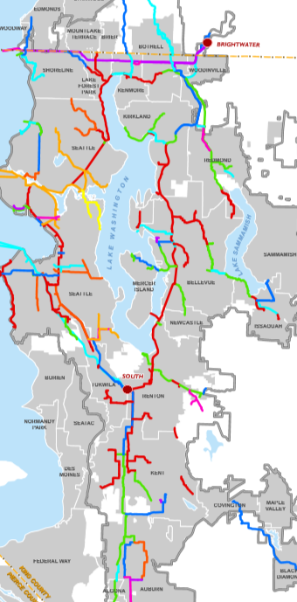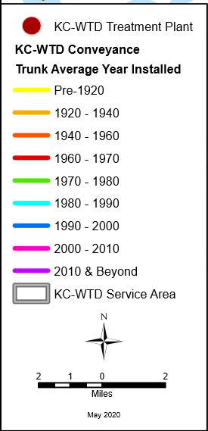

The map above illustrates that a large proportion of the system was built before 1970 and is at or nearing 50 years of service life. In addition to the physical condition of conveyance lines, their age may raise capacity issues. The Division’s Conveyance System Improvement project is intended to assure that the system is capable of conveying wastewater volumes expected for peak 20 year storms. As regional population growth continues, the agency is pressed to address these emerging capacity needs.

As noted, the asset management needs are not confined to the conveyance system; the treatment plants—two of which are over 50 years old—also are the focus of asset management evaluation. The agency indicates that, for the system as a whole, they have designated $1.6 billion in critical asset management projects as “Tier 1” highest priority asset management projects.

The historic mid-century project to restore the water quality of Lake Washington, which was the original undertaking of Metro government, is often cited as a major regional accomplishment. That project was begun in the late 1950s, with construction of wastewater facilities—plants and interceptor pipelines—getting underway in the 1960s. Parts of the extensive construction of that period is now reaching the end its service life, much of it at about the same time, placing intensified asset management pressure on the wastewater capital program.

The capital program also supports the Combined Sewer Overflow program. The agency is required by a Consent Decree to complete a total of 14 Combined Sewer Overflow projects by 2030; negotiations are underway with the Environmental Protection Agency and the Washington Department of Ecology to extend that deadline until 2040. However, while previous rate proposals deferred expenditures for future projects assuming completion in 2040, the current transmittal accelerates the scheduling of a portion of the expenditures for these projects. A number of projects are currently underway including the Joint Ship Canal project, and the Georgetown Wet Weather Treatment Plant. Four earlier projects have been completed. Remaining projects (some of these are combined projects) include the Hanford/Lander/Kingdome/King Street (HLKK) Wet Weather Treatment Station, the Montlake Storage Tank/Green Stormwater Infrastructure, and the University Storage Tank/Green Stormwater Infrastructure.

Long Term Sewer Rates. The Executive has prepared a ten-year sewer rate plan that projects rates anticipated over the coming decade. Of particular note, the plan projects that, after five years of 5.75% rate increases, beginning in 2028, the Executive anticipates proposing rate increases of 9% per year.

Table 10.
Long Term Sewer Rates

Revenue needs are expected to grow substantially over that period. The chart below suggests that the greatest proportion of the growth in revenue need is driven by revenue demand for cash-funded capital, and for new debt service—both driven by a growing capital project demand. Over that time frame, capital expenditures will include accelerated combined sewer overflow spending as well as substantially increasing costs for nutrient management, and conveyance system capacity improvements, repair and upgrade, and asset management capital costs.

Chart 5.
Wastewater Long-Term Revenue Needs

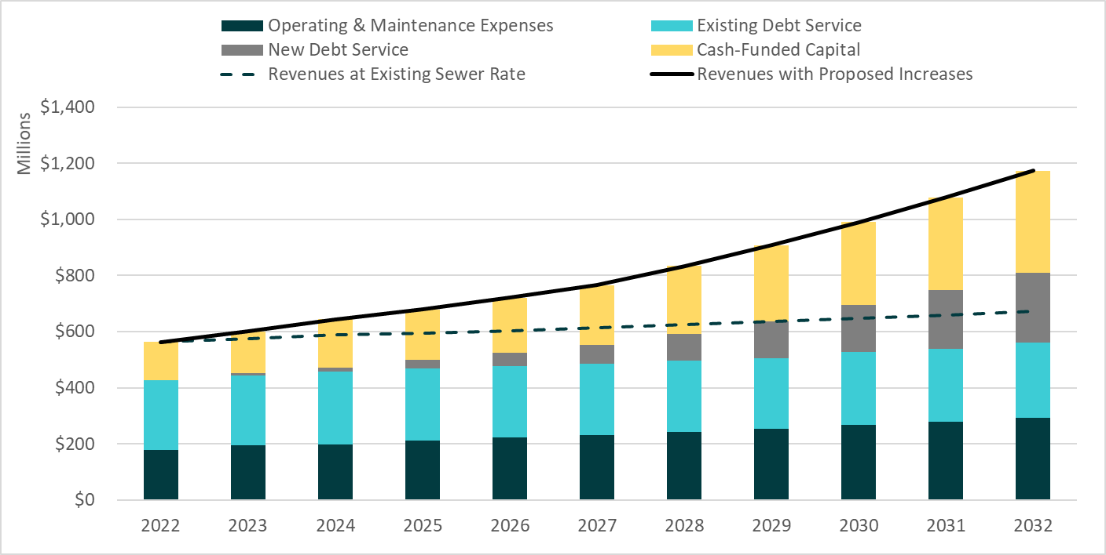

Rate Context Analysis
There is an element of “catch-up” about this rate proposal, as it seeks to address a number of urgent system concerns and priorities, some of which might have been addressed through earlier rate setting periods.
- The 2023-2032 Sewer Rate Plan notes that the Conveyance System Improvement program has identified a number of high-priority projects—but that updated modeling analysis and staff input indicate that “all project locations identified have less than a five-year level of service; some have less than a one-year level of service. Sanitary sewer overflows have occurred at several project locations.” Noting the timelines of recent CSI projects, some have taken over a decade from project identification to completion of construction.
- Capacity concerns have been identified at all three regional treatment plants, by the agency’s Flows and Loadings study. “some of these critical projects are past the indicated start date…and have been prioritized to ensure treatment capacity and compliance with NPDES permits…”
- There appear to be continuing events of facility challenges, emergency bypasses, pump failures, overflows, electrical system problems and similar issues. These can be seen as warning signs that early and aggressive attention is needed to the status and condition of the physical plant, on a system-wide basis, to mitigate future failures.
- In the 2022-2031 Rate Plan adopted by Council last year, the Executive structured rates based on the assumption that remaining Combined Sewer Overflow project costs would be addressed over the period through 2040, with remaining projects to be undertaken between 2030 and 2040. However, the current rate proposal accelerates the costs for part of those projects, by including 40% of the remaining project costs, or $1.68 billion, to be expended for the projects during the period 2023-2032. The Rate Plan indicates that this is being done “in recognition of approaching milestones”. While the Executive has noted that the negotiations on this matter are confidential, some will read this acceleration as raising question as to the likelihood of an agreement on a 2040 completion date for Consent Decree projects with state and federal authorities—which could mean that all projects—$4.28 billion worth—would need to be accelerated. If that turned out to be the case, rate impacts could be severe.
- The Nutrients General Permit requirements are expected to result in major costs to the wastewater system over time. These requirements shouldn’t have been unexpected—EPA has required similar Nutrients-related reductions for systems on the Chesapeake Bay, Great Lakes and elsewhere, going back at least 15-20 years. With early action, the regional system could have undertaken efforts to mitigate costs, or develop alternative strategies, in anticipation of an eventual regulatory requirement. Strategies could have included some that the agency is currently advocating, such as a watershed-based approach to incentivize nutrient discharge limits from other sources, upstream/distributed waste treatment options, spreading costs out over a longer time frame, or others. The region is currently in the position of reacting to a regulatory mandate, with all the inflexibility and costs that imposes.
- The 5.75% rate proposal provides for a percentage increase that is 44% greater than the 4% increase projected in the 2022-2032 adopted rate plan. Projected rate increases beginning in 2028 are 9% annually.
Some of these costs could have been addressed earlier. Since 2003, there has been a 0% rate increase every other year (county code language encourages, but doesn’t mandate, alternate year rates, for rate stability purposes for local partners); since shortly after the completion of Brightwater, beginning in 2013 rates have averaged about 6.2% per biennium, or about 3.1% per year. Those years when rates were lower, particularly the period between 2014 and 2020, could have been appropriate times to begin to absorb predictable coming costs.

It should be noted, however, that even during periods of lower rates, there was pressure to keep rates low from authorizing structures, including ratepayers, the Metropolitan Water Pollution Abatement Advisory Committee, and elected officials. Also noted are a number of agency cost-saving and revenue-generating initiatives, including bond sales during periods of low interest rates, scrubbing of capital projects for potential cost savings, pursuit of low-interest loans, grants, and other alternative capital sources, sales of renewable resources such as process gas and Renewable Identification Numbers, office space savings resulting from work-from-home strategies, sale of biosolids for agricultural uses, and related undertakings.

Table 11.
WTD Work-At-Home Facility Cost Savings

Biennium | FMD Space Cost | Sq. Footage
2017-2018 | $3.921,564 | 55,448
2019-2020 | $4,085,548 | 55,448
2021-2022 | $4,246,616 | 50,178
2021-2022 Revised | $2,763,254 | 50,178
2023-2024 | $1,418,876 | 17,064
Reflects impact of COVID pandemic (telework mandate)

The “catch-up” elements described above are complicated by a number of rate context elements, including:
- Substantially increasing inflation rates, which will impact payments on variable rate debt instruments; and while no significant additional bond sales are on the immediate horizon, if inflation remains high for an extended period, the cost of debt for future sales could present a challenge;
- Supply chain complications that constrain the on-time completion of capital projects;
- Challenges in recruiting and retaining talented staff, together with extended ramp-up periods for new staff; additionally, the agency has a significant number of long-time staff nearing retirement, and will face the need to both capture their institutional knowledge, and replace them upon departure; and
- Revenue shortfalls resulting from Covid-related reduced industry/business activity.
Metropolitan Water Pollution Abatement Advisory Committee Comments. The Metropolitan Water Pollution Abatement Advisory Committee (MWPAAC) advises the King County Council and Executive on matters related to water pollution abatement. It was created by state law (RCW 35.58.210) and consists of representatives from cities and local sewer utilities that operate sewer systems within King County’s sewer service area. These cities and sewer utilities deliver their sewage to King County for treatment and disposal.

MWPAAC forwarded an advisory letter to the County Executive, Attachment 3, which is included in the transmittal. MWPAAC subsequently forwarded a letter identical in substance to Council.

The MWPAAC letter:
- Includes an indication that MWPAAC “understands the needs” driving the rate proposal, and supports “adequate revenue to meet…regulatory requirements and…system investments”;
- Highlights the fact that the recommended 2023 5.75% increase is larger than the forecasted 2023 increase of 4.0%, due to accelerated combined sewer overflow expenditures, asset replacement projects, and the West Point Power Quality Improvement Project;
- Expresses alarm at the proposed ten-year rate plan, showing a doubling of the regional monthly sewer rate by 2032; and
- Requests additional dialogue and information on
  - Consent decree negotiations
  - Asset Management
  - Capacity Improvements
  - Staffing and Programs
  - The Clean Water Plan
  - Financial Questions, including
    - Cash Funding of Capital Projects
    - Construction Cost Inflation Factor
    - Allocation of Growth-related capital improvements between Sewer Rate and Capacity Charge.

TIMING

The wastewater contracts with participating cities and sewer districts specify that the sewer rate be in place by July 1 of each year (partner city and sewer districts act after the county sets the sewer rate to establish their local rates, all of which go into effect on January 1, 2023).

RESPONSES TO COMMITTEE INQUIRIES FROM 5/25/2022 BFM SEWER RATE BRIEFING

Committee members raised several questions at the May 25 briefing of the Budget and Fiscal Management Committee on the proposed 2023 Sewer Rate and Capacity Charge as transmitted. Below are the enumerated questions, together with responses prepared by the Executive.

- What would happen if we were to reduce to, say, a 30% cash policy, rather than 40%? How much of the proposed rate increase is related to the 40% cash funding practice (in a table form, if possible)?
The table below provides information on 30% cash funding.

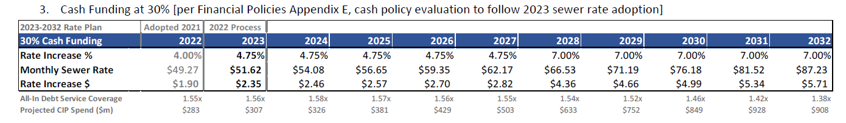

WTD has an upcoming workplan to evaluate the cash funding approach used in preparing the proposed sewer rate and ten-year forecast. Our evaluation of that practice will include identifying multiple options, reviewing industry best practices, assessing sensitivity of the sewer rate to alternative approaches, and reviewing impacts to rating agency criteria such as the debt service coverage ratio. We will engage the Metropolitan Water Pollution Abatement Advisory Committee (MWPAAC) in these discussions. Please note that given the timing for this work, any changes to the cash funding practice would need to be considered in the 2023 process leading to the 2024 sewer rate proposal.

The target schedule for that work is as follows:
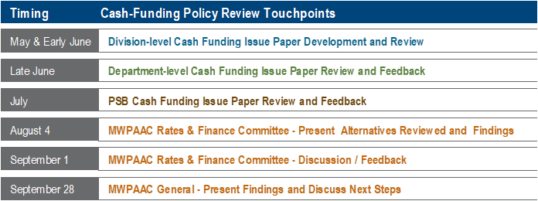

2. What will be the cost of the nutrients element, and the rate impact for the 2023 period? What specifically would be done?
The proposed 2023 sewer rate and 10-year (2023-2032) rate forecast includes $50m in the capital budget to respond to the Puget Sound Nutrient General Permit (PSNGP) that took effect on January 1, 2022. These are necessary and prudent investments, regardless of the outcome of the pending challenges to the permit, because this work will provide more information on the County’s current wastewater discharge, projects to improve operations, and what it would take to achieve permit compliance.

Of the proposed $50m investment, $25M is allocated for small capital projects to support optimization at the South and Brightwater Treatment Plants, mitigate the risks of permit noncompliance, and improve treatment plant process performance. The Wastewater Treatment Division’s (WTD) initial optimization planning efforts resulted in a list of available options for optimizing treatment plant operations to help with nutrient reduction. The order of magnitude estimates for each identified improvement range from $100,000 to $10m. WTD will work with a consultant to refine cost and benefit information that will inform an implementation plan for selected projects from the available options.

WTD will also undertake planning-level analysis to recommend long-term solutions to achieve low effluent total inorganic nitrogen (TIN) targets as required by the PSNGP; $25M is allocated for this work. This work will include characterization of wastewater, treatment technology analysis, economic evaluation, and an environmental justice review for West Point, South, and Brightwater Treatment Plants. The final work product will include two recommended solutions per plant. If the current targets in the PSNGP for nutrient reduction remain unchanged following the resolution of the permit appeal, WTD will not have sufficient time to complete this work in the timeframe allowed by the permit unless this work begins now.

While rate increases are generally smoothed to quarter percent increments, removing the $50M from the proposed rate would reduce annual rate increases by approximately 0.15% between 2023 and 2027.

3. What if we were to implement an additional charge to take care of the aging asset—that would be paid by existing users to the system—say, a sinking fund? As distinct from a capacity charge for new users

All sewer rate payers are existing users of the system, so the cost of asset management is currently assessed to existing users of the system through the sewer rate. To contrast, the capacity charge is a one-time (though can be financed through payments that end when the balance is repaid) fee for a new connection to reimburse existing rate payers for the capacity that was financed ahead of their time of connection. Last year’s new connections are this year’s existing customers. The charge is tied to the property and remains when the property changes hands.

The portion of the sewer rate that funds asset management related capital investments could be considered for a sinking fund if identified as such and cash funded at an amount equal to the asset management investments. The amount of cash funding could vary from year to year as projects are identified and completed. This option is one of the approaches to be evaluated in this year’s evaluation of the cash funding policy approach.

4. Pls prepare a table? Chart? That looks at the capacity charge ten years back, and ten years ahead, and what it has paid for and is there an economy of scale?

Please see table below that shows the data requested.
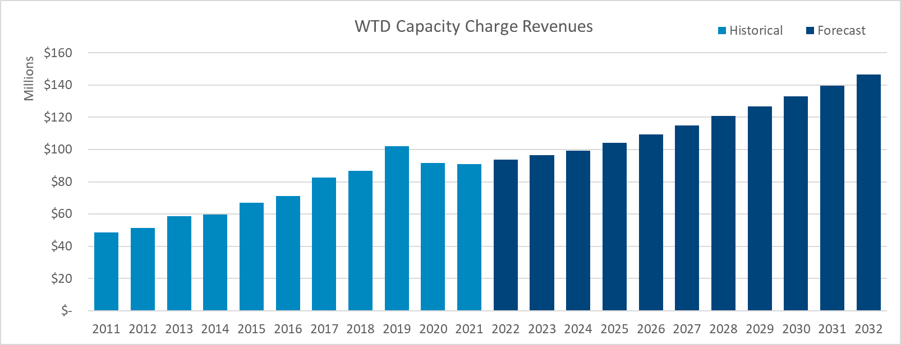
What it has paid for: The capacity charge is targeted to recover the proportionate cost of capital projects necessary to provide sufficient sewer capacity to serve new connections. The agency’s comprehensive sewer plan, currently the Regional Wastewater Services Plan (RWSP), is the source for both the units of capacity and cost of capacity that inform the capacity charge calculation. This targets funding capacity costs over time as newly connected properties pay the fee (either at time of connection or financed by the agency over 15 years).

King County code requires that the charge be recalculated every three years, examining actual costs and new connections compared to projections. The 2023 charge update will be performed when the Clean Water Plan is adopted by Council. Ordinance 19403 defers the capacity charge update calculation in order to allow time to incorporate capital costs and system capacity data that emerge from a completed Clean Water Plan. An annual three percent inflator will continue to be applied as is done in interim years between calculation updates.

Economies of scale: While King County’s population growth has averaged 1.8 percent annually before COVID-19 (2011-2019), annual Residential Customer Equivalent (RCE – sewer rate billing unit) growth for the same period is 1 percent (more on why below). Sewer rate revenue is directly tied to RCEs, so that sewer rate revenue grows at the pace of RCE growth. This rate of revenue growth is less than general cost inflation (CPI at 2.3 percent for the same period), and less than impacts of new regulation. Since RCE growth is incorporated into the sewer rate forecast, any savings from economies of scale are incorporated and reflected in the proposal.

Historically, single family RCEs have averaged about 55 percent of the total customer base and agencies are charged based on the count of connected single detached homes. The remainder of the customer base is charged based on converting their reported water use to an RCE based on a factor of 750 cubic feet per month. The volume-based RCE class has not grown at the rate of population growth due to significant water conservation.

INVITED

- Kamuron Gurol, Director, Wastewater Treatment Division
- Courtney Black, Rates, Capital and Debt Management Supervisor, Wastewater Treatment Division

ATTACHMENTS
- Proposed Ordinance 2022-0172 (and its attachment)
  - Attachment A: Financial Plan
- PO 2022-0172 Transmittal Letter
- PO 2022-0172 MWPAAC Letter with rate recommendation
- PO 2022-0172 2023-2032 Sewer Rate Plan
- PO 2022-0172 Fiscal Note
- Thurston County Superior Court Declaratory Judgment on Nutrients General Permit

The County has a contractual relationship with cities and utility districts to collect wastewater from them and convey it to County treatment plants for treatment and discharge. The component agencies that provide direct services to the ratepayers and use the County conveyance and treatment facilities are charged for the customers within their districts. The utility providers, as direct service providers, set their own rates to recoup the payments required by use of County services plus their own “local” cost of service.
A single family residence is one RCE. Commercial and industrial customers are charged based on the amount of wastewater they generate, calculated using the quantity of water consumed. For commercial and multi-family residences, the calculation is then converted into RCEs. One RCE (750 cubic feet of wastewater) represents the average amount of wastewater a single family residence would generate in a month.
The variable rate debt portfolio consists of a Floating Rate Note (weekly SIFMA rate + 0.23%), commercial paper with maturities between 1 - 270 days, Short-term Fixed Rate PUT Bonds with a 3 to 6-year maturity each prior to mandatory purchase, and two Variable Rate Demand Obligation issuances with a daily and weekly reset each.
Prior to actuals, the 'Blended Variable Interest Rate' is used to estimate interest payments: 1.38% in 2020, 0.72% in 2021, and 1.54% in 2022.
K.C.C. 28.86.160 (FP-15) sets the charge via the following calculation: Capacity charge = (total system costs – rate revenue from existing customers) – rate revenue from new customers number of new customers
The RWSP financial policies, established in county code, require the capacity charge to be a uniform charge, approved annually, and the charge is not to exceed the cost of capital facilities necessary to serve customers establishing new connections to the sewer system.
NorthShore – Bimonthly rate including King County is 127.93.; monthly rate $63.97 minus $49.27 (KC rate) =$14.69 Source http://www.nud.net/about-us/departments/finance/service-rates . Renton – $31.12 fixed Source: https://www.rentonwa.gov/cms/one.aspx?portalId=7922741&pageId=17174716 Redmond--$14.15 Source Water-and-Wastewater-Rates---Ordinance-2941-PDF (redmond.gov) Sammamish Plateau Water/Sewer District – $39.29 Source: https://spwater.org/384/Single-Family-Residential-Water-and-Sewe. Soos Creek Water Sewer District – $21.22 Source: https://www.sooscreek.com/static/7/utility-rates.

