King County Search and Rescue Fuel and License Plate Plan

December 2019

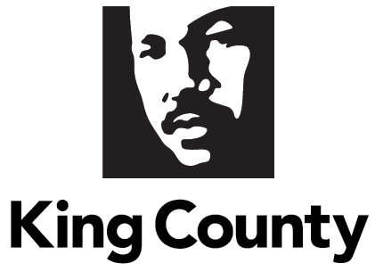

Proviso Text

Ordinance 19021, Section 3, P7 PROVIDED FURTHER THAT:

Of this appropriation, $100,000 shall not be expended or encumbered until the executive transmits a plan, developed in consultation with the sheriff, to provide bulk rate gasoline and vehicle license plates to King County search and rescue volunteers and a motion that should acknowledge receipt of the plan and reference the subject matter, the proviso's ordinance, ordinance section and proviso number in both the title and body of the motion, and a motion acknowledging receipt of a plan is passed by the council.
The executive should file the plan and a motion required by this proviso by December 31, 2019, in the form of a paper original and an electronic copy with the clerk of the council, who shall retain the original and provide an electronic copy to all councilmembers, the council chief of staff and the lead staff for the law and justice committee, or its successor.

Ordinance 19021, Section 3, Office of Performance Strategy and Budget, Proviso 7

Executive Summary
The Office of Performance, Strategy and Budget (PSB) has researched options to provide bulk rate gasoline and vehicle license plates to the King County search and rescue volunteers in order to reduce costs to this volunteer organization.

In conjunction with the King County Sheriff’s Office (KCSO), PSB has determined that the goal of reduced fuel costs for the King County Search and Rescue organization can be achieved efficiently using County financial resources to subsidize the organization’s purchase of gasoline.

In conjunction with the Records and Licensing Services Division of the Department of Executive Services, PSB has determined that State law makes no provision for providing exempt license plates for Search and Rescue vehicles.

Report Requirements
Provision of Bulk Rate Gasoline:
The King County Fleet Services Division of the Department of Executive Services offers agency vehicle users the option to purchase bulk rate fuel at specified locations. This cost of this fuel is approximately one-third less per gallon than fuel purchased at retail gas stations.

PSB and KCSO found that the transactions necessary to track an independent organization’s use of the bulk rate discount card would be time consuming and difficult to audit. The King County financial accounting system has not been structured to efficiently allow transactions posted by non-County organizations.

However, a more efficient option to provide a low-cost fuel benefit to the King County Search and Rescue organization is available in the form of an appropriation from the General Fund. Using this option with gas usage rates provided by the King County Search and Rescue representatives can result in the provision of fuel at a rate approximately equal to the bulk rate available to County government vehicle users. If the County Council is interested in pursuing this option, a proposal could be developed for the 2021-2022 budget.

Provision of Vehicle License Plates:

The Records and Licensing Services Division is responsible for managing vehicle licensing on behalf of the State. They note that current State law allows exempt plates to be issued only to vehicles owned by certain types of organizations, such as governments or Native American tribes. State law has no provision allowing exempt vehicle licenses for King County Search and Rescue vehicles, so providing such licenses is not possible.

Conclusion/Next Steps
In the interest of reducing costs for the vital work of the King County Search and Rescue organization the County government can provide a financial benefit equivalent to the reduced cost of bulk rate fuel available to users of King County government vehicles.

This proposal can be further developed for the 2021-2022 biennial budget in meetings with representatives from the Executive, Council, Sheriff’s Office, and the King County Search and Rescue organization. If the Council is interested in this idea, a joint analysis should be completed to estimate the fiscal effect of this proposal. This work should be completed prior to June 30, 2020.

