Ravensdale Park Improvements
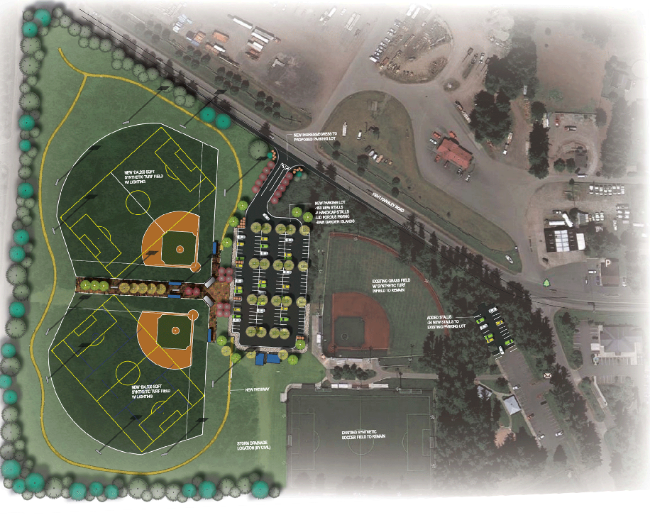
Image from Ravensdale Park Foundation: http://ravensdalepark.org/

