STAFF REPORT

Agenda Item: | 6 | Name: | Scarlett Aldebot-Green
Proposed No.: | 2017-B0164 | Date: | August 22, 2017

SUBJECT

Briefing 2017-B0164 will provide an implementation update on the overarching strategy, School to Life Success Strategy, in the Sustain the Gain Allocation (5 – 24 Years) of the Best Starts for Kids Initiative.

BACKGROUND

On November 3, 2015, King County voters approved a six-year property tax levy to fund Best Starts for Kids (BSK), a prevention-oriented regional plan. Ordinance 18088, the legislation that placed the BSK levy on the ballot, required that the Executive transmit to the Council an implementation plan (BSK Implementation Plan) that “identifies the strategies to be funded and outcomes to be achieved with the use of levy proceeds” by June 1, 2016. The King County Council approved the Best Starts for Kids Implementation Plan in September 2016 through Ordinance 18373.

The BSK Implementation Plan identified funding strategies and outcomes for levy proceed expenditures as allocated in the levy ordinance (excluding set-asides from the first year’s proceeds for the Youth and Family Homelessness Prevention Initiative and election costs):

- 50 percent of levy proceeds for the Invest Early Allocation (0-5 year olds);
- 35 percent for the Sustain the Gain Allocation (5-24 year olds);
- 10 percent for the Communities Matter Allocation (Communities of Opportunity); and
- 5 percent for the Outcomes-Focused and Data-Driven Allocation.

Within the 35 percent Sustain the Gain Allocation, or an estimated total of $129,483,000, six programmatic strategic areas were identified in the BSK Implementation Plan:
- build resiliency of youth and reduce risky behaviors;
- meet the health and behavior needs of youth;
- create healthy and safe environments for youth;
- help youth stay connected to their families and communities;
- help young adults who have had challenges successfully transition into adulthood; and
- stop the school-to-prison pipeline.

This briefing by Executive Staff will focus solely on the last strategy area, Stop the School-to-Prison Pipeline/School to Life Success Strategy. The Best Starts for Kids Implementation Plan outlines four programmatic approaches within this strategy area and estimates funding levels at $500,000 for 2016 and an annual average of $4,380,000 for 2017-2021 for all programs. The four programmatic approaches in this strategy area are:
- Prevention/Intervention/Reentry Program
- Youth and Young Adult Employment Project
- Theft 3 and Mall Safety Pilot Project
- Students Creating Optimal Performance Education (SCOPE)

According to the approved BSK Implementation Plan, Sustain the Gain allocation strategic investment areas and programmatic approaches will contribute to improvement of the following headline indicators:
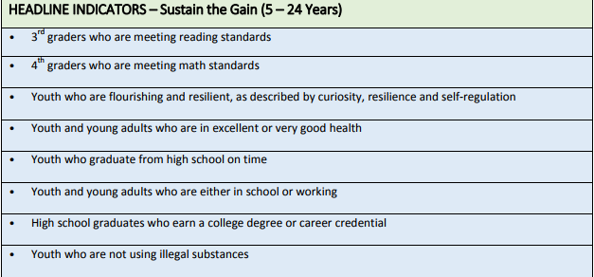

INVITED

- Sarah Wilhelm, Strategic Advisor for Trauma-Informed Systems, Best Starts for Kids, Public Health - Seattle & King County
- Zac Davis, School to Life Success Program Manager, Department of Community and Human Services
- Andre Bullard, Outreach Specialist, Multi-Service Center

This strategy has been known as the Stop the School-to-Prison Pipeline strategy. Executive Staff indicate that the name of this strategy is being phased out to better reflect the evolution of the strategy’s direction, still within the framework adopted in the BSK Implementation Plan, as implementation continues. The new name notwithstanding, Executive Staff indicate that this strategy as well as other strategies in the Sustain the Gain Allocation are intended to broadly align with the recommendations of the Youth Action Plan, adopted by Motion 14378. The Youth Action Plan Recommendations in Area 3, School-to-Prison Pipeline, were: 1) support preventative practices and programs that reduce likelihood of juvenile justice system contact; 2) reduce detention of and move toward elimination of detention of youth ages 18 and under for non-violent crimes; 3) provide training, consultation, and support to providers of early childcare and education on discipline alternatives; and 4) alternative discipline policies for school-aged children.
Ordinance 18088.
The Youth and Family Homelessness Prevention Initiative has a separate implementation plan, approved by Ordinance 18285 and later amended by Ordinance 18373.
See footnote 1.
The Theft 3 and Mall Safety Pilot Project was recommended for inclusion into the BSK Implementation Plan by the KC Juvenile Justice Equity Steering Committee as a project under the strategy area of Stop the School-to-Prison Pipeline. The Youth and Young Adult Employment project and the Prevention/Intervention/Reentry Project, in particular, are reflective of themes raised by this committee during its deliberations.
Proposed Motion 2017-0286, which would approve the BSK Evaluation and Performance Measurement Plan, has been mandatorily referred to the Regional Policy Committee and then to the Health, Housing and Human Services Committee. Staff analysis on this item is ongoing.

