

Metropolitan King County Council
Budget and Fiscal Management Committee

AGENDA ITEM | 5 |  | DATE: | Sept. 18, 2012
PROPOSED No.: | 2012-0113 |  | PREPARED BY: | Amy Tsai

STAFF REPORT

SUBJECT: A MOTION accepting a proviso response regarding Major Maintenance Reserve Fund carryover.

SUMMARY: On March 15, 2012, the Executive transmitted a report in response to a 2012 budget proviso requiring a report on the Executive’s implementation of a carryover reduction model established in 2010. The report gives a status report on the carryover model, but also proposes a new methodology for improved management of MMRF carryover with new milestone targets for implementation. The accompanying motion, Proposed Motion 2012-0113, would release $100,000 upon acceptance of the report.

BACKGROUND:

In the 2009 budget process, the Council had concerns about the level of carryover in the Major Maintenance Reserve Fund (MMRF) within the Facilities Management Division (FMD). Carryover is the amount of unexpended project appropriation from each previous calendar year. That year, the Council required a carryover report that directed the Executive to recommend a targeted maximum annual capital carryover amount for MMRF with a plan and timeline for implementation. In that report, the Executive identified targets to achieve by 2012.

Since that time, the Council has taken a variety of steps to monitor the performance of MMRF projects in meeting scope, schedule and budget and the impact on carryover. In order to obtain a better picture of the status of FMD’s capital projects, the Council in the 2010 and 2011 budget process required a series of quarterly reports from FMD on the appropriation, expenditure, baseline, and estimated total cost of FMD’s capital projects. A template for reporting was developed in conjunction with Council staff, and provided for the first time a comprehensive picture of all of FMD’s capital projects. One issue that became clear in those reports is that there was a significant number of projects remaining in closeout for a long period of time. This administrative backlog in closing out projects was an additional contributor to MMRF carryover.

In the 2012 budget, the Council continued its oversight of MMRF carryover by placing a proviso on the MMRF sub-fund. The proviso, which required a report on implementation of the targets from the previous carryover report, was as follows:

Of this appropriation, $100,000 shall not be expended or encumbered until the executive transmits a report and a motion that acknowledges receipt of the report and references the proviso's ordinance, section and number and motion is adopted by the council.
The report shall be on the implementation of project delivery performance targets highlighted by the executive in the 2010 proposed budget transmittal that proposed an expenditure model intended to reduce carryover budget authority. The performance target that thirty percent of the project budget authority will be used in year one, sixty percent in year two and the remaining ten percent in year three shall be the basis of the report, although it is acknowledged that adjustments based upon the complexity of the individual projects may be required. The report shall outline strategies to be used to reduce major maintenance reserve fund carryover budgets. The report shall be submitted for all major maintenance projects and shall be presented in a reporting format developed collaboratively by council staff, facilities management staff and staff from the office of performance, strategy and budget. It is the intent of the council that the format that is developed shall inform the executive's proposed 2013 budget for the major maintenance reserve fund projects.
The executive must transmit to the council the report and motion required by this proviso by March 15, 2012, filed in the form of a paper original and an electronic copy with the clerk of the council, who shall retain the original and provide an electronic copy to all councilmembers, the council chief of staff and the lead staff for the budget and fiscal management committee, or its successor.

On March 15, 2012, the Executive transmitted the report and draft motion. Proposed Motion 2012-0113 would accept the report and release $100,000 of the MMRF sub-fund.

ANALYSIS:

The carryover report transmitted by the Executive in 2009 laid out a “30/60/10” annual expenditure percentage rate schedule to occur for projects budgeted in 2010 and beyond. The idea was that major maintenance projects typically take three years, with design in the first year, construction in the second year, and close-out in the third year. The ultimate goal was to have 45% as the target carryover starting in 2012 (carrying over 70% of the current year’s budget for new projects and 10% of the prior year’s budget for projects in progress).

There were several difficulties with the proposed model. Because these targets relied on year-end fund-level values, they were not useful for project management at the individual project level. Another problem with the proposed model was that it used calendar years as the basis for the targets as a proxy for identifying the phase of spending each project should be in, when it would have been more accurate to use the phase. In addition, the target carryover for prior years’ budgets for carryovers going forward from 2012 was set at 10% even though presumably not all of those projects would be in closeout.

As a result of the difficulties with the 30/60/10 model, FMD and the Office of Performance Strategy and Budget (PSB) worked with Council staff to modify the model to make the calculations more meaningful, and in addition developed a new schedule-tracking system to improve management of carryover. The report transmitted by the Executive (Attachment A to Proposed Motion 2012-0113) reports on the 30/60/10 status of MMRF projects (Attachment B to the proposed motion), provides another 30/60/10 status updated with the new calculation methodology (Attachment C to the proposed motion), and in the report accompanying the motion outlines the new schedule-tracking system and lays out milestone due dates for implementation of the schedule-tracking system.

Attachment B to Proposed Motion 2012-0113 shows that of projects receiving appropriations in 2010, by the end of 2010 they had spent or encumbered 30.3% of the 2010 appropriation amount across all projects. This is consistent with the 30/60/10 targets set by the carryover report. The attachment also shows that in 2011, 86.5% of the 2010 appropriation amount was spent in 2011. This data does not include how much was appropriated in 2011 for the projects. Due to the difficulty in computing a meaningful measure from this metric, no additional reporting was done on the original 30/60/10 model.

To address limitations in the original model, FMD and PSB worked with Council staff to create a new 30/60/10 report, which is Attachment C to Proposed Motion 2012-0113. In Attachment C, spending is tied to project phase instead of to calendar years. A project in any design phase has a target expenditure of 30% of the estimated total project cost at completion, 90% for construction or implementation (which is 30% + 60%), and 100% for closeout (30% + 60% + 10%). This method makes it possible to get a picture of expenditure rates tied to project phase against the total project cost. By moving away from the calendar year, project targeted spending is not unduly affected by factors such as projects being placed on hold.

The results of Attachment C show that across all MMRF projects, on average (not weighted for the size of projects), MMRF projects are expending funds 16% less than the 30/60/10 target. In the absence of a benchmark, that metric is not necessarily a useful figure. However, Attachment C is a global measure of how FMD is doing in managing MMRF expenditure rates (which affect carryover), which can be monitored from year to year. FMD can also use the tool as a warning sign for individual projects.

With the revised metric not tied to calendar years, the new 30/60/10 model does not provide insights into project performance with regard to meeting scheduling targets. As a result, FMD and PSB proposed a red-green-yellow method of schedule tracking, developed in consultation with Council staff, that is included in their proviso response report. The red-green-yellow model will use the same format that the rest of the county already uses for Project Information Center (PIC) reporting, expanded to cover all discrete baselineable MMRF projects. Projects that are progressing on schedule are more likely to be expending their funds at the scheduled rate, and are therefore less likely to contribute to unplanned carryover.

In his proviso response, the Executive outlines major milestones in the development and implementation of a red-green-yellow schedule model, with identified due dates. The deliverables and due dates are reproduced from the report in the table below.

Table 1. Red-Green-Yellow Schedule Model Deliverables and Due Dates
Goal | Due Date
Completed development of red-green-yellow model (schedule based tracking tied to spending plan) | 3/31/2012
Description of carryover work to date | 4/30/2012
Implementation of red-green-yellow model within Unifier (all project data entered), ability to generate quarterly report data within 30 days after close of quarter (reporting approach to be finalized) in beta not live --- but FMD still expects to be able to do the 10/30/12 RGY quarterly report to Council. | 7/31/2012
Decide on criteria and format for quarterly PIC reporting (FMD, PSB, KCC staff) (yes, the RGY criteria is variance of 0% or less is green, 0-15% is yellow, 15% is red – add description of what start and end dates for substantial completion it is measured against for the schedule criteria) | 7/31/2012
100% of projects managed in Unifier (yes everything in MMRF is being managed in Unifier; but some scheduling information still needs to be updated and project budgets are not in EBS to be pulled into Unifier) 1) unifier has budget estimates/cap form, 2) hyperion pulls info from unifier, generates the budget request, which is appropriated, 3) EBS will pull the information from Hyperion by phase, 4) Unifier gets the appropriated budget and actuals from EBS. (EBS can look but not modify) | 7/31/2012
Red-green-yellow data exportable (e.g., Access, .csv files) ** | 8/31/2012
First quarterly red-green-yellow report sent to Council | 10/30/2012
Develop and implement necessary capabilities within Unifier to automate estimating, tracking, and reporting project metrics as described above – should be done with RGY data for first quarterly report ** | 12/31/2012
Training of all Project Managers in new Unifier capabilities | 6/1/2013
Develop and implement web-based reporting system for metrics (program as well as individual projects) (w/PSB) | 6/1/2013

Finally, the graph below provided by FMD shows the historic carryover levels from 2005 through projected 2012. The blue bars show carryover levels of unencumbered funds. This contains the unplanned carryover that better project management should ideally reduce. The yellow bars show carryover levels of encumbered or contracted funds. The graph shows that carryover has been increasing over time, but is projected to drop to 53% in 2012 (or 39% if one counts only the unencumbered carryover).

Figure 1. MMRF Carryover 2005 to 2012 (projected)
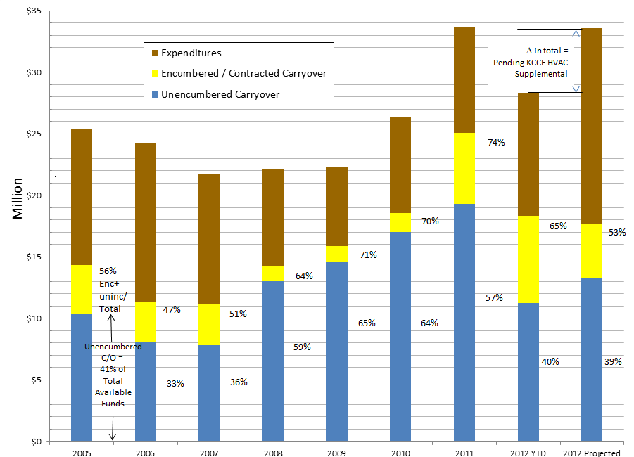

In conclusion, a modified 30/60/10 metric is a tool that can be used as a high level indicator of projects contributing to carryover, but because it is not tied to schedules needs to be viewed in conjunction with a schedule tracking tool and overall carryover levels. The proviso response provides a complete package to address these points. Consistent reporting will give Council better tools to ask questions about specific projects; and also can show when things are going well (when projects are in green status).

As a result of the tracking and reporting requirements that have been developed in response to Council provisos, the county has a more complete picture of the status of MMRF project scopes, schedules and budgets than it has ever had before. This information is also providing FMD with data that it is finding useful to improve its project management and carryover levels.

REASONABLENESS:

The proviso response contains the required elements and was submitted on time. Approval of Proposed Motion 2012-0113 would be reasonable.
INVITED:
None, consent item.
ATTACHMENTS:
- Proposed Motion 2012-0113
- Executive’s Transmittal Letter

