Lease Property Summary
Photo of Property:

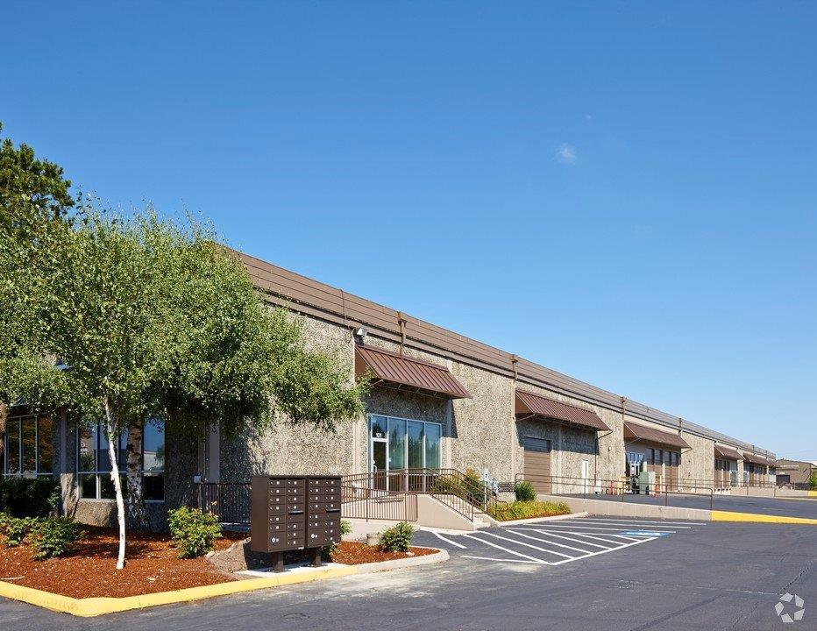

Property Owner: PS Business Park, L.P. and Sub-lessor: Kent Fire Department Regional Fire Authority
Address: 8320 South 208th Street, Kent, WA 98032
Cost Per Sq. Ft.: $7.35 per square foot per year for a subleased space of 3,000 rentable square feet
Operational Costs: 12.5 % of building operational costs plus one percent administration fee. $6 per square foot is the estimated amount for operating expenses.
Term: 68 months
Square Footage: 3,000
Council District: Council District 5
Funding Source: Emergency Medical Services Operating Budget
Previous Location: The previous vehicle service location was at an Auburn Fire Department facility. Auburn now needs this space for their exclusive use and consequently King County Emergency Medical Services(EMS) needs to vacate the location. EMS combined this vehicle electronics service warehouse requirement to the lease search for it’s Administration functions. The warehouse location is for the supplies for the administrative offices and training facilities which are located across the driveway. Council passed legislation in July of this year for the adjacent administrative office and training facility space.

Sublease Synopsis:
The proposed new location provides an opportunity to co-locate with a strategic partner, Kent Fire Department Regional Fire Authority (KRFA) in an updated facility. The space is centrally located in the south King County service area and is near main arterials and freeways. Three-thousand square feet of warehouse space is a small requirement for the Kent market so partnering with KRFA is beneficial. The proposed tenant improvements are designed to accommodate current vehicles and equipment connections. A temporary seven month short-tem sublease with KFRA has been executed to 1.) accommodate Auburn Fire Departments request to relocate out of their facility: 2.) to accommodate storage from the former Administration location on 220th; 3.) to exercise the KRFA master lease option for this space in the timeframe provided. The temporary, month to month sublease can be terminated with thirty days notice and is otherwise set to expire on May 31, 2015. No tenant improvements will occur until the appropriation ordinance is approved.

Context
Rationale for transaction: The current Medic One vehicle electronics parking and service space that was provided by Auburn Fire Department is no longer available. Medic One needs a warehouse location, with vehicle electronics service space, that is proximate to the their new administrative space and this location meets those needs.

Policy considerations: The new facility is a partnership and co-location with the Kent Fire Department Regional Fire Authority’s South County Training Consortium, which has a shared mission and need. Locating all of the Medic’s One administrative and warehouse at an adjacent location provides for a more efficient operation.

Political considerations: This sublease represents a partnership with the Kent Regional Fire Authority.

Community considerations
or partnerships: This facility allows King County EMS to maintain a strong presence in the Kent area.

Fiscal considerations: This legislation includes two components: a sublease ordinance including tenant improvements and an appropriation ordinance. The appropriation ordinance includes costs for improvements at the leasehold. A net present value (NPV) analysis was not completed on this transaction because only one location was available near the Administration facility.

Other considerations: This new facility will be under Medic One’s control and will reduce costs associated with drive time required if it had stayed in the Auburn location. Staff can cross the alley to go to this facility instead of driving to Auburn.

CIP/operational impacts: This project will require a capital investment for tenant improvements and will cost $71,746. The tenant improvements are primarily associated with modifications to the equipment bays to allow current equipment and vehicle access and installing partitions to separate the KRFA’s space from the County. EMS is unable to fully utilize this space until the tenant improvements are made. A companion appropriation ordinance is included with this transmittal. The capital costs will be resourced with EMS fund balance. This location has a positive operational efficiency that occurs from having the material storage adjacent to the administrative offices, which reduces drive time and down time. The warehouse space also allows material storage at a lower cost per square foot than could be achieved in the administrative offices. The original capital project also included funding for the E-911 relocation from the 7300 Building at King County International Airport. This part of the effort, which was originally in the scope of this project, is under review.

King County Strategic Plan impact: The proposed project furthers the following King County Strategic Plan goals:
- Service Excellence: Establish a culture of customer service and deliver services that are responsive to community needs
- Financial Stewardship: Exercise sound financial management and build King County’s long-term fiscal strength
- Health and Human Potential: Promote opportunities for all communities and individuals to realize their full potential

Equity and Social Justice impact: This proposal maintains the continued provision of emergency services to the diverse communities of South King County.

Energy Efficiency impact: There is a reduction in greenhouse gases due to the elimination of trips to the Auburn location.

Lease Alternatives Analysis
Summary: King County and the Kent Regional Fire Authority engaged Meriwether Partners Commercial Real Estate to survey the market. The Kent warehouse market did not have small 3,000 square foot warehouses within a three mile radius of the new Administration site. Therefore this sublease location with KRFA was determined to be the most advantageous.

Vicinity View Map
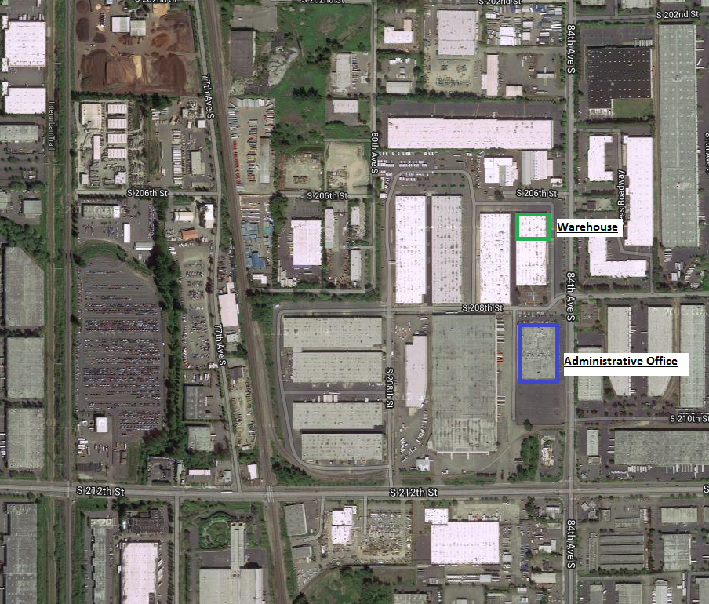

Parcel Map
