STAFF REPORT

Agenda Item: | 4 | Name: | Clifton Curry
Proposed No.: | 2012-B0067 | Date: | April 24, 2012
Invited: | Nate Caldwell, Director, Community Corrections Division, Department of Adult and Juvenile Detention  Lauren Main, Community Corrections Division, Department of Adult and Juvenile Detention

SUBJECT

Briefing on the Status of Community Corrections Programs and Initiatives

SUMMARY

Today the committee will receive an update on the county’s community corrections programs. These programs were established as a result of the adoption of the Adult Justice Operational Master Plan. Since the inception of these programs, the county has seen a significant decline in its secure jail population and continuing increases in its use of alternatives to secure detention. The director of the Community Corrections Division is here today to describe the progress of these community alternatives programs.

BACKGROUND

King County’s criminal justice system, that includes law enforcement, secure detention, prosecution, indigent defense, and adjudication of criminal matters in superior and district courts, accounts for over three quarters of the county’s annual discretionary budget. While these responsibilities are mandated by constitutional, statutory, and other requirements, the county has a great deal of flexibility in establishing levels of service to meet its mandated requirements. In 2002, the county council adopted the Adult Justice Operational Master Plan as Ordinance 14430 that established policies for the use of secure detention, alternatives to jail, and overall system efficiency.

With the approval of the Adult Justice Operational Master Plan, the county established policies for the use of secure detention capacity. It also established as a county policy the requirement for the use of integrated and coordinated treatment of those offenders whose criminal activity is related to substance abuse or mental illness. The county acknowledged that this policy would help the county avoid future system costs, reduce jail utilization for these groups, and reduce future criminality thus improving public safety. These policies emphasize system and process efficiencies that reduce the utilization of jail and reduce overall criminal justice expenditures, while also encouraging the use of alternatives to secure detention. By adopting these policies the county has sought to make the best use of its limited detention resources and preserve public safety. Specifically, the council adopted as policy in Ordinance 14430:

SECTION 5. The council also encourages the development and use of alternatives to the use of secure detention for adult offenders in order to make best use of limited detention resources and preserve public safety. These intermediate sanctions should be used in a graduated and measured manner, appropriate to the offense and cognizant of the cost effectiveness—measured through lower costs, or reducing the costs of future offending.

Therefore, it has been the County’s adopted policy for adult criminal justice since 2002 to make maximum use of alternatives to secure detention. In addition, county policy includes the council’s stated intent that treatment—when it reduces offender recidivism—should be used to the fullest extent possible.

Absence of Alternatives. When the reform efforts began, the county had minimal numbers of individuals involved in alternative programs using secure detention instead. In 2001, before the creation of the county’s system of alternatives, the county’s Average Daily Population (ADP) in jail was 2,901 inmates. In contrast, there were just 133 inmates in the county’s Work Release Program and on electronic home release on a daily basis.

To implement the AJOMP policies, the county created a Community Corrections Division within the Department of Adult and Juvenile Detention. As the following table shows, since the creation of the new division, the county’s community programs have grown significantly while the county’s secure detention population has declined.

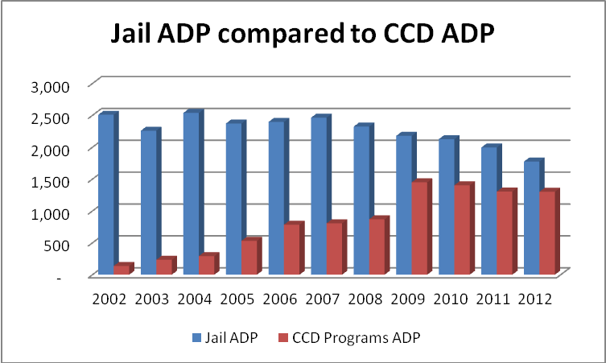

History of Adding New Programs. After the creation of the new division, staff worked successfully with the Superior and District Courts (along with the prosecutor and public defender) to develop the means by which the courts would use alternatives to secure detention. To ensure public safety and avoid liability issues—the decision to place an individual in a community corrections program is always done through a judicial decision. The division was initially established with a day reporting program, work/education/release facility, and electronic home detention program, but has added several new initiatives since its creation.

The council recognized during its 2003 budget deliberations that, with the goal of maximizing the use of alternatives and treatment options, the county’s judges would need to have specific information in order to make appropriate placement decisions. As a consequence, the council added to the 2003 budget an appropriation for the development of an “intake services pilot program.” The council placed this appropriation within the Superior Court’s budget. However, after review, the responsibilities of the Intake Services Unit were transferred to the Division of Community Corrections in 2003. Additionally, resources were made available to the Department of Community and Human Services for the development of “Criminal Justice Initiative” programs that sought to provide appropriate services and treatment to individuals to avoid secure detention and to reduce re-offending. Many of these programs have been implemented to support the community corrections division.

In 2004, the council added resources to community corrections for expanded work crews, intake services, and community alternatives programs. The council also provided funding for inmate re-licensing programs and added resources to develop the “Helping Hands” initiative (that ensures offenders complete court-ordered community service). In 2005, the budget added resources for the development of information technology initiatives and a community “re-entry program.” For 2006, the council added resources for the expanding alternatives programs and to initiate a learning center. Finally, in the last three years, the council has also asked the division to develop a pilot risk needs assessment project for placing inmates in community programs and is also developing a pilot project for the use of graduated sanctions for offenders sentenced to division programs.

In 2012, the county’s community corrections division has, on average, over 1,300 individuals involved in its various program each week—an almost ten-fold increase in less than five years.

ATTACHMENTS

- PowerPoint Presentation,

