Lease Property Summary

Photo of Property
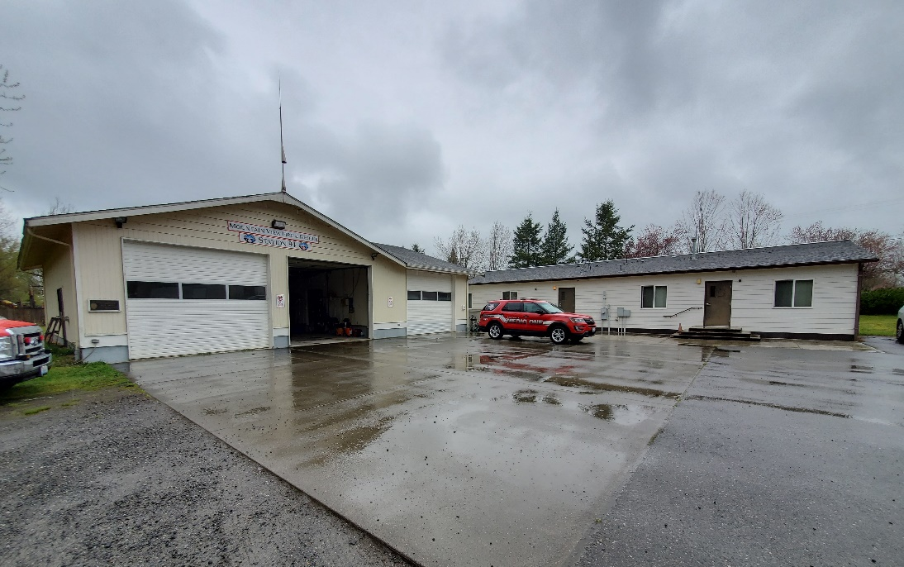

Property Owner: Mountain View Fire and Rescue
Address: 39404 244th Ave. SE, Enumclaw, WA 98022
Cost Per Sq. Ft.: $1.55 per square foot
Operational Costs: Estimated at $8,125.00 for 2025, based off prior years’ cost
Term: Five years + five one-year options
Square Footage: 1,000 SF exclusive use space + 1,000 SF shared use space
Template: County
Council District: Nine
Funding Source: Medic One Levy, Ordinance 18932
Previous Location: New lease at existing location
Offer Expiration: N/A, currently in holdover with no additional costs until lease is in place.

Lease Synopsis:
The proposed Ordinance provides for leasing real property known as Mountain View Fire and Rescue - Station 94, which located between Enumclaw and Black Diamond, for use by King County’s Medic One (Medic One), a division within Public Health-Seattle King County (PHSKC). Medic One is the County’s sole public first responder in the vicinity that provides Advanced Life Support (ALS) and Basic Life Support (BLS) to the cities of Enumclaw, Black Diamond, and the surrounding unincorporated areas of southeast King County.

Context
Rationale for transaction: Station 94 is located between the cities of Enumclaw and Black Diamond and has convenient access to these major southeast King County population centers and the surrounding area via arterial roads. The lease includes the exclusive use of approximately 1,000 square feet and shared use of approximately 1,000 square feet, which includes two dormitory rooms, one office, one bathroom, two garage spaces, kitchen, laundry facilities, one storage room, and an open staging area. The square footage provides parking for ambulance and temporary living accommodations for on-duty first responders. The proposed lease agreement allows Medic One to continue to provide first responder service to the southeast county area from a centrally located and established location.

Policy considerations: The proposed lease agreement supports Medic One’s mission to provide ALS, BLS, and other first response services to Enumclaw, unincorporated southeast King County, and surrounding areas.

Political considerations: N/A

Community considerations
or partnerships: The proposed lease agreement allows for Medic One and Mountain View Fire and Rescue to continue to provide ALS and BLS services to Enumclaw, unincorporated southeast King County, and surrounding areas.

Fiscal considerations: The previous lease expired on December 31, 2023, and the County is in holdover that will be reconciled on commencement of this lease. The negotiations for this lease were delayed while the landlord assessed its operational needs for this site.
The annual cost to lease the facility is $18,540.00. In addition, the lump sum payment to reconcile the difference between the previous rental rate and the rate established by this lease for the period from January 1, 2024, to the lease commencement date in 2025 if approved by Ordinance.
The lump sum payment is calculated by multiplying the rental rate difference by the number of applicable months:
- 2024 Calculation:
  - $1,500.00 (this lease’s rental rate) - $576.88 (previous rental rate) = $923.12
  - This difference is multiplied by the number of months between January 1, 2024, and December 31, 2024.
  - Total for 2024: $11,077.44
- 2025 Calculation:
  - $1,545.00 (this lease’s rental rate) - $576.88 (previous rental rate) = $968.12
  - This difference is multiplied by the number of months between January 1, 2025, and the lease commencement date.
  - The total amount for 2025 will depend on the lease commencement date.

Additional county responsibilities are outlined in Section 7.2 of the lease. The County is responsible for:
- Securing its pharmaceuticals
- Participating in daily housekeeping and periodic cleaning
- Arranging for a waste collection service equipped to handle medical waste
- Covering non-structural repairs and maintenance
- Paying for electricity used to charge vehicles and apparatus beyond the current usage level
In 2024, these costs amounted to $7,888.21. The 2025 costs are estimated to be $8,125.00
Other considerations: The location of the leased property provides easy access to major roads and highways and public transit facilitating the provision of Medic One’s services to the surrounding area.

CIP/operational impacts: N/A

King County Strategic Plan impact: N/A

Equity and Social Justice impact: In accordance with Real Property Asset Management Plan policies, the Facilities Management Division and the PHSKC reviewed this proposed legislation for Equity and Social Justice impacts. The Medic One program is the only public service for first responders that supports the cities of Enumclaw and Black Diamond and the surrounding unincorporated areas southeast King County to provide ALS and BLS emergency medical services.

Energy Efficiency impact: N/A

Lease Agreement Alternatives Analysis
Summary: King County searched for other facilities in 2021 prior to securing this location. This location met, and continues to meet, the ALS and BLS needs of the City of Enumclaw, unincorporated southeast King County, and King County EMS.

Vicinity View Map
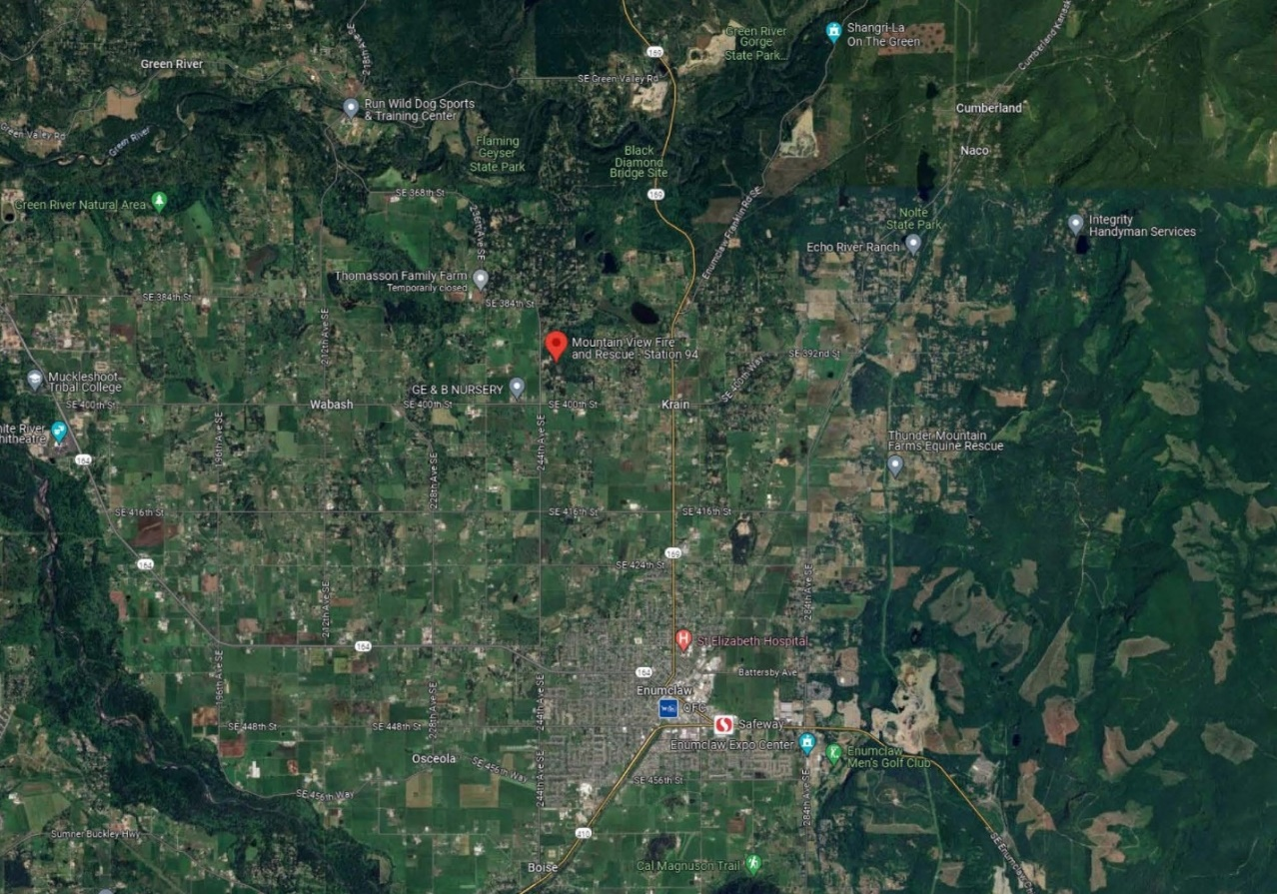

Parcel Map
