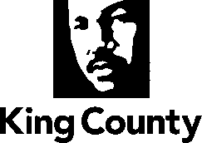

Metropolitan King County Council
Committee of the Whole

STAFF REPORT

Agenda Item: | 9 | Name: | Mac Nicholson
Proposed No.: | 2025-0088 | Date: | March 25, 2025

SUBJECT

A Motion adopting the King County 2025 Federal Legislative Priorities.

SUMMARY

Proposed Motion 2025-0088 would adopt the 2025 Federal Legislative Priorities. The document is a statement of King County Federal policy priorities and provides direction to the County’s Federal advocacy team.

BACKGROUND

Each year, King County develops Federal Legislative Priorities. The Council and the Executive work together through their respective government relations staff, and in consultation with County departments, to decide on the policy positions that are most important to bring to the attention of the U.S. Congress and Federal bureaucracy. These are then reduced to writing in the form of a Legislative Priorities document.

ATTACHMENTS

- Proposed Motion 2025-0088

