April 5, 2004

The Honorable Bob Ferguson, Chair
Regional Policy Committee
Metropolitan King County Council
516 Third Avenue, 12th Floor
Seattle, WA 98104

Dear Councilmember Ferguson:

We would like to invite participation from the members of the Regional Policy Committee to a King County Regional Human Services Design Retreat.

Regional Human Services Design Retreat
May 13, 2004
8:00 a.m. – 5:00 p.m.
St. Margaret’s Episcopal Church
4228 Factoria Boulevard
Bellevue, WA 98006

The Task Force’s mission is to “examine the current Regional Health and Human Services system and provide practical and strategic recommendations for stabilizing, improving and maintaining the regional human service system for the future.” The Task Force, a volunteer citizen advisory group, has been meeting for the past two months with representatives from cities, human service providers, United Way, King County and others to learn about current service delivery and financing.

The Task Force has relied heavily on the extensive work completed last year by the King County Regional Policy Committee (RPC) and the identification of a list of “regional services to be provided through a countywide partnership” reported in the RPC Task 2 Report on Human Services. Taking that work another step forward, the Task Force has commissioned the development of a comprehensive Data Collection Tool currently being completed by service providers across King County. That information will help us to assess the current level of services as well as the gap between the current level and a projected “Basic Level of Services”.

We have planned a full-day key stakeholder retreat to discuss the results of the data collection effort and guide our next steps. In order to obtain broad input into our work we are inviting elected representatives, human service providers, city and county staff, board and commission members to join us for these important discussions. The enclosure with this letter provides more information about the location, goals and invitees.

During the day, we plan a mixture of both large and small discussions on the analysis of the data collection findings on current service levels and gaps in regional service delivery, financial implications, and financing and administrative options for stabilizing the regional human service system for the future. We are not looking for commitments, nor will participation in this day be interpreted as “buy-in” to the Task Force’s future recommendations.

We invite participation from each member of the Regional Policy Committee. We hope that a substantial number of elected officials will join us. We are also separately inviting staff. We look forward to hearing from the members of the Committee.

We would appreciate hearing from you by April 16, 2004, with your representatives’ names and contact information. If you have any questions or need additional information, please feel free to contact Barbara Mauer, Task Force Project Manager, at 206-613-3339 or via e-mail at barbara@mcpphc.com. We will be providing materials to all confirmed attendees in advance of the retreat.

We appreciate that your schedules are very busy but we hope, as key stakeholders in the human service system, you will be able to participate in this important regional discussion. Whatever decisions are subsequently reached by elected officials, council members, or human service providers in the future, we feel we will all be enriched by the opportunity to hear and openly talk with one another about the issues.

Thank you for your consideration.

Sincerely,
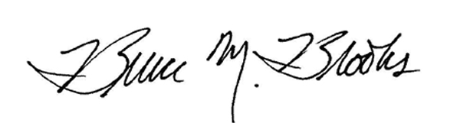
Bruce M. Brooks
Co-Chair

Enclosure

