METROPOLITAN KING COUNTY COUNCIL

Introduction Slip

DATE: August 25, 2020

TO: Clerk of the Council

ORDINANCE 2020-0234

AN ORDINANCE naming the park complex of Preston Athletic Fields, Preston Park, and Preston Mill as the Jim Ellis Memorial Regional Park at Preston in honor of the late James Reed “Jim” Ellis, considered one of King County’s greatest civic leaders.

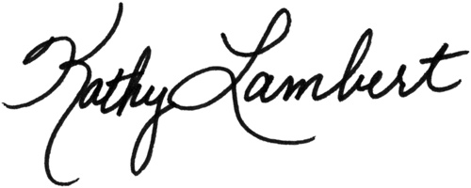

Councilmember Kathy Lambert

