STAFF REPORT

Agenda Item: | 9 | Name: | Jenny Giambattista
Proposed No.: | 2023-B0068 | Date: | July 6, 2023

SUBJECT

Discussion and possible action on a proposed motion requesting the Wastewater Treatment Division research and identify methodologies to forecast long-term financial investments for its capital improvements.

SUMMARY

Currently the Wastewater Treatment Division (WTD) forecasts the financial requirements for its capital improvement program for a 10-year forecast window as part of its annual sewer rate proposal. At the June 7, 2023 Regional Water Quality Committee (RWQC) meeting, Councilmember Balducci directed staff to develop a motion to request WTD research and identify methodologies to forecast the long-term financial investments for its capital improvements.
This staff report summarizes the draft version of the motion that was e-mailed to members for comments on June 23, 2023. Councilmember Balducci will present an updated version of this motion at the RWQC meeting for committee discussion.

As noted in the 2023 RWQC work program, the RWQC is interested in addressing issues related to long-term sewer rates. As a major driver of rates, forecasting future investments in capital improvements will be necessary in order to forecast future rates. The proposed draft motion would request WTD research and identify methodologies to forecast the long-term financial investments for its capital improvements and to seek comment on the methodologies from the Metropolitan Water Pollution Abatement Advisory Committee (MWPAAC).

The proposed draft motion also requests WTD to provide a status update briefing to RWQC in September 2023 and by December 2023 to brief RWQC on the recommended methodologies for forecasting the long-term financial investments for capital improvements.

This motion is proposed for consideration by the King County Council under Section 270.30 of the King County Charter and K.C.C. 1.24.065 which allow for regional committees to develop and propose legislation for introduction to the King County Council.

BACKGROUND

The Wastewater Conveyance and Treatment System Is Made Up of Thousands of Assets. The wastewater treatment system includes three regional treatment plants, 397 miles of conveyance lines, 48 pump stations, 25 regulator stations, five combined sewer outflow storage facilities, four combined sewer overflow storage facilities, 39 combined sewer overflow outfall locations, two small treatment plants, and one community septic system on Vashon. WTD reports the equipment necessary to run this system results in an asset inventory of over 66,000 assets.

Current Forecasting Related to Capital Improvements. Currently, WTD has a six-year capital improvement program (CIP) which identifies all capital improvements expected to be in process during the six-year plan period. This CIP is transmitted along with the Executive’s biennial budget. Please see Attachment 2 for the 2023-2024 CIP. WTD reports the projects included in CIP are determined by an assessment and prioritization using a ranking system that considers multiple factors such as risk of failure, capacity needs, regulatory requirements, and impacts to water quality and public health. The CIP include projects in the following categories:
- Known and anticipated regulatory requirements.
- Asset Management projects necessary to maintain the systems and prevent overflows
- Capacity projects need for growth and required by contracts.
- Resiliency
- Other Capital Projects

Additionally, as part of the annual sewer rate development process, WTD forecasts capital improvement spending by category over a ten-year period. Figure 1 below includes the ten-year capital improvement forecast transmitted with the 2024 rate proposal.

Capital Improvements Not Included in Forecast. WTD reports there are major expenditures not included in the 2023-2033 forecast. The forecast only includes those projects expected to be started during the forecast window and supported by expected revenues and financing. For the 2024-2033 forecast window, the following regulatory CIP projects were not included:

- Consent Decree CSO costs through 2034-2040 ($1.8 billion to complete)
- Draft NPDES Permit Impacts to Elliott West (50 million +) and Alki ( cost TBD)
- Potential Sediment Cleanup Consent Decree Impacts (cost TBD)
- PFAS (cost TBD)

For capacity improvement, the following capacity improvement (system expansion) projects are not included.

- Near term lower risk Capacity System Improvements and Infiltration/Inflow ($420 million + estimate at completion)
- Other conveyance areas nearing capacity (cost TBD)
- Longer term treatment plant capacity needs

Plans for Capital Spending Projections Beyond Ten Years. At the June 7, 2023 RWQC meeting WTD announced it is working to expand its forecast of projected capital spending by 10 years. See Figure 1 below. Additionally, WTD reports that in intends for the update the Regional Wastewater Services Plan to include long term forecasting for capital investments in the regional wastewater system beyond a 20-year period and up to 50 years.

Figure 1
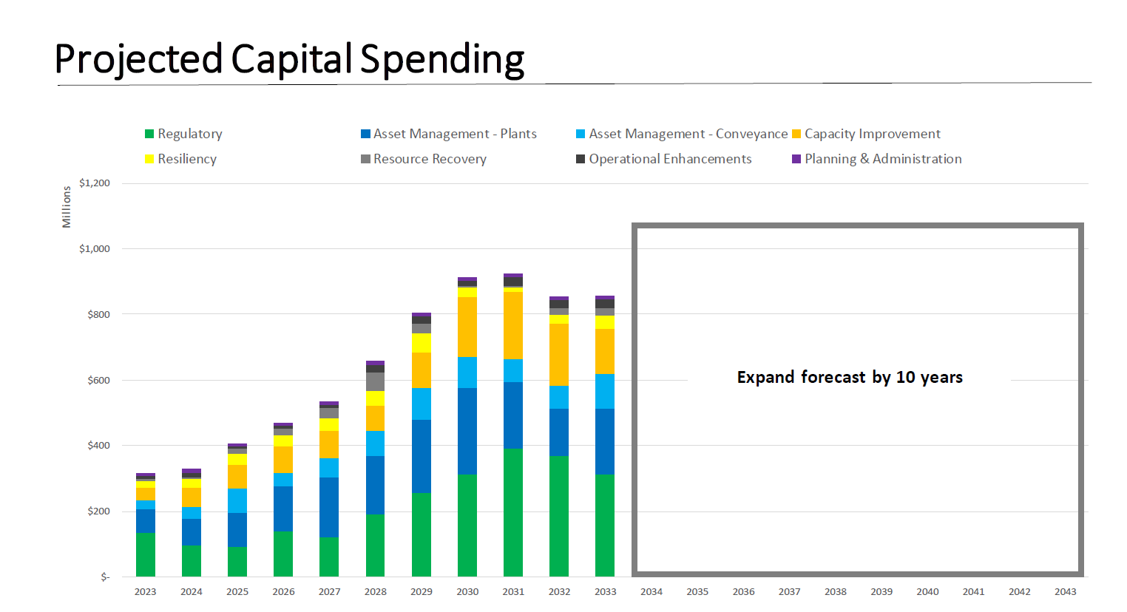

Asset Management as a Category of Capital Improvement. For WTD, asset management refers to the planning, design, procurement, refurbishment or replacement of existing sewer lines, equipment, and structures at the County’s wastewater treatment facilities and infrastructure. WTD uses an asset management software to predict the lifecycle of assets and then applies measurable criteria to prioritize asset management projects. WTD notes there is a large amount of uncertainty in the asset management outlook for differences in asset condition versus expected engineered life. Additionally, longer term asset data is not yet formulated into capital project scope with project-level cost estimates.

As part of WTD’s initial planning work for the Clean Water Plan, the update to the Regional Wastewater Services, WTD did begin working to forecast asset management costs out to 2060. This initial forecast which WTD intends to update is shown below.

FIGURE 2
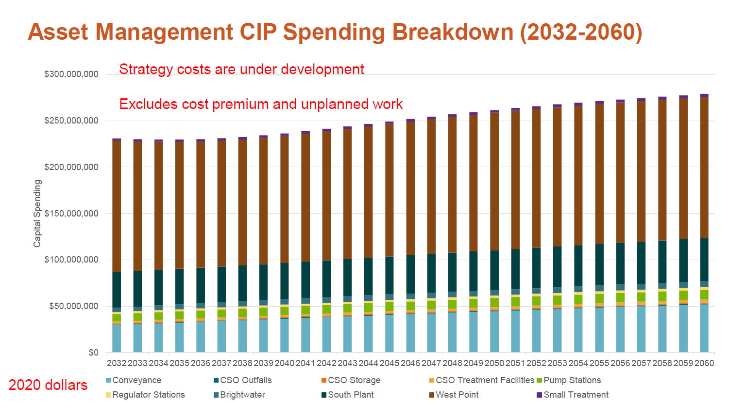

RWQC Work Program Calls for Review of Long-Term Sewer Rates. The RWQC 2023 work program includes addressing long-sewer rate projections. The first sub-topic in the work program under addressing long-term sewer rates is long-term capital improvements because capital improvements needed for regulatory purposes, growth capacity, and asset management are a primary driver of the increasing sewer rates.

RWQC Role in Developing Legislation. Section 270.30 of the King County Charter and K.C.C. 1.24.065 allow for regional committees to develop and propose legislation for introduction to the King County Council. For legislation to be introduced to the County Council, the RWQC needs to vote to approve the motion and then the Chair of the RWQC could then sponsor the legislation on behalf of RWQC. The legislation would then be referred to a standing committee following the normal course of referrals. The proposed legislation would not be subject to a dual referral.

Action by a standing or the Council (if the proposed legislation is acted on by the Council without referral to a standing committee or is pulled from a standing committee) must occur within 120 days of the first reading and referral. If the Council amends the legislation as was originally introduced from RWQC, the amended legislation is referred back to RWQC for “further review and recommendation.” However, once the RWQC’s review and recommendation is completed and the legislation is referred by to the Council, another round of rereferral to RWQC is not required.

ANALYSIS

The proposed draft motion includes the following substantive provisions:

Forecast Methodology Requested.
- Lines 69-72 of the proposed draft motion request the Wastewater Treatment Division research and identify at a high level, methodologies to forecast the long-term financial investments for its capital improvements and to seek comment on the methodologies from the Metropolitan Water Pollution Abatement Advisory Committee (MWPAAC).

The words “high level” were added at the request of WTD. Council staff have asked WTD for further clarification on the intent of this addition.

Forecast Requirements.
- Lines 72-74 specify that the forecast should include, but not be limited to the following capital improvement categories, asset management; capacity improvements; and known and potential regulatory requirements.

- Lines 74-77 includes language which recognizes that forecasts beyond the standard six-year capital improvement program will have increasing levels of uncertainty with each year.

- Lines 77-81 specifies the recommended methodologies should allow for forecast periods of 20, 50, and up to 75 years. The methodology should also allow for changes in various assumptions including growth capacity and known and projected regulatory requirements such that forecast scenarios can be compared with different assumptions.

Implementation.
- Lines 82-85 specify the implementation of long-range forecasting beyond 20 years should occur during the update to the Regional Wastewater Services Plan. This update was started in 2019 and has been on pause but WTD expects it to restart again in 2023. Council staff have asked WTD if the RWSP update process is delayed longer than anticipated, will long range capital improvement forecasting be able to be implemented without an update to the RWSP.

- The proposed legislation does not request WTD implement the methodology at a particular time. At the time at which WTD presents its recommended methodology to RWQC, if RWQC supports the methodology, the committee may wish to specify a timeline by which it would like to see the capital improvement investment forecast implemented.

- Lines 85-86 also specify that WTD may adopt revisions to the identified methodologies during the implementation of any forecast beyond twenty years.

Timing.
- Lines 87-91 request WTD to provide a status update briefing to RWQC in September 2023 and by December 2023 to brief RWQC on the recommended methodologies for forecasting the long-term financial investments for capital improvements.

- If approved by RWQC today, the deadline to be added to the July 18th Council agenda is July 13th at 10 am. Alternatively, Councilmember Balducci could request at the July 11th County Council meeting that this motion be added to the Council’s agenda for that day. The motion would then be referred to one of the Council’s standing committees for consideration. Depending on the committee’s schedule, this legislation may not be adopted by the Council until after September 2023. The Council also has the option to suspend the rules and take action without referral to committee.

INVITED

- Kamuron Gurol, Director, WTD
- Crystal Fleet, Capital Portfolio Planning and Analysis Unit Manager, WTD
- Devin ViBarnes, Rates, Capital, and Debt Manager, WTD

ATTACHMENTS

- Proposed Draft Motion 2023-XXXX
- 2023-2024 WTD Capital Improvement Plan

Prepared by WTD and included in April 5, 2023 Presentation to RWQC
Prepared by WTD and included in October 21, 2021 presentation to MWPAAC

