Lease Property Summary
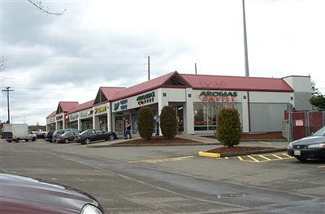

Property Owner: Curran Properties/Fairwood Square, LLC.
Address: 17620 140th Avenue South East, C-10, Renton, Washington
Cost Per Sq. Ft.: $1.33
Operational Costs: None
Term: Three years
Square Footage: 1,000 square feet
Council District: Nine
Funding Source: General Fund
Previous Location: Second amendment of lease at this location.

Lease Synopsis:
King County Sheriff's Office (KCSO) is renewing its lease for the office space located at 17620 140th Ave Southeast, C-10, Renton, Washington, in the Fairwood Square. This will be the second amendment to the original lease agreement signed May 1, 2005. There are no tenant improvements required for this location. Maintaining this office location encourages safe communities and provides quick response times to service calls in King County's unincorporated areas.

Context
The second amendment of the retail space includes square footage, current and renewal terms, and rent. This agreement is for a three year term with the option to automatically extend the term for three consecutive one year periods.

Rationale for transaction: Amending this lease provides King County Sheriff's Office a competitively priced retail space in the Fairwood area (Southeast King County).

Policy considerations: The continued leasing of this retail space in Fairwood Square will allow the County to avoid costs associated with moving and maintains a centralized location for KCSO to promote public engagement and establish a culture of customer service in response to the communities needs.

Community considerations
or partnerships: The landlord and the community support the proactive law enforcement presence in the Fairwood neighborhood.

Fiscal considerations: This transaction represents an increase from the previous lease agreement. A Net Present Value analysis was not performed because it was determined that staying at the current location represents a good value. King County is receiving a security presence credit of $833 per month for a savings of $28,988 over a 36 month period. Additionally, there are no operating expenses associated with this lease and no parking charges. Upon approval by the King County Council, the lease amendment will be extended for three years effective as of January 1, 2015, and will expire on December 31, 2017.

Other considerations: This three year lease term shall be automatically extended for three consecutive one year periods (each Renewal Term) unless a written notice is given to the landlord of its election not to extend the lease by no later than September 1, 2017 in the case of the first renewal term, by September 1, 2018 in the case of the second renewal term and by September 1, 2019 in the case of the third renewal term. If King County does not notify the landlord of its election not to extend for a renewal term on a timely basis, then the lease shall be extended for that renewal term on the same terms and conditions as written in the amendment.

CIP/operational impacts: Continuing operation at this location saves moving costs and other charges associated with relocation.

King County Strategic Plan impact: This transaction supports the strategic plan goals of keeping people safe in their homes and communities, exercising good financial stewardship, planning for the long-term sustainability of county services, and service excellence of delivering services that are responsive to community needs.

Equity and Social Justice impact: This amendment will enable KCSO to continue to provide service to citizens who live far from the metropolitan centers of King County.

Energy Efficiency impact: The Fairwood neighborhood precinct has a positive energy efficiency impact by reducing travel time for King County Deputies and unincorporated residents in the area.

Lease Alternatives Analysis
Summary: Since this is an amendment to the current lease with a discounted rate and no operational and maintenance costs, no other lease sites were considered.

Vicinity View Map
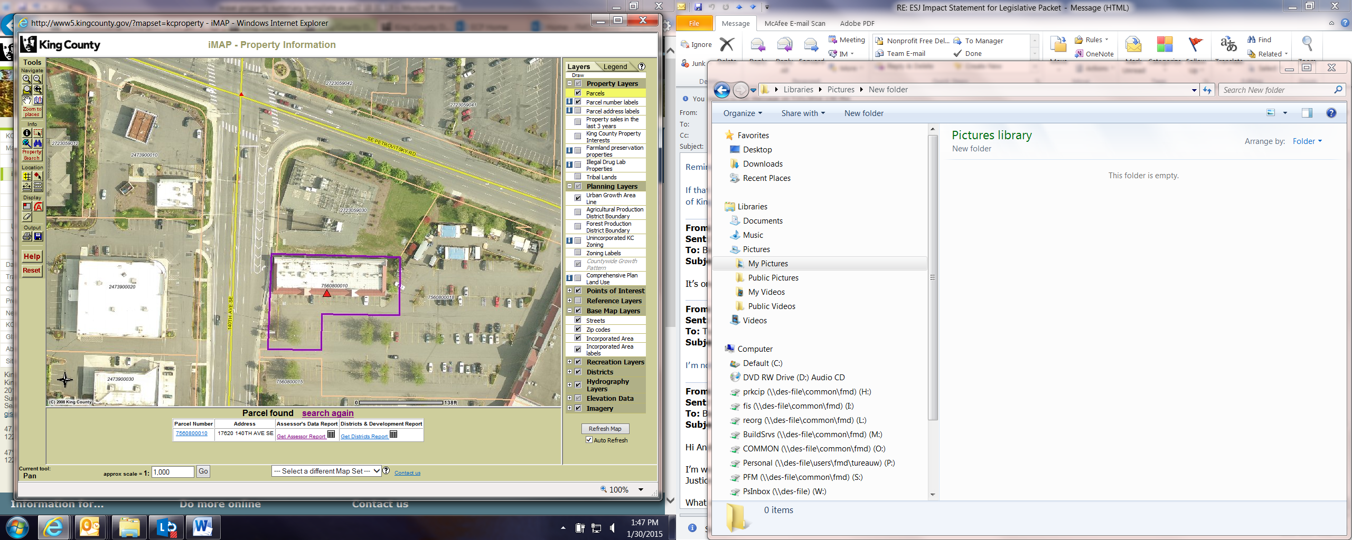

Parcel Map
