STAFF REPORT

Agenda Item: | 10 | Name: | Sherrie Hsu
Proposed No.: | 2022-0180 | Date: | June 1, 2022

SUBJECT

An ordinance to submit a charter amendment to the voters to move elections for county executive, county assessor, county director of elections, and county councilmembers to even-numbered years.

SUMMARY

Proposed Ordinance 2022-0180 would place on the November 2022 election ballot a charter amendment to move elections for county executive, county assessor, county director of elections, and county councilmembers from odd-numbered to even-numbered years.

Each of these county positions was most recently elected in an odd-numbered year (2019 or 2021) for a four-year term (ending 2023 or 2025). For each position, the proposed charter amendment would change the following term only to a three-year term (2023-2026 or 2025-2028) to move to an even-numbered year schedule. Subsequent terms, starting in 2026 and 2028, would again be four-year terms.

To place this potential charter amendment on the November 8, 2022 ballot, the last regular Council meeting date for adoption as a non-emergency is July 19, 2022. The deadline for Elections to receive the effective ordinance is August 2, 2022.

BACKGROUND

General elections in Washington State. Every November, the state holds a statewide general election. In even-numbered years, general elections include the following:
- federal, state, and county officers; and
- state or local ballot measures such as initiatives, referenda, and constitutional amendments.

In odd-numbered years, general elections are limited to the following:
- city, town, and special district officers;
- federal, state, and county officers, state legislators, supreme court justices, and superior court judges to fill the remainder of unexpired terms;
- county officers in a county governed by a charter that provides for odd-year elections; and
- state ballot measures.

By default, in Washington county officer elections are held in even-numbered years, with an exception for counties governed by a charter that provides for odd-year elections. King County is a home rule charter county governed by a charter that currently provides for odd-year elections.

Election of county officers in King County. Elections for the following county offices are outlined in Article 6 of the King County Charter.
- County Executive and County Assessor. Under Section 640, the county executive and county assessor have been elected every four years – since 1971 for the county assessor and since 1973 for the county executive.
- County Director of Elections. Under Section 647, the county director of elections has been elected every four years since 2011.
- County Councilmembers. Under Section 650, the county councilmembers have been elected every four years, since 1971 for even-numbered districts and since 1973 for odd-numbered districts.

The remaining county elected office, the prosecuting attorney, is a position created by state law. The position is currently elected in even-numbered years, most recently in 2018, and serves four-year terms.

Other elections administered by King County Elections. The King County Elections department administers elections countywide for federal, state, judicial, and local positions, along with state and local ballot measures.

Table 1 summarizes the current election schedule.

Table 1. Current Election Schedule for Offices and Measures in King County

Even Year Ballot | Odd Year Ballot
U.S. President  U.S. House of Representatives  U.S. Senate  State Governor  State Lieutenant Governor  State Attorney General  Secretary of State  State Superintendent of Public Instruction  State Commissioner of Public Lands  State Treasurer  State Auditor  State Insurance Commissioner  State House of Representatives  State Senate  State Supreme Court  Court of Appeals  King County Superior Court  County Prosecuting Attorney  Local ballot measures  Seattle Municipal Court | County Executive  County Assessor  County Director of Elections  County Councilmembers  Court of Appeals  Port of Seattle Commissioners  City and town officers  School district officers  Special district officers
Even or Odd Year Ballot
State ballot measures
Special elections
Recall elections

Proposed House Bill 1727. In the 2022 State legislative session, House Bill 1727 was introduced, which would have eliminated the statewide general election in odd-numbered years, except for limited circumstances, including special elections and local government elections for jurisdictions that choose to maintain odd-numbered-year elections until 2028. The proposed substitute house bill advanced out of committee but ultimately was not passed.

Other counties in Washington. Of the seven home rule charter counties in Washington, King, Snohomish, and Whatcom counties hold elections for county officers in odd-numbered years.

ANALYSIS

Proposed Ordinance 2022-0180 would place on the November 2022 general election ballot a charter amendment to move elections for the following county offices from odd-numbered to even-numbered years:
- County Executive
- County Assessor
- County Director of Elections
- County Councilmembers in all nine districts

Each of these positions was most recently elected in an odd-numbered year (2019 or 2021) for a four-year term. For each position, the proposed charter amendment would change the following term only to a three-year term (2023-2026 or 2025-2028) to move to an even-numbered year schedule. Subsequent terms, starting in 2026 and 2028, would again be four-year terms.

The remaining county elected office, the Prosecuting Attorney, is already elected in even years.

Revisions to Charter. The proposed charter amendment would change the following sections of the King County Charter:

County Executive and County Assessor. In Section 640, the proposed charter amendment would change the election of county assessor to 2023 and county executive to 2025 for three-year terms, then in even-numbered years starting with 2026 for the county assessor and 2028 for the county executive, and every four years after.

County Director of Elections. In Section 647, the proposed charter amendment would change the election of the county director of elections to 2023 for a three-year term, then in even-numbered years starting with 2026, and every four years after.

County Councilmembers. In Section 650, the proposed charter amendment would change the election of county councilmember offices as follows:
- For districts 2, 4, 6, and 8, change the election in 2023 to a three-year term, then hold elections in even-numbered years starting in 2026 and every four years after;
- For districts 1, 3, 5, 7, and 9, change the election in 2025 to a three-year term, then hold elections in even-numbered years starting in 2028 and every four years after.

Table 2 shows changes to the election schedule under the proposed charter amendment.

Table 2. Summary of Changes under Proposed Charter Amendment

County Office | Year Elected | Current Term End | Next Term Under Current Charter  (4 Years) | Next Term with Proposed Charter Amendment  (3 Years) | Subsequent Terms
Assessor | 2019 | 2023 | 2023 – 2027 | 2023 – 2026 | 4 Years
Executive | 2021 | 2025 | 2025 – 2029 | 2025 – 2028 | 4 Years
Director of Elections | 2019 | 2023 | 2023 – 2027 | 2023 – 2026 | 4 Years
CM District 1 | 2021 | 2025 | 2025 – 2029 | 2025 – 2028 | 4 Years
CM District 2 | 2019 | 2023 | 2023 – 2027 | 2023 – 2026 | 4 Years
CM District 3 | 2021 | 2025 | 2025 – 2029 | 2025 – 2028 | 4 Years
CM District 4 | 2019 | 2023 | 2023 – 2027 | 2023 – 2026 | 4 Years
CM District 5 | 2021 | 2025 | 2025 – 2029 | 2025 – 2028 | 4 Years
CM District 6 | 2019 | 2023 | 2023 – 2027 | 2023 – 2026 | 4 Years
CM District 7 | 2021 | 2025 | 2025 – 2029 | 2025 – 2028 | 4 Years
CM District 8 | 2019 | 2023 | 2023 – 2027 | 2023 – 2026 | 4 Years
CM District 9 | 2021 | 2025 | 2025 – 2029 | 2025 – 2028 | 4 Years

Repealed Sections. The proposed charter amendment would repeal the following sections:
- Section 650.40.15, "Districting in 2004": This was a transitional provision, related to elections in 2004, that no longer applies.
- Section 650.40.25, "Elections and terms of office for 2004 and thereafter": This was a transitional provision, related to elections from 2005 through 2007, that no longer applies.
- Section 660, "Commencement of terms of office": This section references county officer office terms commencing on the date "specified by general law for public officers elected at city general elections," which according to RCW 29A.04.330 would be in odd-numbered years.

Cost considerations. This section summarizes potential cost considerations.

Operational costs. Elections staff indicate that moving county officer elections from odd to even years would not directly result in operational changes or costs for the department.

Elections staff believe it is unlikely that this proposed change would impact turnout in even or odd years, and therefore unlikely that it would impact staffing and costs. In even years, the department would continue to administer elections for federal, state, and county races and ballot measures. In odd years, the department would continue to administer elections for over 191 jurisdictions, including city, town, and special district officers; state ballot measures; special elections; and recall elections.

Elections staff note that the only potential operational change or cost would be if moving to even year elections resulted in two-page ballots. Administering two-page ballots would incur additional costs from printing, storage space for ballots, and staff time to sort through boxes. Data does not show that moving to even year elections would necessarily result in two-page ballots. According to Elections staff, historically, odd year ballots have been more likely to become a two-page ballot due to the number of ballot items. To date, there has not been a need for a two-page ballot.

Table 3 summarizes the total number of ballot items in recent general elections. The exact number of contests on a given ballot varies based on a voter's jurisdiction.

Table 3. Total Ballot Items in General Elections, 2016-2021

 | Total Races | Total Measures | Total Number of Contests
2016 General | 68 | 30 | 98
2017 General | 334 | 12 | 346
2018 General | 90 | 17 | 107
2019 General | 324 | 28 | 352
2020 General | 64 | 22 | 86
2021 General | 332 | 15 | 347

Allocation of election costs among county, state, and local jurisdictions. Election costs are divided proportionally (based on number of registered voters) across jurisdictions appearing on a given ballot. The allocation of costs would shift if moving county officer elections to even years changes whether or not the county appears on the ballot.

Table 4 summarizes the potential fiscal impact if county office elections had been held in even years, rather than odd years, since 2009.

Fiscal impacts to county. Moving county officer elections from odd to even years would have a fiscal impact to the county in even years if the county would otherwise have no races or measures on the ballot.
- Since 2009, there have been two elections when holding county officer elections in even years (rather than odd years) would have had an impact to the General Fund – the 2016 and 2020 primary elections. In Table 4, these are highlighted in blue.
- In these even-year elections, the county did not have any races or measures on the ballot. If county officer elections had taken place that year (rather than in an odd year), there would have been an additional cost to the county: $1.6 million in 2016; $2.6 million in 2020. There would also be corresponding cost decreases to local districts and to the state due to the re-allocation of costs.

Fiscal impacts to local jurisdictions. Elections staff note that if the county does not run a ballot measure in odd years, local jurisdictions may see an increase to their election costs since there would be no county races or measures.
- Since 2009, there have been three elections when holding county officer elections in even years (rather than odd years) would have increased costs to local jurisdictions – the 2009 primary, 2011 general, and 2015 primary elections. In Table 4, these are highlighted in orange.
- In these odd-year elections, the county did not run a ballot measure and only ran county officer races. If county officer races had instead been held in even years, the county would not have had any races or measures on the ballot. An additional cost would have been passed along to local jurisdictions: approximately $690,000 in the 2009 primary; $860,000 in the 2011 general; $880,000 in the 2015 primary, divided among jurisdictions proportionally. The cost to the county would decrease in those years due to the re-allocation of costs, and the cost to the state would increase.

Table 4. King County Races and Measures on Ballots, 2009-2021

Election | Even/ Odd | County Race | County Measure | County on Ballot | Fiscal impact if county officer elections held in even year instead of odd year
Primary 2009 | Odd | ✓ |  | Yes | Cost decrease to county $1.1M  Cost increase to local districts $690,000  Cost increase to state $370,000
General 2009 | Odd | ✓ | ✓ | Yes | No impact
Primary 2010 | Even | ✓ |  | Yes | No impact
General 2010 | Even | ✓ | ✓ | Yes | No impact
Primary 2011 | Odd | ✓ | ✓ | Yes | No impact
General 2011 | Odd | ✓ |  | Yes | Cost decrease to county $1.1M  Cost increase to local districts $860,000  Cost increase to state $200,000
Primary 2012 | Even |  | ✓ | Yes | No impact
General 2012 | Even | ✓ |  | Yes | No impact
Primary 2013 | Odd | ✓ | ✓ | Yes | No impact
General 2013 | Odd | ✓ | ✓ | Yes | No impact
Primary 2014 | Even | ✓ |  | Yes | No impact
General 2014 | Even | ✓ |  | Yes | No impact
Primary 2015 | Odd | ✓ |  | Yes | Cost decrease to county $900,000  Cost increase to local districts $880,000  Cost increase to state $21,000
General 2015 | Odd | ✓ | ✓ | Yes | No impact
Primary 2016 | Even |  |  | No | Cost increase to county $1.6M  Cost decrease to local districts $570,000  Cost decrease to state $1.0M
General 2016 | Even |  | ✓ | Yes | No impact
Primary 2017 | Odd | ✓ | ✓ | Yes | No impact
General 2017 | Odd | ✓ | ✓ | Yes | No impact
Primary 2018 | Even |  | ✓ | Yes | No impact
General 2018 | Even | ✓ |  | Yes | No impact
Primary 2019 | Odd |  | ✓ | Yes | No impact
General 2019 | Odd | ✓ | ✓ | Yes | No impact
Primary 2020 | Even |  |  | No | Cost increase to county $2.6M  Cost decrease to local districts $170,000  Cost decrease to state $2.4M
General 2020 | Even |  | ✓ | Yes | No impact
Primary 2021 | Odd | ✓ | ✓ | Yes | No impact
General 2021 | Odd | ✓ | ✓ | Yes | No impact

Policy considerations. Below are potential policy considerations for Council in deliberating the proposed ordinance.

Voter turnout. Over the last 20 years, King County has seen higher voter turnout in even-numbered years, as shown below. Since 2010, the county's average voter turnout rate is 77% in even-numbered years, and 47% in odd-numbered years.

If past trends hold, moving these county officer elections from odd-numbered to even-numbered years would likely result in higher voter turnout for these county officer elections. Whether Council wants to increase voter turnout for the election of these county offices is a policy decision for the Council to make.

Historical King County Voter Turnout: General Elections
Voter turnout demographic data. Voter turnout data is available from King County Elections by precinct. In 2020, voter turnout was over 70% in almost every precinct, with some precincts in the 61-70% range. In 2019, voter turnout varied across all ranges across the county. Voter turnout data is not available by other demographic characteristics.

King County Voter Turnout by Precinct: 2020 General Election
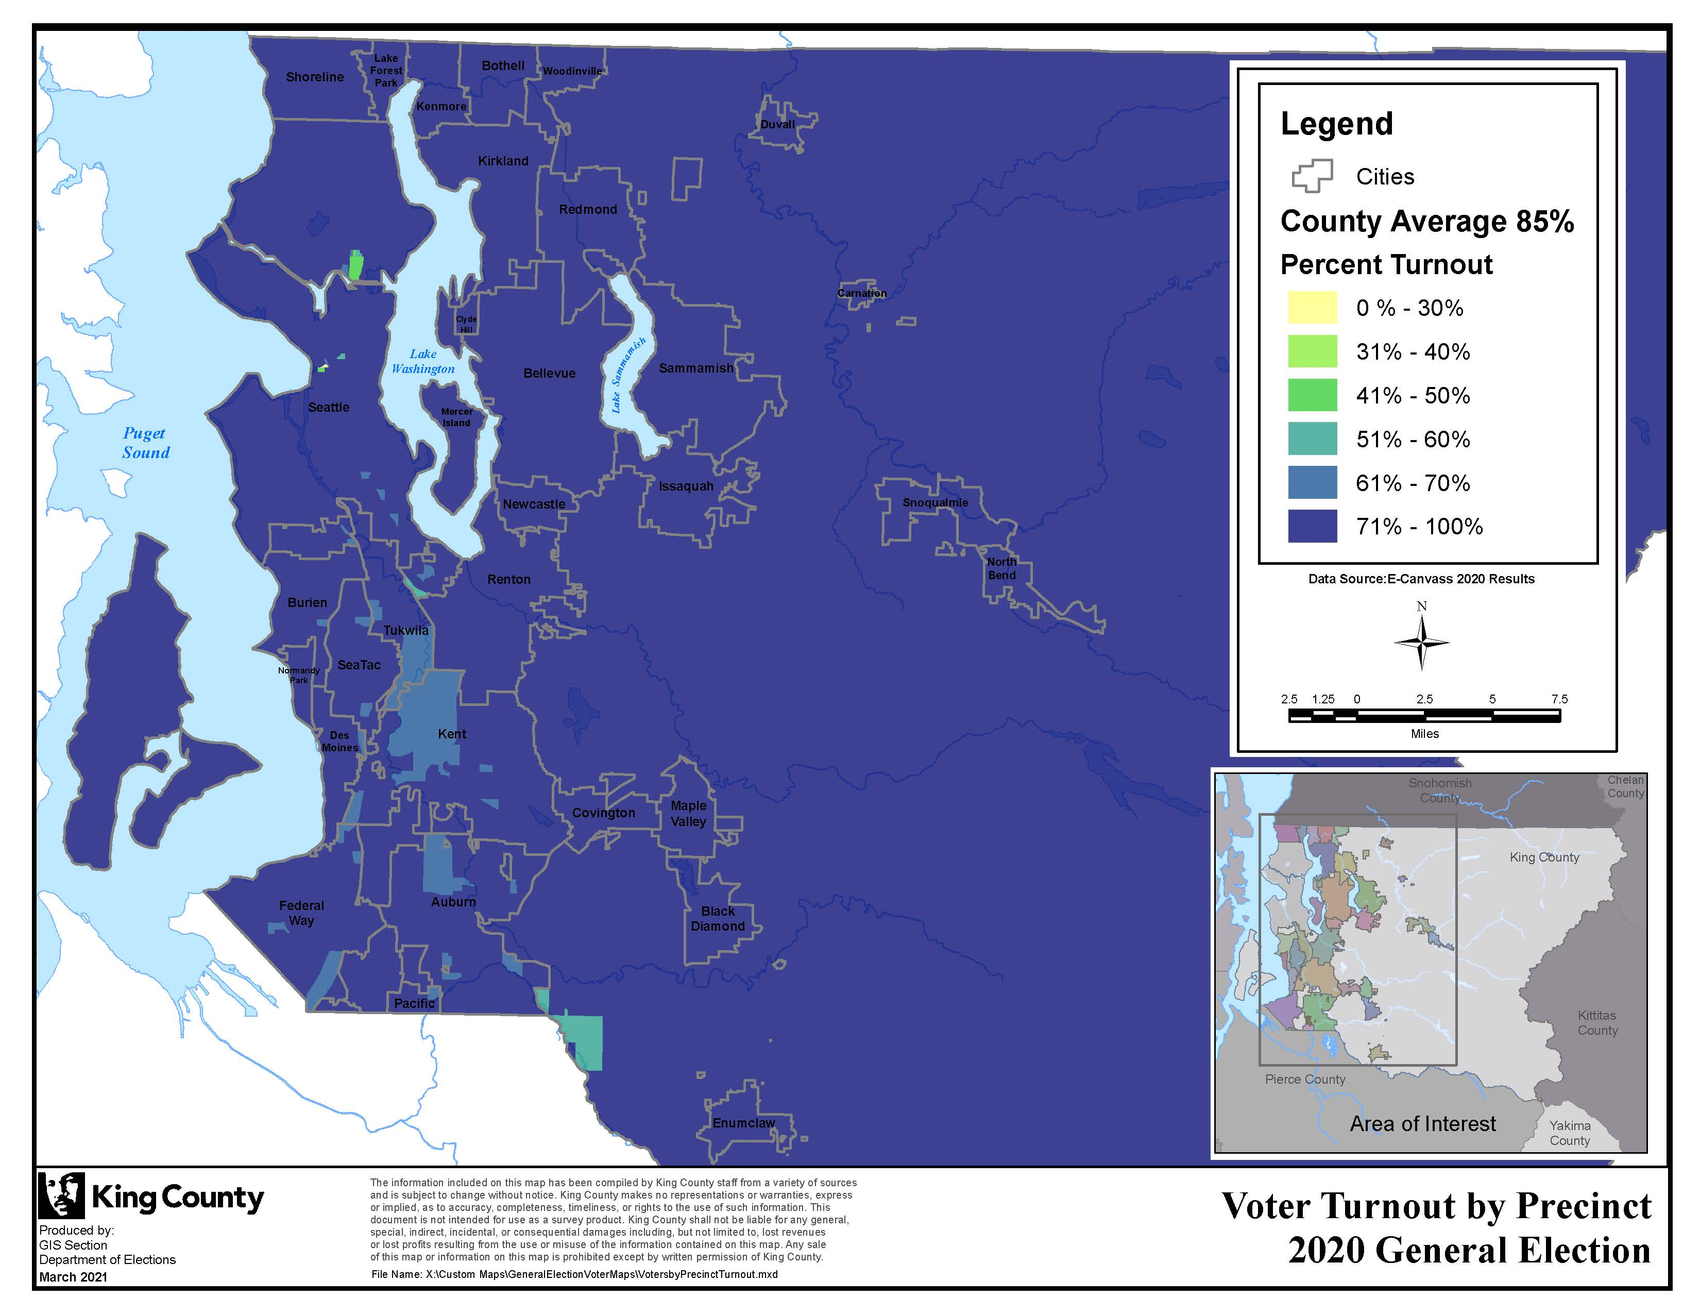

King County Voter Turnout by Precinct: 2019 General Election
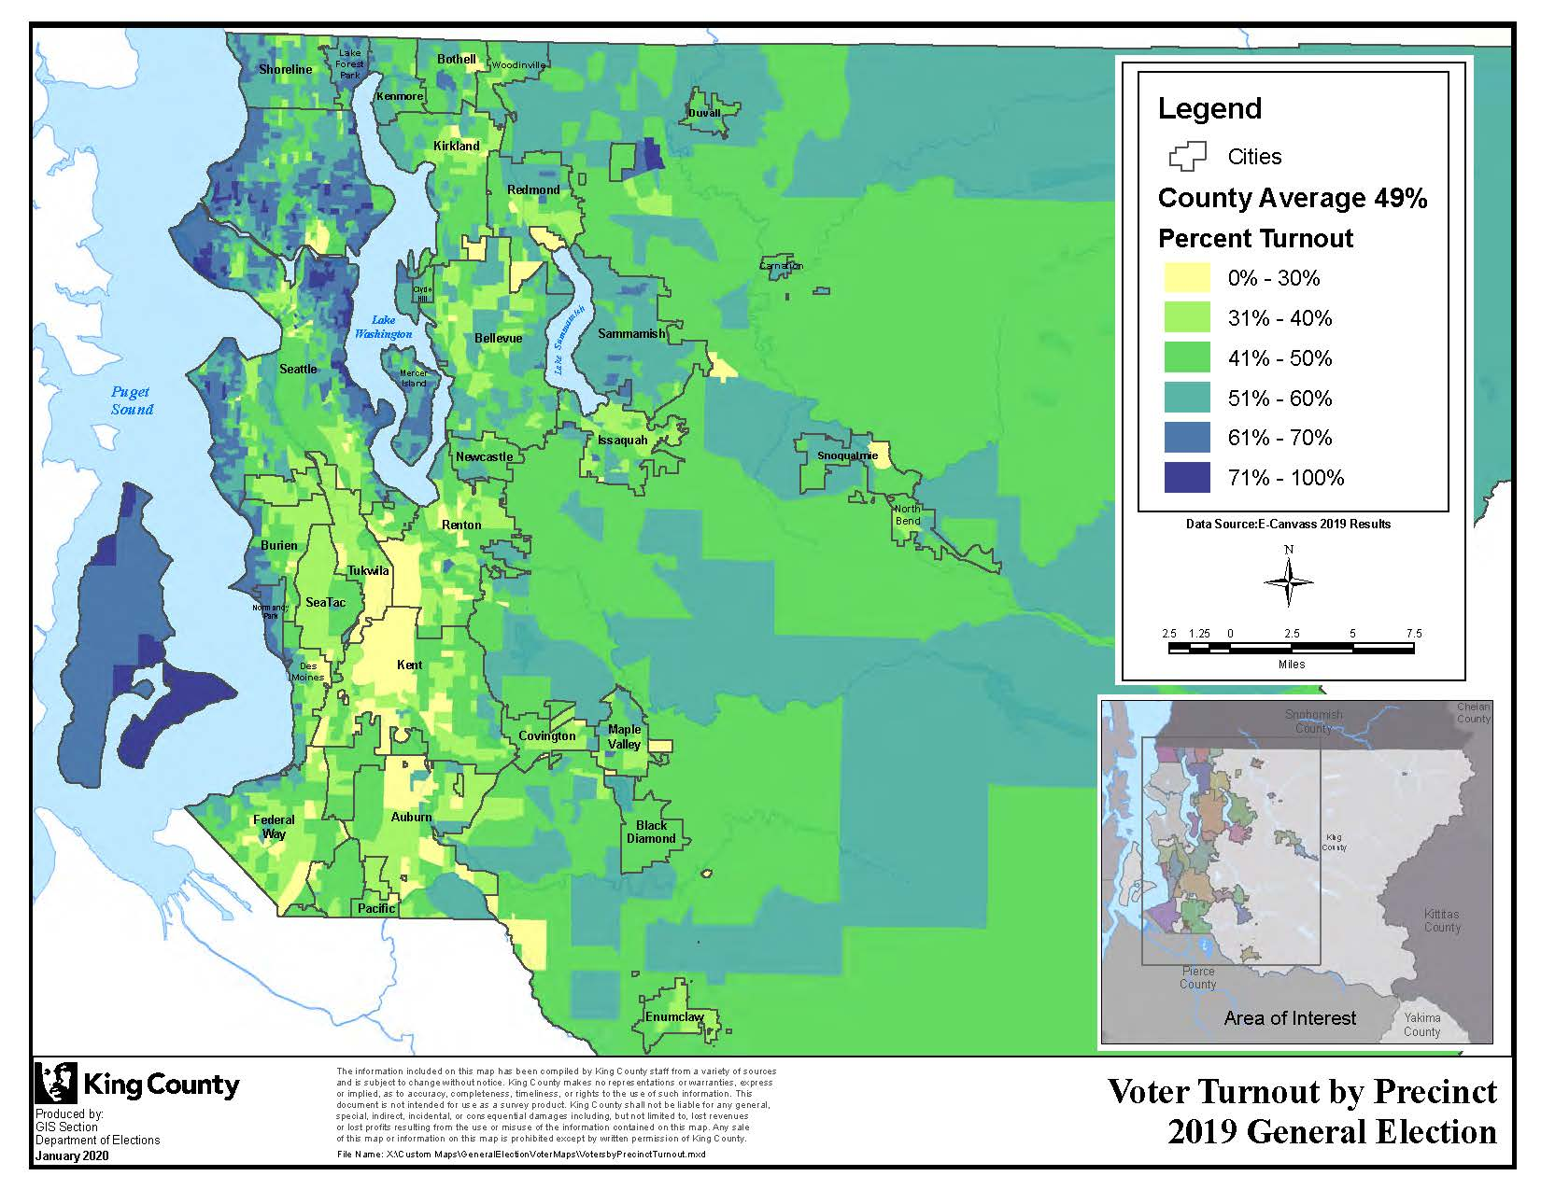

Impacts to odd-year voter turnout. Data does not suggest that holding county officer elections in even years, rather than odd years, would impact odd-year turnout. Table 5 compares voter turnout in the seven home rule charter counties during the 2021 general and primary elections. There is no clear trend distinguishing voter turnout across counties holding county officer elections in even years (Clallam, Clark, Pierce, San Juan) compared with those holding county officer elections in odd years (King, Snohomish, and Whatcom).

Table 5. 2021 General and Primary Election Voter Turnout

County | County Officer Elections | Voter Turnout: 2021 General Election | Voter Turnout: 2021 Primary Election
Clallam | Even-year | 48% | 37%
Clark | Even-year | 35% | 25%
King | Odd-year | 44% | 35%
Pierce | Even-year | 32% | 23%
San Juan | Even-year | 57% | 50%
Snohomish | Odd-year | 36% | 27%
Whatcom | Odd-year | 49% | 34%

Number of contests on ballots. Moving these county officer elections to even years would increase the number of contests on even-year ballots and reduce the number of contests on odd-year ballots.

It is unclear to what extent voter response rates are impacted by ballot length, ballot position, or voter interests in the types of races or measures. As two sample points, in the November 2020 general election, the first countywide item was a referendum with a response rate of 82%; the furthest down countywide position on the ballot was a Superior Court position with a response rate of 69%. In the November 2021 general election, the first item was a state advisory vote with a response rate of 41%; the furthest down countywide position on the ballot was a Port of Seattle position with a response rate of 39%.

Alignment with federal and state elections. The proposed ordinance would align the election schedule of these county offices with federal and state elections, which are held during even years. This means county officer elections would take place in a different electoral context. It is difficult to conclude exactly how this would impact interest in or the nature of county officer elections. Whether the Council desires to align county officer elections with federal and state elections is a policy decision for the Council.

Timing considerations. Proposed Ordinance 2022-0180 was introduced and referred to the Committee of the Whole on May 12, 2022. To place this potential charter amendment on the November 8, 2022 ballot, the last regular Council meeting date for adoption as a non-emergency is July 19, 2022. The deadline for Elections to receive the effective ordinance is August 2, 2022.

If approved by voters, the charter amendment would take effect 10 days following certification of election results, unless a later date is specified in the amendment.

INVITED

- Julie Wise, Director, Department of Elections
- Kendall Hodson, Chief of Staff, Department of Elections

ATTACHMENTS

- Proposed Ordinance 2022-0180

An ordinance adopting a charter amendment is not subject to Executive veto, so the legislation is effective ten days after the Council adopts it.
RCW 29A.04.321
State ballot measures must appear on the next regular general election, so they may appear in either even- or odd-numbered years. Special elections and recall elections may occur in either even- or odd-numbered years.
RCW 36.16.010; RCW 29A.04.321
Home rule charter counties adopt a charter to provide their own forms of government that may differ from the commission form prescribed by state law.
Chapter 36.27 RCW; King County Charter Section 649
Other exceptions would have been: special elections called for any purpose authorized by law; elections for recall of a public officer; public utility districts, conservation districts, or district elections at which property; ownership is a prerequisite to voting; consolidation proposals and non-high capital fund aid proposals; and special flood control districts consisting of three or more counties.
Clallam, Clark, King, Pierce, San Juan, Snohomish, Whatcom; MRSC: County Forms of Government.
Figures are rounded to two significant digits.
Figures are rounded to two significant digits.
Figures are rounded to two significant digits. Assumes odd year county officer elections would be moved to the following even year (for example, the 2009 primary would instead be during 2010 primary).
Voter turnout is defined as the ratio of ballots returned to active registered voters. In the 2021 general election, there were 1,400,321 active registered voters and 616,085 ballots returned, for a voter turnout rate of 44%.
https://kingcounty.gov/depts/elections/elections/maps/voter-turnout.aspx
An ordinance adopting a charter amendment is not subject to Executive veto, so the legislation is effective ten days after the Council adopts it.
King County Charter Section 800

