Overview of the Proposed Combined Sewer Overflow (CSO) First Material Modification to the 2013 Consent Decree Between King County, Washington State Department of Ecology, and United States Environmental Protection Agency

June 2024

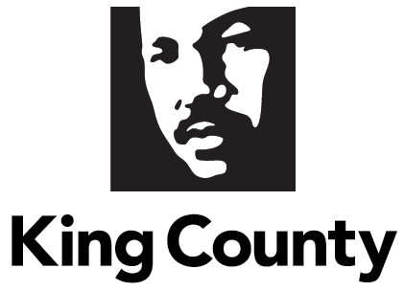

- Contents
II. Summary 3
III. Background 4
IV. 2013 Consent Decree and 2016 Non-Material Modification 6
V. Proposed First Material Modification to Consent Decree 9
VI. Remaining Project Costs and Rate Impacts 13
VII. Conclusion 15

Summary
In 2013, the United States Environmental Protection Agency (EPA) and the Washington State Department of Ecology (Ecology) filed a lawsuit alleging King County (County) violated Sections 301 and 402 of the Clean Water Act and the conditions and limitations of the County’s West Point Treatment Plant National Pollutant Discharge Elimination System (NPDES) permit issued to the County by Ecology. The alleged violations related to the quality of the effluent released from combined sewer overflow (CSO) wet weather treatment stations that act as satellite treatment plants to the West Point Treatment Plant (West Point) and multiple unauthorized discharges from King County’s combined sewer system. In response, King County, without admitting any liability related to the alleged violations, entered into a Consent Decree with EPA and Ecology. King County approved Ordinance 17514, authorizing the King County Executive to execute the federal CSO Consent Decree, which took effect in July 2013.

The 2013 Consent Decree obligates King County and the Department of Natural Resources and Parks (DNRP), through its Wastewater Treatment Division (WTD), to complete a series of CSO control projects by 2030. The projects listed in the 2013 Consent Decree were based on WTD’s 2012 Long-term CSO Control Plan Amendment approved by King County in September 2012 (Ordinance 17413). In addition, the 2013 Consent Decree directed the following:

- Implementation of CSO control projects already in design prior to the Consent Decree,
- Improvements in operations of existing CSO wet weather treatment stations to meet effluent standards,
- Reporting regarding progress towards the Consent Decree objectives, post-construction monitoring, etc.,
- Dispute resolution procedures, and
- Stipulated penalties for non-compliance.

The 2013 Consent Decree also directed King County to pay a $400,000 civil penalty split between EPA and Ecology. The City of Seattle (Seattle) entered into a separate Consent Decree in July 2013, to address alleged Clean Water Act violations associated with discharges from Seattle’s CSOs.

In 2016, a federal court approved a non-material modification to the 2013 Consent Decree. The non-material modification enabled the County to combine two of its projects with three Seattle projects into a single joint-project, known as the Ship Canal Water Quality Project.

In 2019, King County and Seattle requested to enter negotiations with EPA and Ecology to modify their respective 2013 Consent Decrees due to several changed conditions. In mid-2024, King County, Ecology, and EPA reached agreement in principle on the proposed First Material Modification to the County’s 2013 Consent Decree (First Material Modification). The First Material Modification extends the compliance milestones for the remaining CSO control projects and extends the County’s overall compliance schedule from 2030 to 2037. Additionally, the First Material Modification updates design criteria for future projects, obligates the County to complete a sewer system optimization study with Seattle, updates some reporting requirements, clarifies post-construction monitoring periods, and clarifies flexibility to change design specifications for future projects, if necessary. Seattle, Ecology, and EPA also reached agreement in principle on a material modification of Seattle’s Consent Decree that, among other changes, also extends Seattle’s overall compliance schedule to 2037.

The First Material Modification to King County’s Consent Decree maintains the overall goal of the 2013 Consent Decree to ensure the CSOs at King County’s outfalls occur on average only once per year, based on a 20-year moving average, and the effluent discharged from CSO wet weather treatment stations meets applicable NPDES discharge standards.

By King County agreeing to the First Material Modification, the Consent Decree will reflect updated project design specifications to achieve the regulatory and Consent Decree goals for CSO control and extend the overall compliance date to 2037 to complete the remaining projects. Stipulated penalties (with payments to EPA and Ecology) remain in place should King County fail to comply with the provisions of the Consent Decree and the First Material Modification.

The benefits of the First Material Modification include more time to build the larger projects necessary to achieve compliance and help with ratepayer affordability. The First Material Modification provides flexibility to adjust project size to handle larger, more frequent storms resulting from climate change. The remaining CSO projects are also re-sequenced to begin the Mouth of the Duwamish project, ahead of the University and Montlake CSO projects, thus prioritizing investments in underserved communities.

Background

With a service area encompassing over 424 square miles, King County provides regional wastewater treatment services in King County and parts of Pierce and Snohomish Counties. The County’s major wastewater treatment facilities include:

- Three regional treatment plants located in Seattle (West Point Treatment Plant), in Renton (South Plant), and near Woodinville (Brightwater Treatment Plant),
- Two smaller local treatment plants at Vashon Island and Carnation,
- 397 miles of conveyance lines,
- 48 pump stations,
- 25 regulator stations,
- Five CSO wet weather treatment stations (WWTSs), and
- 38 CSO outfalls.

The County’s combined sewer system is located within the City of Seattle. A combined sewer system means that wastewater and stormwater flow into the same pipe and are delivered to a treatment facility. This is in contrast to a separated system, in which wastewater and stormwater have separate pipes and only the wastewater is delivered to the treatment facilities. The County’s service area outside of Seattle is a separated system.

The County serves as a wholesale provider of wastewater treatment to 34 local sewer agencies. The local sewer agencies own and operate their own pipelines and associated facilities to collect and deliver wastewater to King County for treatment and disposal. Seattle, as one of the 34 local sewer agencies, manages its local sewer system. Like King County, Seattle also has its own combined sewer system and manages 82 CSO outfalls. The County works closely with Seattle to coordinate programs and projects to reduce CSOs and achieve each agency’s respective Clean Water Act obligations.

The vast majority of flows from the County’s combined sewer system go to West Point or one of five County wet weather stations for treatment prior to discharge. During heavy storms, however, untreated combined flows that exceed the capacity of sewers, storage facilities, and treatment plants discharge through CSO outfalls to Elliott Bay, Puget Sound, the Duwamish River, Lake Union, the Lake Washington Ship Canal, and Lake Washington. These CSOs serve as a safety valve in preventing sewer backups into homes and businesses. The Municipality of Metropolitan Seattle, or Metro, King County’s predecessor, built most of the CSO outfalls while developing the regional wastewater system.

CSO control is required by the federal Clean Water Act and Washington state law. “Control” means reducing the number of untreated overflows from each permitted CSO location to the Washington state standard of once per year based on a 20-year moving average. Any additional discharge events or discharges from unpermitted locations are unauthorized discharges in violation of Clean Water Act and NPDES permit conditions. Through independent and joint efforts, King County and Seattle have reduced the annual volume of untreated CSOs discharged to local waterbodies. Since the CSO control program began in the early 1980s, King County has invested more than $1 billion to reduce the average CSO discharge volume from an estimated 2.3 billion gallons to approximately one billion gallons per year.

2013 Consent Decree and 2016 Non-Material Modification

In July 2013, a Consent Decree between the EPA, Ecology, and King County was approved by a federal judge in the U.S. District Court for the Western District of Washington. A Consent Decree is a written agreement between all parties to a lawsuit that describes the actions that will be taken to resolve alleged violations of law. A Consent Decree can avoid the cost and uncertainty of litigation. Rather than litigating with EPA and Ecology regarding alleged Clean Water Act violations, the County negotiated the Consent Decree to complete a compliance program for its CSO facilities.

The County’s 2013 Consent Decree compliance program included a schedule to complete five CSO control projects that were already under way at the time the Consent Decree was filed and included requirements to develop plans to implement supplemental control measures for three CSO outfalls. In addition to those “early action” projects, the compliance program established a schedule to complete nine future CSO control projects to control the remaining 14 CSOs. The nine future CSO control projects are described in Appendix B of the Consent Decree.

Finally, the compliance program included requirements to develop a Sewer System Operations Program Plan, as well as to develop and regularly update a Joint Operations and System Optimization Plan with Seattle. The 2013 Consent Decree requires the County to complete all elements of the compliance program no later than December 31, 2030. The CSO control projects included in the 2013 Consent Decree were based on the 2012 Long-term CSO Control Plan Amendment, which was approved by King County and Ecology.

In 2015, King County and Seattle requested a non-material modification to their respective Consent Decrees to enable the County and City to combine two future County CSO control projects and three future City CSO control projects into a single joint-CSO control project. The U.S. District Court for the Western District of Washington approved the non-material modification in 2016. The joint project is currently known as the Ship Canal Water Quality Project (SCWQP) and will control King County’s 3rd Ave. W. and 11th Ave. N.W. CSO outfalls and Seattle’s 147, 174, 150/151, and 152 CSO outfalls. This non-material modification reduced the number of “future” projects to be implemented from nine projects to eight projects.

The County has made significant progress in completing the compliance program outlined in the 2013 Consent Decree and in the 2016 non-material modification. To date, the County has completed all five of the 2013 early action CSO control projects and all three of the early action supplemental compliance projects. The County has also completed two of the eight CSO control projects mentioned in Appendix B. Capital project planning and delivery has launched for four of the CSO control measures in Appendix B, with two of the projects in alternatives analysis, one in design, and one in construction. The final two CSO control projects (Montlake and University) in Appendix B are anticipated to be launched as capital projects (including alternatives analysis, design, and construction) by the end of 2027. Prior to the launch of the Montlake and University capital projects, WTD will reassess the project sizes and control measures to account for climate change and other changed conditions. Table 1 below provides an overview of the County’s progress on the 2013 Consent Decree.

Table 1: County Progress on 2013 Consent Decree Compliance Projects
CSO Control Project | Outfalls Addressed | Compliance Project Status | Current Outfall Status
Currently (as of 2013) Underway and Early Action CSO Control Measures
Ballard Siphon Replacement | 003 | Complete | Controlled
North Beach | 048a  048b | Complete | Uncontrolled – in supplemental compliance  Controlled
Barton Street | 057 | Complete | Uncontrolled – in supplemental compliance
South Magnolia | 006 | Complete | Uncontrolled – in supplemental compliance
Murray | 056 | Complete | Controlled
Dexter Ave. Supplemental Compliance | 009 | Complete | Controlled
Denny Way Supplemental Compliance | 027a | Complete | Uncontrolled – in supplemental compliance
Harbor Ave. Supplemental Compliance | 037 | Complete | Controlled
“Appendix B” CSO Control Measures
Rainier Valley Storage (Hanford #1) | 031 | Complete | Uncontrolled – in supplemental compliance
Georgetown WWTS (Brandon St./S. Michigan St.) | 041, 039 | Complete | Uncontrolled – in post-construction monitoring period
SCWQP (3rd Ave. W./11th Ave. N.W.) | 008, 004 | In construction | Uncontrolled – in construction
West Duwamish (W. Michigan St./Terminal 115) | 042, 038 | In design | Uncontrolled – in design
Chelan Ave. | 036 | In alternatives analysis | Uncontrolled – in alternatives analysis
Lander, Kingdome, and King (Hanford #2) | 032, 030, 028, 029 | In alternatives analysis | Uncontrolled – in alternatives analysis
University | 015 | Future project | Uncontrolled
Montlake | 014 | Future project | Uncontrolled
Compliance Program Plans
Sewer System Operations Program Plan | N/A | Complete | Update as necessary
Joint Operations and System Optimization Plan | N/A | Complete | Update on a regular three-year cycle

Proposed First Material Modification to Consent Decree
Due to changed conditions since the signing of the 2013 Consent Decree, King County and Seattle requested in 2019 to enter negotiations with EPA and Ecology to modify their respective Consent Decrees. The primary changed condition was an unexpected increase in CSO volumes for the remaining future projects, due in part, to climate change impacts on storm patterns. Increased control volumes require increased anticipated project sizes and complexities, which were projected to cause implementation costs that were significantly greater than expected in the 2013 Consent Decree. These changed conditions affect the County’s ability to complete the 2013 Consent Decree compliance program by 2030. Additional changed conditions include:

- Anticipated regulatory requirements for nutrient discharges to Puget Sound,
- Increasing need to invest in aging wastewater equipment and facilities,
- Preparation of a new long-term strategic plan for the regional wastewater system,
- Coordination with Seattle, and
- Rate affordability challenges to meet all obligations by 2030.

The negotiations between King County, EPA, and Ecology resulted in proposed modifications to address the changed conditions and other coordination, procedural, and reporting requirements that will enhance water quality improvements and ease implementation. The proposed modifications to the 2013 Consent Decree are detailed below.

- Updates projects with larger sizes, more control measure options, and a clarified process to adjust project sizes.

Recently developed hydraulic models indicate that the design criteria (facility sizes) identified in the 2013 Consent Decree would not achieve compliance with the CSO control standard of one event per year based on a 20-year moving average. In 2021, King County finalized its most recent hydraulic models based on three different climate scenarios. The first model used historic rainfall data and the remaining two models used different climate projections to estimate potential impacts of climate change on CSO design criteria. The results of this effort showed the design criteria identified in the 2013 Consent Decree would not achieve compliance with the CSO control standard, even before accounting for potential impacts of climate change.

The 2013 Consent Decree allows for limited changes in the design criteria, with any changes beyond a certain threshold requiring federal court approval. The First Material Modification lays out a non-material modification process by which further adjustments may be made to design criteria. The updated design criteria for each of the remaining Appendix B CSO control projects are shown in Table 2 below.

In addition to updating the design criteria for the remaining CSO control projects in Appendix B, the County added flexibility for project selection by negotiating the addition of multiple CSO control measures for three future CSO control projects. Both the 2013 Consent Decree and the First Material Modification require federal court approval to deviate from the CSO control measures identified in Appendix B. A comparison of the 2013 Consent Decree and the First Material Modification design criteria and control measures are provided in Table 2.

Table 2: 2013 Consent Decree and First Material Modification Design Criteria Comparison
CSO Control Project | 2013 Consent Decree Design Criteria | First Material Modification Design Criteria
W. Michigan St./Terminal 115 | - 0.32 MG of peak CSO storage | - 1.25 MG of peak CSO storage
Chelan Ave. | - 3.85 MG of peak CSO storage | - Incorporated with Hanford #2/Lander St./Kingdome/King St.
Chelan Ave./Hanford #2/Lander St./Kingdome/King St. | Hanford #2/Lander St./Kingdome/King St.  - 151 MGD of peak CSO treatment | Chelan Ave./Hanford #2/Lander St./Kingdome/King St.  - 190 MGD of peak CSO treatment  OR  - 170 MGD peak CSO treatment and 6 MG of peak CSO storage  OR  - 150 MG of peak CSO storage
University | - 2.94 MG of peak CSO storage  OR  - 5.23 MG of peak CSO storage (joint project option with Seattle) | - 16.1 MG of peak CSO storage  OR  - 24 MG of peak CSO storage (University/Montlake combined project)
Montlake | - 6.6 MG of peak CSO storage  OR  - 7.87 MG of peak CSO storage (joint project option with Seattle) | - 11 MG of peak CSO storage  OR  - 24 MG of peak CSO storage (University/Montlake combined project)

- Extends overall compliance schedule from 2030 to 2037.
The compliance deadline in the 2013 Consent Decree is December 31, 2030, while the First Material Modification compliance deadline is December 31, 2037. Extending the compliance deadline to December 31, 2037, allows King County to stagger the remaining CSO projects within the larger wastewater capital program to minimize the rate impacts of the CSO program to ratepayers. Table 3 provides a comparison of the 2013 Consent Decree milestones with the First Material Modification milestones for the following projects:

Table 3: 2013 Consent Decree and First Material Modification Milestone Comparison
CSO Control Project | 2013 Consent Decree Milestones | First Material Modification Milestones
3rd Ave. W./11th Ave. N.W. (SCWQP) | - Construction Completion by Dec. 31, 2025 | - Construction Completion by Dec. 31, 2027
W. Michigan St./Terminal 115 (West Duwamish) | - Submission of Engineering Report by Dec. 31, 2020  - Completion of Bidding by Dec. 31, 2022  - Construction Completion by Dec. 31, 2025 | - Submission of Engineering Report by Dec. 31, 2020  - Completion of Bidding by Dec. 31, 2026  - Construction Completion by Dec. 31, 2029
Chelan Ave./Hanford #2/Lander St./Kingdome/King St. (Mouth of Duwamish) | Chelan Ave.  - Submission of Engineering Report by Dec. 31, 2018  - Completion of Bidding by Dec. 31, 2020  - Construction Completion by Dec. 31, 2023  Hanford #2/Lander St/Kingdome/King St.  - Submission of Engineering Report by Dec. 31, 2024  - Completion of Bidding by Dec. 31, 2026  - Construction Completion by Dec. 31, 2030 | Chelan Ave./Hanford #2/Lander St./Kingdome/King St.  - Submission of Engineering Report by Dec. 31, 2026  - Completion of Bidding by July 31, 2029  - Construction Completion by Dec. 31, 2034
University | - Submission of Engineering Report by Dec. 31, 2023  - Completion of Bidding by Dec. 31, 2025  - Construction Completion by Dec. 31, 2028 | - Submission of Engineering Report by Dec. 31, 2029  - Completion of Bidding by July 31, 2032  - Construction Completion by Dec. 31, 2037
Montlake | - Submission of Engineering Report by Dec. 31, 2023  - Completion of Bidding by Dec. 31, 2025  - Construction Completion by Dec. 31, 2028 | - Submission of Engineering Report by Dec. 31, 2029  - Completion of Bidding by July 31, 2032  - Construction Completion by Dec. 31, 2037

- Re-sequences the remaining projects to construct Chelan Ave./Hanford #2/Lander St./Kingdome/King St. project before the University and Montlake projects.
Resequencing enables King County to maintain its commitment to prioritize environmental projects in the County’s underserved areas first, as well as to prioritize completing projects that will achieve the greatest reasonable reduction of CSOs. This also enables the County to maintain alignment with the Harbor Island Superfund clean-up and source control activities.

- Clarifies the definition of the “20-year moving average” compliance standard.
The First Material Modification clarifies how to calculate the 20-year moving average using monitored data, modeled data, or a combination of both. This clarification ensures that the County, EPA, and Ecology are aligned with the methods used for annual CSO outfall compliance reporting.

- Clarifies and extends the post-construction monitoring periods to provide greater certainty of facility performance and time for operational adjustments.
The First Material Modification establishes that two wet seasons of post-construction monitoring is required for all CSO control projects, regardless of what control measure is used. Additionally, the First Material Modification clarifies that two complete wet seasons are required for post-construction monitoring to determine a CSO’s compliance with the control standard.

The 2013 Consent Decree only allowed for one wet season (October through April) of monitoring for CSO control projects using a storage control measure, and two wet seasons of monitoring for CSO control projects using a treatment control measure to determine the project’s compliance status. Additionally, the 2013 Consent Decree is unclear on whether a complete wet season or partial wet season of monitoring is required to achieve compliance.

- Adds an option for the West Point NPDES permit CSO corrective actions to also satisfy Consent Decree supplemental compliance requirements if both apply.

The First Material Modification provides the County the option to lessen the administrative burden by producing one set of documents to satisfy supplemental compliance requirements and proposed NPDES permit CSO corrective action requirements if both apply.

- Changes Joint Operations and System Optimization Plan (Joint Plan) updates from a three-year interval to a five-year interval.

The First Material Modification extends the update interval for the Joint Plan from three to five years. The Joint Plan is an effort to optimize system operations collaboratively between King County and Seattle. The County and City CSO program staff work collaboratively to review and update the Joint Plan.

- Commits King County and Seattle to complete a Coordinated Optimization Evaluation

The First Material Modification also allows the County to collaborate with Seattle to further explore optimization opportunities, including:
- Strategically removing stormwater and infiltration and inflow from the collection systems,
- Maximizing use of all available capacity,
- Reviewing the use of real-time controls, and
- Defining planning parameters for future plans and reports.

Completing the Coordinated Optimization Evaluation effort will help ensure that King County and the City of Seattle are fully utilizing existing wastewater system capacity before building new projects.

Remaining Project Costs and Rate Impacts

The planning-level project cost estimate to complete the remaining CSO control projects is approximately $3.3 billion in 2022 dollars, though the total costs may range between $1.7 billion to $4.9 billion in 2022 dollars. More than half of these cost estimates fall within the next 10 years of capital spending and are already included in the recently proposed 10-year sewer rate forecast under an assumption of a 2040 completion date. A completion date of 2037 is anticipated to increase the currently proposed rate forecast by less than one percent over the next 10-year period (Figure 1). However, the County will update the accomplishment rate assumption for the CSO Consent Decree projects to reflect the added certainty (and necessity) of timely delivery, as it did for the Georgetown Wet Weather Treatment Station and Joint Ship Canal Water Quality Projects in the past. Assuming a 100 percent accomplishment rate for CSO Consent Decree projects and a completion date of 2037, the anticipated increase to the proposed rate forecast would be approximately seven percent (Figure 2).

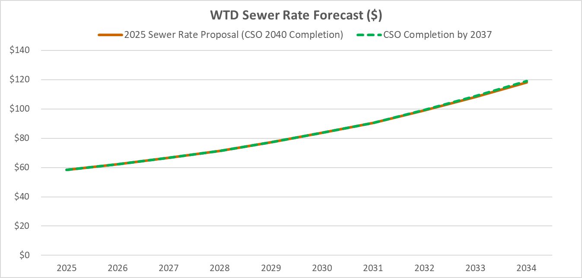
Figure 1: Sewer Rate Forecast of 2040 CSO Completion v. 2037 CSO Completion

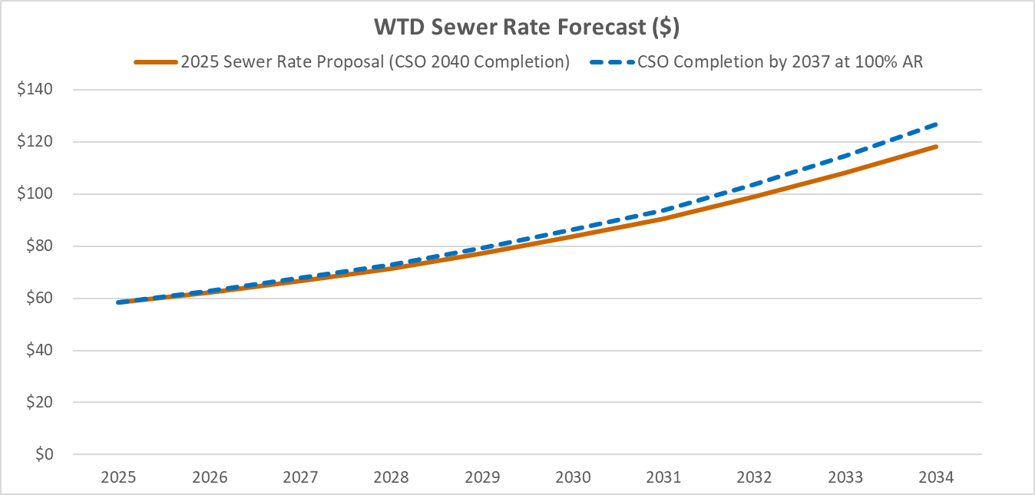
Figure 2: Sewer Rate Forecast of 2040 CSO Completion v. 2037 CSO Completion at 100% Accomplishment Rate

Conclusion

In mid-2024, King County, Ecology, and EPA reached agreement in principle on the First Material Modification. The First Material Modification extends the compliance milestones for the remaining CSO control projects and extends the overall compliance schedule from 2030 to 2037. Additionally, the First Material Modification updates design criteria for future projects, obligates the County to complete a sewer system optimization study with Seattle, updates reporting requirements, clarifies post-construction monitoring periods, and clarifies flexibility to change design specifications for future projects. The First Material Modification maintains regulatory certainty to complete the Consent Decree CSO compliance program, provides an opportunity to balance rate affordability with legal and regulatory obligations, and prioritizes projects that reduce the largest CSO volumes in one of King County’s priority equity and social justice areas.

The Clean Water Act establishes the basic structure for regulating discharges of pollutants into the waters of the United States and regulating quality standards for surface waters.
The EPA’s lawsuit related to violations of the Clean Water Act was part of a national enforcement strategy to compel completion of CSO control and water quality improvements across the country.
The 2013 consent decree is filed in the United States District Court for the Western District of Washington under Case 2:13-cv-00677-JCC.
The 2016 non-material modification is filed under the same case number as the 2013 consent decree and can be found here. More information about the Ship Canal Water Quality project can be found here.
Per the West Point Treatment Plant’s NPDES permit, Ecology evaluates compliance with the CSO control performance standard of no more than one discharge event per outfall per year based on a 20-year average. The 2013 consent decree also recognizes the 20-year period to evaluate compliance with CSO control performance standard.
WWTSs operate only when flows cannot be managed immediately at West Point Treatment Plant and may be used only a few times a year to achieve the CSO regulatory control standard.
Washington state law for Water Pollution Control can be found in Chapter 90.48 RCW.
This represents investments made through September 2023.
Supplemental compliance plans are required by the 2013 consent decree for CSO control projects that are completed, but do not meet the CSO performance standard of one event per year on a 20-year moving average.
The purpose of the Sewer System Operations Plan is to operate the treatment plants and conveyance system as one dynamic system to maximize the capture and treatment of service area flows, including CSOs. The Joint Operations and System Optimization Plan documents the framework within which the County and City work together to understand each agency’s facilities and operations to optimize overall system performance.
The Ship Canal Water Quality Project (SCWQP) is a joint project between the Seattle and King County. Seattle is the lead agency for design, construction, and operation of the SCWQP.
The Puget Sound Nutrient General Permit was issued to the County on December 1, 2021. The new permit focuses on controlling discharges of excess nutrients – particularly nitrogen – to Puget Sound from domestic wastewater treatment plants. The Puget Sound Nutrient General Permit conditions apply to the County’s three regional wastewater treatment plants and the Vashon Treatment Plant.
The 2013 consent decree allows for a 20 percent design criteria threshold for all Appendix B CSO control projects except for Hanford #1 and W. Michigan/Terminal 115. The Hanford #1 and W. Michigan/Terminal 115 were allowed a 40 percent design criteria threshold because of their relatively small design criteria.
The Construction Completion Milestone is based on the 2016 non-material modification for the joint-project (Ship Canal Water Quality Project) option.
The EPA’s Superfund Program is responsible for cleaning up some of the nation’s most contaminated land and responding to environmental emergencies, oil spills and natural disasters, of which Harbor Island has been identified. More information about the Harbor Island Superfund site can be found here.

