STAFF REPORT

Agenda Item: | 9 | Name: | Jenny Giambattista
Proposed No.: | 2011-B0113 | Date: | June 21, 2011
Invited: | Marlin Blizinsky, Government Relations Officer, Office of Information Resource Management (OIRM)

SUBJECT

An update on the Emergency Radio Replacement Project.

SUMMARY

The Government Accountability and Oversight Committee was briefed in February 2011 on the Radio Replacement Project. At that time, the Executive anticipated the consultant for the project would have completed key planning documents for the Council to review by June 2011. As will be discussed today, the key deliverables were not completed by the consultant and the project is taking a different approaching to addressing its technical planning needs.

Executive staff has prepared the attached presentation for today’s committee meeting.

BACKGROUND

History of the Project
The emergency radio system in King County allows public safety communications for police, fire, emergency medical, public schools, and public hospital agencies within King County. It is also important for day to day business, such as school communications and county landfill operations. The emergency radio system in King County is jointly owned and operated by King County, City of Seattle, and Eastside Public Safety Communications Agency (EPSCA), and Valley Communications Center (ValleyCom).

There are about 16,000 radio users and 29 radio towers that are part of the King County Emergency Radio System. As shown in the graphic below provided by OIRM, all of the radio users are connected together with central equipment and the fact that they all have the same type of equipment. This allows responders to work across jurisdictional boundaries.

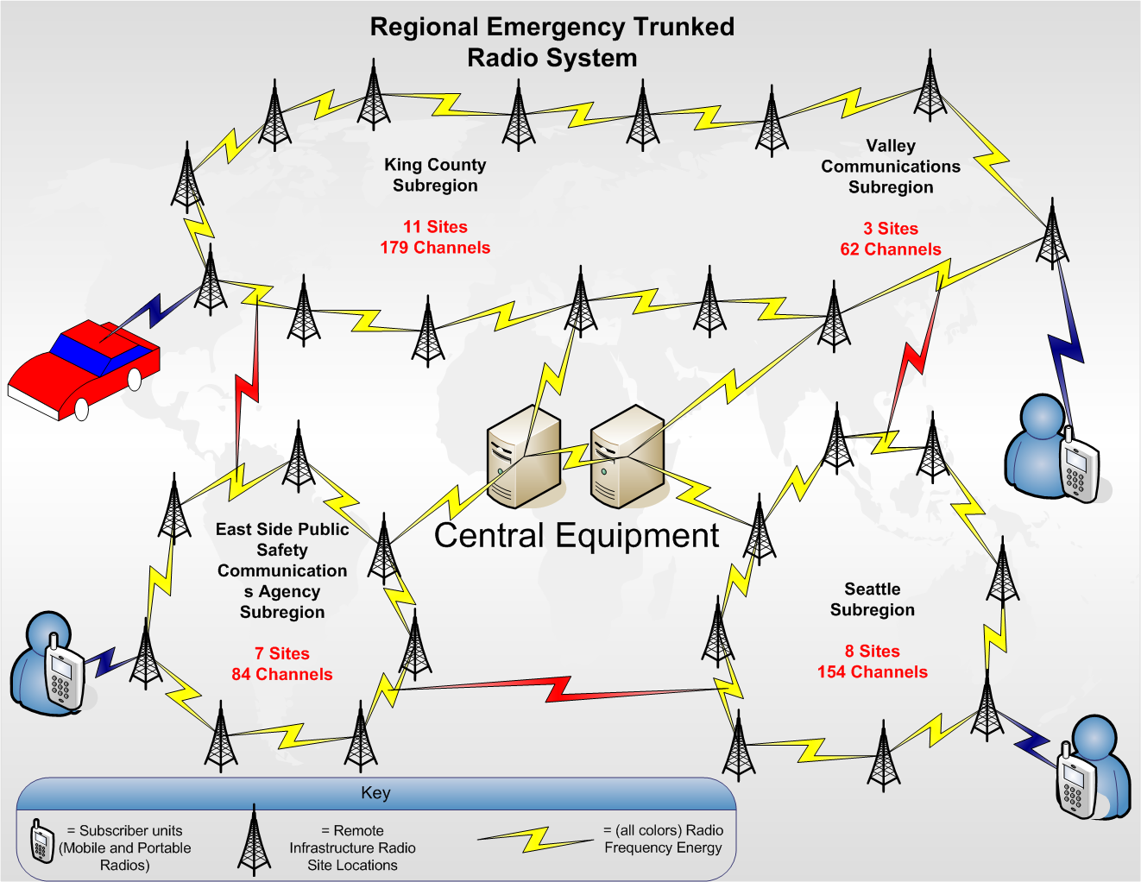

The existing system needs replacing because the current system is reaching the end of its useful life. The equipment vendor for our system has begun withdrawing support for our equipment, selling new parts and repairing broken parts, a process that will proceed over several years. There is no end date when the system must be turned off.

In order to begin planning for the replacement of the emergency radio system, the Council established a C.I.P. Project in 2007. In 2008 a Radio Executive Policy Committee (REPC) was formed. This is an advisory body and members include King, Pierce, and Snohomish Counties; Cities of Puyallup, Seattle and Tacoma; Port of Seattle; Eastside Public Safety Communications Agency; Valley Communications; King County Suburban Cities Association; Snoqualmie Tribe; and Washington State Patrol.

The diverse geographic representation of the REPC is intended to facilitate a discussion of a tri-county solution for the emergency radio system. In addition to the technical decisions, there are many other questions that must be addressed:

- Should we have one system, or three individual county systems?
- What do we want to do about data services such as images?
- What operations should we do in-house, contract out, or in some combination?
- How do we pay for it?

The REPC meets monthly and hired a consultant to advise it on technical, operational, and governance issues. The consultant was scheduled to complete work by June 2011.

Update on Project
As will be discussed by the executive staff, the REPC decided to terminate consultant contract in April 2011 and revise how it will address the regional radio planning needs. The new approach will be for the Project Steering Committee made up of REPC members to analyze four options:

- Maintain system for foreseeable future
- Upgrade current Motorola system
- Build a new system—new bid
- Build or lease a cell phone technology system

The REPC has also hired a consultant to serve a quality control function.

Next Steps
The Project Steering Committee will deliver their report to the REPC in November 2011 that will include specific recommendations on the options above. The REPC will then begin deliberations on the reports and develop a set of recommendations. There has been no date established by which a recommendation has been achieved. Once the system recommendations have been made, a budget subcommittee will likely be formed to come up with recommendations on how to finance this project. If a recommendation is made to move forward with a new system then operational governance issues would need to be addressed

While there are benefits to a larger regional system, King County will need to ensure that participating in a regional system is cost effective for King County; that we don’t wait so long for a regional solution that King County citizens and responders don’t face unnecessary risk, and that King County gets a fair share of funds/benefits and doesn’t overpay cost.

It would be informative for the Executive to know any policy guidance from the Council during the REPC deliberation time beginning November. Therefore, the Committee may wish to schedule another briefing in November, pending the budget deliberation schedule, to hear the Steering Committees findings and establish any policies as appropriate to direct King County’s deliberations as part of the REPC.

ATTACHMENTS

- PowerPoint Presentation Public Safety Radio Replacement Project

