King County Metro Transit
Mobile Ticketing Pilot Project Work Plan

May, 2015
Prepared for:
King County Council
Prepared by:
Department of Transportation
Metro Transit Division
Service Development Section
King Street Center, KSC-TR-0415
201 S Jackson St.
Seattle, WA 98104
www.kingcounty.gov/metro
Alternative Formats Available
206-477-3832 TTY Relay: 711

Contents
Introduction 3
Background 3
Work Plan 6
Mobile Ticketing Overview 6
Summary of the Pilot Project 7
Project Management and Organizational Structure 9
Explanation of How the Demonstration Participants will be Chosen 10
Discuss whether the Application will be Developed by KCIT or the Vendor 10
Data to be Collected and how it will be used 10
Measures of Assessment 12
Project Timeline 12

Introduction

Ordinance 17941, adopting the 2015-2016 Biennial budget and making appropriations for the operation of county agencies and departments and capital improvements for the fiscal year beginning January 1, 2015 and ending December 31, 2016, was enacted on November 20, 2014.

Included in the budget is Transit capital project 111694 to develop and deploy a mobile ticketing pilot project. Section 129, Proviso P2 provided further that:

Of the appropriation for capital project 1116944, mobile ticketing pilot project, $440,000 shall not be expended or encumbered until the executive transmits a mobile ticketing pilot project work plan and a motion that accepts the work plan and the motion is passed by the council. The motion shall reference the subject matter, the proviso's ordinance, ordinance section and proviso number in both the title and body of the motion.

The work plan shall include, but not be limited to:
- A summary of the pilot project;
- An explanation of how the demonstration participants will be chosen;
- A discussion of whether the application will be developed by KCIT or by an outside vendor; and
- An explanation of what data will be collected and how it will be used.

The executive must file the work plan and motion required by this proviso in the form of a paper original and an electronic copy with the clerk of the council, who shall retain the original and provide an electronic copy to all councilmembers, the council chief of staff, the policy staff director and the lead staff for the transportation, economy and environment committee, or its successor.

Mobile ticketing is an emerging technology that allows customers to pay their transit fares using their smartphones instead of cash. This pilot project will test and evaluate the potential of mobile ticketing to provide a convenient prepayment method and assess how such technology can improve customer satisfaction and reduce cash collection on the bus. This pilot is an important first step in determining if, and how, mobile ticketing or similar technology can be incorporated into a second generation ORCA program for regional fare payment planned for 2021.

Background

King County Metro currently accepts ORCA cards, cash, and certain legacy fare media for transit fare payment. In recent years as smartphones have become more popular, technologies have developed that allow customers to prepay (before boarding) their transit fares using their phone and board using an electronic ticket rather than paying cash or using paper tickets.

King County Metro’s 2014 Report on Transit Fares notes that:

“The primary purpose of Metro’s fares is to recover a portion of operating costs, but designing the fare system is about much more than setting fare levels to achieve a target amount of revenue. Fares, the fare structure, and fare payment methods affect many aspects of service that also must be considered, such as ridership, operating speed and costs, customer satisfaction, and affordability for people with low incomes. “
In support of this, Section 4 of that report entitled “The Road to a Cashless System,” identifies mobile ticketing as one approach to providing an alternative to cash payment and providing new fare payment options for customers. Along with ORCA, the ticket vending machine pilot project, and evolving electronic payment technologies, mobile ticketing offers the potential of reducing the volume of cash collected at the farebox and improving transit operations through reduced dwell times at stops. Customers are also beginning to demand this type of service as a convenient way of paying fares, and anecdotal feedback from agencies such as TriMet in Portland is that customers have a high degree of satisfaction with such systems.

Mirroring trends in the broader economy, fully cashless fare payment is an emerging policy goal for public transit worldwide. In implementing the ORCA system for regional fare payment, Metro and its regional partner agencies have made significant progress towards cashless fare payment. Metro’s implementation of the ORCA LIFT program will also help move in this direction. The ORCA LIFT program has earned recognition nationwide as a groundbreaking effort to provide low-income riders with access to discounted, pre-paid fare media. Working with Seattle/ King County Public Health and partner agencies, Metro has established a network of locations throughout King County to make it easy for low-income customers to register and receive free ORCA LIFT cards that will provide them with discounted fares. Further movement towards the cashless goal for Metro will take time, continued testing of new technologies and programs and require Council approval of key policy changes.

The primary goals of this pilot test project are to understand the effectiveness of mobile ticketing in Metro’s fare and operational environment, and to assess how it complements existing products offered today and its potential role as Metro and the other ORCA agencies begin planning for the future of regional fare collection. Additionally, a mobile ticketing pilot provides an opportunity to assess how to integrate a new technology with the County’s financial processes. Finally, this pilot offers the potential to support many of King County Metro’s goals and objectives as defined in the King County Metro Transit Strategic Plan for Public Transportation (2011-2021) including:

Goal 2, Objective 2.1: Provide public transportation products and services that add value throughout King County and that facilitate access to jobs, education and other destinations.

Mobile ticketing provides a prepaid media choice that does not require the customer to travel to a physical location to purchase it. Instead, all purchase activity can be conducted using the phone, at any time, and at any location
Goal 3, Objective 3.1: Support a strong, diverse and sustainable economy.

High technology is part of the economic backbone of King County, and mobile ticketing is part of that technology industry. Mobile ticketing also offers the potential for business and economic partnerships with the mobile ticketing provider and potentially local businesses and others who may wish to offer new options for their employees or constituents beyond what is available today through ORCA.

Goal 5, Objective 5.1: Improve Satisfaction with Metro’s products and services and the way they are delivered.

Anecdotal data from the limited deployments of mobile ticketing to date across the US indicate a high degree of customer satisfaction which, coupled with ORCA’s high satisfaction rates contributes to overall satisfaction with King County Metro’s products and services. There are also demands for mobile applications in general, and mobile ticketing adds to Metro’s suite of mobile options.

Unfortunately mobile ticketing deployments to date in the US are limited, and virtually none of them have been in cities where there is an existing smart card system such as ORCA so peer agency experience cannot reliably be used to predict the uptake, benefits and impacts of such a system. Agencies such as Virginia Rail Express and San Francisco Muni have smart card technology and are also conducting pilot tests of mobile ticketing, but to date there is no definitive data documenting what impact mobile ticketing has on cash or smart card utilization.

This pilot test project is designed to begin developing answers to these and other questions to help King County Metro decide if and how to provide and use mobile ticketing as part of its suite of fare products and offerings, and what role it might play in future regional fare collection. Customer adoption patterns will be assessed to determine if current cash paying customers are likely to embrace this new technology and thereby increase the use of electronic fare payment media. This will include an assessment of the benefits of and barriers to adoption by different market segments and demographic groups. The pilot project will also seek input from the vendor community on where and how this technology is evolving, and what features are available now or potentially in the future to further provide options for customers traveling locally, regionally, and/or on multiple modes.

This pilot will focus on assessing mobile ticketing as a convenient single trip alternative to cash fare payment. The target market is infrequent riders without ORCA cards, including visitors. This pilot project is not intended to erode Metro’s current ORCA market share, and will be monitored to determine any such impact. Mobile tickets for Metro will be valid only on Metro, and will not provide customers with the intersystem transfer privileges provided by ORCA and ORCA LIFT cards. Nor will it provide customers with the unlimited ride options provided by ORCA passes.

King County Metro is the lead for this project and will be responsible for all contracting and project administration. Recognizing the potential regional and multi-modal applications of this technology, Sound Transit will be an operating participant, allowing mobile ticketing to be used on certain Sound Transit services. They will also participate in vendor request for proposals development; implementation, operation and testing of the mobile ticketing system on Sound Transit services; and participation in the evaluation.

Sound Transit will not be a party to the vendor pilot test contract; however the development of the contract terms and conditions is being coordinated between King County procurement and Sound Transit procurement to ensure that the form of contract is acceptable to both. Operating roles and responsibilities for King County and Sound Transit will be defined once approval is received to move forward with the pilot test project.

Depending on the outcome of the pilot test project, King County will have an opportunity to decide whether to conclude the pilot test and close the project, or move forward with a wider scale deployment of the technology either using the pilot test vendor or go through a new procurement process.

Work Plan

The mobile ticketing pilot project work plan was developed with input from different groups and stakeholders within King County Metro and Sound Transit including:
- Transit operations
- Revenue and finance
- Customer service
- Research and management information
- ACCESS and vanpool services

Requirements for the vendor request for proposals as well as potential pilot test evaluation criteria have been identified by this group and include an assessment of the degree to which mobile ticketing technologies can reduce cash utilization onboard transit services; whether the benefits of mobile ticketing outweigh the costs; the overall viability of mobile ticketing applications; the degree to which it contributes to customer satisfaction; and confirmation that this technology is viable and beneficial for all riders (included in the project is a Title VI analysis).

Also included is an assessment of the potential of this technology to support multi-agency, regional, and multi-modal fares, as well as specialized fares for services such as vanpool and paratransit services. Mobile ticketing systems deployed to date have focused on selling specific tickets for specific agencies and services, and currently do not provide the same options for multi-agency services and revenue sharing that systems such as ORCA do. These systems have historically relied on visual inspection by a coach operator to verify the fare on boarding, however, new technologies are being developed that would electronically validate mobile ticketing fares without the need for such visual inspection.

Looking to the future, the vendor request for proposals will solicit ideas, concepts and thoughts from the vendor community on where this technology is heading and try out as many of these as possible as part of controlled testing with staff and potentially customer focus groups. It will also invite the vendors to describe possible partnership and business models that King County could consider if the project were to move into full deployment.

Mobile Ticketing Overview

The way mobile ticketing systems work is that the customer, using their smartphone or computer, sets up an account with the mobile ticketing system provider. The customer can then purchase and store a bank of tickets electronically. When he or she is ready to board a bus or rail vehicle, the customer uses an application on the phone to “validate” a ticket and board the vehicle.

Mobile ticketing implementations to date have generally relied on visual verification by a coach operator or inspector to confirm that a mobile ticket has been purchased. These screen shots from mobile ticketing applications in Portland, Oregon and New York, New York provide an example of what typical tickets look like.

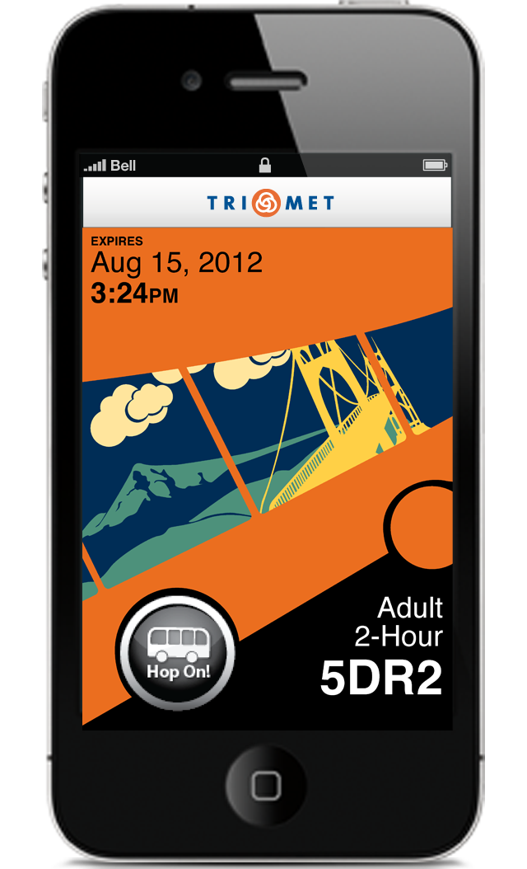 | 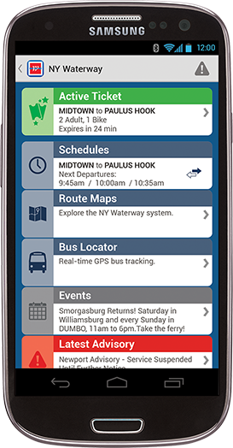
Example mobile ticket application used by TriMet in Portland, Oregon | Example mobile ticket application used by the New York Waterways

In all cases, visual cues and other security features are used to reduce the potential for fraudulent duplication or reuse of the mobile tickets.

Some vendors are also developing electronic means of verifying tickets to reduce or eliminate the need for visual verification by the transit operator or fare inspector. While some such as barcodes have been used in applications for airline tickets and retail payment, barcode technology is generally considered too slow for electronic validation on boarding but is commonly used by fare inspectors to check tickets. As part of the mobile ticketing pilot test project a fare inspection application will be provided and tested.

The vendor community continues to try to find faster, reliable ways of electronic inspection (especially during boarding) and are experimenting with Bluetooth, location-based services and other technologies commonly available on smart phones. Part of this project includes testing what is available and understanding what might be coming available with respect to electronic validation.

Summary of the Pilot Project

The pilot project will include two primary elements:
- A public facing test with up to 10,000 volunteers from the general public where they can set up accounts, purchase and redeem mobile tickets, and provide feedback on their experiences with the system; and
- Controlled tests where King County Metro staff, and possibly also focus groups or specific volunteers, will be able to test and assess advanced functionality such as electronic validation of tickets, new fare products, and products for special services such as paratransit and vanpool services.

For the public facing tests, the following King County Metro fares will be offered:
  - KCM Adult Off-Peak
  - KCM 1-Zone Peak
  - KCM 2-Zone Peak
  - KCM Youth Fare
  - KCM Special Event Tickets as provided for in King County Code 4A.700.090 Limited Service Fares
  - Water Taxi-only fares (both routes)

Certain Sound Transit fare products will be available as well including:
  - Sound Transit LINK light rail one-way tickets (including fares from SeaTac)
  - Sound Transit Sounder Commuter rail one-way tickets
  - Potentially day passes for LINK and Sounder

King County mobile tickets will be useable on all King County Metro-branded services and routes. Water Taxi tickets will be valid for fare payment only on the Water Taxi, not on Metro. Since these tickets are an alternative to cash fare payment, they will not be valid on the Seattle Streetcar, since the new Streetcar agreement does not provide for cash transfers. Sound Transit mobile tickets will be valid on LINK and Sounder, but not Sound Transit Express bus services as this would require the participation and training of staff from Community Transit and Pierce Transit who, along with King County Metro, operate those services.

One limitation of the mobile ticketing systems in use today is they have generally been designed for either single agencies or to sell single agency tickets only in multi-agency regions, which is why single agency products currently available to the public have been identified above for the public-facing testing.

To assess the potential of going beyond single agency products and supporting multi-agency, multi-modal, regional and special fares, the vendor RFP will also include requirements for the vendor to propose ways that they could provide this functionality and then test it as part of controlled testing. Examples of products that vendors may be requested to test include:

  - Fare products that allow transfers between services operated by King County (e.g. fixed route bus services, streetcar services, and/or the Water Taxi).
  - Fare products that allow multi-agency or potentially regional travel, including how the vendor could allocate revenue by participant.
  - Special products for vanpool and paratransit services.
  - Other services such as parking payment, trip planner integration, etc.

Data collected from this testing will provide information on the potential this technology has to offer in supporting both local and regional travel.

Project Management and Organizational Structure

The following chart presents the overall organizational structure for the project including the specific individuals involved.
Structurally, the project has been organized as follows:
- Kevin Desmond, the King County Metro General Manager, is the Executive Sponsor.
- A Steering Committee has been formed of senior management staff from King County representing the key stakeholder groups impacted by mobile ticketing. The Steering Committee meets monthly on average and provides direction and decision making.
- Liviu Prisecaru is the King County Metro Project Manager responsible for the day to day activities of the project.
- Project leads from the stakeholder group and project consultant have also been assigned to provide input on requirements and review materials as they are being prepared. That group meets on an as-required basis.
Representatives from Sound Transit are also participants in the Steering Committee and stakeholder groups, and have assigned Michael Berman as their internal coordinator to liaise directly with the King County Project Manager.

Explanation of How the Demonstration Participants will be Chosen

Metro will use existing public communications channels to seek up to 10,000 participants in the public-facing element of mobile ticketing pilot project. Notices will be provided at a number of locations, including Metro Online, transit centers, buses, Link light rail stations, Link light rail trains, and SeaTac airport. Participation will be open to anyone who is interested, has an Apple, Android or Windows smartphone and has a credit/debit card. All sign up and application loading will be able to be done using the phone. Efforts will be made to attract participants who are representative of Metro’s customer base, while recognizing this mobile ticketing application will most likely appeal to a niche market.

As part of the procurement, the mobile ticketing system provider will be required to set up a mobile website for people to apply. King County Metro will provide instructional information on how to apply, and will also review applications to confirm that the applicant has met the basic criteria of being willing to participate, sharing information, having a suitable smartphone, and being able to use a credit or debit card to pay for purchases. The instructional information will also provide information about how to qualify and apply for Metro’s ORCA LIFT Program for low-income riders, and encourage customers who might qualify to apply for the program. The application process will be kept open until 10,000 participants have been signed up, or the first six months of testing has concluded, whichever comes first.

Each participant will be informed that this is a test project and that in order to properly evaluate the system participants will be asked to provide certain information about themselves and their travel behavior, and also respond to questionnaires and surveys to help with the evaluation. Providing this information will not be a condition of signing up, but will be strongly encouraged in order to fully assess the effectiveness of the pilot test.

Discuss whether the Application will be Developed by KCIT or the Vendor

It is expected that an off-the-shelf mobile ticketing system will be procured for the pilot test project as there are a variety of systems and vendors available in the market. Some system configuration will likely be required to accommodate the identified fare products, along with potentially some software updates and enhancements to demonstrate desired functionality, but all software development work (if any) will be conducted by the vendor.

The pilot system itself will operate as either a hosted or software as a service system, with all user interfaces being through either mobile or desktop web applications. No direct integration with King County networks or systems are expected, nor is any development work by KCIT, but some network assistance may be required to allow web access from King County workstations to the vendors hosted system.

Data to be Collected and How it will be Used

The Mobile Ticketing Pilot Project will collect four types of data. A description of each type of data and how it will be used is provided below.

- Mobile Ticketing Account Data
Mobile ticketing systems are account-based systems requiring all participants to register and provide a credit or debit card as a payment mechanism (similar to what is required for most online accounts today such as eBay or Amazon). True anonymous accounts are not provided for in mobile ticketing applications.

Data collected in the account setup will depend on the vendor, but would generally consist of the following:
- name and address
- email address
- username for the account
- password for the account
- phone number of the smartphone used to purchase the mobile ticket
- PIN code used to access the mobile ticketing information on the phone for validating tickets before boarding, purchasing new tickets, accessing history, etc.
- credit/debit card data that will be stored only in the secured environment (backend of the system) and not on the phone.
A core requirement for the system is that it is compliant with Payment Card Industry (PCI) rules that govern credit card transactions, and Washington State Personally Identifiable Information (PII) laws.
- Transaction Data
Transaction data (i.e. information on what tickets are purchased and when each is redeemed) will be collected as part of the system operation and be used for evaluation purposes. Such data will be stored in the vendors hosted solution and made available both to the customer and King County for evaluation purposes (this will be explained in the terms and conditions associated with the pilot test project).

For evaluation purposes transaction data will not be connected with the customer account information. Instead, a numeric or other non-personalized identifier will be used to aggregate and analyze data.

- Financial Account (Debit/Credit) Data
Metro will not have access to any debit or credit data. In accordance with Payment Card Industry (PCI) rules, the vendor will be obligated to protect any such data. PCI certification and adherence will be a requirement of the vendor contract.

- Mobile Ticket Pilot Project Survey Data
The mobile ticketing pilot project will include a customer feedback website and various surveys to assess adoption patterns, complexity of the technology, and acceptance by the test participants. The vendor will be required to develop the customer feedback website and survey mechanism; however, the content will be determined by the Project Leads with approval by the Steering Committee.

The survey program will be developed in coordination with the selected vendor in mid-2015, but it is expected customers will be asked to provide details on the trips taken using the mobile ticket; frequency of transit use (before and after); method of payment (before and after); and demographic data such as age, gender, ethnicity, language spoken at home, education level, income brackets, and where they live or work. This survey data will be anonymous and not tied to specific user accounts. From time to time select customers may be asked to participate in focus groups or focused testing that may require that other data be collected. Focus group participants will be recruited from the customer account data. Participants will be selected to provide a range of ridership frequency as well as geographic and demographic diversity. As Metro evaluates the results of this pilot, we will be able to compare the ridership and demographic characteristics of Mobile Ticketing participants with the characteristics of Metro’s ORCA LIFT participants to identify potential ways of better serving both market segments.

Part of the requirements for the vendor will be to generate customer feedback reports for use and analysis by Metro staff.

Measures of Assessment

An initial set of measures of assessment have been defined for the mobile ticketing pilot project by the Project Leads and Steering Committee, but it is expected this list will be refined further as the project proceeds. Preliminary measures identified include:
- Customer satisfaction and support for the system, including potential for wide market penetration
- Impacts on cash fares and the use of other fare options such as ORCA
- Ease of recognition for operators and fare enforcement officers
- Effectiveness of automated inspection and validation technologies
- Boarding times using this fare payment technology
- Potential for fare evasion and methods to mitigate
- The mobile application demonstrates the ability to comply with the Americans with Disabilities Act and Section 508 of the Rehabilitation Act of 1974.
- The viability of deploying the technology across multiple modes and agencies, and supporting new fare options and alternative transit services such as vanpool and paratransit
- Value added features and the ability to support new and emerging technologies and consumer applications
- The overall feasibility of mobile devices as a new sales channel for fare media.

Project Timeline

The system will operate for a period of six months, extendable by another six months. An initial evaluation will be conducted after the first six months of operation, during which time a Title VI assessment will be conducted as well. Should the project proceed for another six months, the evaluation will be updated based on the additional data collected.

The overall projected schedule is as follows:

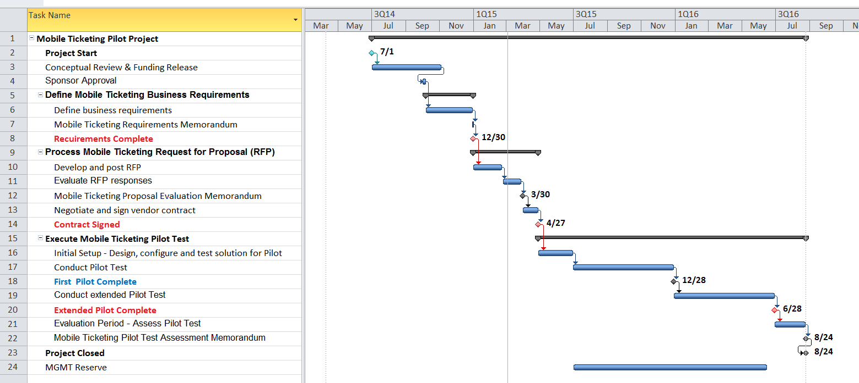

Key milestone dates may be found in the table below.

Phase | Deliverables | Target Completion Date
Business needs/Business requirement | Document of business needs from sections | 12/30/2014
PRB funding released | Project Funding Released | TBD
Develop and post RFP | RFP posted | 02/20/2015
Sign Contract with selected vendor | Signed Contract | 04/27/2015
System Design and Configuration | Notice of apparent completion to vendor | 06/29/2015
Public Pilot Test Period – Phase 1 | Notice of apparent completion to vendor | 12/28/2015
Public Pilot Test Period – Phase 2 | Notice of apparent completion to vendor | 06/28/2016
Pilot Test Evaluation | Test Assessment Memorandum | 08/23/2016

King County Metro Report on Transit Fares dated August, 2014
Telephone discussion with Chris Tucker at TriMet regarding their experiences with mobile ticketing
Source: Presentations made at a meeting between Chief Information Officers in mid-2014 on the topic of mobile ticketing
2012 King County Metro Rider Survey; ORCA had an 82% customer satisfaction rate.

