Lease Property Summary

Photo of Property

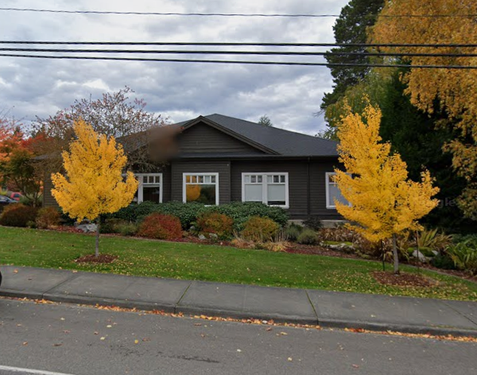

Property Owner: Vashon Properties LLC
Address: 17141 Vashon Highway SW, Suite #114, Vashon, WA 98070
Cost Per Sq. Ft.: $5.80/SF/month for the office space and $150/parking space/month (for each of three parking spaces)
Operational Costs: N/A
Term: Five years
Square Footage: 100 SF
Template: Landlord’s template with County edits
Council District: Eight
Funding Source: Metro’s Access Transportation Program
Previous Location: This is a new lease at the existing location
Offer Expiration: Previous Department of Local Services (DLS) lease for this property expired on August 31, 2024. DLS is currently occupying the space on a month-to-month basis. Metro Transit Department (Metro) intends to move into this space upon approval by the County Council and execution of the new lease.

Lease Synopsis:
The proposed Ordinance would approve a new five-year lease for this location with an option to renew for two additional periods of five years each. The space would be jointly utilized by DLS and Metro. DLS currently utilizes this location to host in-person office hours to provide supportive services to the Vashon community for accessing available County resources. Metro’s Access Transportation Program currently leases nearby office space with designated parking approximately one mile north of this property on a month-to-month basis. Metro’s current landlord is proposing a significant rent increase.

Context

Rationale for transaction: This location provides access to King County resources to residents of the unincorporated Vashon Island community. DLS hosts in-person office hours at this location to provide information, technical assistance, notary services, and other support services to Vashon residents. The location and partnership with DLS enables Metro to continue to provide equitable access to public transportation for persons with disabilities on Vashon. Metro and DLS will share the cost of the office rent, while Metro will solely be responsible for the parking fee.

Policy considerations: N/A

Political considerations: N/A

Community considerations
or partnerships: This new lease will allow King County DLS and Metro to continue to provide their services to the Vashon community with the advantage of being in a co-located facility.

Fiscal considerations: The monthly rent of the new lease is $579.63 for the office suite, which will be paid for by both Metro and DLS. Metro will pay seventy percent of the monthly office rent in the amount of $405.74 and DLS will pay thirty percent of the monthly office rent, in the amount of $173.89. There will be three designated Access vehicle parking spaces. The monthly parking fee is $150 per parking space for the Access vehicles, which will be paid for by Metro, in the sum of $450, for a total rental cost to Metro of $855.74. The total monthly cost to King County is $1029.63. The monthly rent and parking fees will increase annually by three percent. No tenant improvements are needed for the new term of the lease at this location. At Metro’s current location, the landlord is proposing a new lease with a monthly rent of $1,500.00 with a three percent to six percent annual increase.

Other considerations: N/A

CIP/operational impacts: No additional capital improvement or operational cost impacts are anticipated for this lease.

King County Strategic Plan impact: N/A

Equity and Social Justice impact: In accordance with King County’s Real Property Asset Management Plan (RAMP) policies, FMD reviewed this legislation for potential equity and social justice (ESJ) impacts. This location provides access to King County resources to residents of the unincorporated Vashon Island community. DLS hosts in-person office hours at this location to provide information, technical assistance, notary services, and other support services. The Metro Access Transportation program operates a network of accessible vans to provide service to those whose disabilities prevents them from riding traditional buses and trains.

Energy Efficiency impact: This location is close to Metro bus stops, which makes it convenient for employees and customers to access. Additionally, this location is across the street from the Park & Ride Ober Park, which is a candidate for future installation of vehicle charging infrastructure. As Metro transitions its fleet to zero emission, the proximity to the Park & Ride will allow Metro to charge its vehicles there.

Lease Alternatives Analysis
Summary: No alternatives were considered as the rental rate and parking fee is less than the proposed increase at Metro’s current leased space for their Vashon Island Access Transportation program.

Vicinity View Map

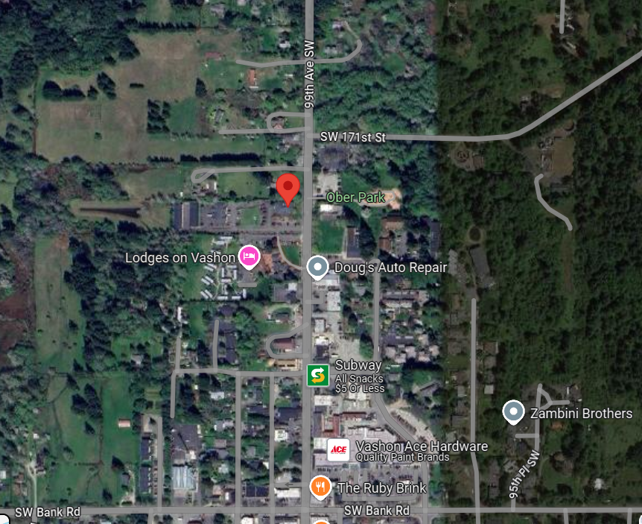
Parcel Map

