METROPOLITAN KING COUNTY COUNCIL

Date: August 20, 2020

TO: MELANI PEDROZA, Clerk of the Council

RE: INTRODUCTION OF LEGISLATION

Number: 2020-0284

Title:

A MOTION appointing Michael Ramos to the King County Regional Homelessness Authority's Implementation Board as a King County council appointee for a five-year term expiring December 31, 2024.

is introduced by:

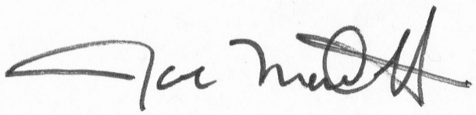__________________________
Councilmember Joe McDermott

