Real Estate Excise Tax 1 and 2
Analyst: Jake Tracy

REET 1

 |  | 2026-2027 Proposed |  | 2028-2029 Projected |  | 2030-2031 Projected
Revenues |  | $ 17,979,314 |  | $ 21,680,000 |  | $ 19,600,000
Appropriations |  | $ 17,979,314 |  | $21,680,000 |  | $ 19,600,000
Major Revenue Sources: Real Estate Excise Tax

REET 2

 |  | 2026-2027 Proposed |  | 2028-2029 Projected |  | 2030-2031 Projected
Revenues |  | $ 17,979,314 |  | $ 21,330,973 |  | $ 19,254,843
Appropriations |  | $ 17,979,314 |  | $ 21,330,973 |  | $ 19,254,843
Major Revenue Sources: Real Estate Excise Tax

Description

King County levies two Real Estate Excise Taxes (REET) on sellers of real property in unincorporated King County. Each tax is 0.25% of the property value and each is regulated by both State law and the King County Code.

REET 1 is permitted by State law to be used to finance capital improvements that are listed in a capital improvements plan, capital facilities plan element of the Comprehensive Plan, or for housing relocation assistance. The King County Code specifies that these proceeds may only be used “for capital needs of the unincorporated area of the county.”

REET 2 is permitted by State law to be used for limited types of capital projects identified in the capital facilities plan element of the Comprehensive Plan. King County Code requires that REET 2 only be used for the "planning, construction, reconstruction, repair, rehabilitation or improvement of parks located in or providing a benefit and open to residents of the unincorporated area of King County.”

Figure 1 below shows actual and projected REET revenues from 2015 through 2034. According to the Executive's proposed budget, REET revenue declined in 2022 and 2023, driven by the slowdown in the housing market and higher interest rates. Current estimates project a gradual recovery in REET revenue through 2034. The County expects to collect $38.3 million in the 2026-2027 biennium. As the chart below shows, REET revenues are anticipated to remain between $18 million to $22 million per year through 2033.

Figure 1. REET Revenue 2015 through Projected 2034
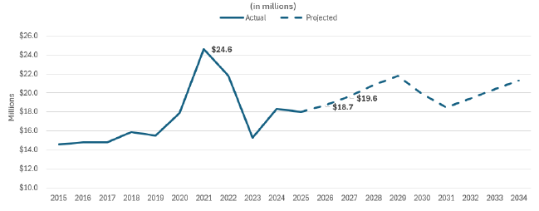
Source: Executive Proposed 2026-2027 Biennial Budget

Summary of Proposed Budget and Changes

In the proposed 2026-2027 Biennial Budget, REET would support Roads Services Division and Parks Division capital projects through transfers to the Parks and Roads Divisions.

REET proceeds are proposed to be used for the following in the 2026-2027 Biennial Budget:

- $17.9 million for Parks to fund various projects including fish passage projects; rehabilitation of play areas at Preston Athletic Fields, Lake Geneva Park and others; environmental remediation and monitoring work; and the new Skyway Community Center.
- $3.6 million for debt service for the central maintenance facility and bridge replacement projects.
- $14.4 million for Road Services to fund projects in unincorporated King County including roadway preservation, bridge replacement design, and the removal of fish barriers.

Key Issues

Staff have not identified any key issues for this fund.

RCW 82.46.010
K.C.C. 4A.200.580
RCW 82.46.035
K.C.C. 4A.200.590.E

