STAFF REPORT

Agenda Item: | 13 | Name: | Clifton Curry
Proposed No.: | 2017-B0088 | Date: | May 9, 2017

SUBJECT

Juvenile Detention Trends Update.

SUMMARY

Last year, the Committee received several overviews of racial disproportionality and disparities in the county’s criminal justice system, especially in juvenile detention. During these meetings, it was noted that King County had significantly reduced its secure detention populations, but had not impacted racial disparity in the county’s juvenile and adult justice systems. Nevertheless, staff noted that no other jurisdictions around the country appear to have been able to reduce disparity in their systems using evidence-based best practices. The most recent data from the County’s juvenile justice system shows that detention continues to decline, but unlike all previous years, disproportionality for but Hispanic youth, has slightly decreased also. Today, Executive staff will provide recent data on juvenile justice detention in King County.

BACKGROUND

Through the efforts of the County Council, Executive, and separately elected criminal justice officials, King County has taken significant steps to improve its criminal justice system for both adults and juveniles. The County has adopted policy frameworks for the use of secure detention while also establishing policy direction to develop alternatives to secure detention. The County has also responded to the need for treatment services in the community to reduce repeat justice system involvement and improve public safety. As a result, even though the County’s overall population has grown, the number of persons arrested, charges referred, charges filed, and the use of secure detention for adults and juveniles has declined significantly over the past 15 years.

Juvenile Justice Background. The King County Department of Adult and Juvenile Detention (DAJD) has operated the county’s juvenile detention system since 2002. The juvenile system had 1,446 admissions (bookings) in 2016, down from 1,815 admissions in 2015—a decrease of 20.3 percent. The department houses an average of 40.7 pre- and post-adjudicated felons and misdemeanants every day (through March 2017).

Under state law, King County is required to operate a detention facility for juvenile offenders. Nevertheless, since 1999 the county has restricted admissions to its juvenile detention facility. Law enforcement agencies have minimum criteria that must be met before a youth can be admitted to the county’s juvenile detention facility at the Seattle Youth Service Center. The county has established “Juvenile Detention Intake Criteria” that identifies the circumstances in which a youth can be brought for admission to detention—which includes standards for what types of offenses for which the youth is being detained, prior and pending criminal history, and other specified circumstances (e.g., the youth cannot be identified and guardians notified). Law enforcement agencies must call Juvenile Probation Screening staff (part of the King County Superior Court, not DAJD) prior to bringing a youth to the Youth Services Center to determine if the youth is eligible for detention.
While detained, youth receive a medical assessment to determine if the youth is in crisis and needs immediate medical or mental health intervention. The youth also receives an assessment to determine the youth's appropriate placement in detention and any special issues that may need to be addressed. During the week, detained youth attend school. The Seattle School District provides regular and special education. Detention (DAJD) staff work closely with probation (Superior Court) staff to keep probation advised when a youth is detained.
Juvenile detention also manages programs providing alternatives to secure detention for those youth who require monitoring but do not need to be detained in a secure setting. These programs include electronic home monitoring, day and evening reporting, group care and work crew.

Data on Racial Disproportionality and System Disparities. The department, along with the Superior Court, the Department of Judicial Administration, Prosecutor’s Office, and the Office of Performance, Strategy and Budget, have maintained demographic data—including ethnicity, and gender—for juveniles with charges referred (that is, youth that have been arrested and their cases sent to the Prosecutor’s Office), charges filed, admissions to secure detention (booked), held in secure detention, and placed in alternatives to secure detention (see attached data). This data has been aggregated into reports since the county’s participation in the national Juvenile Detention Alternatives Initiative (JDAI) began in 1999.

Overall, juvenile referrals, filings, and secure detention average daily population (ADP) has declined significantly since the adoption of the Juvenile Justice Operational Master Plan and JDAI. For example, the following chart shows the decline in ADP since 1998.

Juvenile Secure Detention ADP
1998-March 31, 2017

During this timeframe, the use of juvenile detention, as measured by ADP, has declined 78 percent, even though the juvenile population significantly increased in the county during this time. The number of police referrals and charges filed during this timeframe has also decreased by similar margins.

Demographic Data on Detention Population. According to 2015 demographic data from the U.S. Census, White youth, at 55.5 percent made up the bulk of juvenile population in the county. The county’s African American juvenile population made up an estimated 10.2 percent of the total population. The following table shows the demographic composition of the secure juvenile detention by ADP from 2011 through March 31, 2017.

Secure Juvenile Detention ADP
2011-March 31, 2017

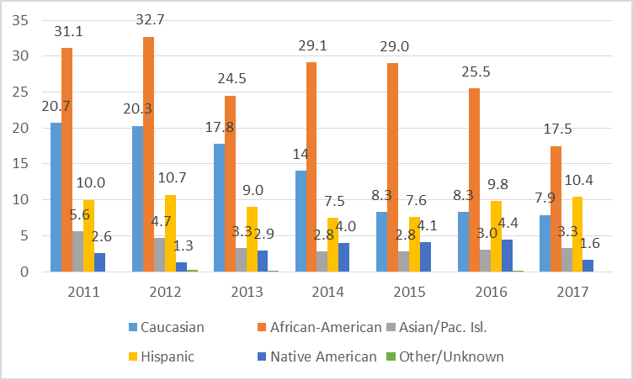

This chart shows the demographic composition of the secure detention population for all youth in juvenile detention as measured by ADP. The absolute numbers show a decline in ADP between 2011 and through the first three months of 2017 for all demographic groups except Hispanic youth.

The following chart, shows the demographic makeup of the secure detention population by percent of the whole.

Demographic Composition of the Secure Detention Population by
Percentage
2011-March 31, 2017

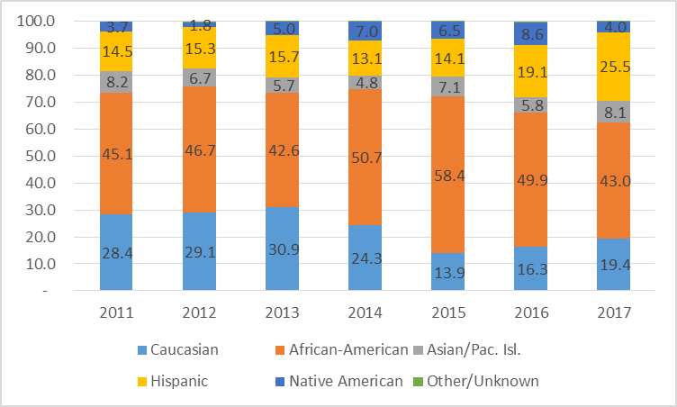

Throughout the period, the County has had disproportionate minority confinement of African Americans and other youth of color when compared to the population at large. In 2011, the percentage of African Americans as part of the total secure detention ADP was 45.1 percent and had grown to as high as 58.4 percent in 2015. However, in 2016 the percentage had decreased to 49.9 percent.

Staff are here today to brief members on juvenile police referrals, prosecutor criminal filings, secure detention, and the use of secure detention for Becca youth (non-criminal detention).

INVITED:

- Dave Chapman, Justice System Improvement Manager, Office of Performance, Strategy and Budget
- Elizabeth Haumann, Data and Evaluation Analyst, Office of Performance, Strategy and Budget

ATTACHMENTS:

- King County Secure Juvenile Detention Population - Secure, Trends 2012-2016
- King County Juvenile Justice Statistics, Comparison of 2015 and 2016
- King County Juvenile Justice Statistics, Comparison of 2016 to 2017 through March 31st
- King County Juvenile Court Admissions to Secure Detention of BECCA Youth Calendar Year 2016

