

Metropolitan King County Council

Regional Policy Committee

Staff Report

Agenda Item No.: | 8 |  |  | Name: | Beth Mountsier
Briefing No.: | 2011-B0125 |  |  | Date: | July 13, 2011
Attending: Tom Goodwin, Chief Economist, King County

SUBJECT:

A briefing and overview of the King County economy in 2011.

SUMMARY:
In November 2008, King County voters approved an amendment to the King County Charter creating the Office of Economic and Financial Analysis as an independent agency of King County. The office was created to produce independent economic and revenue forecasts using best practices to produce economic and revenue forecasts for budgeting purposes for King County. In addition, the office conducts economic studies at the request of the Forecast Council (comprised of representatives of the executive and legislative branches).
The committee will be briefed by the Chief Economist, Tom Goodwin regarding the current economic conditions in King County and the outlook for 2012. Below is some employment data as summarized and tabulated by the Office of Economic and Financial Analysis. Additional information regarding the housing market and other factors at the local and national level will be presented.
Washington State Chief Economist Arun Raha has been quoted as saying he expects the second half of 2011 to “see stronger growth”. Aside from a weak construction market which is expected to continue without much change, the state’s economist is seeing several positives for the state economy including booming Boeing production, hiring in the software industry and a modest rebound in retail sales and perhaps stabilization in housing prices. How these predictions affect the King County economy is of interest to the private and public sector.
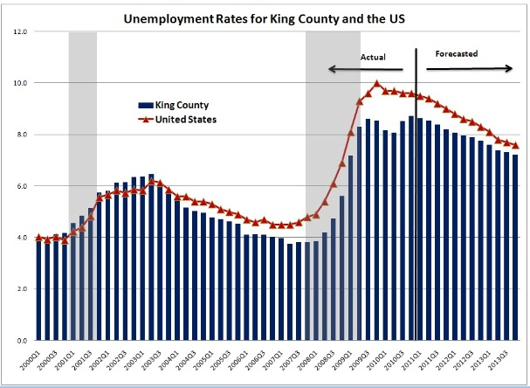
How Does Unemployment in King County Compare to the Rest of the US? Aerospace, software and health are stable employers that have helped keep the King County rate of unemployment below the national rate. The rate is projected to come down only gradually for several reasons: discouraged workers coming back to the job market, new graduates on the job market for the first time, and an influx of unemployed from surrounding areas with higher unemployment. Forecasts are from Global Insight and Puget Sound Economic Forecaster.
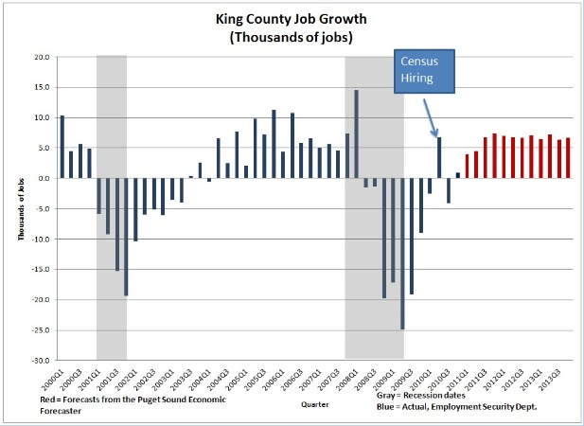

Job Growth to Get Back on Track in 2011. King County lost 85,000 jobs as a result of the recession. The Census hiring gave us a temporary boost in early 2010, but then gave most of them back up. We should see steady job growth in 2011. But as the next chart shows, it will be 2014 before all the jobs are made back.
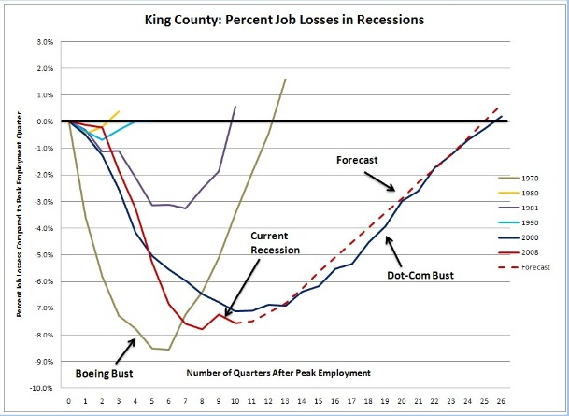
How Bad is this Recession Compared to Previous Ones? This chart shows the percent loss in King County jobs from the previous peak for the last 6 recessions, including the current one. When the percent loss gets to 0% then all the lost jobs have been made back. The current recession has resulted in a greater loss of jobs, percentage-wise, than any since the "Boeing Bust" of 1970. Current projections are that the time until all the jobs lost since 2008 are made back will be 25 quarters from the start in 2008. That would be some time in 2014. Only the "Dot-Com Bust" of 2000 was as long. (Forecasts are from the Puget Sound Economic Forecaster)
Long Term Unemployment is a Worrisome Trend in King County. The whole household tightens its belt when someone in the household is out of work for a long period of time, cutting back spending in the local economy. It also can mean that the household will run through its savings, increasing foreclosures. The longer someone is out of the workforce, the more difficult it can be to reconnect. The State has two Federally funded programs for those whose standard unemployment benefits have been exhausted after 26 weeks. One is the Emergency Unemployment Compensation (EUC) program that extends benefits for another 27 weeks beyond the initial 26 weeks of benefits. The other is the Extended Benefits (EB) program that adds another 20 weeks of benefits if needed beyond the 53 weeks covered by standard unemployment and EUC. The number of claimants on both programs has decreased in recent months. The worry is that a portion of those no longer on the EB program have not found jobs, but rather became a "99-er" - someone who has been out of work for more than 99 weeks and whose benefits have completely run out. Statewide, the number of “99-ers” is increasing by 1,000 per week.
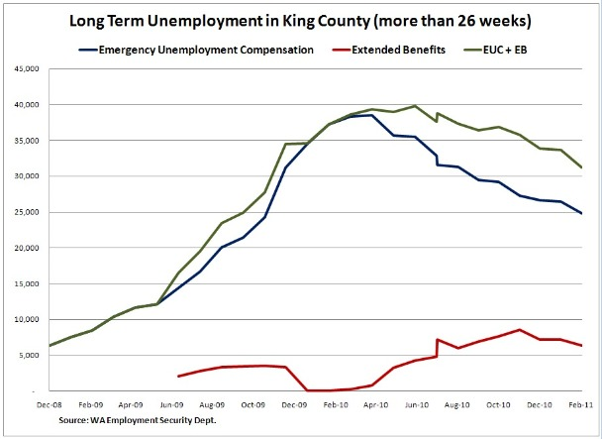
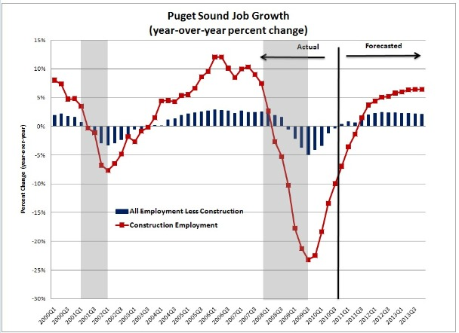
Construction is the Most Volatile Employment Sector in the Region. Forecasts from the Puget Sound Economic Forecaster do not anticipate positive growth in construction employment until mid 2011. The Puget Sound Region includes King, Pierce, and Snohomish counties.

