Puget Sound Taxpayer Accountability Account
Analyst: Miranda Leskinen

 |  | Expenditures |  | Revenues |  | FTEs |  | TLTs
2024 Revised Budget, Annualized |  | $7,845,288 |  | $9,785,000 |  | 7.0 |  | 0.0
2025 Base Budget Adjustments |  | $116,653 |  | $0 |  | 0.0 |  | 0.0
2025 Decision Packages |  | $1,959,813 |  | ($4,675,000) |  | 0.0 |  | 0.0
2025 Proposed Budget |  | $9,922,000 |  | $5,110,000 |  | 7.0 |  | 0.0
% Change from prior biennium, annualized |  | 26.5%
Dec. Pkg. as % of prior biennium, annualized |  | 24.9%
Major Revenue Sources: State revenue from the state Puget Sound Taxpayers Accountability Act Fund.

Description

The Puget Sound Taxpayers Accountability Account (PSTAA) is funding solely supported by state moneys associated with a sales tax offset assessed on Sound Transit 3 projects. PSTAA funds are to be distributed to King, Pierce, and Snohomish counties proportionately based on the population of each county that lives within Sound Transit’s jurisdictional boundaries. An April 2020 forecast by Sound Transit estimated that the County will receive $318 million in funding between 2019 and 2035 to be invested in early learning facilities, the King County Promise (post-secondary educational support), and community-based support for K-12 learnings. The council adopted Motion 15492 in August of 2019 that allocates funding over the life of the fund and approved an implementation plan (Motion 15673) in September of 2020 that further governs how the funds will be used.

Summary of Proposed Budget and Changes

Motion 15492 requires that up to 7% of proceeds over the life of the account be used for evaluation and administrative costs. Of that, up to 10% of each year's evaluation and administration moneys will be used to provide for technical assistance and capacity building for small organizations, partnerships, and groups to provide services like legal, accounting, human resources, and leadership development support.

The remaining proceeds would then be distributed over the 15-year life of the fund among the three priority areas identified in Motion 15492 as follows:
- 52% for Early Learning, including up to 7.5% for home care provider dedication.
- 38% for King County Promise, distributed as follows:
  - 45% to K-12
  - 45% to Postsecondary
  - 10% to Community Based Organizations
- 10% for K-12 Community Based Organizations (identified as Love and Liberation in the implementation plan)

The 2025 proposed PSTAA budget is approximately $9.9 million, which is a 26% increase from 2024. The proposed budget includes a technical adjustment to align revenues and expenditures based on the most recent Sound Transit revenue projections from October 2023. According to Executive staff, PSTAA is proposing to deploy its stabilization reserve to offset 2025’s revenue reduction and sustain its current levels of program implementation. Table 1, provided by Executive staff, shows planned PSTAA spend across implementation plan categories through 2025.

Table 1.
PSTAA Expenditures (by Category) through 2025
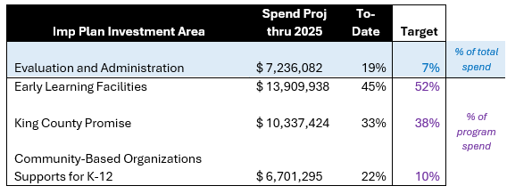
As noted by Executive staff:
- The cumulative spend through 2025 represents only ~12% of lifetime anticipated PSTAA revenues.
- The near-term investment allocations seen in the table were intentionally designed in partnership with stakeholders to best support PSTAA programming goals, including equity considerations, following reduced revenue forecasts reported by Sound Transit in 2021.
- Investment allocations adjust over time to balance to the [PSTAA] implementation plan; however, these continue to be refined over time in response to ongoing revenue forecast updates and program implementation needs.

Key Issues

Issue 1 – Revenue Monitoring

Council may desire to regularly track the progress of PSTAA revenue projections and investments during 2025 and beyond.

The Rate Stabilization Reserve, identified in the PSTAA financial plan, buffers against revenue volatility to sustain program and contract commitments.

