STAFF REPORT

Agenda Item: | 8 | Name: | John Resha
Proposed No.: | 2012-B0068 | Date: | April 24, 2012
Invited: | Dave Jutilla, Chief Deputy, King County Sheriff’s Office

SUBJECT

Briefing on the implementation of Zone Patrol Operations in the King County Sheriff's Office (KCSO).

BACKGROUND

The KCSO provides law enforcement services for County and State laws in King County. It has both regional and local unincorporated areas responsibilities. In addition to local and regional law enforcement services, The KCSO provides contracted law enforcement through approximately fifty agreements. These contracts include:

- KCSO as the local police agency for twelve suburban cities
- Transportation police for Metro, Sound Transit and the King County Airport
- Tribal police for the Muckleshoot Tribe
- Housing Authority policing in two communities
- Fire investigations in fifteen cities
- Marine patrol services for eight cities
- Air support for the Coast Guard, Washington Department of Ecology and King County Department of Natural Resources

In addition to providing local law enforcement services, the KCSO has a number of regional responsibilities, including the operation of the county’s Automated Fingerprint Identification System (AFIS), E-911 call and dispatch, and King County Search and Rescue, and air and marine patrol. The Sheriff is also responsible for armed security in the county’s courthouses.

King County Sheriff's Office Reorganization
In 2010, the Sheriff began implementing significant portions of reorganization. These actions included:

- Realigning Precinct Two which includes North/East: North Bend, Woodinville, Kenmore, Sammamish, and Skykomish and Precinct Three (East/South: Covington, Maple Valley, Newcastle, Muckleshoot Tribe, and Beaux Arts Village) into a new single East Precinct under a single command structure

- Realigning the KCSO by consolidating management structures, shifting Special Operations into its support role of Patrol Operations, and identifying a senior professional manager (Chief Deputy) for KCSO

- Restructuring physical precinct and other KCSO locations, including establishment of the East Precinct Command Center in Sammamish, and providing for shared desks and computer login locations (also known as "hot desking") at remote city locations

2011 Audit
A King County Auditor performance audit of the KCSO in 2011 identified a need for alternative workload and staffing levels, as overtime was being relied upon to meet the number of programmed posts. This reliance on overtime in lieu of dedicated FTE/positions resulted in more than a $1 million overage in overtime spending for KCSO.

Key Workload and Staffing Level Audit Findings and Recommendations (from the 2011 King County Auditor's Report):
- The number of calls for service responded to by patrol has declined substantially, likely as a result of annexations. Response times have improved countywide.
- FTE staffing levels for patrol have been reduced by relatively the same amount as workload declines attributable to annexations. However, patrol minimum staffing levels by patrol district have not been reduced to the same degree. With FTEs having been reduced more than minimum staffing levels, the use of overtime to cover patrol staffing posts has increased.
- The KCSO has not yet developed monitoring and reporting systems that would enable it to report on other aspects of workload and performance, such as the results of its proactive, community policing efforts.
- The KCSO has streamlined its operations by consolidating precincts and reducing command staff, and is currently exploring further operational changes which are expected to improve patrol efficiency by combining patrol districts.
- Develop a patrol staffing plan tied to workload and performance.
- Develop a plan that identifies its patrol operations goals, activities, measures of success and workload, and including community- and problem-oriented policing activities.
- Pursue economies of scale by continuing to explore merging precincts and patrol districts.

KCSO largely agreed with the findings of the audit and established a goal to realign and define their business processes in to2012. As an early step in responding to these audit findings, KCSO initiated a process evaluation, known as a Lean kaizen event, to identify a better approach to overtime/staffing of the unincorporated areas. The event included staff, management, and labor representatives working together. One of the results of the lean process was identifying a more efficient approach to staffing the unincorporated areas precinct operations. Consequently, the, KCSO is implementing a zone approach in the unincorporated areas, identifying four geographic zones, plus a modifying its approach for Vashon Island police staffing.

Zones versus Precincts
KCSO's historical approach to staffing has been a Precinct model, with individual command structures and independent operations based on and around geographic boundaries. This system resulted in an imbalance of staffing in precincts, with some precincts requiring overtime to meet staffing minimums while other precincts had more than minimum levels of staffing available. Additionally, the precinct model required the replication of individual command staff structures resulting in inefficiencies.

The zone approach is still geographically designated for roll call purposes, it addresses inefficiencies by functioning as one "precinct" with more effective and efficient accountability between deputies, sergeants, captains, and the major as shown in the below DRAFT Organizational Chart for unincorporated areas patrol operations (note this organizational chart is draft as KCSO is still finalizing implementation issues with labor):

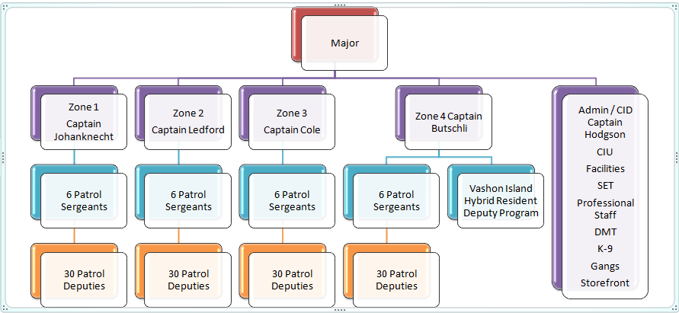

One of the ways that this new zone approach is markedly different is that it allows for flexible staffing of zones. The deputies are assigned to one of the four zones for roll call, dispatch and patrol, they can then be "slid" from one zone to another if needed, based on daily operational needs and minimums staffing requirements, or to respond to leave, training and other absences.

The lean process helped identify that the operational needs should be influenced by both safety and dispatched calls for service (DCFS), which is an indicator of workload for KCSO and are characterized by a 1 to 4 priority with 1 being the highest priority for response. The chart below compares draft zone-based staffing levels over the DCFS over the twenty-four hour period. This chart highlights the relationship between the new staffing model and the priority 1 and 2 calls. KCSO anticipates that based on this model, at non-peak times, deputies will not be available to respond to low priority (3-4) calls.

KCSO is finalizing issues with labor and is implementing the Zone staffing model. Chief Dave Jutilla will brief the Law, Justice, Health and Human Services committee regarding this approach and its implications to law enforcement in the unincorporated areas.

Potential Budgetary Implications: This approach is intended to reduce overtime expenses and better align KCSO staffing with unincorporated area needs.

ATTACHMENTS

- Zone Staffing Model Presentation

Lean Kaizen events are events where staff and management work together to identify and create rapid, breakthrough improvements in as little as a few days, while creating a continual improvement culture. More information can be found at: http://www.kingcounty.gov/employees/Lean.aspx

