STAFF REPORT

Agenda Item: | 4 | Name: | Jenny Giambattista
Proposed No.: | 2024-0188 | Date: | August 22, 2024

SUBJECT

Proposed Ordinance 2024-0188 would authorize the King County Executive to execute an agreement between the Longacres Owners Association and the Wastewater Treatment Division.

SUMMARY

Proposed Ordinance 2024-0188 would authorize the King County Executive to execute an agreement between the Longacres Owners Association and the Wastewater Treatment Division (WTD). The agreement would allow the Longacres Owners Association to own and utilize an existing, almost 30-year-old effluent cooling system at the Longacres office park, and equipment at the adjacent WTD’s South Plant.

The effluent cooling system is a legacy sewer heat recovery system, utilizing the wastewater effluent line from the South Treatment Plant in Renton. The system was built in the mid-1990s through an agreement with the Municipality of Metropolitan Seattle, the predecessor to WTD. In 2021, the Boeing Company sold the Longacres property to Unico Properties. Portions of the property, including the effluent cooling system, will be transferred to the Longacres Owners Association in 2024.

The proposed agreement with the Longacres Owners Association memorializes commitments made in the 1992 agreement for user ownership of the equipment utilized in the effluent cooling system. The proposed agreement also includes key Council-approved terms from Ordinance 19161, namely that the user is responsible for the cost and risk associated with operating and maintaining the system; the user will reimburse the County for any costs incurred by the County to operate or maintain the system including materials or staff time; and, the user will pay an Energy Transfer Fee to King County based on actual energy transferred into the County’s wastewater line.

WTD does not expect any changes in the current operation of the heat recovery system or South Plant operations as a result of this proposed agreement.

BACKGROUND

What is sewer heat recovery? Wastewater contains thermal or heat energy. Various technologies have been and are being developed that allow for the potential transfer of heat energy to or from wastewater pipelines to provide heating and cooling to individual buildings. Sewer heat recovery is the process of capturing the heat energy from wastewater as it flows through pipelines to the treatment plant.

History of the Longacres Agreement. In 1992, the former Municipality of Metropolitan Seattle wastewater utility, now known as the King County Wastewater Treatment Division, and the Boeing Company realized the potential to utilize effluent (treated water leaving the plant) from the Municipality of Metropolitan Seattle's South Treatment Plant in Renton to cool buildings at the adjacent Boeing Longacres building complex, as an early sewer heat recovery system. Metro and Boeing signed an agreement in 1992 for the construction, operation, and ownership of an effluent cooling model project at the site. The effluent cooling system was constructed, has been operating successfully since the mid-1990s, and is currently serving the property located at 1301 SW 16th Street, Renton, WA. The agreement expired in 2017.

The sewer heat recovery system transfers six to eight percent of the effluent from the South Treatment Plant to cool 1 large building (former Boeing Training Center) at the Longacres site. (According to WTD, this energy use is about the estimated amount of energy needed to cool about 320 typical homes in King County annually.) The effluent is then returned to the South Treatment Plan immediately downstream of its withdrawal point, just at a higher temperature.

During the term of the 1992 agreement, ownership of most components of the effluent cooling model project passed to Boeing. However, the transfer of title to the components may not have been formally memorialized. In December 2021, the Boeing Company sold the Longacres site to Unico Properties, and in 2024 Unico will transfer ownership to the Longacres Owners Association. The Longacres Owners Association wishes to continue using the existing effluent cooling system.

Figure 1
Longacres Campus Chiller System
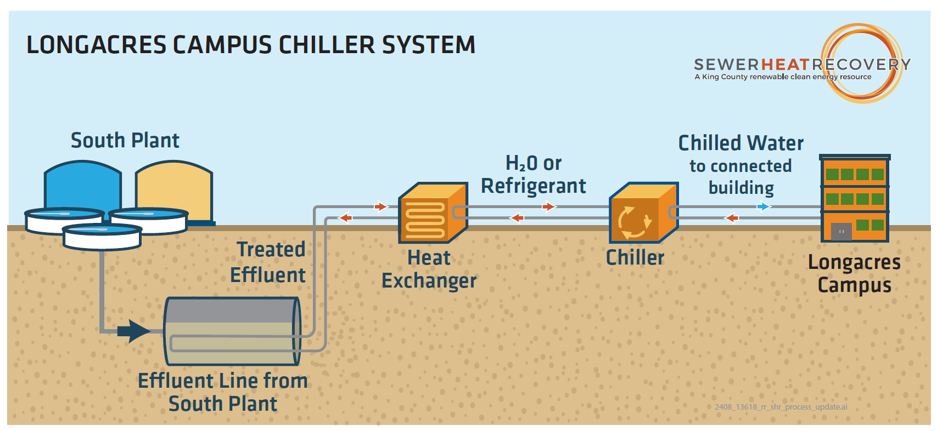

Ordinance 19161. In September 2020, Ordinance 19161, creating a sewer heat recovery pilot program for new sewer heat recovery installations, authorizing a template agreement for users, and authorizing the executive to execute up to three agreements with new sewer heat recovery users, was enacted. The pilot projects are intended to provide information to WTD to assist in developing appropriate energy transfer fee levels for subsequent projects. According to Executive staff, the Longacres site is an established project, already constructed and operational, and as such would not yield useful data on the market for new installations, and thus it is not suitable for inclusion as a pilot project in the sewer heat recovery pilot program.

ANALYSIS

Proposed Ordinance 2024-0188 would authorize the Executive to execute an agreement with Longacres Owners Association for the sale and use of thermal energy from King County wastewater. The agreement with Longacres Owners Association, Attachment A to this ordinance, for the sale and use of thermal energy from King County wastewater at the Longacres site in Renton memorializes commitments made in the 1992 agreement including transfer of ownership of most system components to the site owner; upholds the intent and terms of the template agreement for the sewer heat recovery pilot program in Ordinance 19161, which holds the user responsible for operation, maintenance, and risk associated with operating the system; and provides for the financial terms in Ordinance 19161 including reimbursement for county staff time and user payment of an energy transfer fee to provide a public benefit for generating revenue. The agreement sets the energy transfer fee at the same level as specified in Ordinance 19161, $0.005 per ton hour energy transferred from the County’s wastewater to the Project. This is estimated to generate about $2,000 a year in revenue. Currently, the thermal energy user is not paying a fee for the use of the effluent.

To the extent that any Renewable Energy Credits or other environmental credits become available during the term of this agreement, the user and the County would share ownership evenly of any such credits.

The agreement also allows for the use of thermal energy to expand at Longacres beyond the one building currently served. Any increase in heat transferred into the effluent would be reflected in a proportionally higher energy transfer fee paid to WTD.

While the agreement formally transfers ownership of most system components to the site owner, WTD reports the flow metering system should be permanently owned and operated by the County consistent with other sewer heat recovery projects. This is the system that provides flow and temperature data to the county. The proposed agreement provides County ownership of the flow metering system and since it is obsolete and needs to be upgraded, WTD expects to replace it for $180,000.

The agreement specifies that the County’s operation of its wastewater conveyance system shall have priority over the Energy’s users use of the effluent and that the County may require the Energy user to temporarily suspend and/or terminate operation of the heat recovery operation if the County determines that such suspension of operation is necessary to ensure reliable performance of the wastewater system. Similarly, in the agreement County makes no warranties as to the quality or quantity of wastewater available in the County’s South Plant effluent line delivered to the thermal energy user.

The agreement becomes effective upon execution by both parties and will remain in full force until the 20th anniversary of the effective date.

WTD does not expect any changes in the current operation of the heat recovery system or South Plant operations as a result of this proposed agreement.

ATTACHMENTS

- Proposed Ordinance 2024-0188 and its attachment
- Transmittal Letter
- Fiscal Note

Under the proposed agreement, all of the items in Figure 1 to the right of the effluent line from South Plan would be owned by Longacres.
A “ton-hour” is measured as a function of the number of gallons of water that pass through the Energy Transfer Station, the temperature difference of the water at the delivery and return point, resulting in the aggregate BTW transfer occurring within the Energy Transfer Station. 1 ton-hour =12,000 BTU.

