Lease Property Summary

Photo of Property

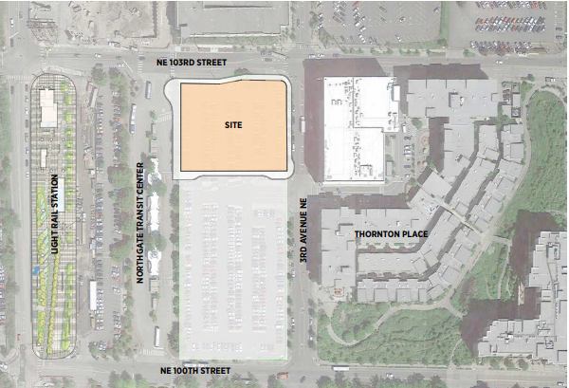

Property Owner: King County Metro
Address: 301 NE 103rd Street, Seattle WA, 98125
Term: 75-year ground lease
Rent: $1.00 per year, paid in a single payment at lease commencement
Square Footage: 48,060
Council District: One
Funding Source: 36250 - EXT L T SPACE FAC RENT
Previous Location: N/A
Offer Expiration: The offer does not expire. The original ground lease, covering both the residential and commercial elements of the project closed December 21, 2023, and remains in effect for 75 years. The developer team requested that King County bifurcate the current ground lease into two ground leases separating out the residential and commercial components of the future development to solve a funding challenge to complete the commercial space. Creating a separate commercial lease allows an additional funder, who can close the construction funding gap currently guaranteed by Community Roots Housing, to participate in the commercial project and protects the residential lenders from any possible default due to the financing of the commercial space. Other than minor revisions necessitated by the bifurcation process, there are no material changes to the terms and conditions set forth in the original ground lease approved by Council.

Declared Surplus December 6, 2018

Lease Synopsis:
Per RFQ/C No. 1207-18-VLN issued in 2018, Metro entered into a 75-year ground lease with the development team of Bridge Housing and Community Roots Housing to redevelop the northern half of the Northgate Park and Pool lot shown on the site plan attached hereto. The development team is developing and will operate 232 units of housing affordable to households making at or below 60 percent of the area median income (AMI) and three additional units for on-site management, for a total of 235 housing units. Ten percent of the project’s units are set-aside for system-connected households. The project includes a total of 10,669 sf for the childcare facility on the ground floor and its adjacent outdoor playground, a 1506 sf retail bay, and a 264 sf comfort station designed and delivered for Metro as a part of this project. This lease applies to the commercial components of the beforementioned project.

This project meets the goals of Metro’s Equitable Transit Oriented Communities policy that prioritizes affordable housing outcomes on Metro property and strengthening the pedestrian-orientation of transit communities. With the opening of Northgate Link light rail immediately adjacent to the neighboring Northgate transit center, Metro believes the Park and Pool parking is no longer needed to support Metro’s riders and pursuing redevelopment is the site’s highest and best use.

Context
Located just eight miles from downtown Seattle, Northgate is an evolving neighborhood. Long the home of one of America’s oldest malls, the neighborhood is a designated urban center and in recent years has seen new housing, community amenities, the redevelopment of the Northgate Mall property, the introduction of professional hockey facilities, and the new multi-modal transit station providing light rail, bus, bike, and pedestrian connections and a large Transit Oriented Development delivered in phases, which is anticipated to serve more than 15,000 persons per day in 2030. This affordable housing project represents the first phase of King County’s Transit Oriented Development at Northgate. The project, a 235-unit mixed-use affordable housing project, includes three ground floor commercial spaces, specifically a childcare center, a comfort station for Metro drivers, and a retail space.

Rationale for transaction: ​The original transaction meets a stated goal of the RFQ/C to provide land at no cost for affordable housing as a part of the Transit Oriented Development strategy at the Northgate Transit Center and satisfies both King County and City of Seattle goals to locate subsidized housing proximate to frequent transit service to have a greater impact on lowering the overall cost of living for qualified households. Bifurcating the existing ground lease into two leases, residential and commercial, does not diminish the project’s success or change the project’s goals. Rather, bifurcating the existing lease allows the county’s original project vision to be realized by creating conditions necessary for the developer to close the construction funding gap and allows the residential funders security from any uncertainty associated with the commercial project. The project’s commercial program has a funding gap currently covered by a guarantee from Community Roots Housing. Bifurcating the lease and approving the commercial lease will facilitate additional funding for the commercial piece of the project. This transaction is the first phase of a multi-phased redevelopment of King County’s Northgate Transit Center properties.

Policy considerations: This project meets the goals of Metro’s Equitable Transit Oriented Communities Policy, is supported by the goals of King County’s Strategic Climate Action Plan, which calls out the importance of dense development and specifically affordable housing near transit as a key strategy for reaching climate goals, and delivers on the goals set forth in the establishment of King County’s Transit Oriented Development Bond Fund that seeks to target housing subsidies near frequent transit service.

Political considerations: Transit Oriented Development at Northgate has been a shared goal of the City of Seattle and King County for over a decade, with affordable housing as a key component. At the RFQ/C, both City and County funders partnered to secure funds for 200+ units of affordable housing targeting households at or below 60 percent of AMI at this location. Originally, the City and King County’s Department of Community and Human Services (DCHS) were each going to contribute $10 million towards the project. Subsequently, the City determined that it did not have the authority to fund a ground lease, as compared to a fee simple project; however, DCHS and the City agreed to shift the City’s $10 million to other King County projects, which allowed DCHS to double its contribution to $20 million. As the parties neared closing the combined ground lease, both Freddie Mac and Bank of America, two funders of the residential component of the project, expressed distress and an unwillingness to fund the project without a fully funded commercial space. The development team was still working to find commercial funders and both Freddie Mac and Bank of America were concerned that delay or inability to fully fund the commercial space could cause a whole project default. After joint problem-solving, Community Roots Housing signed a guarantee to fund the commercial project gap, but Community Roots Housing needs the commercial and residential project components split into separate leases to meet the terms required by the commercial lender which will fund the construction and release Community Roots from its guarantee. Community Roots’ guarantee allowed the original lease to close and construction to begin in January 2024 while the parties bifurcated the original lease.

Community considerations or partnerships: The Northgate neighborhood supports the provision of affordable housing in the station area. There is a desire for the project to deliver active space for the community. Metro believes the ground floor childcare center meets the community’s goal.

Fiscal considerations: This property’s unrestricted fair market value was set by appraisal in February of 2021 at $12.85M. The appraisal also valued the affordable housing restriction imposed by the RFQ/C and determined that the restricted land value was $5M. King County Metro entered into a low-cost ground lease on the basis that the County will retain long-term ownership and eventually all improvements made to the site. The value of the ground lease has been paid in full. Bifurcating the lease and creating two leases, one residential and the other commercial, does not directly affect the County. Bifurcating the existing lease provides a pathway to fully funding the commercial piece of this project and solidifying the commitments made by the low-income housing tax credit lender and the permanent lender, who have both stated that they will not provide funding without a fully funded commercial project.

CIP/operational impacts: The original ground lease reduced commuter parking at the Northgate Park and Ride lot by 186 stalls beginning in 2023 and required the relocation of ADA compliant parking stalls to the southern portion of the remaining Park and Pool lot. Bifurcating the ground lease will have no additional operational impacts.

Change in property use: The original ground lease replaced the 186 surface parking stalls available for commuter parking with 232 units of housing affordable to households making at or below 60 percent of AMI and three units for on-sight management for a total of 235 units; a comfort station for Metro operators; 10,000 sf childcare center; and 1,506 sf retail bay. Bifurcating the original ground lease into a residential lease and a commercial lease has no effect on the property’s use.

SEPA Review Required yes/no: No. A SEPA review was completed for the original ground lease. This bifurcation of the original ground lease into the residential and commercial ground leases is exempt from SEPA review because there is no change in use under WAC 197-11-800(5)(c).

King County Strategic Plan impact: This transaction does not affect the 235 units already under construction on the Northgate Park and Pool lot. Proceeding with this transaction allows the development team to secure a needed lender for the commercial development program and provides the residential lenders security from the commercial portion of this project, allowing the vision for the mixed-use affordable housing project to be realized. Proceeding with this transaction to add 232 affordable homes in the Northgate Station area meets two Strategic Plan goals: 1. encourage dense affordable housing near transit; and 2. reduce car trips. By locating a mixed-use, multi-family housing project adjacent to the existing Northgate Transit Center and proximate to the new Link station, this project both increases existing density and reduces car trips. Additionally, this project will be built sustainably, meeting the Evergreen Standard.

Equity and Social Justice impact: Proceeding with this transaction will provide 235 total additional homes, including the three units set aside for on-site management, 232 of which are to be affordable for households making at or below 60 percent of the AMI in the Northgate neighborhood of Seattle. Because this project is the redevelopment of a surface parking lot, it does not displace existing residents and is not expected to disproportionately impact low-income communities, communities of color, or limited English proficient communities at this location but rather, provides those populations with additional opportunities to live in the station areas. Locating affordable homes in the Northgate station area will promote greater use of the transit investment our region has made and will provide residents with excellent regional access to jobs and regional services and amenities.

Energy Efficiency impact: Converting a surface parking lot to a seven-story, mixed-use building will inevitably use more energy than the existing surface parking lot does currently. The project does not include residential parking and it is expected that the future residents of the project will have the ability to use transit for most of their transportation needs, lowering their individual carbon footprints. The building itself is required to meet the Evergreen Standard, a green building standard specific to affordable housing projects.

Lease Alternatives Analysis
The alternative to pursuing this transaction is:
- to leave the existing ground lease in place and rely on the developer’s guarantee to self-finance the buildout of the childcare facility interior. One risk of that alternative is that if the project is not fully funded when the permanent lender, Bank of America, finances the long-term loan to the project after construction, then Freddie Mac might not underwrite that loan, potentially jeopardizing the whole project.

Vicinity View Map
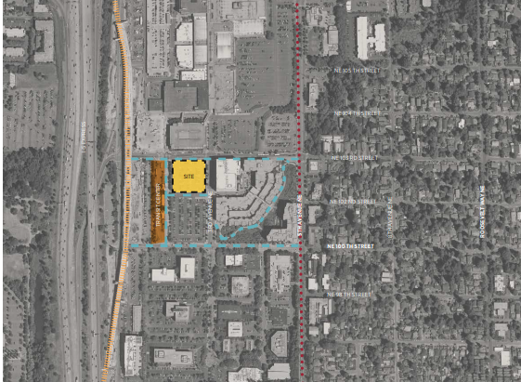

Parcel Map (placeholder until LBA)
