Veterans, Seniors and Human Services Levy Assessment Report

August 2022

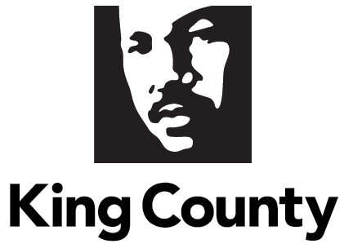

- Contents
II. Executive Summary 5
Background 5
Assessment of the Effectiveness of the VSHSL 8
Recommendations 24
III. Background 26
A. VSHSL Framework 27
1. Funding Structure 27
2. VSHSL Strategy and Program Structure 28
B. Department Overview 29
C. Key Historical and Current Context and Conditions 30
D. Report Methodology 33
E. Community Engagement 34
IV. An Assessment of the Effectiveness of the VSHSL 37
A. An Analysis of Investments by Geographic Area 39
1. How the VSHSL Distributes VSHSL Investments Across King County 39
2. VSHSL Service Sites 40
3. VSHSL 2018-2021 Service Participants 42
B. A Result-Based Analysis of the Impact the VSHSL Has Made 45
1. Housing Stability 47
2. Healthy Living 53
3. Financial Stability 59
4. Social Engagement 63
5. Service System Access and Improvement 71
C. An Analysis of Levy Proceeds to Fund Technical Assistance and Capacity Building 80
1. Technical Assistance for RFPs (Application Assistance) 80
2. TA/CB Funds Awarded to Small Providers 81
3. TA/CB Consultant Supports 81
D. An Analysis of the VSHSL’s Work in Advancing Equitable Access to Levy Resources 82
1. Community Partnership 82
2. County Infrastructure 83
3. System Partnerships and Filling System Gaps 85
4. Equity-Focused Funding Decisions and Programming 86
V. Recommendations For a Renewed VSHSL 89
A. Maintain or Modify the Housing Stability Programming 90
1. Continue to Increase the Number of Affordable Homes and Continue Strategies That Prevent Housing Loss 90
2. Increase Access and Speed to Open Affordable Housing 91
B. Maintain or Modify the Healthy Living Programming 92
1. Sustain and Explore Increasing Investments in Gender-Based Violence Prevention Programs to Address Root Causes of Violence and Abuse 93
2. Explore Community-Based Approaches that Reimagine Community Safety 93
3. Sustain the Geriatric Regional Assessment Team’s Ability to Support Senior Health in the Short- and Long-Term 93
4. Explore Expansion of Investments to Prevent Behavioral Health Crises 93
C. Maintain or Modify the Financial Stability Programming 94
1. Expand the Collaborative Case Management (CCM) Program to Meet Needs. 94
2. Modify and Increase Flexibility for Veteran Employment and Training Programs 94
D. Maintain or Modify the Social Engagement Programming 94
1. Redefine the Virtual Village Concept as a Model for Aging in Place 95
2. Consolidate Separate Veteran and Senior Caregiver Community Building and Respite Strategies 95
3. Increase Investments to Support Those Reentering from the Criminal Legal System 95
E. Maintain or Modify the Service System Access and Improvement Programming 95
1. Maintain Community-Centered Programming for Survivors of Gender-Based Violence. 96
2. Consolidate Investments for People with Disabilities and Create a Comprehensive Investment for the Disability Community. 96
3. Expand Role of Veteran Pathfinders to Include Direct Services to Veterans 96
4. Increase Flexibility of Resources Supporting the Levy Provider Network 97
5. Strengthen King County’s Nonprofit Workforce Through Continued Wage Studies and Explore Opportunities to Decrease Livable Wage Disparities 97
F. Alignment and Coordination with Best Starts, MIDD, and other Federal, State, and Local Funding Streams 97
1. Strengthen Integration and Alignment across the Regional Human Services System 98
2. Invest in County Staff Capacity to Connect Residents and Resources 99
G. Maintain or Modify the Distribution of Levy Funds Among Population Groups or Result Areas 100
1. Maintain Existing Result Areas and Commitment to the Three Priority Populations 100
2. Increase Total Resources to Better Address the Scale of Community Needs 100
3. Create an Emerging Needs Fund to Flexibly Meet Community Needs 100
VI. Assessment and Recommendation Related to Gender-Based Violence 101
A. Assessment of Current Needs and Funding Opportunities 101
B. Recommendation 105
1. Sustain and Explore Expanding Investments for Gender-Based Violence Services, Specifically for Mobile Advocacy Services for Survivors of Domestic Violence. 105
VII. Assessment and Recommendation Related to Services for Individuals with Behavioral Health Conditions 105
VIII. Conclusion/Next Actions 106
IX. Appendices 108
A. Appendix A: Motion 16129 108
B. Appendix B: 2022 VSHSL Renewal Community Engagement Meetings 110
C. Appendix C: 2018-2021 VSHSL RFP Community Planning Sessions 112
D. Appendix D: VSHSL Countywide and Mobile Services 114
E. Appendix E: VSHSL Funded Housing Developments 117

Charts, Maps and Tables
Chart 1: VSHSL Funding Structure 2019-2023 28
Chart 2: VSHSL’s 2018-2023 Investments Grew County Funding Significantly for Gender-Based Violence, Legal Aid, and Senior Centers 32
Chart 3: VSHSL Mobile Advocacy Survivors Served by Race 104

Map 1: 2021 VSHSL Service Sites 41
Map 2: Distribution Among Zip Codes of 2019-2021 VSHSL Service Participants 42
Map 3: Distribution of King County Residents, 18 and Older by Zip Code 43
Map 4: COO Composite Index of Health & Well-Being Measures in King County 44

Table 1: VSHSL Housing Stability Strategies 48
Table 2: VSHSL Healthy Living Strategies 53
Table 3: VSHSL Financial Stability Strategies 59
Table 4: VSHSL Social Engagement Strategies 64
Table 5: VSHSL Service System Access and Improvement Strategies 72
Table 6: King County Funding for Gender-Based Violence, 2012-2017 Compared to 2018-2023 101

Executive Summary

Background
King County’s Veterans, Seniors and Human Services Levy (VSHSL) expands access to critical human services to improve overall health and well-being, create thriving communities, and reduce disparities throughout King County. The VSHSL is a six-year property tax levy that invests in three priority populations:
- veterans, servicemembers, and their families;
- seniors and their caregivers; and
- other resilient communities.

In 2017, King County voters approved the current VSHSL, that expires December 31, 2023. The King County Executive and King County Council are now considering whether, and in what form, a renewal levy should go to the voters. To begin the discussion and planning process, the County Council passed Motion 16129 on May 17, 2022, requesting an assessment report of the VSHSL from the County Executive. Motion 16129 is included as Appendix A. This report will inform deliberations about the potential renewal of the VSHSL. It includes an assessment of the existing VSHSL and recommendations for a renewed Levy.

VSHSL Framework
The VSHSL’s levy rate of $0.10 per $1,000 in assessed valuation generates more than $55 million per year in King County. As directed by Ordinance 18555, King County sets aside at least one percent of funds annually for technical assistance and capacity building, and divides the remaining proceeds into thirds among the Levy’s focus populations to provide regional health and human services and capital facilities: one-third for veterans, military servicemembers and their respective families; one-third for seniors and their caregivers; and one-third for vulnerable populations (also referred to as resilient communities)., , , , , Throughout this report, these three groups may be referred to as the Levy’s priority populations. Within each priority population allocation, at least 25 percent of the funding annually is dedicated toward housing stability investments.

The VSHSL Implementation Plan structures the Levy’s focus on achieving outcomes for its three priority populations in five result areas:
- housing stability,
- healthy living,
- financial stability,
- social engagement, and
- service system access and improvement.

Department Overview
The Department of Community and Human Services (DCHS) manages a broad range of programs and services with a mission to provide equitable opportunities for people to be healthy, happy, and connected to community. DCHS administers the VSHSL to support community-led and community-informed organizations that are reflective of and embedded in the communities they serve.

Key Historical and Current Context and Conditions
Voters approved implementation of the VSHSL in November 2017. It is the third iteration of the Veterans and Human Services Levy initially approved in 2005 and renewed in 2011., Implementation of the VSHSL began in 2018 after the approval of the VSHSL Transition Plan by the King County Council in November 2017 through Ordinance 18638. The VSHSL Implementation Plan was approved by the King County Council in July 2018 through Ordinance 18768.
By early 2020, most of the programming directed by the VSHSL Implementation Plan was procured, and the VSHSL was firmly establishing itself as a flexible funding source with the ability to serve those that others could not. However, the arrival of the COVID-19 pandemic undermined housing stability, healthy living, financial stability, and social engagement, even for many residents that were secure in these areas before the pandemic. Service system access evolved to incorporate more virtual and hybrid services, and it became even more challenging as providers adjusted services to fit the changing landscape while facing staffing shortages. In response, the VSHSL worked with its providers to adjust current programming as needed and used unspent and unallocated Levy funding to introduce new services to address emerging needs.

Report Methodology
DCHS developed this report, which covers the VSHSL’s first four years, from 2018 through 2021. To inform this report, DCHS compiled qualitative and quantitative data about VSHSL programs that was available at the time of this report’s drafting:

- Program performance measure data,
- Feedback from VSHSL providers through annual program narrative surveys, and
- Preliminary community feedback acquired through VSHSL renewal conversations in the spring of 2022.

Community Engagement
The VSHSL has engaged with community throughout development and implementation to nurture partnerships and ensure programming is responsive to community needs. Community voice informed the VSHSL’s Implementation Plan, procurements, and funded programs and services. The community engagement adds to the performance measure data to inform the assessment and recommendations made in this report.

Between March and June 2022, the VSHSL hosted 20 community conversations, 20 focus groups/listening sessions, and 12 informational presentations. Appendix B lists the location of the community conversations and the participants of the focus groups and informational presentations.

Several themes emerged from the VSHSL’s multi-pronged community engagement:

- The VSHSL is a uniquely flexible funding source.
- The VSHSL expands organizations’ impact in the community.
- Technical assistance and capacity building (TA/CB) and other Levy provider supports help broaden organizations’ ability to serve the community.
- Housing affordability continues to be a pressing concern across populations.
- Performance measurement is necessary but sometimes burdensome.
- Additional resources are needed to retain and attract qualified staff.

Community partnership and feedback will continue to inform renewal planning should policymakers authorize a ballot measure to renew the VSHSL.

Assessment of the Effectiveness of the VSHSL
The 2018-2023 levy expansion has allowed the VSHSL to serve more than 146,000 people throughout King County with community-driven programming. It has expanded and widened its reach significantly, with a 69 percent increase in people served from 2017 to 2021. The renewed levy has made significant progress since its launch. The VSHSL has:

- funded over 300 programs.
- established infrastructure to advance racial equity and broaden its services throughout King County.
- transformed its data collection system and partnership with providers.
- distributed its investments and programming geographically, both in service availability as well as in service reach.
- made measurable progress, to be detailed throughout this report, in supporting King County residents with housing stability, healthy living, financial stability, social engagement, and system access.
- distributed key technical assistance and capacity building supports to strengthen smaller, community-based organizations.
- advanced equitable access to Levy resources for community providers and communities.
- conducted a 2021 Service Satisfaction Survey to hear from service participants, receiving responses that were overwhelmingly positive and which indicate high satisfaction.
Analysis of Investments by Geographic Area
The VSHSL achieves broad geographic coverage in its investments and services through intentional efforts: holding numerous community planning sessions throughout the county to gather community feedback to inform service needs, gaps, and best practices ahead of launching procurements (see Attachment C for a list of VSHSL community planning sessions); advertising these sessions and upcoming procurements through email and newsletter distribution and its online strategy and procurement tracker; offering assistance to support small applicants’ ability to respond to RFPs; and funding programs to provide services countywide.,

Thanks to those efforts, VSHSL services are distributed geographically, both in service availability (i.e., funded programs and service sites) as well as in service reach (i.e., program participants served), in ways that advance Equity and Social Justice (ESJ), follow the VSHSL Implementation Plan, respond to community feedback, and reflect the results of competitive procurement processes. A majority of VSHSL-funded programs offer countywide services, with some specifically providing mobile services, and physical service sites are available throughout the county.

Result-Based Analysis of Levy Impact
VSHSL follows the Results Based Accountability framework (RBA). The Levy has five result areas that each include a suite of strategies to advance the goals and outcomes outlined in the VSHSL Implementation Plan. The RBA framework asks: How much did we do? How well did we do it? Is anyone better off? This structure emphasizes outcomes that better measure and demonstrate how funded activities combine to change lives and drive achievements in the five Levy result areas.

Below is a summary analysis of the VSHSL’s impact:

- How much? Since 2018, the VSHSL has served more than 146,000 people throughout King County.
- How well? Results from the VSHSL’s 2021 Service Satisfaction Survey were overwhelmingly positive, showing high satisfaction with VSHSL-funded programs.

- Is anyone better off? Yes. Through its result area programming, VSHSL programming has:

- Housing Stability: Helped to prevent and reduce homelessness as well as address the affordable housing issue in King County. From 2018-2021, 80 percent of VSHSL Housing Stability program outcomes showed positive housing results – such as remaining housed or finding permanent housing.
- Healthy Living: Supported King County residents in pursuing happier, healthier lives and prevented bigger crises. From 2018-2021, 76 percent of Healthy Living outcomes showed
improved health and well-being.

- Financial Stability: Supported King County residents in gaining and maintaining self-sufficiency. From 2018-2021, 66 percent of VSHSL Financial Stability program outcomes showed increases in financial security through employment obtainment, education enrollment, public benefit/veteran assistance, or other progress on financial goals.
- Social Engagement: Helped King County residents feel more engaged in community. From 2018-2021, 57 percent of VSHSL Social Engagement program outcomes showed reduced isolation through increased feelings of connection or increased engagement in community.
- Service System Access and Improvement: Connected veterans, seniors, and other populations to human services while also improving the ability of these systems to coordinate and strengthen. From 2018-2021, 78 percent of VSHSL Service System Access and Improvement program outcomes showed connection to services through referral or direct service and 66 percent of VSHSL Gender-Based Violence program outcomes showed survivors made progress or met their self-defined goals each year.
The sections below provide an overarching summary of VSHSL outcomes in each result area to date.

Housing Stability
Strategies in the VSHSL’s Housing Stability result area promote housing stability for veterans, seniors, and other resilient communities. Eighty percent of Housing Stability program outcomes from 2018-2021 showed households were able to remain housed or find permanent housing. Figure 1 below shows examples of the VSHSL’s work in driving housing stability outcomes.

Figure 1: Example Housing Stability Outcomes

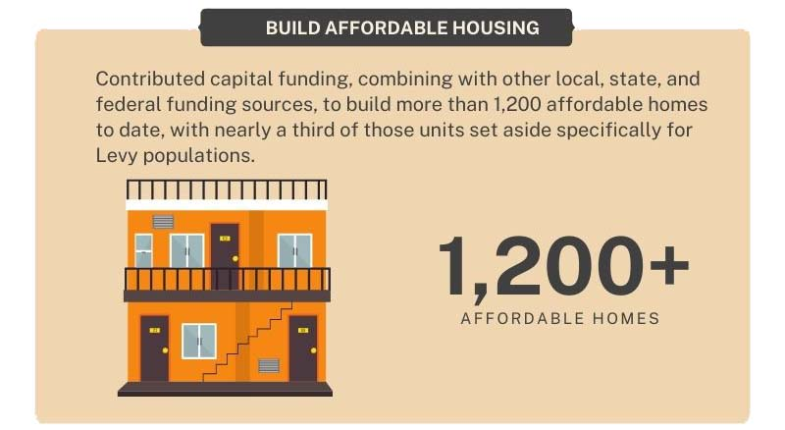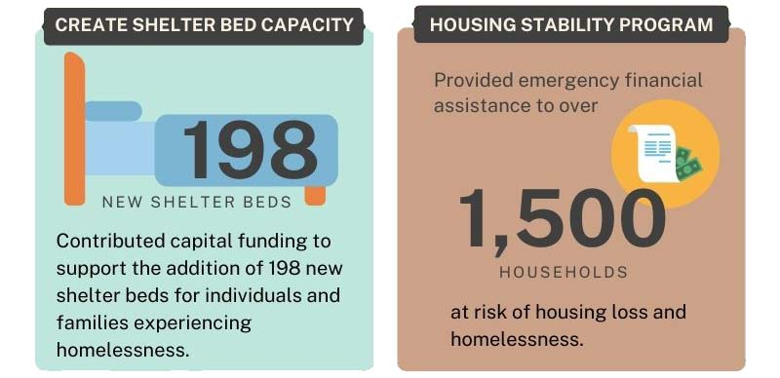
29

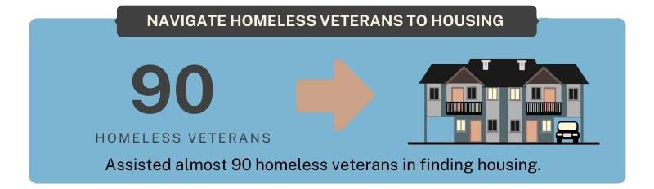
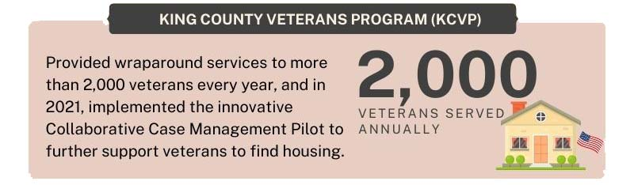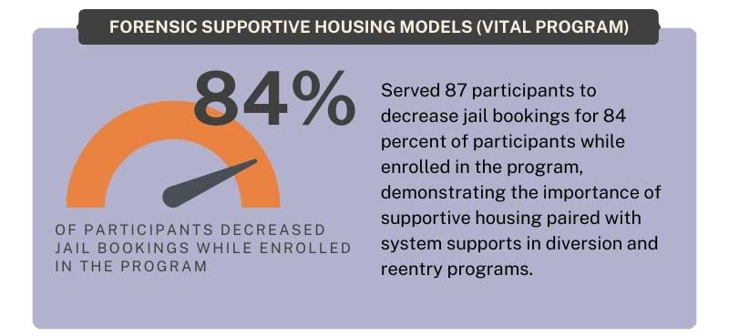
30
31

Healthy Living
Strategies in the VSHSL’s Healthy Living result area meet residents where and when they most need support, promoting better health outcomes for individuals and a more sustainable medical care system that anticipates and prevents emergencies. From 2018-2021, 76 percent of Healthy Living outcomes showed improved health and well-being. Figure 2 below shows examples of the VSHSL’s work in driving healthy living outcomes.

Figure 2: Example Healthy Living Outcomes

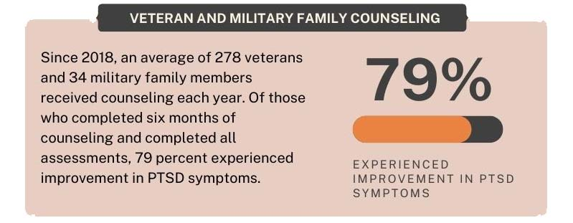

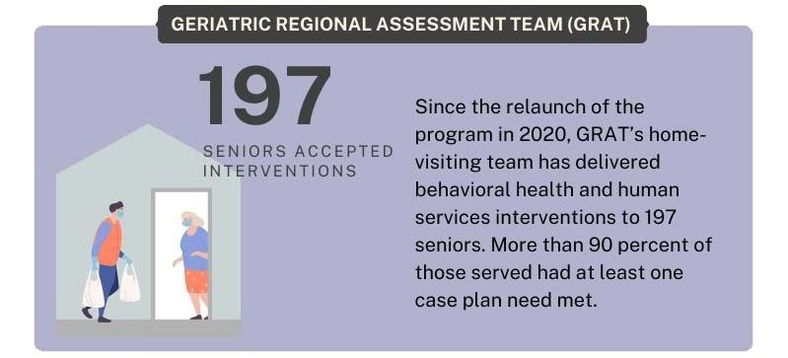
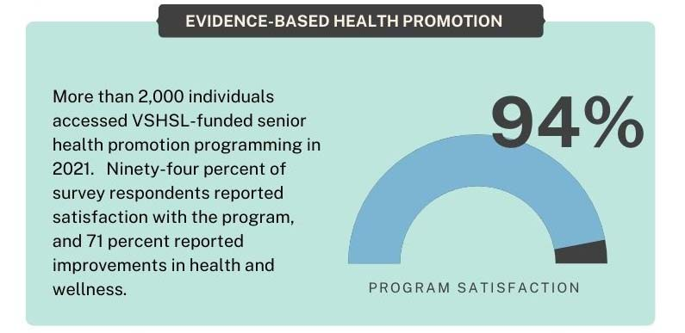
33

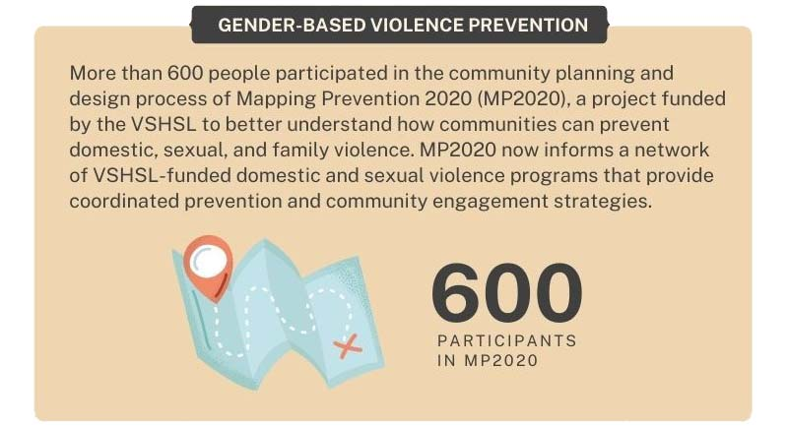
34

Financial Stability
Strategies in the VSHSL’s Financial Stability result area meet the Levy’s priority populations where they are, helping them identify roadblocks to financial well-being and giving them the tools to achieve financial independence and resilience. From 2018-2021, 66 percent of VSHSL Financial Stability program outcomes showed increases in financial security through employment obtainment, education enrollment, public benefit/veteran assistance, or other progress on financial goals. Figure 3 shows examples of the VSHSL’s work in driving financial stability outcomes.

Figure 3: Example Financial Stability Outcomes

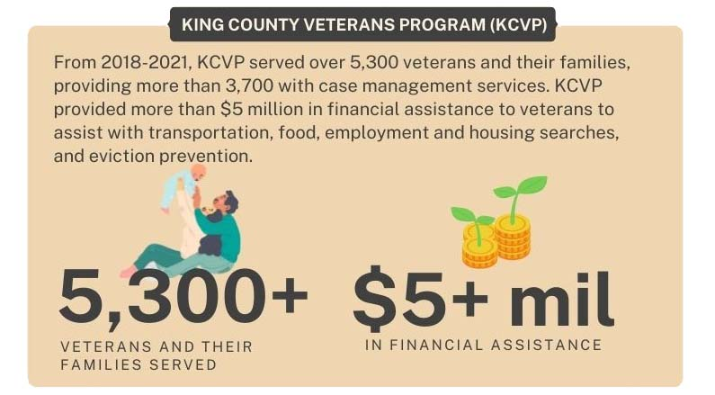

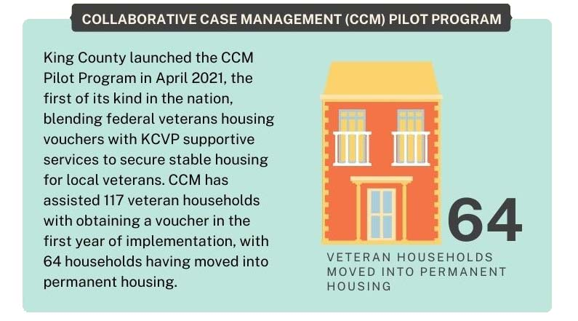
36

Social Engagement
Strategies in the VSHSL’s Social Engagement result area promote belonging through personal and system connections among those individuals most often isolated by systems, biases, miscommunication, or cultural differences. Fifty-seven percent of VSHSL Social Engagement program outcomes showed reduced isolation through increased feelings of connection or increased engagement in community. Figure 4 shows examples of the VSHSL’s work in driving social engagement outcomes.

Figure 4: Example Social Engagement Outcomes

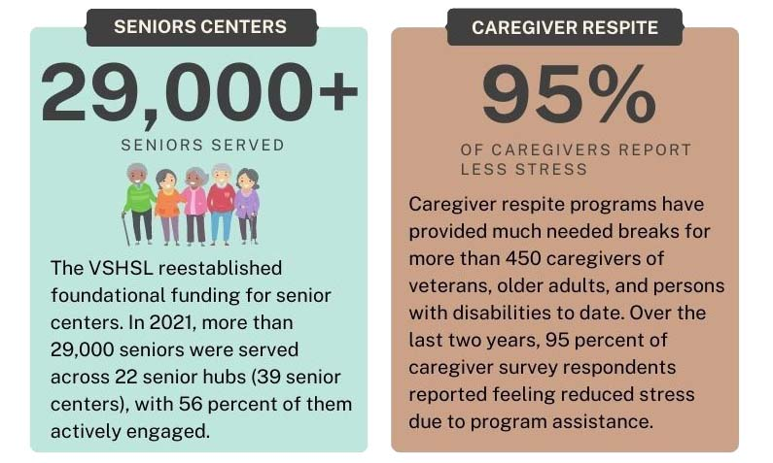
38, 39, 40

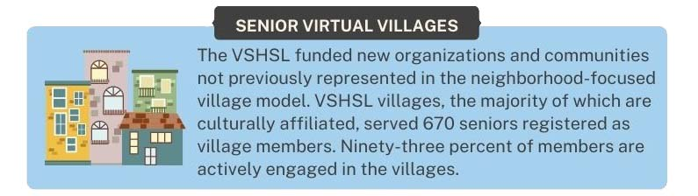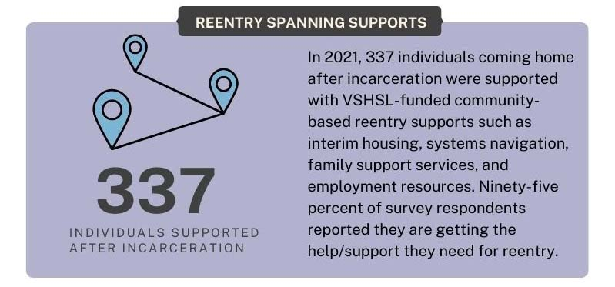
41
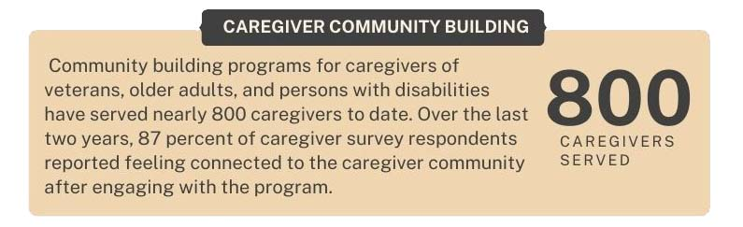

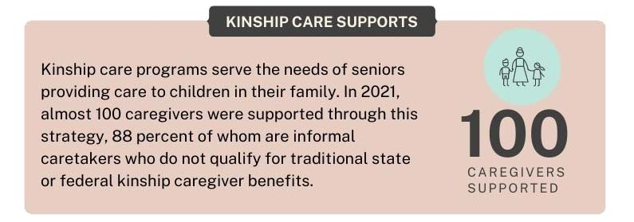
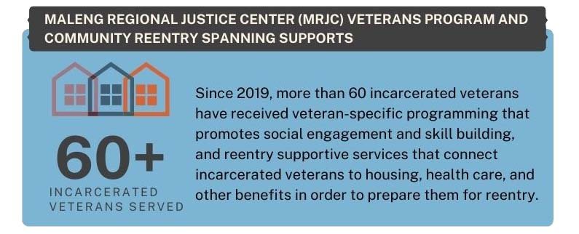

Service System Access and Improvement
Strategies in the VSHSL’s Service System Access and Improvement result area promote people’s ability to access the human services system, and improve the ability of these services to connect, integrate, and engage in continuous improvement. From 2018-2021, 78 percent VSHSL Social Engagement program outcomes showed reduced isolation through increased feelings of connection or increased engagement in community and 78 percent of VSHSL Service System Access and Improvement program outcomes showed connection to services through referral or direct service. Figure 5 shows examples of the VSHSL’s work in driving service system access and improvement outcomes.

Figure 5: Example Service System Access and Improvement Outcomes

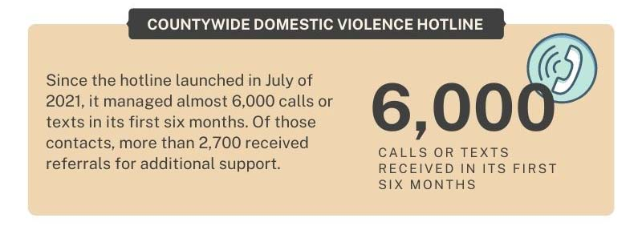

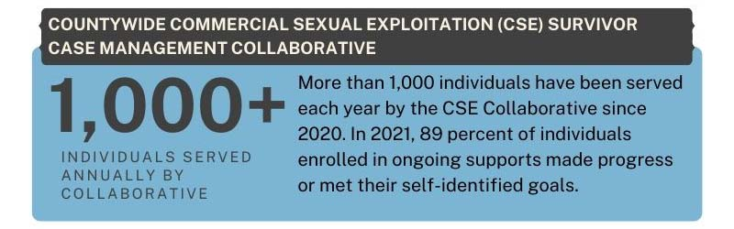
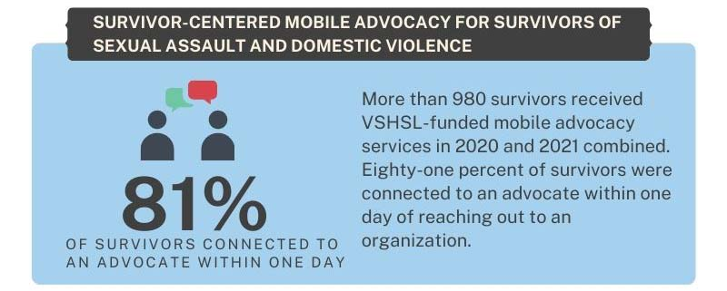
43
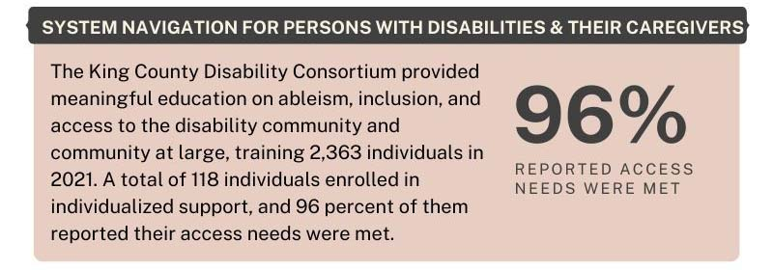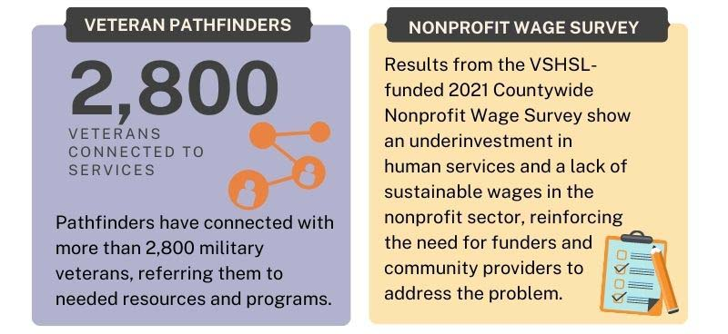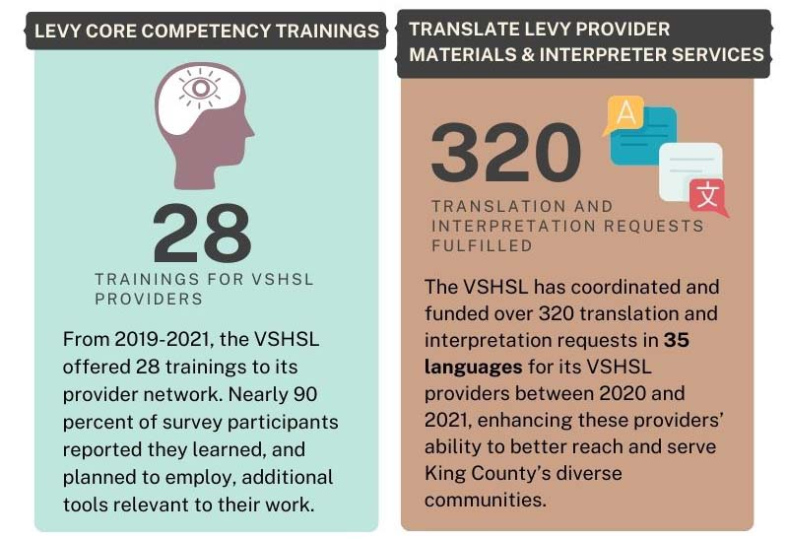

Analysis of Technical Assistance and Capacity Building Investments
Through its technical assistance and capacity building (TA/CB) resources, the VSHSL helps small, community-based agencies increase their ability to apply for public funding and strengthen their organizations, bolstering their ability to administer VSHSL-funded programs more effectively., The VSHSL administered its TA/CB funds through:
- Technical assistance for RFPs (application assistance): The VSHSL supported grassroots and cultural organizations’ ability to respond to VSHSL RFPs, which helped attract and diversify the VSHSL applicant pool. This assistance reduced linguistic, cultural, and procedural barriers that smaller agencies face in applying for government funding. Below is a summary of technical assistance used to date:
  - 83 agencies utilized more than 1,200 hours of application assistance.
  - 54 percent of agencies that receive application support were successful in securing VSHSL funding.
  - Over 30 percent of applicants were applying to King County funding for the first time.
  - Almost 10 percent were first time grant applicants, having never applied for grants from any funder previously
  - Half of applicants received TA related to clarifying government processes or translating/addressing language barriers.
- TA/CB award funds: The VSHSL awarded funds directly to contracted providers, allowing them to make purchases that improve their ability to provide services or pursue training, consultant services, or other resources that strengthens their skills or organizational capacity. The VSHSL awarded over $2.9 million in TA/CB funds to 57 small agencies to support their ability to deliver levy programming.
- TA/CB consultant supports: The VSHSL connects consultants to small VSHSL providers to access needed technical assistance or capacity building supports in common areas of need. Through this program, the VSHSL can strengthen funded agencies’ ability to administer their VSHSL programs, with 80 percent of participating agencies reporting a strengthened organizational infrastructure.
VSHSL providers indicate that TA/CB provides vital supports to strengthen their infrastructure, quality, sustainability, and ability to provide services effectively. This not only strengthens Levy-funded programming but fortifies the overall system of community-based agencies in King County delivering critical human services.

More Equitable Access to Levy Resources
The VSHSL took intentional steps to advance racial equity and bolster the breadth and depth of connection to human services throughout King County so that every person can thrive. Thanks to these efforts, over a third of VSHSL providers are small, community-based organizations offering services to diverse communities across King County. From 2018 to 2021, the number of BIPOC participants served increased by 193 percent.

  - Community Partnership. The VSHSL partnered with communities each step of the way, from conceptualizing the vision and programs of the Levy to working with funded organizations to share power and equip them with the tools to succeed. As a result, VSHSL programming reflects community voice and is led by communities historically underrepresented, bringing them to the table which in turns promote service access to the communities they represent.
- County Infrastructure. As an expanded initiative, the VSHSL spurred the creation of a new division within DCHS, the Adult Services Division, and included the launch of millions of dollars in new investments. DCHS took advantage of this unique opportunity to embed equity into its infrastructure.
  - Adult Services Division Staffing: King County hired ASD staff at all levels who are representative of the division’s priority service populations, either in demographic or in experience serving those populations.
  - Transparent and Equity-Focused Funding Processes: The VSHSL incorporated an equity and social justice lens in VSHSL funding processes through communications, RFP structure, and application supports. These improvements facilitated access for small, community-based organizations and solicited applications that reflected needs identified through the VSHSL’s community feedback process and available data.
  - Contracting and Performance Measurement: The VSHSL and DCHS evaluation staff worked collaboratively with providers to establish shared goals and results. Using King County’s new Client Outcome Reporting Engine (CORE), the VSHSL continues to collect more data to better understand program trends and service demographics, helping to understand progress, allowing the County and providers to make adjustments as necessary to better reach historically underserved and marginalized communities.
- System Partnerships and Filling System Gaps. Some King County residents face barriers to human services access due to race, place, or restrictive eligibility criteria. The VSHSL collaborated with local funding partners to deploy flexible Levy funds responsively and efficiently to meet service needs while filling federal and state gaps. Further, the VSHSL’s inclusive definitions for eligible service recipients enable it to serve a wider array of people who may not otherwise receive services.
- Equity-Focused Funding Decisions and Programming. Across many strategies, the VSHSL funded providers that represent and are best able to serve their communities. Over a third of VSHSL providers are small, community-based organizations offering services to diverse communities across King County. These funding decisions creates access for communities that historically have not been able to successfully access government funding which in turns creates programming that connects marginalized communities to services and programs for which they historically have not been able to successfully access.

Recommendations
Based on the successful outcomes of the 2017-2023 levy, identified in this report, the Executive intends to propose a renewed levy for consideration by the Council and voters in 2023: In preparing a renewal proposal, the Executive plans to incorporate the following recommendations:

Housing Stability
- Continue to increase the number of affordable homes and continue strategies that prevent housing loss.
- Increase access and speed to open affordable housing.

Healthy Living
- Sustain and explore increasing investments in gender-based violence prevention programs to address the root causes of violence and abuse.
- Explore community-based approaches that focus on community safety.
- Sustain the Geriatric Regional Assessment Team’s ability to support senior health in the short- and long-term.
- Explore expansion of investments to prevent behavioral health crises.

Financial Stability
- Expand the Collaborative Case Management (CCM) program to meet needs.
- Modify and increase flexibility for veteran employment and training programs.

Social Engagement
- Redefine the virtual village concept as a model for aging in place.
- Consolidate separate veteran and senior caregiver community building and respite strategies.
- Increase investments to support those reentering from the criminal legal system.

Service System Access and Improvement
- Maintain community-centered programming for survivors of gender-based violence.
- Consolidate investments for people with disabilities through a comprehensive strategy for the disability community.
- Expand role of veteran pathfinders to include direct services to veterans.
- Increase flexibility of resources supporting the Levy provider network.
- Strengthen King County’s nonprofit workforce through continued wage studies and explore opportunities to decrease livable wage disparities.

System Alignment and Coordination
- Strengthen integration and alignment across the regional human services system.
- Invest in County staff capacity to connect residents and partners to resources.

Distribution of Levy Funds
- Maintain existing result areas and commitment to the three priority populations.
- Increase total resources to better address the scale of community needs.
- Create an Emerging Needs Fund to flexibly meet community needs.

Assessment and Recommendation Related to Gender-Based Violence (GBV)
The VSHSL currently funds gender-based violence strategies that work to prevent violence and offer crisis and short- to medium-term response for survivors. (See Section IV.B for descriptions of Gender-Based Violence Prevention Pilot, Countywide Domestic Violence Hotline, Countywide Commercial Sexual Exploitation Survivor Case Management Collaborative, and Survivor-Centered Mobile Advocacy). However, as with other investment areas, public funding continues to be inadequate to address community needs. Because of its prevalence and impact, domestic violence is a major cause and contributor to demand for other human service supports funded by the Levy, and marginalized communities are often the most impacted by lack of services.

The VSHSL’s investments have more than doubled County funding for GBV services in 2018-2023, augmenting the historic and steady King County General Fund investments in these services. Specifically, investments in mobile advocacy for domestic violence survivors have expanded upstream intervention points, potentially reducing utilization of legal services, homelessness services, and behavioral health supports. Given the breadth of continued need and strengths of VSHSL investments, this report recommends sustaining and exploring expanding investments for gender-based violence services, especially for mobile advocacy services, in the renewal proposal.

Assessment and Recommendation Related to Behavioral Health
The Executive’s analysis of regional behavioral health needs and opportunities, including intersections with homelessness, social service needs, and criminal legal system interactions, is still ongoing. This fall, the Executive plans to provide for Council consideration additional information and proposed actions to address behavioral health needs using other revenue streams.

Conclusion
The VSHSL and its partners are making meaningful impact in the community. The renewed and expanded VSHSL’s more than 300 programs have reached 146,000 people. King County can build on these achievements, refine, and adapt to respond to changing and better understood conditions, and to deepen its impact on equity and racial justice. The modifications discussed in this report would enable the VSHSL to build on the foundation it has laid, meet increasing community needs by supporting and strengthening partners to provide services that are even stronger and more effective.

Background
King County’s Veterans, Seniors and Human Services Levy (VSHSL) expands access to critical human services to improve overall health and well-being, create thriving communities, and reduce disparities throughout King County. This report reviews the impact of the VSHSL since 2018 to inform deliberations about the potential renewal of the VSHSL before it expires at the end of 2023.

The VSHSL is a six-year King County property tax levy that invests in three populations: veterans, servicemembers, and their families; seniors and their caregivers; and other resilient communities. Throughout this report, these groups may be referred to as the Levy’s priority populations. The Levy funds strategies and programs to promote outcomes in its five result areas: housing stability, healthy living, financial stability, social engagement, and service system access and improvement.

The VSHSL seeks to serve those that others cannot. Across its programs, the VSHSL uses inclusive and more expansive eligibility criteria, which provides flexibility and support for those who may not otherwise be able to access services. Additionally, the VSHSL focuses on fostering connections among the people served by the Levy and among the people who provide the Levy’s services. The VSHSL is guided by these core principles:
- People do best when they feel a sense of belonging based in interpersonal connection and community.
- Human services investments are more effective and efficient when they are connected to form systems.
In 2017, King County voters approved the VSHSL with 68 percent of the vote, authorizing the expansion and renewal of the previous Veterans and Human Services levies approved in 2005 and 2011., , The expanded levy strengthened the community’s commitment to supporting local veterans, servicemembers and their families, and other resilient communities, and added robust investments to support a new identified population: seniors and their caregivers.

The current levy expires December 31, 2023. The King County Executive and King County Council are now considering whether and in what form a renewal levy should go to the voters. To begin the discussion and planning process, the County Council passed Motion 16129 on May 17, 2022, requesting an assessment report of the VSHSL from the County Executive. Motion 16129 is included with this report as Appendix A. The purpose of this report is intended to inform policymaker deliberations about potential renewal of the VSHSL. It also responds to the Council’s request to assess the existing VSHSL and propose recommendations for a renewed Levy. This report includes:
- An assessment of VSHSL programming, including:
  - Analysis of investments by geographic area;
  - Analysis of the impact the VSHSL has made in its five result areas;
  - Analysis of technical assistance and capacity building investments; and
  - Analysis of the impact of the VSHSL’s work in advancing equitable access;
- Recommendations on:
  - Whether a renewed Levy should maintain or modify the five result areas;
  - How a renewed Levy would align and coordinate with other federal, state, and local funding streams and programs, to integrate, align, and avoid duplication of effort; and
  - Whether to maintain or modify the distribution of Levy funds among population groups or result areas;
- An assessment of current needs and funding opportunities related to gender-based violence and a recommendation on whether a renewed Levy should maintain or modify funding for those services; and
- Information about the Executive’s ongoing assessment of the current needs and funding opportunities for services for individuals with behavioral health conditions.

VSHSL Framework

Funding Structure
The VSHSL’s levy rate of $0.10 per $1,000 in assessed valuation generates more than $55 million per year in King County. As directed by Ordinance 18555, King County sets aside at least one percent of funds annually for technical assistance and capacity building. The proceeds are then divided into thirds among the Levy’s focus populations to provide regional health and human services and capital facilities: one-third for veterans and military servicemembers and their respective families; one-third for seniors and their caregivers; and one-third for vulnerable populations (also referred to as resilient communities)., , , , , Within each population allocation, Ordinance 18555 requires at least 25 percent annually to be dedicated toward housing stability investments. , This distribution of funding is shown in Chart 1 below.

Chart 2: VSHSL Funding Structure 2019-2023
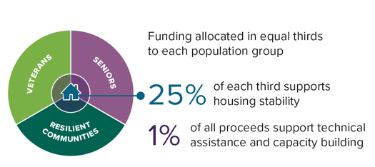

VSHSL Strategy and Program Structure
Community partnership was essential to the design of the current VSHSL, and partnerships have informed every aspect of the VSHSL’s development and implementation. In administering the VSHSL, King County has involved communities throughout the phases of program planning, service delivery, and performance measurement. King County invested new Levy funds in close consultation with impacted communities and partners. This work is described further in Section IV.D.

To inform the design of the VSHSL, King County Department of Community and Human Services (DCHS) conducted an extensive community engagement and partnership process in 2016 through February 2018. This process incorporated input from providers, board members, service participants, and residents on the effectiveness of the former levies, areas for improvement, and service gaps and needs. The Veterans, Seniors and Human Services Levy Implementation Plan, adopted by Ordinance 18768, structures the Levy’s focus on achieving outcomes for its three priority populations in five result areas:,

- Housing Stability: Supporting a household’s ability to gain and maintain safe, livable housing in one’s chosen community for less than 40 percent of household income.
- Healthy Living: Improving the overall health of King County residents by preventing behavioral health crises, providing education and care to those who would not otherwise have access, preventing abuse and violence, and enabling parents to pursue educational advancement.
- Financial Stability: Increasing an individual’s ability to cover necessary expenses while making modest investments to secure their long-term ability to accomplish personal goals.
- Social Engagement: Promoting belonging and interpersonal connections where systems, biases, miscommunications, or cultural differences too often serve to isolate.
- Service System Access and Improvement: Facilitating access for focus populations to the human services system and the ability of these services to systematize and continuously improve.

For each of these five result areas, the VSHSL includes a suite of strategies to deliver meaningful and measurable impact to support the communities of King County. VSHSL’s individual strategies are listed by result area in Tables 1, 2, 3, 4, and 5 in Section IV.B of this report.

Department Overview
The Department of Community and Human Services (DCHS) manages a broad range of programs and services to help King County’s most vulnerable residents and to strengthen its communities. The mission of DCHS is to provide equitable opportunities for people to be healthy, happy, self-reliant, and connected to community. DCHS administers housing and homelessness investments, behavioral health treatment, and human services. To do so, it draws upon many different federal, state, and local funding streams to support and promote a more comprehensive system of care and supports for King County residents. Among these, DCHS oversees and stewards the revenues from the voter-approved VSHSL, the Best Starts for Kids levy, and two County Council-approved sales taxes: the MIDD behavioral health sales tax fund and the Health through Housing initiative., , DCHS partners with local agencies and community organizations to provide most services via contracts.

DCHS administers the VSHSL, Washington State veterans relief funds, limited King County General Funds, and federal American Rescue Plan Act funds. Through collaborative partnerships with local agencies and community organizations, DCHS stewards these funds with a focus on equity to serve veterans, servicemembers and their families; older adults and their caregivers; and resilient communities. Particularly with VSHSL funding, DCHS seeks to support community-led and community-informed organizations that are reflective of and embedded in the communities they serve.

Key Historical and Current Context and Conditions
Voters approved implementation of the VSHSL in November 2017. It is the third iteration of the Veterans and Human Services Levy initially approved in 2005 and renewed in 2011. ,

Initial Implementation of Expanded Services in 2018
King County DCHS staff began implementing the Veterans, Seniors and Human Services Levy in 2018, after the approval of the VSHSL Transition Plan by the King County Council in November 2017 in Ordinance 18638. The VSHSL Transition Plan was the first step in executing the expanded VSHSL, making it possible to continue without disruption previously funded levy-supported programs while also beginning to introduce new initiatives to address the homelessness and housing affordability crisis in King County and to increase support for the fast-growing older adult population.,

The King County Council adopted the VSHSL Implementation Plan in July 2018 by Ordinance 18768. The plan provides the new structure for the full-scale levy, guiding investments for 2019 through 2023. Between 2018 and 2020 VSHSL programming began contributing to the five result areas. The VSHSL introduced its first wave of unique programming outlined in the VSHSL Transition Plan in 2018. To aid in transparency and guide this new body of work, the VSHSL Advisory Board was also established that year and initial appointments to the board were made in 2019.

The VSHSL implements its investments through:
- Partnerships between King County and community-based organizations providing direct services. Organizations were selected through competitive procurements in accordance with the VSHSL Implementation Plan;
- Partnerships between King County and system partners such as the City of Seattle and Workforce Development Council;
- Programs administered by King County departments that provide direct services; and
- Strengthening and improving the VSHSL’s service system, such as technical assistance and capacity building to support small agencies and service system strategies that cultivate a more effective network of providers.,

Shifting to Individual-Level Reporting
Throughout the current Levy, VSHSL providers partnered with King County program staff and evaluators to implement more detailed and accurate data collection from programs. At the start of the VSHSL in 2018, all data was reported in the aggregate with no individual-level reporting. By the end of 2021, individual-level reporting represented 93 percent of the VSHSL’s data. With individual-level data, the VSHSL can more accurately know who and how individuals are being served and conduct more in-depth equity analyses of Levy programming.

Major Investment Growth in Gender-Based Violence, Legal Aid, and Senior Center Services
Notably, some of the new investments introduced in the 2018-2023 VSHSL included robust funding for gender-based violence, legal aid, and senior center services, three program areas historically funded at steady, but minimal levels by King County General Funds. As depicted in Chart 2 below, the 2012-2017 levy formerly had included a small amount of funding for legal aid and no dedicated funding for gender-based violence or senior centers. Through the 2018-2023 VSHSL, King County significantly increased its investments in the three aforementioned program areas: it increased county funding for gender-based violence by 152 percent; for legal aid by 658 percent; and for senior centers by 2,689 percent.

Chart 3: VSHSL’s 2018-2023 Investments Grew County Funding Significantly for Gender-Based Violence, Legal Aid, and Senior Centers
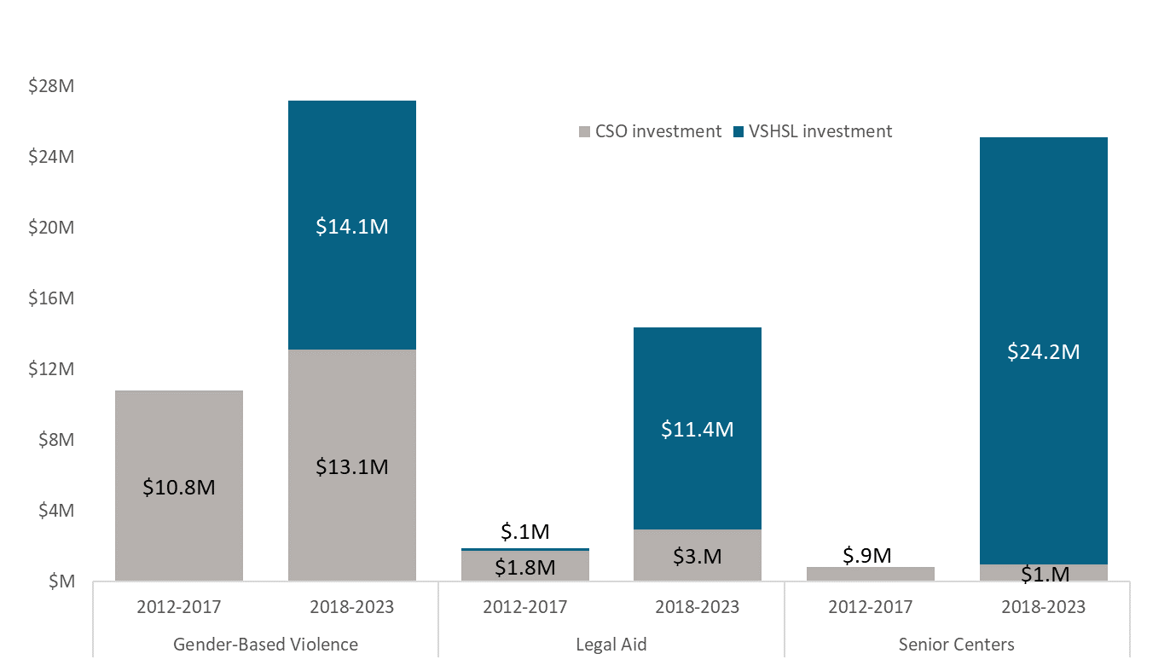

Adaptation to Respond to Emerging Needs During COVID-19 Pandemic
By early 2020 most of the programming directed by the VSHSL Implementation Plan was procured and the VSHSL was firmly establishing itself as a flexible funding source with the ability to serve those that others could not. However, 2020 would be a year of change and transition not only for King County and the Levy but for the world.

The Washington State Governor issued a state of emergency to address the COVID-19 pandemic in February 2020. In March, the death of George Floyd initiated a nationwide social reckoning on race. A few months later King County declared racism a public health crisis. The pandemic undermined housing stability, healthy living, financial stability, and social engagement, even for many residents that were secure in these areas before the pandemic. Service system access evolved and became even more challenging as providers adjusted services to fit the changing landscape while facing staffing shortages.

Vaccinations for COVID-19 became available for most populations in 2021 but the human services landscape had permanently changed with virtual or hybrid services in place and nonprofits experiencing significant staff turnover., The VSHSL responded to evolving conditions by working with its providers to adjust current programming where needed and using unspent and unallocated Levy funding to introduce new services to address emerging needs.

Nonprofit Wages
In 2021, with VSHSL funding, King County worked with 501 Commons to administer a countywide nonprofit wage and benefits survey to better understand the factors, including wages, that influence recruitment, retention, and satisfaction. The survey had two parts: a survey for employers to report wage and benefits information and an engagement survey for employees. More than 230 nonprofits based in and serving King County responded to the wage survey. More than 1,200 nonprofit workers from 263 organizations participated in the employee survey. The results, released in early 2022, show that many nonprofit employees working in critical services like shelter provision, violence prevention, and community health earn wages at levels that make it difficult to sustain a career doing community-based work in the King County region. See Section IV.B.5 for more information on the nonprofit wage survey.

The VSHSL Furthers Foundational County Policies and Plans
The VSHSL’s work furthers the King County Strategic Plan goal to improve the health and well-being of people in the King County community through housing and other human services supports, as well as the objective of ensuring a network of integrated and effective health and human services is available to people in need. The VSHSL also supports the goals of the King County Equity and Social Justice Strategic Plan through supporting organizations that recognize and address the disparities and disproportionality that exist in communities.

Report Methodology
Department of Community and Human Services (DCHS) staff developed this report. It reflects subject matter expertise and data analysis covering the period from 2018 through 2021, the VSHSL’s first four years.

To inform this report, DCHS staff compiled information about strategy implementation to date, incorporating feedback from community partners and the division’s own experiences with successes, challenges, lessons learned, and recommendations for improvement. Specifically, these analyses incorporated qualitative and quantitative data about VSHSL programs that was available at the time of this report’s drafting:
- Reviewed program performance measure data with providers about who was served, how well were they served, and how the program is improving lives. Feedback from VSHSL providers through annual program narrative surveys from 2018 through 2021, including the 2021 survey which specifically invited feedback on existing VSHSL strategies and current conditions.
- Preliminary community feedback acquired through VSHSL renewal conversations in the spring of 2022 with funded and system partners and the broader community, as described further in Section III.E.

Data Limitations
There are some limitations to the data used for analysis in this report. Due to aggregate level and anonymous reporting, and the ways annual outcomes are analyzed, some duplication may exist in the data for certain programs:
- At the start of the VSHSL in 2018, all data was reported in aggregate with no individual-level reporting. By the end of 2021, annual individual-level reporting represented 93 percent of the VSHSL’s data. This combination of aggregate and individual level data presents limitations for multi-year analysis, and thus duplication may occur in some instances. As part of the shift to using data for continuous improvement, VSHSL evaluators worked with providers to move from aggregate reporting to individual level reporting via King County’s Client Outcomes Reporting Engine (CORE) online data submission system that launched in January 2020. Going forward, this shift will allow for deeper analysis of programming effectiveness, including through an equity lens.
- DCHS deduplicates in all cases possible, however some duplication will always exist to some extent. DCHS is committed to ensuring VSHSL client privacy. Many communities experience harm because of the ways in which human services systems ask them to identify their race/ethnicity, gender identity, and sexual orientation. DCHS works to reduce this harm by allowing individuals served by the VSHSL to opt out of answering these personal questions. Additionally, in cases where safety and security are at risk, such as in gender-based violence and immigrant/refugee programs, DCHS recognizes individual-level data collection is not appropriate and instead collects data at an aggregate level to ensure anonymity.
- When referring to outcomes across the duration of the levy (2018-2021), there may be some duplication. Outcomes for each participant are analyzed annually per their program enrollment. When calculating the proportion of positive outcomes, we include all annual outcomes in the denominator. Thus, if a participant receives services for multiple years, their outcome will be reflected more than once in the denominator. Additionally, some programs report outcomes in aggregate or anonymously without personal identifiers which limits the ability to fully deduplicate.

Community Engagement
Community partnership and accountability is essential to the success of human services programs and investments. King County has engaged with community throughout implementation of the VSHSL to nurture meaningful partnerships and to ensure VSHSL programming is responsive to community needs. Community voice informed the VSHSL’s Implementation Plan, the development of the Levy’s procurements, and levy-funded programs and services. The community engagement adds to the performance measure data to inform the assessment and recommendations made in this report.

King County conducted VSHSL community outreach and engagement with three goals:
- Spread awareness about VSHSL resources and increase access to the range of programs and services the VSHSL funds.
- Hear the community’s perspective on how well Levy programs are working and ways Levy programs could be improved.
- Develop recommendations for a renewed VSHSL that are responsive to community feedback and needs.

Between March and June 2022, the VSHSL hosted 20 community conversations, 20 focus groups/listening sessions, and 12 informational presentations. During this time, DCHS staff also met with other King County agencies that carry out VSHSL programming on behalf of DCHS. Outreach began virtually with meetings convened over Zoom. Meetings then transitioned to in-person gatherings that also offered options for virtual participation. DCHS staff partnered with service providers, board members, and other interested parties to co-host meetings and amplify the events through partner networks to encourage wide participation. Staff also worked with human services coalitions and advisory groups to identify pre-existing opportunities for engagement. Together, these meetings and presentations provided many opportunities for people who live or work in King County to receive an introduction to the VSHSL and its possible renewal. These events also provided a forum for community to share their thoughts on renewal planning. Appendix B lists the location of the community conversations and the participants of the focus groups and informational presentations.

Community conversations invited residents and service providers to discuss how well the Levy’s programs meet the need of either one’s geographic community or serves people with a cultural identity that spans the county. This approach enabled residents to provide input on issues related to the communities that feel most relevant to them. The geographically focused meetings included at least two gatherings in each of the nine King County Council districts. Participants shared feedback about their community’s experience with the VSHSL and had the opportunity to ask questions about it. The community conversations utilized small group conversations within the larger gatherings to discuss a series of question. The small group discussions were reported out to the larger group, sharing highlights of their table’s discussions.

Focus groups/listening sessions provided the County with more specific perspectives than could be captured in the general community conversation sessions. These program-specific sessions enabled service providers, advocacy groups, and program participants to share expertise from their professional or lived experience. Focus group participants were asked how the needs within their specific program have changed in the five years since the current VSHSL was renewed, as well as what the VSHSL does well that should be continued and what the VSHSL can do better.

Informational presentations leveraged existing meetings of partner organizations and advisory groups to present the history and impact of the VSHSL; describe a high-level timeline for renewal planning; and advertise the upcoming community conversations.

Annual report surveys allow VSHSL-contracted providers a regular opportunity to offer feedback and reflections on their programs. Anticipating this assessment report and the levy renewal process, King County asked providers to describe their recommendations for how their VSHSL strategy could be modified in the future, and to highlight any changing needs in their 2021 provider annual narrative report.

The VSHSL Summit, hosted for the first time in May 2022, provided VSHSL-contracted providers and the broader human services community the opportunity to gather, share experiences, and build relationships with each other to strengthen the VSHSL network. The Summit had hybrid programming with both in-person sessions and virtual streaming capabilities to maximize accessibility and participation. More than 200 participants attended the three-day summit either in-person or virtually. In addition to panel discussions and trainings, summit activities included a focus group for summit participants to share what they felt went well and what they would like to see improved in a renewed Levy.

Several themes emerged from the VSHSL’s multipronged community engagement:

- The VSHSL is a uniquely flexible funding source. The Levy’s flexibility was frequently described as a strength. Several participants shared that Levy programs that allow organizations to offer flexible financial assistance best help clients meet their basic needs. Participants also expressed that the flexibility allows their organizations to better serve individuals, including providing culturally specific responses to community needs. VSHSL-funded providers in attendance appreciated the ability to work with King County in 2020 to make programming adjustments to be more responsive to emergent community needs at the start of the COVID-19 pandemic and asked the County to consider flexible funding in the renewed VSHSL to take care of emerging needs that are not anticipated.
- The VSHSL expands organizations’ impact in the community. The addition of Levy funds into an organization’s budget allows services to have a higher impact, serving people and extending service to residents and communities who might not otherwise have access. For example, in some programs the VSHSL provides for specific outreach and case management staff to help identify and engage with those who are difficult to reach. The inclusive definitions of the VSHSL populations help to fill eligibility gaps from other programs, thus enabling more people within King County to get the help they need. Simultaneously, the expanded service delivery unearthed the expansive need to the VSHSL-funded service providers, particularly as the pandemic shifted people on the brink of crisis into crisis situations.

- Technical assistance and capacity building (TA/CB) and other Levy provider supports help broaden organizations’ ability to serve the community. Many participants expressed appreciation for the resources made available by the Levy, including TA/CB, language access support, and training. They also emphasized the continued need for these services and asked whether smaller, grassroots organizations serving underrepresented populations were aware of this funding and support.

- Housing affordability continues to be a pressing concern across populations. According to community members, finding affordable housing is a challenge and is only getting harder. The number of affordable housing units available do not meet the need for affordable housing. Participants described long wait lists and low vacancy rates at affordable housing units throughout the county, and the increasing cost of affordable housing units relative to a person’s fixed income. Participants reflected that it can be difficult to help someone make progress in their financial stability, social engagement, physical/emotional health, or ability to access services (the Levy’s other result areas) when someone is not stably housed.

- Performance measurement is necessary but sometimes burdensome. Community expressed a deep understanding and appreciation for the collection of data. Additionally, they shared concerns around the staff burden and time commitment adversely impacting their organizations when fulfilling data reporting requirements specified in VSHSL contracts.

- Additional resources are needed to attract and retain qualified staff. VSHSL-contracted providers and other human service organizations conveyed their direct experiences with the growing need for services beyond their current capacities. Participants stated that more is asked of nonprofits than ever before at a time when nonprofit employees in the region are leaving their sector for more sustainable working conditions, higher pay, and better benefits. Participants shared that delivery of responsive, culturally appropriate programs requires nuanced experience or credentials. Providers participating in focus groups and community conversations acknowledged the importance of wages and benefits to hire and retain qualified staff but need resources to do so. They further stated that historic underinvestment in the nonprofit sector has led to a workforce shortage crisis that is impacting service delivery. Participants applauded the King County’s partnership with 501 Commons to analyze wages and benefits offered in the nonprofit sector through the 2021 Nonprofit Wage Survey, as well as address employee recruitment retention and satisfaction. Section IV.B.5 describes the 2021 Nonprofit Wage Survey in more detail.

Community partnership and feedback is vital to the VSHSL. It will continue to inform future phases of renewal planning should policymakers authorize a ballot measure to renew the VSHSL.
The assessment and recommendations made in the following sections of this report reflect the above themes.

An Assessment of the Effectiveness of the VSHSL
The Levy has provided critical funding and fine-tuned its programs to help veterans, resilient communities, and their families since 2006. Thanks to the support of King County voters, the renewed and expanded 2018-2023 VSHSL builds on the success of the former levy. This expansion has allowed the VSHSL to:
- Strengthen support for local veterans, and servicemembers and their families.
- Strengthen support for housing stability, including an emphasis on preventing homelessness and increasing the availability of affordable housing.
- Continue and build upon past levy programs that worked to prevent and reduce homelessness, reduce unnecessary use of expensive public systems, and increase self-sufficiency.
- Support seniors and their caregivers, survivors of gender-based violence, the disability community, and residents experiencing geographic and cultural isolation.

Highlights of VSHSL Impact to Date
King County has accomplished much through the renewed levy since its launch. Since 2018, the VSHSL has funded over 300 programs. By the end of 2021, the Levy had:
- Served more than 146,000 people throughout King County with community-driven programming. The Levy has expanded and widened its reach significantly, with a 69 percent increase in people served from 2017 to 2021.
- Advanced racial equity and broadened services throughout King County.
- Transformed data collection and partnerships with providers to move toward shared outcomes and individual-level reporting.
- Distributed investments and programming geographically, both in service availability (i.e., funded programs and service sites) as well as in service reach (i.e., program participants served).
- Made measurable progress in helping King County residents secure housing stability, healthy living, financial stability, social engagement, and system access.
- Strengthened smaller, community-based organizations through technical assistance and capacity building supports.
- Advanced equitable access to Levy resources for community providers and communities, through community-centered programming, county infrastructure to implement investments,
Service Satisfaction: The VSHSL implemented a Service Satisfaction Survey in 2021 to hear from service participants and collect additional “better off” measures directly from those served. Over 5,500 responses were received from programs across all Levy areas. The survey data was a point in time sampling, and service participant responses were overwhelmingly positive. The survey showed high satisfaction with VSHSL-funded programs, including:
- 90 percent of respondents said they are getting the help and support they need.
- 93 percent said they feel staff treat them with respect.
- 93 percent said they would recommend the program to a friend or family member.

Program specific survey results have been shared with providers to inform program adjustments if needed, or to reaffirm program features that are working. Levy staff will build upon implementation and data learnings to continue improving services and ensure high service participant satisfaction.

The next subsections of this report provide more detail on the impact of the VSHSL to date, as requested by Motion 16129. The sections provide an overview and assessment of VSHSL investments, organized by geography and VSHSL result areas, including technical assistance and capacity building. The assessment also includes an analysis of the impact of Levy investments in advancing equitable access to Levy resources for King County human service providers and residents.

An Analysis of Investments by Geographic Area
The Veterans, Seniors and Human Services Levy supports regional community and human services that work to reduce disparities and improve overall health and well-being to create thriving communities throughout King County. Levy practices in community engagement, RFP processes, and award decisions seek to achieve broad geographic coverage in funded providers and services. Simultaneously, levy funded work provides access to resources for communities with dense population and need for services. VSHSL services are distributed geographically, both in service availability (i.e., funded programs and service sites) as well as in service reach (i.e., program participants served), in ways that advance equity and social justice (ESJ), follow the VSHSL Implementation Plan, respond to community feedback, and reflect the results of competitive procurement processes.

King County aims to create a diverse and dynamic community where all people can thrive. However,
past institutional and systemic barriers, as well as current policies and practices, prevent some communities from achieving this vision. Barriers include inequitable access to services, and insufficient services to meet the needs of all individuals, families, and communities. Underrepresentation of communities of color in policymaking that determines how and where health and human services are delivered persists. Inequities that impact health, wellness, and opportunity, remain. These, in turn, create disparities based on such factors as race, ethnicity, gender, sexual orientation, immigration status, disability, language, and age. These factors further intersect with income and affordable housing access, which further increase disparities based on geographic location.

King County recognizes the VSHSL is not alone sufficient to fully connect all of King County’s over two million residents to the services they need. Therefore, King County deploys VSHSL resources to promote equitable access for the populations facing the largest disparities in health and well-being. The distribution of these resources is intended to balance responding to population distribution and areas of concentrated need with ensuring services are available to people throughout the county regardless of their location. Most VSHSL-funded programs offer countywide services, with some offering mobile and virtual services. Physical service sites are available throughout the county. See Appendix D for a list of countywide and mobile services funded by the VSHSL. The information below shows the VSHSL is reaching residents throughout King County, including those most impacted by ESJ disparities and those residing in rural or unincorporated King County.

How the VSHSL Distributes VSHSL Investments Across King County
The 2018 renewal and expansion of the Levy brought the opportunity to reset and launch new programs through competitive procurements. Locations of funded services are dependent on which organizations apply for funding and where they provide services. DCHS staff informed a wide range of organizations of opportunities to shape and respond to VSHSL Request for Proposals (RFPs) or other procurements.

King County held numerous community planning sessions throughout the county to gather community feedback that informed service needs, gaps, and best practices for service delivery ahead of the launch of VSHSL RFPs. See Appendix C for the list of community planning sessions. These engagement sessions were advertised through VSHSL’s email distribution list and e-newsletters as well as VSHSL’s online strategy and procurement tracker. DCHS staff also developed funding opportunity emails and e-newsletters to notify the community about open RFPs. Consistent with the VSHSL Implementation Plan, the planning sessions were also shared with County Council offices for further distribution to the community.

Through its RFP processes, the VSHSL also offered application assistance to small applicants to support grassroots and cultural organizations to respond to RFPs. This assistance helped diversify and potentially broaden the geographic distribution of the applicant pool.

In implementing the VSHSL, DCHS further promoted broad geographic coverage through its procurement and awarding processes. The VSHSL’s standard RFP process includes questions on geography to capture where applicants intend to provide services. This information inform DCHS award decisions to deploy services that meet Levy goals for geographic distribution and address community needs.

VSHSL Service Sites
Due to the expanded breadth of the Levy and intentional planning to balance equitable and broad geographic investments, King County diversified the VSHSL’s geographic impact. From 2018-2021, the VSHSL funded a variety of culturally relevant community-based organizations and organizations spread across King County, ensuring residents throughout King County, including communities historically underserved, can access VSHSL-funded services. This is illustrated through the geographic scope of the agencies funded and the services offered throughout the county.

As shown by the dark blue dots in Map 1 below, VSHSL service site locations exist throughout King County and cover all county districts, ensuring residents have access to physical locations from which they can seek services.

Map 1: 2021 VSHSL Service Sites
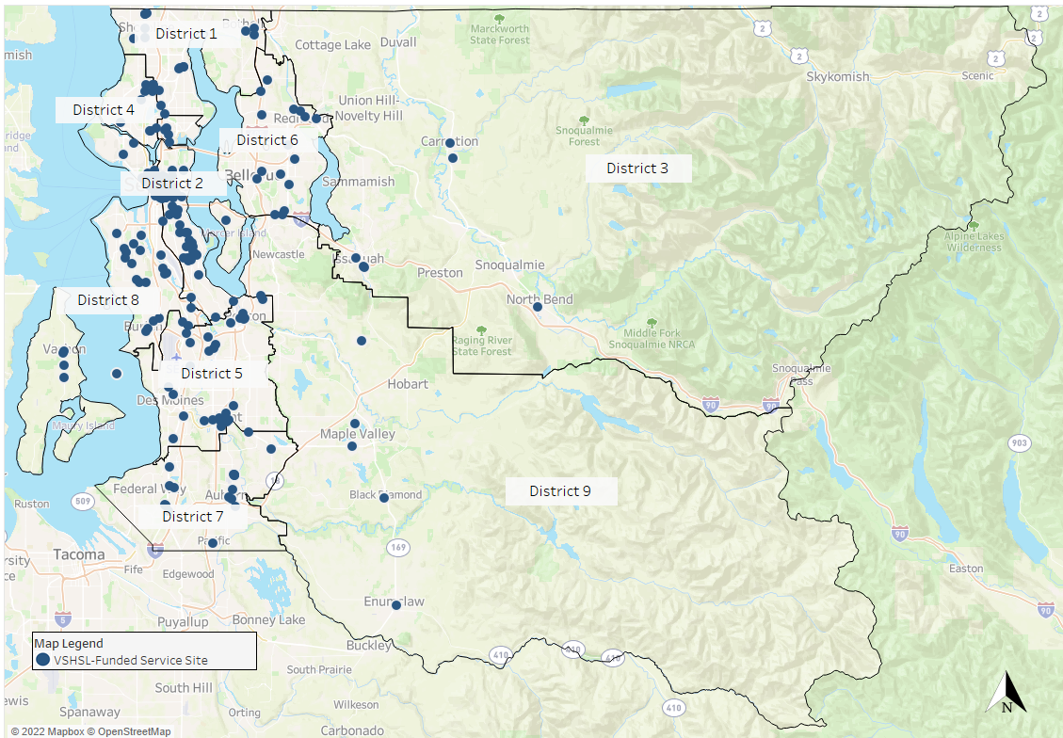

Most brick and mortar locations are located along the I-5 corridor. This service site distribution reflects the location of human service programs in the major cities and communities of King County. Map 1 also shows that VSHSL services are available on Vashon Island, the east side of Lake Washington, and rural King County.

Many of the services identified on Map 1 extend beyond their immediate locations to serve clients located throughout King County. Nearly 75 percent of VSHSL programs offer countywide services that serve people throughout King County. Additionally, several VSHSL programs are mobile in nature, such as pathfinders programs, mobile medical services, and mobile advocacy for survivors of gender-based based violence. These programs meet clients where they are and thus are not represented as a single dot on the map. Finally, with the onset of the pandemic, many programs moved to a virtual or hybrid model that continues to the time of the writing of this report (July 2022). By the end of 2021, 80 percent of VSHSL providers responding to the 2021 annual narrative survey reported that they offer remote services “all or most of the time.” Now, more than ever, VSHSL services are available and accessible to King County residents regardless of where they live.

VSHSL 2018-2021 Service Participants
This section of the report examines the geographic reach of participants served through VSHSL-funded programs in 2018-2021 via service participant zip codes (Map 2). It includes maps of the adult population in King County (Map 3) and the distribution of where communities experiencing lower measures of health and well-being reside (Map 4) as comparisons. These maps together illustrate VSHSL participants are served across the county, including in the areas of highest concentrated need.

Geographic Distribution of the VSHSL’s Service Participants
The VSHSL’s distribution of service participants, as shown in Map 2 below, illustrates the density of service participants by zip code. The darker colors represent a higher concentration of people served; the lighter colors represent a lower concentration.

Map 2: Distribution Among Zip Codes of 2019-2021 VSHSL Service Participants
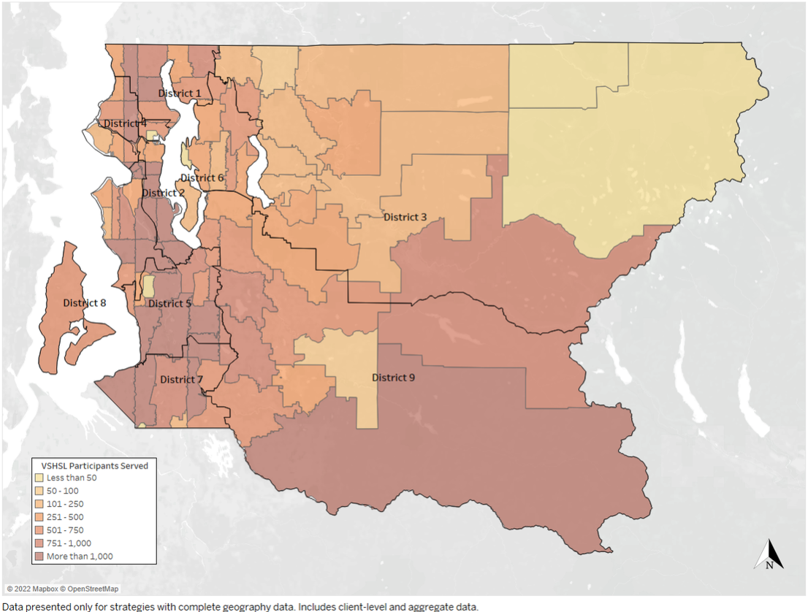

Comparison Metric: Overall Adult Population in King County
Map 3 shows the proportion of all adult King County residents that live in each zip code, with darker shading representing higher concentration of residents and lighter shading representing a lower concentration.

Map 3: Distribution of King County Residents, 18 and Older by Zip Code
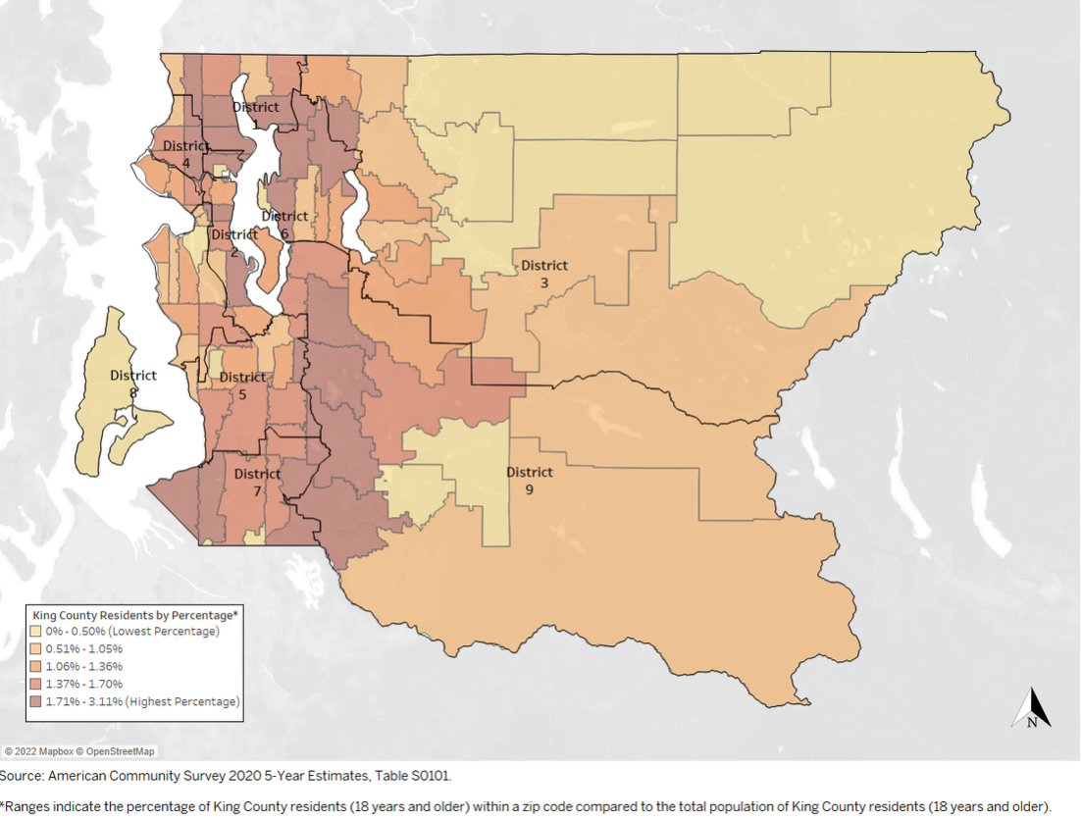

Comparison Metric: Index Distribution of Health and Well-Being Across King County
Communities of Opportunity (COO), a unique partnership of King County and the Seattle Foundation, created a map (Map 4) to show the index of health and well-being in King County. This index is based on analysis of data points for obesity, smoking, diabetes, frequent mental distress, adverse childhood experiences, prevention quality index, life expectancy, 200 percent poverty, unemployment, and poor housing. Map 4 shows the COO composite index distribution of communities experiencing lower measures of health and well-being, and thus the greatest opportunity to close gaps that exist, largely in south Seattle and south King County.

Map 4: King County COO Composite Index of Health & Well-Being Measures in King County
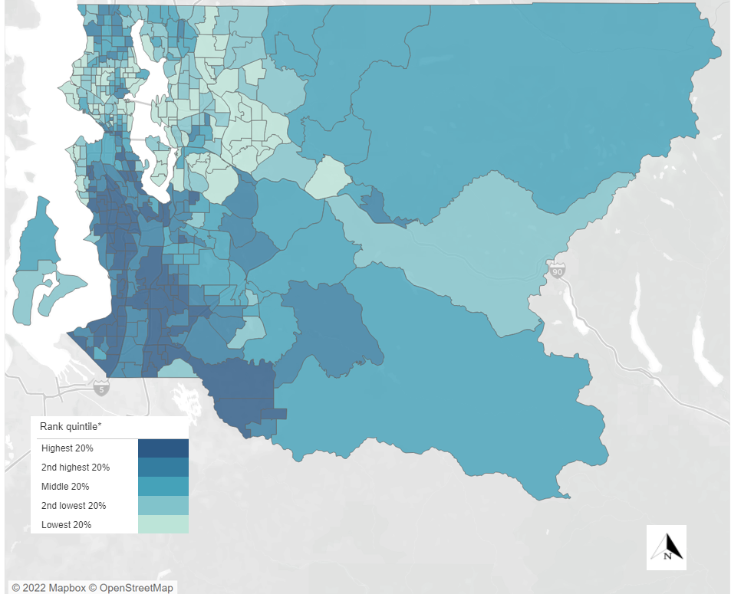
Map 2 of VSHSL service participants shows people who access VSHSL services live throughout the entire county, including rural and unincorporated areas. Shown in the darkest color, high concentrations of VSHSL service participants were located in west and south King County, which correlate to the home addresses of residents 18 and older in King County (see Map 3). This illustrates the VSHSL’s efforts to expand services geographically across the county.

The VSHSL’s service participant reach also reflects the residence of people experiencing lower measures of health and well-being according to the COO composite index (see Map 4). This index reflects a history of disinvestment and racist policymaking that resulted in the place-based disparities evident today. The VSHSL brings services to the communities of more low-income people as they attain lower cost housing options, especially in south King County. The geographic distribution of VSHSL service participants reflects gentrification and displacement trends driven by lack of access to affordable housing. Further, the County’s dedication, as expressed in the VSHSL Implementation Plan, to serving people with low incomes, people who are unstably housed, and other underserved populations supports providing comparatively lower level of services in zip codes with disproportionately higher-income households and in zip codes that are less populated.

The VSHSL invests where needs are greatest, but also throughout King County, to ensure all residents, including those most impacted by disparities, have access to resources and services.

A Result-Based Analysis of the Impact the VSHSL Has Made
Full implementation of the VSHSL occurred in phases between 2018 and 2021 to ensure effective execution, including robust community engagement and stewardship of Levy proceeds. King County prioritized the development of key infrastructure for the distribution of new funding to enable the VSHSL to realize the full breadth of its implementation plan. DCHS made multiyear VSHSL investments with awarded partners, and many new programs spent their first year ramping up programming. Starting in early 2020, the COVID-19 pandemic impacted programs’ ability to initiate and deliver services as originally conceptualized, requiring service changes.

As detailed in Section III of this report, the Veterans, Seniors and Human Services Levy has five result areas: Housing Stability, Healthy Living, Financial Stability, Social Engagement, and Service System Access and Improvement. Each VSHSL result area includes a suite of strategies that advance the goals and outcomes outlined in the VSHSL Implementation Plan, following the Results Based Accountability (RBA) framework.
Evaluation using the RBA framework asks three simple questions: How much did we do? How well did we do it? Is anyone better off? Through this framework, King County uses VSHSL funding to increase across programs and emphasize outcomes that better measure and demonstrate how funded activities work together to improve lives and drive achievements in the five Levy result areas. VSHSL evaluation results as described in this section show the VSHSL has benefited thousands of people and made meaningful improvements in housing stability, healthy living, financial stability, social engagement, and system access for King County residents. The analysis of Levy impact in the five result areas draws from established performance measures, staff assessment, and community narrative reports to identify key accomplishments, highlights, and learnings across VSHSL programming.

This report complements the VSHSL's ongoing annual reporting. The King County Executive transmits for Council review an annual report each year of VSHSL operations. These reports, available online, examine the performance of individual Levy strategies and programs, highlight accomplishments and the VSHSL’s impact in King County each year, and account for the VSHSL’s annual budget and expenditures. By contrast, as directed by Motion 16129, this report provides overarching analysis of VSHSL outcomes in each result area over multiple years.

How Much?
Since 2018, the VSHSL has served more than 146,000 people throughout King County.

How Well?
The VSHSL implemented a Service Satisfaction Survey in 2021 to hear from service participants and collect additional “better off” measures directly from those served. Over 5,500 responses were received from programs across all Levy areas. The survey data was a point in time sampling, and service participant responses were overwhelmingly positive. The survey showed high satisfaction with VSHSL-funded programs, including:
- 90 percent of respondents said they are getting the help and support they need.
- 93 percent said they feel staff treat them with respect.
- 93 percent said they would recommend the program to a friend or family member.

Program specific survey results have been shared with providers to inform program adjustments if needed, or to reaffirm program features that are working. Levy staff will build upon implementation and data learnings to continue improving services and ensure high service participant satisfaction.

Is Anyone Better Off?
Data shows that people are better off after accessing VSHSL programs that are geographically and culturally relevant across King County. Through its programming, the VSHSL has accomplished the following:

- Housing Stability: Helped to prevent homelessness and address the shortage of affordable housing in King County. From 2018-2021, 80 percent of VSHSL Housing Stability program outcomes showed positive housing results – such as remaining housed or finding permanent housing.
- Health Living: Supported King County residents in pursuing happier, healthier lives and prevented bigger crises. From 2018-2021, 76 percent of VSHSL Healthy Living outcomes showed improved health and well-being.
- Financial Stability: Supported King County residents in gaining and maintaining self-sufficiency. From 2018-2021, 66 percent of VSHSL Financial Stability program outcomes showed increases in financial security through employment obtainment, education enrollment, public benefit/veteran assistance, or other progress on financial goals.
- Social Engagement: Helped King County residents feel more engaged in community. From 2018-2021, 57 percent of VSHSL Social Engagement program outcomes showed reduced isolation through increased feelings of connection or increased engagement in community.
- Service System Access and Improvement: Connected veterans, seniors, and other populations to human services while also improving the ability of these systems to coordinate and strengthen. From 2018-2021, 78 percent of VSHSL Service System Access and Improvement program outcomes showed connection to services through referral or direct service and 66 percent of VSHSL Gender-Based Violence program outcomes showed survivors made progress or met their self-defined goals each year.
For each of the five result areas below, the assessment of VSHSL’s impact includes:
- A summary of the result area’s intended outcomes.
- A list of the result area’s strategies and programs.
- A high-level performance measure of the result area’s impact to date.
- Examples of program accomplishments and outcomes.
- Summaries further describing program accomplishments, outcomes, and learnings.

Housing Stability
The VSHSL Implementation Plan directs significant Levy resources to support households’ ability to gain and maintain housing or remain housed in one’s chosen community. A minimum of 25 percent of funding from each of the Levy’s three populations is dedicated to strategies and programs within the Housing Stability result area.

VSHSL investments seek to address the root causes of homelessness, recognizing that crisis services need to be complemented with investments in prevention efforts to keep households from loss of housing in the first place. The Levy’s investments intentionally link housing and services and prioritize programs that respond to King County’s local conditions, values, and diversity. VSHSL funds have increased the affordable housing supply and expanded the homelessness crisis response system through investments in wraparound services and collaborations between service providers. To support individuals in maintaining and finding housing, the VSHSL funds 14 strategies organized under eight main categories shown in Table 1.

Table 1: VSHSL Housing Stability Strategies
Housing Stability: Supporting a household’s ability to gain and maintain safe, livable housing in one’s
chosen community for less than 40 percent of household income.
Strategy |  | Code
Build, Preserve and Operate Affordable Housing and Navigation Centers |  | HS 1
Increase Access  to Tenancy | Master Leasing | HS 2A
 | Shallow Rent Subsidies | HS 2B
Support Aging  in Place | Senior Home Repair and Age-In-Place Modifications | HS 3A
Support Aging  in Place | Adaptive Devices, Training and Counseling | HS 3B
Navigate Homeless Veterans to Housing |  | HS 4
Prevent Inappropriate Housing Loss | Housing Counseling & Foreclosure Prevention | HS 5A
Prevent Inappropriate Housing Loss | Alternative Dispute Resolution | HS 5B
Prevent Inappropriate Housing Loss | Legal Aid | HS 5C
Prevent Inappropriate Housing Loss | Housing Stability Program | HS 5D
Promote Home Ownership |  | HS 6
Reinforce Criminal Justice Diversion and Reentry with Housing | Forensic Supportive Housing Models | HS 7A
 | Passage Point | HS 7B
Support Local Solutions |  | HS 8

Across Housing Stability programs, the VSHSL supported veterans, seniors, individuals experiencing homelessness, people with disabilities, and those returning from incarceration, among others. From 2018-2021, 80 percent of VSHSL Housing Stability program outcomes showed positive housing results – such as remaining housed or finding permanent housing.
Across VSHSL Housing Stability programs from 2018-2021:
80% of Housing Stability program outcomes showed positive housing results – such as remaining housed or finding permanent housing.

Examples of how the VSHSL’s housing stability programming is working to reduce homelessness and increase affordable housing include:
- Build Affordable Housing: VSHSL funding contributed to affordable housing stock for veterans, an aging population, and other populations that experience barriers to traditional housing. The VSHSL contributed more than $25 million in capital funding, combining with other local, state, and federal funding, to build more than 1,200 units of affordable of housing to date, with nearly a third of those units set aside for Levy populations.
- Create shelter bed capacity: The VSHSL contributed capital funding to add 198 new shelter beds for individuals and families experiencing homelessness. These beds provide immediate safety from the streets and connect individuals to permanent housing options and other needed services.
- Navigate Homeless Veterans to Housing: In 2021, Navigator programs helped 85 homeless veterans find housing through veteran documentation, housing search, and other supportive services.
- King County Veterans Program (KCVP): Expanded VSHSL investments increased the scale of the long-standing King County Veterans Program (KCVP), creating a more robust service hub for veterans, servicemembers, and their families. KCVP provides wraparound services to more than 2,000 veterans every year, working directly with them on housing, financial stability, and healthy living. In 2021, KCVP implemented the innovative Collaborative Case Management Pilot to further support veterans in finding housing. For more details on the Collaborative Case Management Pilot program, see Section IV.B.3.
- Housing Stability Program: The Housing Stability Program, which offers short-term support to households at risk of housing loss and homelessness, provided emergency financial assistance to over 1,500 households who were at risk of homelessness, providing critical stabilizing intervention.
- Forensic Supportive Housing Models (Vital Program): The Vital Program serves individuals with frequent jail bookings, with behavioral health conditions, and who are experiencing homelessness or unstable housing. From 2018-2021, the Vital Program served 87 participants. Jail bookings decreased for 84 percent of Vital participants while enrolled in the program, demonstrating the importance of supportive housing paired with supports such as treatment, health care and other service interventions in diversion and reentry programs.

The examples above illustrate the VSHSL’s impact in supporting a household’s ability to gain and maintain safe, livable housing. More detail on each of these significant results is included below.

Producing and Preserving Affordable Housing and Preventing Homelessness
Building Affordable Housing: Across the spectrum of King County’s diverse populations, the issues of affordable housing and homelessness are a recurring concern. Housing is the paramount source of stability upon which lives are built, so King County invested the majority of VSHSL housing stability funds to Build, Preserve and Operate Affordable Housing and Navigation Centers.

This key VSHSL strategy increases the stock of affordable homes for veterans, seniors, and other populations experiencing or at risk of homelessness and funds operating this new housing. In the absence of a sufficient supply of permanent, affordable housing, this strategy also invests in short-term shelter options

The VSHSL awarded more than $25 million in capital funds to developers of low-income housing and shelter providers to build more than 1,200 units of affordable housing and create 198 new shelter beds for individuals and families experiencing homelessness in the region. These include:

- Pioneer Human Services’ Pioneer Belmont/Aspen Terrace, a 90-unit affordable housing facility that includes wraparound services and features 30 units set aside for veterans (opened 2020).
- Bellwether Housing’s Confluence TOD Apartments, a 103-unit facility which includes 20 units for senior veterans and other populations (opened 2021).
- Othello Park Apartments operated by the Low Income Housing Institute, a 93-unit project that includes 30 units specifically for veterans and senior veterans (opened 2021).
- Chief Seattle Club’s ?ál?al, an 80-unit housing facility that includes 10 set-aside units for veterans and focuses on housing for Indigenous people (opened 2022).
- Catholic Community Services’ Kirkland Shelter for Families and Women, which offers 98 beds and includes 40 reserved for VSHSL’s three priority populations. It is the first shelter permanently dedicated to serving women and families in East King County (opened 2020).
- Congregations for the Homeless/Horizon Housing Alliance’s Eastside Men’s shelter, creating 100 new shelter beds in Bellevue for men experiencing homelessness, including 40 specifically for veterans (started construction late 2021).

For a full list of VSHSL-funded housing developments, see Appendix E.
The VSHSL also continues to fund operations for affordable housing and navigation centers. Since 2018, the VSHSL has awarded operating funds to over 25 permanent supportive housing sites, serving the most vulnerable people experiencing homelessness across King County. Additionally, over 550 individuals have been served through the Navigation Center’s service-enriched shelter and the West Wing Shelter, an enhanced shelter for single adults with behavioral health needs. The VSHSL has also supported over 4,000 individuals at the Jefferson Day Center, which offers daytime hygiene, health, navigation, and case management services.

Addressing Veteran Homelessness
Veterans utilizing homeless services such as emergency shelter, prevention, and outreach in King County has declined 36 percent from December of 2017 to December of 2021. While an imperfect measure, the data indicates veteran homelessness is declining in the region. Still, as of December 2021, 756 veterans experiencing homelessness continue to seek assistance from King County’s homeless response system.
The Levy’s specific efforts and outcomes intended to reduce veteran homelessness are summarized below:

Pathfinders: VSHSL pathfinders connect veterans to homelessness resources and other services. Veterans experiencing homelessness are often served by the VSHSL’s pathfinders strategies, despite the intention to seek out and connect other segments of the veteran population to needed human services. One pathfinders strategy specifically seeks out and supports individuals living unsheltered with housing resources. To date, of those identified as homeless and utilizing homeless resources in King County, 35 percent have found permanent housing.

Navigate Homeless Veterans to Housing: VSHSL’s Navigate Homeless Veterans to Housing strategy funds housing navigation and stabilization services for veterans experiencing homelessness who are trying to overcome common obstacles to permanent housing. From 2019 to 2021, navigator programs assisted more than 300 veterans experiencing homelessness in finding housing through veteran documentation, housing search, and other supportive services.

King County Veterans Program (KCVP): The King County Veterans Program successfully connects veterans in a timely manner to appropriate homeless programs resulting in stable housing. It provides wraparound services to more than 2,000 veterans every year, working directly with them on multiple goals such as housing, financial stability, and healthy living. Within six months of working with KCVP staff, over 500 veterans were connected to homeless programs, and 305 (59 percent) of those have found permanent housing. Additionally, KCVP implemented the Collaborative Case Management (CCM) Pilot Program in 2021, which connected more than 140 veterans to housing with Veterans Affairs Supportive Housing (VASH) vouchers.

Preventing Veterans Homelessness: The VSHSL Preventing Inappropriate Housing Loss strategy helps households avoid falling into homelessness. Housing Counseling and Foreclosure Prevention, Alternative Dispute Resolution, and Legal Aid collectively served 4,618 people between 2018-2021. Of those served, 432 of them identified as a veteran, military service member, or a family member. For those at imminent risk of homelessness, the Housing Stability Program provided emergency short-term financial assistance, helping 1,558 households. Of those households, 229 included at least one veteran household member.

Supporting Diversion and Reentry Through Supportive Housing
Inadequate access to supportive housing is a significant obstacle to the success of diversion and reentry programs, which help people who have been incarcerated transition back into the community and avoid jail and hospital visits Too many people are released from incarceration into homelessness. The VSHSL supports reentry programs that connect individuals with housing, treatment, health care and service interventions to prevent homelessness, reduce jail bookings and emergency room visits. The VSHSL’s Forensic Supportive Housing Models strategy funds the Vital Program, an intensive, flexible, community-based team that provides behavioral health treatment integrated with primary health care, care management, housing support, and legal coordination for people with high needs and jail involvement. This long-term treatment program provides services in a comprehensive team-based approach that centers on the participants’ self-determination and individual recovery goals.
Vital services are delivered by three agencies working together to create an interdisciplinary care team. These providers work closely with the King County Prosecuting Attorney’s Office, the Seattle City Attorney’s Office, and the Department of Public Defense to mediate legal entanglement for individuals who have come into contact with the criminal legal system, support reentry and reduce incarceration and crisis system encounters. A continuum of housing options provides permanent supportive housing (PSH) for individuals enrolled in Vital. Evergreen Treatment Services’ REACH and Harborview provide primary health and supportive services, and Plymouth Housing Group provides housing units and housing case management to connect participants to PSH.
Through robust support and integrated care, Vital participants can successfully reenter the community, with improved housing stability and reduced jail and emergency department utilization. From 2018-2021, the Vital Program served 87 participants. Jail bookings decreased for 84 percent of Vital participants while they were enrolled in the program. Among long-term participants, 69 percent are stably housed as of December 2021. Preliminary evidence also suggests that Vital participants who are housed while enrolled in the program have significantly better outcomes than those unhoused (or less stably housed). The program can serve up to 60 participants at once and has seen steady increases in demand, which exceeds this capacity since its launch in 2016. The programs’ 20 units of supportive housing provided by Plymouth Housing is not enough for its program participants, and Coordinated Entry for All does not provide sufficient housing access to additional PSH for Vital participants.

Exploring New Housing Models: Master Leasing
The VSHSL explored several new strategies and innovative programs to promote housing stability efficiently and expeditiously for county residents. One such strategy is Master Leasing, which was introduced in 2018. In this housing model, an agency fully leases a group of housing units from a landlord, building owner, or housing provider for an extended period and then manages those units, making them available to tenants otherwise ineligible or unable to compete for rental housing. King County staff procured funds through three funding rounds, yielding few applications for veterans funding, despite prior outreach to veteran-serving entities to increase provider attention and applications. Provider feedback indicated a reluctance to apply for veterans funding due to concern of an inability to attract the requisite population to fill the units. In response to this feedback, King County staff have worked, and continue to work, to strengthen connections between housing providers and veteran-serving organizations.

Agencies funded under the Master Leasing strategy through other population funding have supported families, seniors, youth, and single adults including veterans facing housing barriers through 105 units of housing. Many Master Leasing agencies also partner or leverage other programs to provide services to residents. This new strategy’s challenges were exacerbated by the COVID-19 pandemic. COVID-19 has made it difficult for some agencies to find open and affordable units, with some experiencing difficulties finding landlords willing to master lease with them. Other agencies have been short staffed due to immediate COVID-19 response needs and other related impacts.

Healthy Living
The VSHSL invests in strategies and programs in the Healthy Living result area to meet residents where and when they most need support, promoting better health outcomes for individuals and a more sustainable medical care system that anticipates and prevents emergencies. Healthy Living strategies work to prevent health crises. In doing so, they empower residents, preserve dignity, and avoid later and much greater human and fiscal costs.

While chronic diseases affect a large portion of the population, other health issues may have a disparate impact on certain groups. Veterans experience higher than average rates of suicide and post-traumatic stress. Older adults, individuals living homeless, persons with disabilities, immigrants and refugees, and survivors of gender-based violence may have significant and/or unique health issues due to their specific experiences or circumstances. For example, disabilities increase with age and older adults need supports to age in place. The VSHSL recognizes the importance of people’s physical and mental well-being to their capacity to meaningfully participate in and contribute to their community of choice. To promote better health outcomes for individuals across a spectrum of needs, the VSHSL funds 18 Healthy Living strategies organized under four main categories shown in Table 2.

Table 2: VSHSL Healthy Living Strategies
Healthy Living: Improving the overall health of King County residents by preventing behavioral health crises, providing education and care to those who would not otherwise have access, preventing abuse and violence, and enabling parents to pursue educational advancement.
Strategy |  | Code
Prevent Behavioral Health Crises | Senior Depression Intervention | HL 1A
Prevent Behavioral Health Crises | Maternal Depression Reduction | HL 1B
Prevent Behavioral Health Crises | Veterans PTSD, MST and End of Life Counseling | HL 1C
Prevent Behavioral Health Crises | Military Family Counseling | HL 1D
Prevent Behavioral Health Crises | Sobering and Emergency Services Patrol | HL 1E
Prevent Behavioral Health Crises | Veterans Court Clinician and Mentor Coordinator | HL 1F
Prevent Behavioral Health Crises | Behavioral Health Integration | HL 1G
Prevent Behavioral Health Crises | Geriatric Regional Assessment Team (GRAT) 2.0 | HL 1H
Provide Care in the Community | Evidence-Based Senior Health Promotion | HL 2A
Provide Care in the Community | Housing Health Outreach Team | HL 2B
Provide Care in the Community | Mobile Meal Delivery for Seniors | HL 2C
Provide Care in the Community | Connections to In-Home Care | HL 2D
Prevent Abuse, Assault and Violence | Countywide Sexual Assault/Domestic Violence/Commercial Sexual Exploitation Prevention Pilot | HL 3A
Prevent Abuse, Assault and Violence | Elder Abuse Multi-Disciplinary Team | HL 3B
Prevent Abuse, Assault and Violence | Support Community Strategies to  Address Gun Violence | HL 3C
Nurture Families | Nurse Family Partnership | HL 4A
Nurture Families | Healthy Start | HL 4B
Nurture Families | Parent Education and Support | HL 4C

Across its Healthy Living programs, the VSHSL has supported veterans, seniors, survivors of gender-based violence, pregnant and parenting individuals, individuals experiencing homeless, among others, with their health. From 2018-2021, 76 percent of VSHSL Healthy Living outcomes showed improved health and well-being. This result demonstrates the VSHSL’s impact on individual lives, helping King County residents in pursuing happier, healthier lives and preventing bigger crises.
Across VSHSL Healthy Living programs from 2018-2021:
76% of Healthy Living outcomes showed improved health and well-being
Examples of how the VSHSL’s healthy living programming is working to improve the health of King County residents and support a more sustainable medical care system that prevents crises include:

- Veteran and Military Family Counseling: Since 2018, an average of 278 veterans and 34 military family members received counseling each year, getting support that they might not otherwise receive through the federal Veterans Administration (VA) that helps them cope in healthy ways with their trauma. Of those who completed six months of counseling and completed all assessments, 79 percent experienced improvement in PTSD symptoms.
- Geriatric Regional Assessment Team (GRAT): VSHSL funding helped GRAT return after a two-year service gap, bringing back a critical bridge between the behavioral health and aging systems of care. Since the relaunch of the program in 2020, GRAT’s home-visiting team has delivered behavioral health and human services intervention to 197 seniors. More than 90 percent of those served had at least one case plan need met.
- Evidence-Based Health Promotion: VSHSL-funded evidence-based health promotion programs prioritize culturally relevant services to senior communities of color that historically experience health disparities. More than 2,000 seniors accessed VSHSL-funded health promotion programming in 2021. Ninety-four percent of survey respondents reported satisfaction with the program and 71 percent reported experiencing improvements in health and wellness.
- Gender-Based Violence Prevention: More than 600 people participated in the community planning and design process of Mapping Prevention 2020 (MP2020), a project funded by the VSHSL to better understand how communities can prevent domestic, sexual, and family violence. This work builds on community solutions to violence and violence prevention, including investing in resources outside of systems of policing and punishment. The community data gathered from MP2020 now informs a network of VSHSL-funded domestic and sexual violence programs that provide coordinated prevention and community engagement strategies.
- Community Strategies to Address Gun Violence: The VSHSL allocated unspent and uncommitted funds to support this unfunded Healthy Living strategy in 2021, enabling a competitive procurement that resulted in awards to four agencies to address and help prevent gun violence within communities disproportionately impacted by gun violence.
The above program outcomes are examples of how the VSHSL is making positive impacts in the lives of King County residents: encouraging healthy lifestyles and wellness, promoting healthy aging, improving physical and behavioral health for individuals and families, reducing unintentional injury, and supporting survivors of domestic violence. More detail on these results is included below.

Connecting Veterans, Military Servicemembers, and their Families to Counseling
The VSHSL provides military and trauma-informed counseling services to support military families with military trauma, post-traumatic stress disorder (PTSD), and reintegration issues. The Levy began funding confidential counseling services in 2006 for current and former military servicemembers and their family members. These services fill capacity gaps in federal Veterans Administration (VA) behavioral health care provision to veterans, and to provide counseling support for veteran families that the VA does not provide. These VSHSL-funded programs specifically deliver services with an awareness of military culture, including recruiting clinicians proficient in evidence-based treatment modalities for PTSD counseling. This focus on military culture in VSHSL counseling programs enables access to the most effective treatments and strongest outcomes by veterans and their family members, regardless of branch, service era or discharge status.

Because military service can cause or exacerbate behavioral health concerns among veterans and servicemembers, these burdens may extend to their families. PTSD, traumatic brain injury, military sexual trauma, anxiety, depression, re-adjustment disorders, and co-occurring substance use disorders are some of the more common diagnoses.

Since 2018, the VSHSL has supported veterans, military servicemembers and their families with evidence-based practices that promote health and wellness. An average of 278 unduplicated veterans and 34 unduplicated military family members received VSHSL funded counseling each year. In 2020 and 2021, more than 10,700 counseling hours were provided, or an average of 18 hours of counseling per veteran, servicemember, or family member each year. Of those who completed six months of counseling and completed all assessments, 79 percent experienced improvement in PTSD symptoms.

To continue to meet the need for mental health services during the COVID-19 pandemic, especially considering severe staffing shortages in clinical psychiatry and at VA health care facilities, DCHS reallocated a total of $531,544 of unspent and uncommitted VSHSL veterans funds to augment funding for these counseling programs in 2022.,, This expanded the network of specially trained counselors to provide high quality PTSD and trauma-informed wellness counseling to veterans, military servicemembers and their families. The additional investments are expected to support an additional 2,000 hours of counseling.

Supporting Seniors with Behavioral Health Assessments to Avoid Crises

The VSHSL’s investment for the Geriatric Regional Assessment Team (GRAT) blends with funds from MIDD to prevent seniors from experiencing avoidable hospitalizations and to reduce their risk for harm. To date, GRAT has received 610 individual eligibility screening referrals, with 197 unique individuals meeting eligibility criteria and receiving services through GRAT that help them stay safe and avoid crises that jeopardize their ability to remain at home. Ninety-one percent of those served had at least one need identified in their care plan addressed by GRAT. Examples of identified needs include connection to eviction prevention resources, services that increase safety of their home environment, or financial management resources.

GRAT is also partnering and deepening relationships with communities of color and communities likely to have experienced barriers accessing health care. The team has hosted monthly meetings with approximately 20 diverse community-based partner organizations, using VSHSL funds to contract with these organizations as cultural navigators. This network of collaboration has helped GRAT to deepen connections with and between organizations, understand cognitive and behavioral health needs of the different culturally diverse communities, and support the region’s network of community behavioral health providers to ensure that residents throughout King County can access GRAT’s necessary services.

Promoting Senior Health Through Evidence-Based and Evidence-Informed Programs
Through funding evidence-based health promotion programs which aim to increase access for King County seniors to evidence-based senior health promotion programs, the VSHSL has improved equitable access for community senior health programs and supports senior health for diverse communities that historically experience health disparities such as chronic disease and fall prevention. To address the challenge of a narrow federal definition of “evidence based,” the VSHSL opened its funding opportunity to evidence-informed senior health promotion programs as well as evidence-based programs.

To date, the VSHSL’s investment has funded 14 organizations to deliver eight evidence-informed and 17 evidence-based senior health promotion programs, all primarily serving senior communities of color that experience disparities around various dimensions of health. Through its array of programs, this strategy offers culturally specific evidence-based and evidence-informed program models to effectively serve these diverse communities. In 2021, more than 2,000 seniors accessed health promotion programming, with more than 71 percent reporting they experienced improvements in health and wellness. Consistent with the strategy’s focus on serving populations that experience systemic health disparities the highest percent of those accessing services in 2021 were Black/African American (64 percent) followed by Asian (18 percent).

Community Safety
Described below, the VSHSL Healthy Living Strategy 3 (HL 3): Prevent Abuse, Assault and Violence includes strategies that promote community safety through investments that prevent abuse for survivors of gender-based violence and elders, as well as investments to address gun violence.

Preventing Gender-Based Violence
This VSHSL strategy supports a unified effort from King County’s network of domestic and sexual violence prevention programs to develop and implement multi-layered and coordinated prevention and community engagement strategies. The network includes different organizations tailored to geographically and culturally diverse communities across the region. Historically, King County’s investments for survivors of gender-based violence have focused on crisis and short- to medium-term responses for survivors. While these supports are an essential part of addressing gender-based violence, they are not sufficient to address the root causes of violence nor build strategies to change the conditions that lead to violence and abuse. King County seeks to address the underlying causes of violence and abuse through its gender-based violence prevention strategy.

This strategy included two phases:
- Phase One: In 2020, the VSHSL funded the Coalition Ending Gender-Based Violence to facilitate a collaborative, community-based planning and design process: Mapping Prevention 2020 (MP2020). This initiative funded the convening of a community advisory group; the conducting of in-depth interviews with youth, subject matter experts, providers, and community members; and administration of a countywide survey to garner broad-based input on the direction for violence prevention in King County. Across all engagement activities, more than 600 people participated including 46 in-depth interviews. Resulting research emphasized the perspectives of Black and Indigenous people and other People of Color (BIPOC) and focused on approaches to domestic and sexual violence prevention that directly address racism and its intersections with sexism and other forms of oppression. Results of this research initiative were released in a final report in September 2021.
- Phase Two: Building on the learnings from Phase One, DCHS staff held a competitive procurement in 2021 resulting in the funding of a network of gender-based violence prevention programs. This network was awarded to develop and implement in-depth, multi-level, coordinated prevention and community engagement strategies tailored to geographically and culturally diverse communities across King County. These VSHSL funded programs are beginning their work, so quantitative performance data is not yet available.

Addressing Gun Violence Through Community Strategies
Gun violence, like other forms of violence, is a complex and multi-dimensional problem that has both risk and protective factors at the individual, relationship, community, and societal levels. Many efforts to-date to address and prevent gun violence have focused on legal system and law enforcement interventions to limit access to firearms and punish certain individuals for possessing guns. These approaches, while receiving general institutional support from local and state government, have shown varying levels of efficacy in gun violence prevention.

In contrast, community-based gun violence prevention and intervention strategies have, until recently, received less investment. These community-based approaches seek to leverage peer and community relational networks to diffuse and respond to specific incidents, as well as shift norms and conditions that allow violence to occur, and have shown great promise in several localities across the U.S.

The VSHSL Implementation Plan included an unfunded strategy related to gun violence prevention. Recognizing that gun violence is a serious public safety and health issue that is disproportionately impacting marginalized communities in the region, in 2021 King County allocated $721,478 unspent and uncommitted dollars to fund this strategy under the VSHSL.

This strategy supports community-based efforts which are situated in and responsive to communities in King County most disproportionately impacted by community, interpersonal, and state gun violence. Funded services, just now ramping up, include community-based crisis response and de-escalation strategies, healing programs, community relationship and capacity building, and supportive services. The goals of the program are to increase community connection, support mental health and wellbeing, and enhance other protective factors associated with reductions in violence.

Financial Stability
Financial stability is the foundation on which so many aspects of an individual’s life are built, including the ability to gain or maintain housing and the capacity to weather an unexpected crisis. Financial instability can be passed down from generation to generation, and intergenerational transfers of wealth are one of the key reasons why racial wealth inequities have become entrenched in society.,

The Financial Stability result area of the VSHSL meets the Levy’s priority populations where they are to help identify roadblocks to financial well-being and provide tools to help them achieve financial independence and resilience, whether they are transitioning from military to civilian life, navigating benefits when disability prevents long-term employment, developing a career or pursuing an education while trying to provide for children. Across its Financial Stability programs, the VSHSL has supported veterans, seniors, individuals with criminal legal system contact, persons with disabilities, among others, with financial stability supports.

To promote financial stability for its priority populations, the VSHSL funds seven strategies organized under four main categories shown in Table 3.

Table 3: VSHSL Financial Stability Strategies
Financial Stability: Increasing an individual’s ability to cover necessary expenses while making modest investments to secure their long-term ability to accomplish personal goals.
Strategy |  | Code
Gain Employment and Increase Household Income | Employment Training, Placement and Supports | FS 1A
Gain Employment and Increase Household Income | King County Veterans Fellowship | FS 1B
Gain Employment and Increase Household Income | Leverage Government Benefits | FS 1C
Promote Financial Literacy |  | FS 2
Support Student Veterans | Vet Corps | FS 3A
Support Student Veterans | Student Veteran Child Care Pilot | FS 3B
Enhance the King County Veterans Program |  | FS 4

From 2018-2021, 66 percent of VSHSL Financial Stability program outcomes showed increases in financial security through employment obtainment, education enrollment, public benefit/veteran assistance, or other progress on financial goals. This result illustrates the VSHSL’s ability to promote financial stability for its program participants, helping them gain financial footing while enabling them to take steps toward longer term goals.
Across VSHSL Financial Stability programs from 2018-2021:
66% of Financial Stability program outcomes showed increases in financial security through employment obtainment, education enrollment, public benefit/veteran assistance, or other progress on financial goals
Examples of how the VSHSL’s financial stability programming is working to help King County residents in gaining and maintaining self-sufficiency include:

- King County Veterans Program (KCVP): Expanded VSHSL investments helped scale the long-standing King County Veterans Program to become a more robust service hub for veterans, servicemembers, and their families. With VSHSL funds from 2018-2021, KCVP has served over 5,300 unique veterans and their families, providing more than 3,700 of them with case management services. KCVP also provided more than $5 million in financial assistance to veterans to assist with transportation, food, employment and housing searches, and eviction prevention. KCVP has provided veteran specific access to shelter beds to help stabilize clients to receive treatment, medical care, and other interventions. KCVP also relocated its Belltown office to Northgate in 2021, creating a new service access point for north-end residents and expanding outreach efforts.
- Collaborative Case Management (CCM) Pilot Program: King County launched the CCM Pilot Program in April 2021, the first of its kind in the nation. It blends federal veterans housing vouchers with KCVP supportive services to make stable housing possible for local veterans. CCM has assisted 117 veteran households with obtaining a voucher in the first year of implementation, with 64 households having moved into permanent housing.
The program outcomes shared above are examples of how the VSHSL is helping people gain education and employment, develop or maintain self-sufficiency, and find stable housing. More detail on each of these significant results is included below.

Transforming Service Delivery for Veterans, Servicemembers and Their Families
KCVP works with partners across the region to provide financial, housing, employment, and other supportive services to veterans, servicemembers, and their families throughout King County. Since the 1950s, KCVP has provided indigent veterans and their surviving spouses with emergency financial assistance. It has grown significantly in recent years thanks to investments by the 2006-2017 Veterans and Human Services Levy, which added a second full-time office for the program and helped transform both KCVP locations, located in Tukwila and in Seattle, into service hubs.

The 2018-2023 VSHSL reaffirms and strengthens the County’s commitment to supporting veterans as they rejoin their families and the region to overcome barriers standing in the way of their long-term success and integration into the community. Over $23 million of VSHSL funds are invested through the Financial Stability strategy to support this commitment. VSHSL investments have helped to enhance KCVP services, positioning both office locations as central hubs through which veterans, — regardless of discharge type or time in service — servicemembers, and their families access other VSHSL-funded veterans services.

VSHSL investments have enabled KCVP to grow in scale and implement several enhancements to better serve veterans include:
- A central hub for veteran services: VSHSL funds enabled KCVP to transition to centralized hubs of service that facilitate efficient access to services for veterans and their families in one location. Integrated services connect clients to on-site, co-located legal assistance, housing coordination, employment assistance and events, benefits support, and navigation and case management services.
- Scaling supports: VSHSL funds have enabled KCVP to scale its long-standing emergency financial assistance, housing system coordination, case management, and social work supports, along with education and employment resources and placements, for enrolled veterans. KCVP achieves this through increased outreach and connection to services. From 2018-2021, KCVP provided over $5 million in financial assistance to assist veterans with transportation, food, employment and housing searches, and eviction prevention. More than 5,300 veterans and veteran family members accessed KCVP services, with more than 3,700 receiving additional case management services from trained KCVP social service professionals to assist with accessing services such as housing, education, legal assistance, and employment resources.
- Moving to Northgate: KCVP moved its Seattle Belltown office to Northgate in 2021 creating a new service access point for north-end residents and expanding outreach efforts, including those conducted by the VSHSL’s population-based pathfinders’ programs.
- Refining and improving technology: King County modernized its data system for its direct services programs, including the KCVP. The new client management information system (CMIS) is a powerful tool introducing more automation to allocate resources, flexibility to coordinate care, and visibility into a client’s experience at the KCVP. Launched in January of 2022, CMIS, funded by the VSHSL, is now enabling KCVP to better serve clients and report program impact.
- Collaborative Case Management (CCM) Pilot Program: Partnering with the King County Housing Authority (KCHA) and the federal Department of Veterans Affairs (VA), KCVP launched a first-in-the-nation pilot program to provide housing stability and further the goal of ending veteran homelessness in King County. See below section for more detail on this innovative CCM program.

Housing Veterans Through a First in the Nation Pilot
In 2021, the KCVP introduced a new way to provide housing for veterans experiencing homelessness. To increase utilization of federal housing vouchers to house more local veterans, the KCVP collaborated with the VA and the KCHA to develop a pioneering new program, the Collaborative Case Management (CCM) Pilot Program.

CCM uses flexibility under the VA’s existing Department of Housing and Urban Development-VA Supportive Housing (HUD-VASH) program to make housing-choice vouchers available to veteran households who are eligible for, and could benefit from, supportive services such as financial, housing employment, and other assistance offered through KCVP case management. While VASH vouchers typically require supportive services provided by the VA, KCVP couples the rental assistance provided by the VASH housing voucher (via KCHA) with case management and supportive services, coordinating with various community partners on outreach and referral to connect with veteran households that are underserved by other existing programs. Social service professionals at both KCVP’s Tukwila and new Seattle Northgate locations help veterans obtain and maintain their housing through a variety of individualized supports that may include housing search services, coordination with KCHA and landlords, employment and training resources, access to physical and behavioral health services, resource linkages and referrals, access to benefits that increase income over time, and financial assistance required for move-in and/or housing stability.
"The CCM program is the best program because it allows Veterans like myself to get housed sooner than being on a housing waiting list. I would recommend the CCM program to any Veteran experiencing homelessness. Now I do not have to stress, I can really focus on my health. I may need surgery again because the hardware in my knee needs to be replaced. Being in permanent housing thanks to the CCM program allows me to prepare for that. Also, I have plans to return to school – I have 10 credits left before I can receive my business associate degree."
- First veteran housed under the CCM pilot program
The CCM program is an example of the positive impact that is available through strong community partnerships, creative resource utilization, and client-centered service delivery. The CCM program has demonstrated success in identifying and connecting with underserved veterans, improving timelines for voucher issuance and housing move-ins relative to similar programs, and contributing to the reduction in veteran homelessness in King County. A year into the program, CCM has assisted 117 veteran households with obtaining a voucher, with 64 households having moved into permanent housing.

Supporting Student Veterans
The COVID-19 pandemic created challenges for VSHSL-funded student veteran programs. As part of the County’s commitment to honoring and welcoming veterans as valuable members of the community through the Levy, the VSHSL funds two strategies to support student veterans: the Washington State Department of Veteran Affairs’ (WDVA) Vet Corps program and a student veteran childcare pilot, the former of which experienced significant interruptions during COVID-19.

The VSHSL has funded the Vet Corps program since 2013. Partnering with AmeriCorps National Service, Vet Corps recruits veterans to serve as peer mentors for other veterans at colleges, training programs, and community-based organizations. Vet Corp members provide peer counseling and benefits navigation support as well as training and support to colleges to help them better understand and support their student veterans.

The arrival of COVID-19 and the subsequent transition of college campuses to virtual learning created significant challenges for the Vet Corps program. The program adapted during this period to conduct outreach at community-based organizations to reach student veterans outside of traditional college settings. Ultimately it was difficult to make connections with student veterans because these sites were not student-veteran focused. As a result, the program saw a significant reduction in service numbers in 2020 and early 2021 – 104 veterans were served in 2019 prior to the pandemic, compared to 40 in 2020 and 18 in the first half of 2021. Throughout 2021, King County and WDVA engaged in extensive strategic planning to identify and address program challenges. Resulting improvements included hiring new WDVA program leadership; re-establishing Vet Corps members’ presence at college and training programs; increasing student mentee enrollments; developing mentee action plans; and improving data quality. These program changes had a positive, immediate impact, By the end of 2021, student veteran mentee enrollments increased substantially, with over 100 more enrolled. Vet Corps will continue to pursue additional activities and improvements to further enhance the program moving forward. Learnings from the pandemic illustrate how the VSHSL veteran student support strategy is affected by intersectional changes in higher education and the economy. The program may benefit from increased flexibility to enable the VSHSL to maintain its support of student veterans more easily in changing conditions while staying true to the goal of supporting student veterans and their career pathways.

Social Engagement
The County invests its VSHSL funds in strategies and programs in the Social Engagement result area to promote belonging through personal and system connections among those individuals most often isolated by systems, biases, language barriers, or cultural differences.

Social isolation and loneliness negatively impact the health and well-being of older adults. Research also indicates that social isolation effects health outcomes for people across age spans. The VSHSL funds 11 strategies organized under six main categories shown in Table 4 to combat social isolation and help promote social engagement for its identified populations.

Table 4: VSHSL Social Engagement Strategies
Social Engagement: Promoting belonging and interpersonal connections where systems, biases, miscommunications, or cultural differences too often serve to isolate.
Strategy |  | Code
Support Reentry from Incarceration | Incarcerated Veterans Case Management | SE 1A
Support Reentry from Incarceration | Maleng Regional Justice Center Veterans Program and Community Reentry Spanning Supports | SE 1B
Support Reentry from Incarceration | Vulnerable Population Reentry Spanning Supports | SE 1C
Care for Caregivers | Caregiver Community Building | SE 2A
Care for Caregivers | Caregiver Respite | SE 2B
Care for Caregivers | Kinship Care Supports | SE 2C
Transform Senior Centers |  | SE 3
Build Community Resilience Networks | Senior Virtual Villages | SE 4A
Build Community Resilience Networks | Veterans, Servicemembers and Family  Community Building | SE 4B
Understand Community Priorities |  | SE 5
Support Legal Services for King County Residents  Who Are Immigrants and Refugees |  | SE 6

Across the VSHSL funded Social Engagement programs, veterans, seniors, people reentering society after incarceration, immigrants and refugees, and caregivers are supported to feel more connected to community. From 2018-2021, 57 percent of VSHSL Social Engagement program outcomes showed reduced isolation through increased feelings of connection or increased engagement in community. These individuals were served across a diverse set of social engagement programs that helped removed barriers to reentry, or helped them socially engage in their senior, kinship, caregiver, or incarcerated veterans’ networks.

Across VSHSL Social Engagement programs from 2018-2021:
57% of Social Engagement program outcomes showed reduced isolation through increased feelings of connection or increased engagement in community.
Examples of how the VSHSL’s social engagement programming is improving King County residents’ feelings of engagement in community include:

- Seniors Centers: Through the Levy’s robust and transformative investments, the County reestablished foundational funding for senior centers that had been declining from other sources in recent years, stabilizing and deepening King County’s senior center network of support. In 2021, more than 29,000 seniors were served across 22 senior hubs (39 senior centers), with 56 percent of them actively engaged. These senior hubs facilitated food access for more than 13,000 seniors through mobile meal delivery and meal pickup, engaged more than 8,500 seniors in health promotion, wellness, and fitness activities, and provided social services related supports to more than 6,300 seniors.
- Senior Virtual Villages: Villages are community-based, grassroots organizations formed as mutual aid collaborations among neighbors who want to age in a place of their choosing, connected to their communities. Bringing a more inclusive version of the neighborhood-focused village movement for aging in place to King County, the VSHSL funded new organizations and communities not previously represented in the village model. VSHSL villages, the majority of which are culturally affiliated, served 670 seniors registered as village members. Ninety-three percent of these 670 members are actively engaged in the villages.
- Reentry Spanning Supports: In 2021, 337 individuals coming home after incarceration were supported with community-based reentry supports, such as interim housing, systems navigation, family support services and employment resources. Ninety-five percent of survey respondents reported they are getting the help/support they need for reentry.
- Caregiver Community Building: Community building programs for caregivers of veterans, older adults and persons with disabilities have served nearly 800 caregivers to date. Over the last two years, 87 percent of caregiver survey respondents reported feeling connected to the caregiver community after engaging with the program.
- Caregiver Respite: Caregiver respite programs have provided much needed breaks for more than 450 caregivers of veterans, older adults, and persons with disabilities to date. Over the last
two years, 95 percent of caregiver survey respondents reported feeling reduced stress due to program assistance.
- Kinship Care Supports: The VSHSL’s funding and flexibility support emerging and established kinship care programs to serve the needs of seniors through kinship mentoring, flexible financial assistance, and training. These supports allow seniors to meet the unique needs of the children in their care. In 2021, almost 100 caregivers were supported through this strategy, 88 percent of whom are informal caretakers who do not qualify for traditional state or federal kinship caregiver benefits.
- Maleng Regional Justice Center (MRJC) Veterans Program and Community Reentry Spanning Supports: Since 2019, more than 60 incarcerated veterans have received veteran-specific programming that promotes social engagement and skill building, and reentry supportive services that connect incarcerated veterans to housing, health care, and other benefits.
The program outcomes shared above are examples of how the County through the VSHSL is promoting social engagement for veterans and other individuals experiencing or returning home from incarceration, caregivers of seniors and persons with disabilities, and seniors, some of whom are providing kinship care to children, among others. More detail on each of these significant results is included below.

Transforming Senior Centers for Better Access and Equity
One of the VSHSL’s landmark seniors investments is through VSHSL’s Transform Senior Centers strategy. This strategy has had a significant impact on seniors who rely on their local senior centers for engagement and access to essential supports and resources, particularly throughout the COVID-19 pandemic.

As seen in recent Census data, aging populations are growing across all racial demographics. Studies indicate disproportionate levels of access to resources and services available to senior BIPOC communities compared to their White counterparts, demonstrating the need for directed investments and broader outreach and inclusion of diverse communities.

Funding Approach for Senior Centers
The VSHSL Implementation Plan envisioned growing certain senior centers into a community of senior hubs. These hubs are where the full diversity of King County’s older adults can build social connection and access aging resources through established partnerships across senior centers.

In 2018 the County invested $3.5 million of one-time VSHSL funds in 38 senior centers throughout King County. The purpose of this initial funding was to stabilize senior centers through project specific infrastructure support, making their facilities safer and more accessible.

In addition, to support the County’s vision of using VSHSL funding for programs reflective of the diverse communities of King County, the VSHSL senior hub concept broadened the definition of a senior center. This change enabled entities serving the same purpose as organizations historically recognized as senior centers, such as culturally identified community based organizations that may not include the words senior center in their names, but provide meals, outreach, and wellness programs for seniors in a particular community. The hub model also included expectations for existing senior centers to broaden their outreach to isolated elders and to strengthen their capacity to meaningfully welcome and include seniors from diverse communities.

Through a competitive RFP process, over $20 million in VSHSL funding to 27 organizations to form into 14 senior hubs over five years was awarded. An additional 13 senior centers received one-year funding of $90,000 each to support infrastructure or short-term program needs. In 2020, King County Council designated $1.5 million unspent and unallocated funds from the VSHSL to provide two additional years of funding to these 13 senior centers, as Expanded Senior Hubs. The 12 senior centers that accepted the Council designated award formed eight hubs. Currently, the VSHSL partners with 39 senior centers that have formed 22 senior hubs.

The Impact of Senior Hubs
Initial results of the senior hubs model have been promising. As senior hubs, senior centers have expanded geographic service areas, partnered with other community organizations, and reached older adults who had not previously participated in senior center programs. In 2021, senior hubs served more than 29,000 unique seniors, with 56 percent of them actively engaged., In the same year, more than 13,000 seniors received over 450,000 meals distributed by or at a senior hub affiliated senior center. Senior hubs engaged more than 8,500 seniors in health promotion, wellness, and fitness activities, and provided social services related supports to more than 6,300 seniors. Through Levy funded resource navigation programs within the senior hubs strategy, the senior hubs also referred more than 900 seniors to programs or services to human service providers within and outside of the VSHSL service provider network.

The work undertaken by the senior hubs are playing a major role in building vibrant senior centers that welcome the full diversity of King County and ensure the seniors who built this region can remain socially connected, engaged in their communities, and access services.

Promoting Community and Belonging Through Senior Villages
The senior village concept brings neighbors together to support one another’s goals in remaining in their homes as they age. Relying on contributions by members who join to create a neighbor-to-neighbor support network, these virtual “villages” provide one option for seniors to age in place.
The VSHSL funded senior villages offer social engagement programming, meal and grocery delivery, volunteer supports, community connections, and opportunities for members to be leaders and share their expertise with other senior members.

In 2021, 670 seniors registered as village members, with 99 percent of survey respondents saying they would recommend the program to a friend or family member. As of 2021 year-end, 93 percent of the village members are actively engaged in virtual village programming. Based on reports from providers, VSHSL senior villages hosted 25 pop-up COVID vaccination clinics and were able to help more than 2,000 seniors receive the COVID-19 vaccines and booster shots. These senior virtual villages continue to conduct outreach and enroll members and alternate between hybrid and virtual programming to offer tailored technical and digital training to increase accessibility to programs and maintain connections to increase social engagement, ensure safety, and prevent isolation.

Promoting Social Stability After Incarceration
The VSHSL funded Reentry Spanning Supports strategy offers comprehensive, community-led services for adults in King County who are coming home to their communities after incarceration. To support reentry, partners funded under this strategy work to mitigate the long-term effects of criminal legal system contact and promote social stability. This work is accomplished and through holistic supports such as: interim housing and systems navigation, family support services, employment resources, flexible financial assistance, and access to culturally responsive healing practices. Services funded by this strategy prioritize leadership within Black and Indigenous communities which are the two communities most impacted by criminalization and mass incarceration in the region.

During the VSHSL’s community planning process, organizations and community members voiced a deep need for holistic and long-term reentry supports throughout King County. This need was again apparent during the procurement process: King County received 24 project proposals totaling $22.6M in requested funding, for the $815,000 in available funds allocated through the VSHSL Implementation Plan. Recognizing strong community need, King County elected to allocate $481,000 in previously unspent and uncommitted VSHSL dollars for the four funded agencies following the reallocation process specified in the VSHSL Implementation Plan. Additionally, technical assistance and capacity building funds were awarded to three of the Reentry Spanning Supports awardees to support these community-based providers in their program implementation and organizational development.

In its first year of programming, Reentry Spanning Supports partners provided holistic, culturally responsive reentry supports to more than 300 unique adults throughout King County. They helped participants build or reconnect to supportive social networks, begin to heal from trauma, and navigate the complex systems around them in order to secure housing, health care, education, employment, and transportation. Flexible financial assistance was also offered to help participants meet basic needs and remove barriers to support them in engaging meaningfully in supportive social networks and systems as they reenter their communities. Eighty-three percent of those served identified as people of color, with the highest percentage identifying as Black or African American. The racial demographics of service participants served reflects this strategy’s provision of services for communities that have been historically disproportionately impacted by mass incarceration. Ninety five percent of program survey respondents reported they are getting the help and support they need from this program.

COVID-19 posed unique challenges for the reentry community in 2021. Washington State's correctional facilities have experienced frequent lockdowns, skyrocketing workloads, and serious staff retention issues, which impacts service referrals to reentry providers. The shift to remote-based services has become a major impediment to recovery and stability for many in the reentry community. Reentry work is highly relational, and agencies report that it is especially challenging to build relationships and trust in a virtual environment. In-person programming imparts opportunities to improve skills for daily living such as practicing healthy verbal/non-verbal communication or how to navigate transportation; it also reinforces a sense of normalcy for individuals who are adjusting to life outside of a carceral setting.

Housing discrimination continues to be a barrier to successful reentry for formerly incarcerated adults in King County. Individuals released from prison in Washington State are directed to return to their county of origin. However, in most cities within King County it is legal (and common practice) to deny someone access to housing based on criminal history. As a result, those returning to cities outside of Seattle are at a disproportionately high risk of homelessness and future criminal legal system contact. Innovations to address this systems barrier include fair housing ordinances as well as strategic investment in regionally distributed, low-barrier housing. The ability of strategies like Reentry Spanning Supports to be able to promote healing, stability, and community connection and sustain those developments over the long term is largely dependent on increased low-barrier housing options.

Caring for Caregivers of Veterans, Seniors, and Persons with Disabilities
The VSHSL’s caregiver community building and caregiver respite programs have each served more than 750 unique caregivers since 2021, helping them to feel connected to their caregiver peers and reducing stress related to caregiving:

- Community building programs for caregivers of veterans, older adults, and persons with disabilities have served more than 750 caregivers to date. Over the last two years, 87 percent of caregiver survey respondents reported feeling connected to the caregiver community after engaging with the program.
- Caregiver respite programs have provided much needed breaks for almost 800 caregivers of veterans, older adults, and persons with disabilities to date. Over the last two years, 95 percent of caregiver survey respondents reported feeling reduced stress due to program assistance, and 94 percent of survey respondents reported feeling connected to a support network after engaging with the program.
The VSHSL funds two social engagement strategies, Caregiver Community Building and Caregiver Respite, to support caregivers in sustaining health and social engagement while providing unpaid care to loved ones. These strategies seek to decrease isolation, promote inclusion and accessibility, and afford opportunities for respite for caregivers of veterans, seniors, and persons with disabilities so they can sustain their vital role and relationship.

Some learnings through the initial implementation of these two VSHSL strategies, which inform some of the recommendations in Section V of this report, include:

- Caregiver definitions and terms need to be reexamined.
  - These strategies are specific to the needs of unpaid family caregivers. Community feedback sharing the lack of trained professional caregivers because there are not enough people to provide care indicates an opportunity to broaden the definition of a caregiver.
  - Additional feedback shows that for many communities, the term “caregiver” is not reflective of their cultural identity, so programming that advertises services for caregivers may not resonate with their experience providing care for a loved one.
  - People from various cultural backgrounds do not identify with the language “respite” and see their role as caregiver as a fundamental part of their familial unit. This in turn inhibits communities’ ability to see themselves in the resources that are being offered, thus losing valuable opportunities to be reached and engaged in programming.
  - Community feedback clearly articulated that for many the term “respite” connotes the idea that individuals with disabilities are a burden and is pejorative to individuals receiving care. What’s more, both caregivers and care receivers want to note that the relationships are not one sided but are mutually beneficial and should be honored as such.
- Flexible financial assistance is impactful. Caregivers need access to flexible financial assistance to identify how they can receive respite and community building in ways that are responsive to their self-identified and cultural needs. For example, using funds to purchase shoes to join walking groups to combat social isolation, or getting acupuncture as non-traditional respite supports.
- Funds should be dedicated to the needs of people with disabilities themselves, rather than just the caregivers. This is consistent feedback from the community. For example, by ensuring the individual with a disability has supportive services that offer meaningful opportunities for inclusion in the broader community, that inclusion in turn acts as opportunities for respite for caregivers.

Supporting Seniors Who Provide Kinship Care
The Kinship Care Supports strategy serves kinship caregivers who are in the early stage of the kinship care connection. The VSHSL funding provides services that are not available or are restricted through federal, state, or local funding, enabling more flexible and responsive supports for older adults providing kinship care in King County.

In 2020, funding for this strategy was awarded to four kinship providers to support senior kinship caregivers through kinship mentoring, flexible financial assistance, and training. In 2021, these providers supported almost 100 unique individuals, 88 percent of whom are informal caretakers who otherwise do not qualify for traditional state or federal kinship caregiver benefits. By end of 2021, the kinship providers distributed $65,994 in flexible financial assistance. These funds helped caregivers pay for such essentials as childcare, groceries, rent, medical fees, relocation fees, transportation, and utilities. The kinship providers also reached more than 760 kinship caregivers through training and workshops on topics such as legal options; community-based kinship care services in King County; accessing services based on geographical, cultural, and linguistic needs; health, mental health, nutrition, financial literacy and problem solving relating to caregiving; and parenting and child development. Through this strategy’s funded activities, 89 percent of survey respondents in 2021 reported feeling more connected to their peers and community.

The impact of the VSHSL’s flexibility through this strategy is illustrated in one provider’s use of funding to support individualized legal guidance for kinship caregivers. Providing this support illuminated the depth of legal need and the benefits of addressing that need. The experience led the provider to successfully advocate for a state-wide program to replicate this type of support. As a result of those efforts, the recently passed biennial state budget includes funding for a statewide Kinship Legal Phone Line operated by two lawyers. The program will be housed within the King County Bar Association and is scheduled to launch by the end of 2022.

Promoting Social Engagement for Veterans at the Maleng Regional Justice Center
Through a collaboration between DCHS and the King County Department of Adult and Juvenile Detention (DAJD), the Maleng Regional Justice Center (MRJC) Veterans Program provides incarcerated veterans with an opportunity to participate in veteran-specific programming that promotes social engagement and skill building. Veterans are invited to join the MRJC shared veteran housing unit, which includes the opportunity for connection with local service providers and resources. Previous to the VSHSL, the programming operated on DAJD volunteer support.

Programming gained momentum in 2019, delivered in a group format that included courses in yoga, mindfulness, therapeutic writing, employment/life skills, communication, problem-solving, and civil legal aid. Community reentry spanning support services were also offered to support veterans in accessing veterans housing, health care, and other benefits upon release. In 2020, challenged by COVID-19 pandemic, the program was temporarily suspended at the onset of the pandemic. Guided by DAJD policy on jail access, under which all group programming is suspended until further notice, the MRJC Veterans Program providers are pursuing alternative approaches to deliver support to program participants on a one-on-one basis, including window visits through a glass barrier for COVID-19 safety, phone calls, video conferences, and postal mail.

Despite the modifications to continue services, the uncertainly of the ongoing pandemic presents many challenges for the program that make it difficult not only to sustain but realize the vision of this VSHSL strategy to foster camaraderie and peer connection among incarcerated veterans. It is unclear when group programming and other aspects of the program promoting social engagement will be able to resume.

Service System Access and Improvement
The VSHSL invests in strategies and programs in the Service System Access and Improvement result area to promote access for focus populations to the human services system and improve the ability of these services to connect, integrate, and continuously improve.
During the VSHSL’s development prior to levy renewal, community members consistently highlighted challenges in navigating a complex service system. They specifically identified the difficulty getting to where services are located; insufficient opportunities for mobile services to come into communities; and a desire for a single point of contact for service information. To promote service system access and improvement, VSHSL funds support 18 primary strategies organized under four main categories shown in Table 5.

Table 5: VSHSL Service System Access and Improvement Strategies
Service System Access and Improvement: Facilitating access for focus populations to the human services system and the ability of these services to systematize and continuously improve.
Strategy |  | Code
Pathfinders: Find, Stabilize and Connect | Pathfinder Training & Coordination | SS 1A
Pathfinders: Find, Stabilize and Connect | Women and Transgender Veterans | SS 1B
Pathfinders: Find, Stabilize and Connect | Veterans of Color | SS 1C
Pathfinders: Find, Stabilize and Connect | Veteran and Military Families | SS 1D
Pathfinders: Find, Stabilize and Connect | Native American Veterans | SS 1E
Pathfinders: Find, Stabilize and Connect | Persons Experiencing Unsheltered Homelessness | SS 1F
Extend the Network | Mobile Medical Outreach | SS 2A
Extend the Network | Countywide Information and Referral | SS 2B
Extend the Network | Consolidated Domestic Violence Hotline | SS 2C
Extend the Network | Remote Access from Rural Food Banks Pilot | SS 2D
Provide Specialized Case Management and Advocacy | Countywide Commercial Sexual Exploitation (CSE) Survivor Case Management Collaborative | SS 3A
Provide Specialized Case Management and Advocacy | Survivor-Centered Mobile Advocacy for Sexual Assault and Domestic Violence | SS 3B
Provide Specialized Case Management and Advocacy | System Navigation for Persons with Disabilities and their Caregivers | SS 3C
Provide Specialized Case Management and Advocacy | Cultural Navigator | SS 3D
Cultivate an Effective Levy Community | Veterans Training Support Center | SS 4A
Cultivate an Effective Levy Community | Levy Core Competency Training | SS 4B
Cultivate an Effective Levy Community | Countywide Nonprofit Wage Survey | SS 4C
Cultivate an Effective Levy Community | Translate Levy Provider Materials and Interpreter Services | SS 4D

Across the VSHSL’s Service System Access and Improvement programs, the County has promoted the ability of veterans, seniors, and other populations to access the human services system while also improving the ability of these services to strengthen and systematize. From 2018-2021, 78 percent of VSHSL Service System Access and Improvement program outcomes showed connection to services through referral or direct service. This result illustrates the ability of VSHSL’s programs to successfully connect veterans, seniors, individuals experiencing homelessness, and persons with disabilities and their caregivers to needed resources, either through referrals or direct services.

For gender-based violence programs, 66 percent of VSHSL Gender-Based Violence program outcomes showed survivors made progress or met their self-defined goals each year. Through these VSHSL programs, survivors have access to advocates or case managers that invest in understanding their circumstances and helping them to get the assistance they need to improve their safety, health, and financial, emotional, and housing stability.
Across VSHSL Service System Access and
Improvement programs from 2018-2021:
78% of Service System Access and Improvement program outcomes show connection to services through referral or direct service.

Across VSHSL Gender-Based Violence programs from 2018-2021:
66% of Gender-Based Violence program outcomes showed survivors made progress or met their self-defined goals each year.
Examples of how the VSHSL’s Service System Access and Improvement programming is promoting access to and strengthening the human services system include:
- Countywide Domestic Violence Hotline: A 24-hour countywide, multi-lingual, multi-modal domestic violence hotline was made possible thanks to VSHSL funding, providing immediate and confidential advocacy for survivors seeking help. After the hotline launched in July of 2021, it managed almost 6,000 calls or texts to assist those in crisis in the second half of the year. Of those contacts, more than 2,700 received referrals for additional support.
- Countywide Commercial Sexual Exploitation (CSE) Survivor Case Management Collaborative: More than 1,000 individuals have been served each year by the CSE Collaborative since 2020. In 2021, 89 percent of individuals enrolled in ongoing supports made progress or met their self-identified goals.
- Survivor-Centered Mobile Advocacy for Survivors of Sexual Assault and Domestic Violence: The VSHSL’s mobile advocacy programs support the self-determination and agency of survivors. More than 980 survivors received mobile advocacy services in 2020 and 2021 combined. Eighty-one percent of survivors were connected to an advocate within one day of reaching out to an organization.
- System Navigation for Persons with Disabilities and Their Caregivers: The King County Disability Consortium provided meaningful education on ableism, inclusion, and access to the disability community and community at large, training 2,363 individuals in 2021. A total of 118 individuals enrolled in individualized support, with 96 percent of them reporting their access needs were met.
- Veteran Pathfinders: The VSHSL’s veteran pathfinders programs seek out and serve veterans that face the most barriers due to culture, race, and experience. To date, Pathfinders have connected with more than 2,800 military veterans, referring them to needed resources and programs.
- Nonprofit Wage Survey: The VSHSL dedicated funding for a Countywide Nonprofit Wage Survey strategy to better understand wages and other factors that contribute to employee recruitment, retention, and satisfaction. Results from the 2021 survey show an underinvestment in human services and a lack of sustainable wages in the nonprofit sector, helping open discussions for funders and community providers to begin addressing the problem.
- Levy Core Competency Trainings: From 2019-2021, the VSHSL offered 28 trainings to its provider network, covering subjects that included diversity, equity and cultural competence; mental health literacy; military and veteran culture; and more. Nearly 90 percent of survey participants reported they learned, and planned to employ, additional tools relevant to their work.
- Translate Levy Provider Materials and Interpreter Services: The VSHSL has coordinated and funded over 320 translation and interpretation requests in 35 languages for its VSHSL providers between 2020 and 2021, enhancing these providers’ ability to better serve King County’s diverse communities.
The program outcomes shared above are key examples of the VSHSL strengthening access to and improving King County’s human services system. More detail on these significant results is included below.

Gender-Based Violence Services
The VSHSL funds several gender-based violence strategies to support survivors and their communities across the spectrum of needs and experiences. This includes upstream supports through a prevention pilot (see Section IV.B.2 on Preventing Gender-Based Violence), two strategies that provide crisis and short- to medium-term response for survivors, and a countywide collaborative network to support people with lived experiences in the sex trades.

Providing Survivors of Domestic Violence with 24-Hour Access to Help
King County is home to a strong network of regional gender-based violence providers serving diverse geographic and cultural communities. However, the network lacked a 24-hour, multi-lingual, multi-modal way for survivors to easily seek help. The VSHSL included funding for the creation and operation of a 24-hour countywide, multi-lingual, multi-modal domestic violence (DV) hotline. Launched in the summer of 2021, DVHopeline provides immediate, confidential advocacy and serves as a connection and referral source for survivors of domestic violence across a broad range of geographic and cultural communities. In the last half of 2021, the hotline triaged almost 6,000 calls or texts to assist those in crisis, with 2,700 receiving referrals for additional support. Serving as an initial contact point, the hotline is providing immediate response and helping survivors connect to needed services: the average time for a contact to be connected to a person is 1.5 minutes. Eighty-five percent of those surveyed after contact felt they received what they needed.

While the DVHopeline is providing critical crisis response, its ability to refer to requested housing, health, legal, financial, advocacy, and counseling services is currently hindered because programs across the network are operating at maximum capacity. The gender-based violence community was already stretched thin before the COVID-19 pandemic, and existing gaps in resources continue to be exacerbated from the pandemic’s additional impact on survivors. Standing up this innovative program that includes not only phone-based but also text and chat functions, requires a high level of coordination and technical assistance. The pandemic has also highlighted the need to ensure thoughtful and coordinated outreach so that individuals are aware of this vital resource. While community programs are best able to support the ongoing needs of survivors, the DVHopeline can also act as a discrete advocacy service by providing space for safety planning, resource sharing, and emotional support.

Supporting Adults with Lived Experiences in the Sex Trades
Through its Countywide Commercial Sexual Exploitation Case Management Collaborative strategy VSHSL funds an integrated, systematic, countywide response to the broad scope of people’s experiences in the sex trades, for whom supportive services is a demonstrated need that has historically fallen short.

Agencies funded through the Collaborative connect adults with lived experience in the sex trade to peer supports, harm reduction resources, housing stability, employment, and behavioral health services. The goal of their programs is to promote the agency and safety of individuals with lived experience in the sex trades by providing person-first services, many of which are peer-led. With facilitation support from the Coalition Ending Gender-Based Violence, the Collaborative works together via cross-referrals, as well as meeting regularly as a cohort, to create a shared vision of countywide supportive services that respect the diverse needs and self-determination of those with lived experience.

The breadth and depth of resources offered through the diverse group of providers has allowed for a wide reach to geographically and culturally distinct communities. Since 2020, more than 1,000 individuals have been served each year by the Collaborative. The largest percentages of individuals served identified as Black/African American (35 percent) and Native Hawaiian/Pacific Islander (17 percent). Ninety-seven percent of survivors were connected to services within one day of their outreach to providers. In 2021, 89 percent of the individuals enrolled in ongoing supports made progress or met their self-identified goals.

Providing Survivor-Centered Mobile Advocacy for Survivors of Sexual Assault and Domestic Violence
The VSHSL’s mobile advocacy programs provide confidential, survivor-driven, and trauma-informed mobile advocacy supports to survivors of sexual and domestic violence throughout King County. Each awarded organization brings a unique geographic and culturally specific lens to fill in existing gaps in services, prioritizing Black, Native and Indigenous, and LGBTQ survivors of domestic and sexual violence. Through this strategy, more than 980 survivors have received mobile advocacy services in 2020 and 2021 combined. Survivors who identify as Black/African American were the highest population served (34 percent) with American Indian/Alaska Native as the second highest (17 percent), highlighting the importance of prioritizing organizations that are meaningfully centered in the community they are serving. Eighty-one percent of survivors were connected to an advocate within one day of reaching out to an organization.

Robust, survivor-centered advocacy is an evidence-based strategy and an important part of the framework of support available to survivors of domestic and sexual violence in the King County region. People experiencing domestic and sexual violence are best served by advocates who are trained in and familiar with providing the most current and effective practices and resources. Survivors receive support navigating complex systems on their journey to safety and stability. Some examples include but are not limited to finding safe and stable housing for themselves and their children, enrolling in or completing school, engaging in mental and behavioral health supports, and navigating the challenges of being entangled with the criminal legal system, often through civil legal and custody proceedings. Mobile advocacy is not a crisis response but rather a mid- to long-term support designed to follow survivors across a wide range of needs, providing flexible supports that “meet” survivors where they are and flexible financial assistance, or short-term funds, that can help survivors address key basic needs and financial barriers.

One of the core tenets of mobile advocacy is its ability to support the self-determination and agency of survivors exactly where they are in their journey. Through this strategy, the VSHSL invests in flexible financial assistance (FFA) to supports survivors’ ability to make progress toward, or to meet, their self-identified goals. To date, 653 FFA payments totaling $416,185 were made to 378 survivors between 2020 and 2021. With a median payment of $344, payments ranged from $5 to address basic needs (second most requested category) to $4,516 to address housing needs (the most requested category).

Evaluation of FFA in this strategy shows 87 percent of participants who receive FFA achieve their goals compared to 75 percent of participants who did not receive FFA.

Helping the Disability Community Navigate Service Systems
In 2020, the VSHSL formalized Levy funding for a cohort of providers known as the King County Disability Consortium (KCDC) to promote system navigation for persons with disabilities and their caregivers across King County. The KCDC promotes systems change at the local and regional level and provides community engagement and learning opportunities for the whole King County region.

In 2021, the King County Disability Consortium provided meaningful education on access and inclusion for people with disabilities, training over 2,000 individuals in 2021. Ninety-six percent of attendees reported their knowledge increased because of the training workshop they took. The King County Disability Consortium also enrolled more than 100 individuals in individualized support, with 96 percent of them reporting that their access needs were met. Their series of trainings called the “Understanding Ableism Series” shepherds attendees through the realities of individuals with disabilities’ experiences of oppression and discrimination. The trainings also share ways the community can create better systems and conditions that are not only accessible, but acceptable – a common refrain of the disability justice community.

Persons with disabilities and their caregivers face particular challenges when attempting to navigate complex human and housing services systems. Persons with disabilities and their caregivers are a diverse community, and the needs and types of services vary not only in accessibility supports but person to person and family to family. Cultural and linguistic barriers further inhibit persons with disabilities and their caregivers’ access to resources. Given the unique and long-term needs of persons with disabilities and their caregivers, it is important that both persons with lived experience and the systems that serve them be given the resources to build capacity needed to promote system navigation. Further, as experts in their lived experience, persons with disabilities and their caregivers have a unique area of expertise in navigating systems and are integral partners in this work.

The VSHSL’s System Navigation for Persons with Disabilities strategy has increased the funded providers’ collective ability to better support the specialized needs of persons with disabilities. The work being done at each individual agency provides systems navigation education, leadership opportunities for self-advocates, and creating spaces for a well-resourced community network to come together for cross-learning and information sharing. Every agency is best equipped to respond to the unique cultural needs of their participants and their disabilities by providing important individualized case management and supports for systems navigation. No one is better equipped to respond to questions about system navigation than individuals who have accessed those systems before.

Seeking Out and Supporting Veterans with Services
Through the Pathfinders strategies, the VSHSL continues its tradition of robust funding for programs to seek out or find persons who will benefit from supportive services and connect them to programs that can promote housing stability, financial stability, social engagement, and healthy living. These strategies primarily include a set of veteran pathfinder programs woven together with the common goal of seeking out veterans, offering them quick-effect stabilizing interventions if needed, and connecting them to services such as those provided by the King County Veterans Program (KCVP) and other veterans service organizations. Pathfinders are established community leaders and experts in their fields and are able to establish trust with Native American veterans, veterans of color, transgender veterans, women veterans, or veterans experiencing homelessness.

Veterans who identify as Native American, people of color, transgender or gender non-conforming, or women often hide their veteran status or are reluctant to accept or follow through on referrals to veteran specific providers due to negative experiences in the military or with veteran service providers in the past. By selecting community leaders and experts with similar lived experiences to serve as pathfinders, veteran participants have become increasingly willing to disclose their veteran status and access services knowing they have culturally-focused pathfinders at their side. By embedding pathfinders with community-based agencies, veterans can continue to receive services from their preferred organizations while the VSHSL strengthens network connections to veteran-specific providers, including KCVP.

Veteran pathfinding agencies have connected with more than 2,800 veterans to date, in all nine council districts, helping refer veterans to needed resources and programs. Service referrals made by pathfinders are based on an individual’s self-identified needs. As needs can change over time, the ongoing relationship with the pathfinder is essential to ensuring timely referrals and service connections. To date, individuals who have engaged in pathfinder services have received an average of five services such as referrals to meet basic needs or access social service systems.

Understanding Nonprofit Wages
Nonprofit agencies provide essential services like legal system alternatives, services for survivors of gender-based violence, supportive housing, shelters, behavioral health services, outreach, and case management across King County. Despite the integral role of nonprofit agencies in the community, a common theme shared by providers and the community was high staff turnover among nonprofits and the impact turnover had on continuity of service provision. The VSHSL dedicated funding for a Countywide Nonprofit Wage Survey strategy to better understand wages and other factors that contribute to employee recruitment, retention, and satisfaction.

King County contracted with 501 Commons to implement the VSHSL’s Nonprofit Wage Survey strategy, which consisted of a Nonprofit Wage & Benefits Survey and an accompanying Nonprofit Employee Engagement Survey, both of which were administered in 2021. More than 230 nonprofits based in and serving King County, employing more than 20,000 people, responded to the wage and benefits survey. More than 1,200 nonprofit workers representing 263 organizations participated in the employee engagement survey. The results released in early 2022 show that many nonprofit employees working in critical services like shelter provision, violence prevention, and community health earn wages at levels that make it difficult to sustain a career doing community-based work in the King County region.

The survey findings which are free and widely available to the public, establish a baseline to inform analyses and decisions about how to best support the nonprofit sector. The VSHSL reallocated unspent and uncommitted Levy funds in spring 2022 to fund a Service Provider Staffing Grant program. The program aims to address the continued hiring challenges that nonprofits are experiencing such as increased staff turnover, longer recruitment processes, and smaller applicant pools by providing sign on and retention bonuses to nonprofit employees. Ongoing discussions with community partners and other government agencies, paired with learnings from this program will help inform the VSHSL on how to partner with the community to address wage disparities in the nonprofit sector.

DCHS intends to repeat the nonprofit surveys in 2023, allowing further data to improve the community’s understanding of pay disparities across King County nonprofit organizations. The data and findings from the surveys are a platform to launch policy and systems change, as King County, other funders, and nonprofits, work together to make durable change in strengthening the nonprofit sector within King County.

Cultivating a More Effective VSHSL Network
The VSHSL’s Service System Access and Improvement result area includes strategies intended to help cultivate a more effective VSHSL network of providers. As part of the VSHSL’s goal of system improvement, it funds two strategies that contribute to the overall functioning of the VSHSL as a system: Levy Core Competency Training and Translate Levy Provider Materials and Interpreter Services.

The Levy Core Competency Training strategy funds professional trainings for VSHSL providers to bolster core competency skills relevant to their work. VSHSL providers directly inform training topics with feedback they submit through annual VSHSL narrative report surveys. The program began in late 2019 and, by the end of 2021, had held 28 training sessions, nearly all of which were delivered remotely due to the COVID-19 pandemic. A total of 790 participants from VSHSL-funded programs attended the sessions. Half of the workshops were recorded and made available online to offer VSHSL providers continued access to these learning opportunities.

The Translate Levy Provider Materials and Interpreter Services strategy provides VSHSL funded organizations access to language translation and interpretation services to support their ability to better reach and serve King County’s diverse communities. This includes both verbal and non-verbal communication. Launched in early 2020, the program has coordinated over 320 language services in 35 languages, with requests doubling in 2021 from the previous year. Providers of interpretation services quickly pivoted to making their services accessible during the height of the pandemic, and many appointments continue to be held in a remote format.

Most of the requests for these language services come from organizations serving the resilient and older adult communities. Translating print communication and interpreting in group or 1:1 meetings is essential to gain the trust of the communities VSHSL seeks to serve. This service assisted program staff and their participants in learning about resources, understanding and filling out forms, completing psychological evaluations, gaining asylum, and more. As the number of immigrants and refugees who are seeking citizenship or asylum increases in King County, the need for language services continues to rise.

The VSHSL’s training and language resource strategies provide important supports to VSHSL-funded organizations that help strengthen their ability to serve clients from all three VSHSL priority populations in a more meaningful way. VSHSL providers that have engaged with and utilized these services have share their need for and appreciation of the programs. Currently, the VSHSL includes funding from all three Levy populations, which has been limiting and presented administrative burdens in tracking allocations.

Conclusion
As detailed throughout this section, with more than 146,000 residents served to date, VSHSL programs are bringing positive impact to King County residents through improved housing stability, healthy living, financial stability, social engagement, and service system access. While it is too early to see long-term impacts, the VSHSL’s intentional data culture shift is enabling a deeper look into service utilization and outcomes. The preliminary data and outcomes to date demonstrate that the VSHSL’s implementation is fulfilling its charge of supporting veterans, seniors, and other resilient communities with needed services. Additionally, the VSHSL has helped to strengthen, connect, and integrate the human services system.

An Analysis of Levy Proceeds to Fund Technical Assistance and Capacity Building
Through its technical assistance and capacity building (TA/CB) resources, the VSHSL supports small, community-based agencies in ways that increase their ability to apply for public funding and strengthen their organizations, which bolsters their ability to effectively administer VSHSL-funded programs. Through conversations with King County staff, annual narrative reports, renewal conversations, and other forms of feedback, VSHSL providers commonly express appreciation and praise for the VSHSL’s flexible TA/CB resources.

The VSHSL seeks to partner with community-led and community-informed organizations that are reflective of and embedded in the communities they serve. Often, these organizations are small, grassroot agencies. Recognizing that many small, community-based agencies face barriers in applying for government funding and administering services, the VSHSL allocates one percent of each year’s levy fund for technical assistance (TA) and capacity building (CB) to support small organizations in applying for Levy funding or in providing levy-funded services.

The VSHSL administered its TA/CB funds through three distinct pathways:

- Technical assistance for RFPs (application assistance).
- TA/CB funds awarded directly to contracted providers, allowing them to directly purchase assets that support their ability to better provide services or to pursue training, consultant services, or other resources that strengthens their skills or organizational capacity.
- TA/CB consultant supports.
The VSHSL does not make suballocations between TA and CB, to allow for flexibility in deployment of TA/CB resources during different states of VSHSL procurement and implementation processes. In the early years of the Levy cycle, the VSHSL deployed a larger amount of TA funds to support application assistance, while in later years, other TA and CB funds were higher as programs scaled their internal infrastructures and capacities to deliver Levy services. Each of the three TA/CB pathways listed above are described further below.

Technical Assistance for RFPs (Application Assistance)
The VSHSL’s TA/CB application assistance work supported grassroots and cultural organizations’ ability to respond to VSHSL RFPs, which helped to attract new and different applicants and diversify the VSHSL applicant pool. This assistance helped to remove linguistic, cultural, and procedural barriers that smaller agencies commonly face in applying for government funding. This TA investment was key in supporting the VSHSL’s vision of funding community-led programming reflective of the communities the VSHSL seeks to serve.

One of the VSHSL’s first procurements in 2019 secured experienced and culturally competent technical assistance consultants to offer TA to applicants applying to VSHSL funding. The VSHSL partnered with seven TA consultants to offer complimentary VSHSL application assistance. These consultants represent a wide range of skills, expertise, and language abilities. They help small applicants determine if their programs are an appropriate fit for VSHSL RFPs, help applicants navigate the proposal process, review drafts, refine budgets, and support them in sharing their impact and stories of success.

VSHSL Application Assistance Helps Small Organizations Apply for VSHSL Funding
Summary highlights:
- 83 agencies utilized more than 1,200 hours of application assistance.
- 54 percent of agencies that received application support were successful in securing VSHSL funding.
- Over 30 percent of applicants were applying to King County funding for the first time.
- Almost 10 percent were first time grant applicants, having never applied for grants from any funder previously.
- Half of applicants received TA related to clarifying government processes or translating/addressing language barriers.

TA/CB Funds Awarded to Small Providers
As the VSHSL brought providers onboard through contracts, it awarded TA/CB funds to support small organizations’ ability to effectively implement their VSHSL-funded programs. The VSHSL awarded over $2.9 million in TA/CB funds to 57 small agencies to support their ability to deliver Levy programming. Many providers used funds to purchase assets such as software, computers, and other essential office equipment, including assets that helped providers pivot to effective virtually programming during the pandemic. Others paid for staff trainings and hired consultants to help with internal systems. These included, equity trainings, fiscal software trainings, HR consulting, data system consulting services, among others. Many VSHSL agencies noted how VSHSL TA/CB funds made possible purchases, services and activities that enabled them to do their job more efficiently and effectively.

TA/CB Consultant Supports
The VSHSL’s TA/CB consultant supports program makes it easy for small VSHSL providers to access needed technical assistance or capacity building supports in common areas of need. Through this program, the VSHSL can strengthen funded agencies’ ability to administer their VSHSL programs, with 80 percent of participating agencies reporting a strengthened organizational infrastructure.

Recognizing that small VSHSL providers may experience common challenges and may not have the time or staffing capacity to pursue supports with directly awarded TA/CB funds, the VSHSL developed a TA/CB consultant supports program to help. Eligible VSHSL-funded agencies in need of specialized supports can submit a request to King County describing the nature of their need. King County then matches the agency to consultants holding that subject matter expertise to address the request. The VSHSL contracted with seven skilled consultants to support capacity building, with each consultant bringing expertise in areas of human resources (HR), board development, IT, fiscal management, and more.

To date, the VSHSL has helped nine agencies with their TA/CB request seeking assistance with IT, HR, strategic planning, communications/marketing, board development, fundraising, and financial systems. All survey respondents from organizations receiving completed TA/CB projects reported they had accomplished their goals through the request. All respondents also reported that their organization had obtained new tools and resources through the consultant they worked with.

Conclusion
The VSHSL relies on the strengths of small, community-based agencies to provide services and create impact for veterans, seniors, and other resilient communities. VSHSL providers indicate that TA/CB provides vital supports to strengthen their infrastructure, quality, sustainability, and ability to provide services effectively. This not only strengthens levy-funding programming but bolsters the overall system of community-based agencies in King County delivering critical human services.

An Analysis of the VSHSL’s Work in Advancing Equitable Access to Levy Resources
The VSHSL works to eliminate disparities in human services access and outcomes in King County by forging better and more authentic community partnerships. Rooted in the Executive Branch’s True North and guided by the belief that communities are best able to define their needs and formulate the best-suited solutions to meet those needs, the VSHSL took intentional steps to advance racial equity and bolster the breadth and depth of connection to human services throughout King County so that every person can thrive. These steps included fostering deep partnerships with community; transforming its county infrastructure to better facilitate access and promote equity; strengthening system partnerships and using its investments to fill system gaps; and directing funding in ways that advance equity. Through this work, the VSHSL has advanced equitable access to Levy resources for community providers and communities and ensured that investments were focused on communities that have been impacted by historic inequity and current discrimination, isolation, and lack of resources. Over a third of VSHSL providers are small, community-based organizations offering services to diverse communities across King County.

Community Partnership
The VSHSL partnered with communities each step of the way, from conceptualizing the vision and programs of the Levy to working with funded organizations to share power and equip them with the tools to succeed. To ensure programming reflected community need, the VSHSL conducted extensive community outreach to inform implementation of VSHSL programs that centered community voice, particularly the voices of those from underserved and underrepresented communities. This intentional community engagement and partnership resulted in VSHSL procurements and funded programs that are reflective of community voice.

Community Planning Sessions
The VSHSL held three dozen broad community planning sessions (including two virtual sessions) throughout King County to capture diverse perspectives from a variety of cities from Seattle to Maple Valley, to unincorporated areas such as Skyway and White Center. These community planning sessions directly informed VSHSL Request for Proposals (RFPs), designated focus populations for services, and program design.

Small Stakeholder Meetings
The VSHSL held small stakeholder meetings to gather feedback directly from service providers and system partners to inform program design and procurements to support best practices and respond to community service needs and gaps.

Community Listening Sessions
The VSHSL held community listening sessions to further center VSHSL strategies in community need by hearing directly from populations that would be directly by VSHSL programming. For example, to inform the Countywide Commercial Sexual Exploitation Collaborative strategy, the VSHSL held four listening sessions throughout the county for adults with lived experience in the sex trades, facilitated by adults with their own lived experience in the sex trades. Recognizing the unique needs and disproportionality of impact on communities of color, one session was specific to people who self-identified as people of color.

County Infrastructure
As an expanded initiative, the VSHSL spurred the creation of a new division within DCHS, the Adult Services Division, and included the launch of millions of dollars in new investments. DCHS took advantage of this unique opportunity to embed equity into its infrastructure. It did this through its hiring practices, funding processes, and contracting and performance measurement.

Adult Services Division (ASD) Staffing
DCHS hired ASD staff at all levels who are representative of the division’s priority service populations. It empowered staff to lead their respective bodies of work using their expertise and expansive community relationships.

Transparent and Equity-Focused Funding Processes
The VSHSL incorporated an equity and social justice lens in the VSHSL funding processes through communications, RFP structure, and application supports. These improvements not only facilitated access for small, community-based organizations, but ensured that funding processes solicited applications with proposed programs that reflected needs identified through the VSHSL’s community feedback process and available data.

- Communications: The VSHSL created an online strategy and procurement tracker to provide a central tool for the community to get real-time information on VSHSL implementation, including dates of community planning sessions and anticipated RFP launch dates, allowing service providers to plan and prepare their capacity to participate in feedback sessions and respond to VSHSL RFPs. VSHSL funding opportunities emails and e-newsletters were developed to notify the community about open RFPs, to help ensure their awareness of, and allow them ample time to apply to, VSHSL funding processes.
- Priority populations: Many VSHSL procurements identified priority populations based on community feedback and research that identified greatest needs. They were also structured to ensure that population groups were not compounded through acknowledgment that while population groups may overlap, there are also important distinctions (for example, low-income does not necessarily equate to communities of color and isolated does not necessarily mean rural).
- RFP questions to identify alignment with communities being served: The VSHSL introduced questions into RFPs to gain an understanding of an agency’s internal alignment with populations served or populations it proposed to serve, including staffing, board, and leadership for gender identity, LGBT status, veteran status, and race.
- Technical assistance (TA) to small agencies: As discussed earlier in Section IV.C of the report, to reduce barriers that small, community-based organizations may face in applying for government funding, VSHSL offered complimentary application support through TA consultants.
- Supporting equitable partnerships between providers: The VSHSL facilitated equitable partnerships between providers of different sizes to ensure that small organizations, many of which are culturally specific, were not in a differential power dynamic with larger agencies such as subcontracting, but rather equal co-partners.
- RFP panels: The VSHSL made equity training a standard for all RFP panels to set the expectation for VSHSL funding and ensure a common ESJ framework for all panelists reviewing applications. To support community voice on RFP review panels, the VSHSL provided stipends to community members with low or fixed incomes with lived experience to enable their participation.

Through these efforts, VSHSL procurements attracted small, community-based applicants. More than half of VSHSL applicants were small agencies the time of application.

Contracting and Performance Measurement
The VSHSL took a new equity-focused approach to contracting and performance measurement. The VSHSL and its evaluators reimagined the power dynamics in the relationship between government and providers by shifting from target-based contracting to working collaboratively towards shared results. This not only reflects the VSHSL and evaluator’s trust in providers’ knowledge in serving their communities, but it also centers the shared results in transparency, accountability, and continuous quality improvement.

The VSHSL transformed contract templates and contracting relationships. When pandemic disruptions tested usual ways of conducting business, the VSHSL listened to the needs of providers, agencies, and service participants. The Levy worked with agencies to flex program design and delivery to respond to evolving needs and a highly dynamic service delivery environment. This flexibility in the VSHSL’s approach highlighted its equity-focused contracting relationship with its providers – work is about sharing power and decision-making in ways that best serve desired outcomes of services to service participants.

Evaluators collaborated with providers to create meaningful performance measures based on the Results Based Accountability (RBA) framework and a shared vision of what data is best to collect and report to determine the program’s impact and effectiveness. In true transparency, evaluators continue to work towards sharing back the data to providers and holding meaningful conversations on how to utilize the data for shared success stories and continuous improvement.

Using King County’s new Client Outcome Reporting Engine (CORE), the VSHSL continues to collect more data that will help both the VSHSL and providers better understand trends in program outcomes and service demographics over time. This shift is particularly important for those programs and partnerships that seek to explicitly deliver services to historically underserved and marginalized communities so that they may remain nimble and responsive to the needs of those they serve.

System Partnerships and Filling System Gaps
Disparities in human services access, including culturally and linguistically appropriate access, are commonplace in King County. Some King County residents face barriers to human services access due to race, place, or restrictive eligibility criteria. These community members may find it very challenging to access federal or state-funded supports and services, much less those that are culturally and linguistically appropriate and scoped to how they would like to address their needs.

The VSHSL sought to fill these funding and service gaps, serving those whom others cannot through an inclusive approach to eligibility criteria and programming. The VSHSL collaborated with local funding partners to deploy flexible Levy funds responsively and efficiently to meet service needs while filling federal and state gaps. For example:

- Workforce Development Council (WDC): Along with the City of Seattle, King County partnered with the WDC to transform the regional workforce system, creating a new model that better aligns federal and local funding to prioritize employment and training for those who face the most barriers to opportunity. Blended federal and local funds enabled more established organizations to create consortia with small, culturally specific organizations that would not otherwise have the capacity or means to apply for funds. More importantly, this partnership transformed services to a range of priority populations, including African Americans, immigrants, LGBTQ residents, people with disabilities, and people reentering the workforce after incarceration, making it possible for clients to receive complete services through one community-based organization, instead of seeking job training and placement support from two or three separate providers.
- Aging and Disability Services (ADS): The VSHSL collaborated closely with City of Seattle’s ADS to ensure local funding could be combined to effectively advance supports for older adults and their caregivers within King County, specifically those for whom supports could not be funded with the use of state or federal dollars.
- Serving a broader swath of veterans and their families: The VSHSL’s inclusive definitions for eligible service participants allows it to serve all veterans and servicemembers and their families, regardless of discharge type, filling in critical gaps in federal- and state-funded veterans services that often cannot serve veterans with less than honorable discharge status, veterans’ families or members of the National Guard and Reserves.
- Connecting seniors and persons with disabilities with qualified in-home caregivers: VSHSL funding created the ability to offer critical connections to in-home care supports for seniors and aging parents of adults with disabilities regardless of whether they were Medicare eligible.

Equity-Focused Funding Decisions and Programming
King County directed VSHSL funding to reflect community feedback and equity and social justice values, supporting community-led and community-informed organizations that are reflective of and embedded in the communities they serve. Across many of its strategies, the VSHSL intentionally funded providers that represent and are best able to serve their communities for strategies that specifically seek to connect marginalized communities to services and programs for which they historically not been able to successfully access funding. Below are just a few examples.

Gender-Based Violence Programs
The Coalition Ending Gender-Based Violence’s Mapping Prevention 2020 research, made possible through VSHSL funding, shares that gender-based violence (GBV) prevention relies on an intersectional understanding of the ways that poverty and racism affect health and well-being outcomes for all individuals, particularly those experiencing violence and GBV specifically. The research further confirmed that exposures to violence are heightened among groups that are targeted by adultism, transphobia, ableism, racism, xenophobia, homophobia, and those living at the intersections of multiple forms of oppression. The VSHSL’s GBV programs (Countywide GBV Prevention Pilot, Commercial Sexual Exploitation [CSE] Survivor Case Management Collaborative, Consolidated Domestic Violence Hotline [DVHopeline], and Survivor-Centered Mobile Advocacy) recognizes that anti-racism and anti-oppression are essential to preventing violence and centralizes these frameworks in their efforts. These programs rely on the strengths of resilient communities to reach those who have historically lacked access to resources and supports. The cohort of GBV programs funded by the VSHSL represents a blend of small, culturally specific providers and established organizations all invested in authentic partnerships with communities of color and other marginalized communities. Services reflect this priority:

- The largest percentages of individuals served by the CSE Collaborative identified as Black/African American (35 percent) and Native Hawaiian/Pacific Islander (17 percent).
- Survivors who identified as Black/African American were the largest group (34 percent) served by Mobile Advocacy programs, with American Indian/Alaska Native being the second (17 percent). Nineteen percent of those served self-identified outside of the binary male or female.
The blend of providers also includes newly funded organizations that are now able to build up their existing capacity to continue to provide services their communities have relied on for many years.

Senior Hubs
At least six of the 14 senior hubs are led by representatives from the cultural communities they serve and provide culturally informed services to older adult communities with disparities in health and access to services. VSHSL funding enabled these senior hubs to build their service capacity by staffing programs to reflect the communities served, many coming from bilingual and multicultural backgrounds. Senior centers strengthened their collaboration with small BIPOC organizations, sharing their resources and facilities to support culturally focused programming. Many members of the Senior Hubs Learning Collaborative received guidance on building more welcoming spaces to LGBTQ+ seniors through the GenPRIDE Hub. More learning collaboratives will take place for senior centers to learn from each other and build community. As vaccine sites at senior centers opened to the general public, senior centers reached community members who had not been part of a senior center before. Resource navigation programs also helped new seniors to access public benefits.

The Levy also allowed senior centers to dedicate time and resources towards equity training for their staff and volunteers. Senior centers gained deeper insight on the practical application of equity and inclusion at their centers through the Age, Race, and Inclusion sessions King County offered. In these sessions, senior centers expanded their knowledge and understanding of ageism and racism. They also joined group discussions on what it means to have a sense of belonging, cultural humility, and inclusion at their centers. Senior centers that received one-time Council-directed funds will also have an opportunity to take part in the Age, Race, and Inclusion sessions in 2022.

Virtual Villages
Through its broadening of the village concept to include communities previously not represented in the model, the VSHSL brought new organizations to the village movement in King County. Among the eight VSHSL awardees, six are culturally affiliated groups, several of which had not previously contracted with King County, that are using VSHSL funds to formalize or strengthen existing villages within their communities. This work has become a pilot in how the village concept can be applied in different models to sustain different communities’ ability to socially engage and support their elders in aging healthily and remaining within the community. Current Levy data highlights positive impacts on BIPOC seniors having culturally relevant opportunities to participate in the village model. Based on services reported in 2021, the highest percentage of seniors served by VSHSL’s virtual villages identified as Black/African American (38 percent), with those identifying as Asian coming in second (32 percent). VSHSL staff and some of the villages now participate in national conversations about inclusion and diversity in the Village movement.

Kinship Care Supports
The VSHSL’s approach to kinship care supports and its funding enables services that are not available through federal or state funding and has provided foundational support to launch new programs focusing on new communities that previously did not exist. The Levy’s flexibility has also enabled funded providers to use flexible dollars without the barriers tied to federal funding, to meet the unique and specific needs of the individualized kinship caregivers more quickly and responsively. Some examples include paying for a car repair, a bill for dental service, or a storage space. As noted in Section IV.B.4, 88 percent of caregivers receiving VSHSL services are informal caretakers who do not qualify for traditional state or federal kinship caregiver benefits. The highest percentage of caregivers served through VSHSL’s kinship care programs identified as Black/African American (42 percent).

Evidence-Based Senior Health Promotion
Culturally based interventions developed from the ground up in communities of color and other marginalized communities are less likely to have gone through the research and testing process needed to become evidence-based. Recognizing that, the VSHSL intentionally scoped its Evidence-Based Senior Health Promotion procurement and definition of qualifying entities to improve equitable access to funding. As previously noted in Section IV.B.2, investments in this strategy are supporting 14 organizations to deliver 8 evidence-informed and 17 evidence-based senior health promotion programs, all primarily serving senior communities of color that experience disparities around various dimensions of health. In 2021, the highest percentage of those accessing services were Black/African American (64 percent) followed by Asian (18 percent). The Levy further helps all programs in succeeding by funding a technical assistance provider to provide support around program delivery and program evaluation.

Veteran Pathfinding Services
The VSHSL started from the premise of finding those veterans that face the most barriers due to culture, race, and experience, then intentionally funded specially trained pathfinders that are embedded within culturally- and community-based organizations that are recognized community connection points for women veterans, transgender veterans, veterans of color, veteran families, Native American veterans, and unsheltered veterans. As a result, the VSHSL has been able to locate and serve more of these specific populations of veterans: participants have become increasingly willing to disclose their veteran status and access services knowing they have culturally-focused pathfinders at their side.
As illustrated in this section, the VSHSL has centered the values of equity and social justice in its work, transforming county practices and service delivery in the process. Putting community partnerships as well at the forefront of its work, the VSHSL invested heavily in community outreach to ensure its programming would be reflective of community voice and need; transformed its county infrastructure to facilitate access and promote equity; strengthened system partnerships in order to streamline funding and fill system gaps; and directed funding to advance equitable access for smaller, grass-roots providers and the historically underserved communities they serve. Thanks to these efforts, over a third of VSHSL providers are small, community-based organizations offering services to diverse communities across King County. From 2018 to 2021, the number of BIPOC participants served increased by 193 percent.

VSHSL staff and funding have helped people maintain or secure housing, pursue healthier lives, pursue education or employment, become connected to community, and get connected to services and resources. They have helped strengthen and connect human services providers and programs and centered community partnerships and equity throughout implementation to advance equitable access to Levy resources. While the VSHSL staff and partners have provided valuable programming and pivoted quickly in the face of COVID-19, there is more to do to build upon the foundation the VSHSL has laid, respond to evolving community needs, and work towards the community-level outcomes of the five Levy result areas.

Recommendations For a Renewed VSHSL

Motion 16129 requested recommendations for a renewed VSHSL, including the following:
- whether a renewed Levy should maintain or modify the five result areas;
- how a renewed Levy would align and coordinate with other federal, state, and local funding streams and programs, to integrate and avoid duplication of effort;
- whether to maintain or modify the distribution of Levy funds among population groups and result areas.
This report makes the following recommendations informed by learnings and feedback collected throughout implementation of the VSHSL to date and outlined in the preceding sections.

Housing Stability
The VSHSL should:
- Continue to increase the number of affordable homes and continue strategies that prevent housing loss.
- Increase access and speed to open affordable housing
Healthy Living
The VSHSL should:
- Sustain and explore increasing investments in gender-based violence prevention programs to address the root causes of violence and abuse.
- Explore community-based approaches that focus on community safety.
- Sustain the Geriatric Regional Assessment Team’s ability to support senior health in the short- and long-term.
- Explore expansion of investments to prevent behavioral health crises.
Financial Stability
The VSHSL should:
- Expand the Collaborative Case Management (CCM) program to meet needs.
- Modify and increase flexibility for veteran employment and training programs

Social Engagement
The VSHSL should:
- Redefine the virtual village concept as a model for aging in place.
- Consolidate separate veteran and senior caregiver community building and respite strategies.
- Increase investments to support those reentering from the criminal legal system.

Service System Access and Improvement
The VSHSL should:
- Maintain community-centered programming for survivors of gender-based violence.
- Consolidate investments for people with disabilities and create a comprehensive investment for the disability community.
- Expand role of veteran pathfinders to include direct services.
- Increase flexibility of resources supporting the Levy provider network.
- Strengthen King County’s nonprofit workforce through continued wage studies and explore opportunities to decrease livable wage disparities.

System Alignment and Coordination
The VSHSL should:
- Strengthen integration and alignment across the regional human services system.
- Invest in County staff capacity to connect residents and resources.
Distribution of Levy Funds
The VSHSL should:
- Maintain existing result areas and commitment to the three priority populations.
- Increase total resources to better address the scale of community needs.
- Create an Emerging Needs Fund to flexibly meet community needs.

These recommendations are described further in the following subsections.

Maintain or Modify the Housing Stability Programming

This report makes the following recommendations that build upon the strengths and learnings of the VSHSL’s Housing Stability programming.

Continue to Increase the Number of Affordable Homes and Continue Strategies That Prevent Housing Loss
As detailed earlier in Section IV.B.1, the County has implemented a set of VSHSL strategies that help King County residents find housing or stay stably housed. Given the challenges noted by community to access affordable housing and the importance of housing stability as a foundation for King County residents to achieve outcomes in the Levy’s other result areas, the VSHSL should maintain its dominant emphasis on housing stability. This report recommends that VSHSL continue to increase the number of affordable homes for VSHSL populations and continue strategies that prevent residents from losing housing in the first place.

Increase Access and Speed to Open Affordable Housing
Housing affordability remains a critical issue across King County. Community members continue to share, via program feedback throughout the levy cycle to date as well as through renewal meetings in 2022, that access to affordable housing is a challenge. The VSHSL has contributed over $25 million of capital funds to construct new permanently affordable buildings and housing units for low-income individuals and those experiencing homelessness. These developments traditionally exist for 50 years or more, serving many households over the life of each building. Therefore, these buildings are the most cost-effective investment for growing affordable housing access for generations to come.

Funding has also been allocated to test different solutions that can be paired with public and private market housing, such as master leasing (see Section IV.B.1) and the Collaborative Case Management pilot (see Section IV.B.1 and Section IV.B.3), to provide affordability more quickly. These programs rely on public and privately-owned housing and are therefore dependent on market conditions and the partnership of willing owners. VSHSL results show these programs do expand affordable housing options for low-income and homeless individuals.

VSHSL staff continue to learn from implementation of these innovative programs, such as:
- Housing timelines can be improved through strong community partnerships, creative resource utilization, and client-centered delivery (see Section IV.B.3 for Collaborative Case Management pilot program learnings)
- Strong connections between housing providers and service providers are key to facilitating housing resource navigation and referrals (see Section IV.B.1 for learnings from Master Leasing)
There continues to be opportunities to revise programs, identify new partnerships, and explore new housing models in a renewed Levy.

For example, learnings from King County’s purchase of former hotels to stand up Health Through Housing is another innovative program from which County staff is learning. During the right market conditions, building acquisition of housing and single-room structures is an important complement to constructing affordable housing new. When applied in the right context, an acquisition strategy can provide housing more quickly. This report recommends the VSHSL explore ways to increase the speed of opening affordable housing, including explicitly allowing acquisition as part of a comprehensive approach to housing stability.

Create Housing for Specific Populations
A variety of specific populations face disproportionate barriers in housing, and yet most government funding is structured to only prioritize housing for limited groups. To respond to the urgent affordable housing crisis, a renewed levy should use flexible funding to achieve the most housing units as quickly as possible. This flexibility would streamline housing administration (or overhead) costs and allow organizations to house individuals as quickly as possible rather than waiting to identify the “right” prioritized individual.

At the same time, a renewed VSHSL should elevate the affordable housing needs of populations underserved by other government resources. While leveraging other government resources remains the best way to expedite housing construction and reduces the cost per unit VSHSL must pay, VSHSL funds should also be used to more completely fund sites for underserved populations. For example:

- Survivors of domestic violence: This population sometimes does not meet the “literally homeless” definition that federal, state, and local programs often require.
- Individuals reentering from criminal/legal involvement: As noted in Section IV.B.4, housing options are limited for those released from King County jails. Barriers to housing include housing discrimination, high costs of housing, and a shortage of homes with supportive services (also called supportive housing). Too many people are released from incarceration into homelessness. According to some research, many people in diversion programs would have better success with continuity of behavioral health care or would avoid disproportionate criminal legal system contact if they were stably housed. , The Executive intends to consider options for a renewed Levy to invest in housing units or buildings that support VSHSL-funded reentry programs in successfully housing individuals with criminal legal system contact in reentry to community, and reinforcing criminal legal system diversion through housing.
- Seniors: The number of seniors in need of affordable housing is expected to increase dramatically as baby boomers age into retirement and experience limited incomes. The Department of Housing and Urban Development (HUD) Section 202 Program (senior affordable housing program) continues to be extremely limited. Housing options for low-income older adults with personal care needs are even more limited, due to a lack of Medicaid funded beds in assisted living or other service programs. While Washington State’s Aging and Long Term Support Administration (ALTSA) provides opportunities for developing supported housing programs that could help fill this gap, the model has not found footing in King County. VSHSL funds could be leveraged to support partnerships unique to King County, for example, through incentives to local providers to provide housing or services or by filling in funding gaps not covered by ATLSA funding.
- Veterans: Learning from the CCM pilot, a renewed VSHSL should further expand access for underserved veterans to much-needed housing resources, including VASH vouchers. Currently, most government programs prioritize serving individuals with disabilities, those experiencing homelessness, and those with other significant service needs. In addition to serving these high priority individuals, the VSHSL has an opportunity to invest resources to serve more individuals by connecting them to existing housing.

This report recommends a renewed Levy explore ways to increase access to affordable housing, including targeting housing supports for specific populations furthest from access, such as survivors of domestic violence, those reentering from the criminal legal system, seniors, and veterans.

Maintain or Modify the Healthy Living Programming

This report makes the following recommendations that build upon the strengths and learnings of the VSHSL’s Healthy Living programming:

Sustain and Explore Increasing Investments in Gender-Based Violence Prevention Programs to Address Root Causes of Violence and Abuse
The gender-based violence prevention pilot program (discussed in Section IV.B.2) has been a valuable resource and is almost exclusively funded by the Levy. Historically, King County’s investments for survivors of gender-based violence have focused on crisis and short- to medium-term response. Building upon learnings from the pilot program, this report recommends a renewed Levy maintain or increase investments like these, to further address root causes of violence and change the conditions that lead to violence and abuse in the first place.

Explore Community-Based Approaches that Reimagine Community Safety
The VSHSL Implementation Plan did not initially allocate funding to the Support Community Strategies to Address Gun Violence strategy. The VSHSL reallocated unspent funds in 2021 to launch this strategy. Programs have been ramping up and began providing services in early 2022. Many efforts addressing gun violence have focused on legal system and law enforcement, and have shown varying levels of efficacy. In contrast, community-based gun violence prevention and intervention represents an important part of a gun violence prevention strategy that has historically received less investment. Under a renewed VSHSL, the Executive will explore the creation of a new overarching strategy of Community Safety to house community-based violence prevention programs and other investments that provide primary prevention or deterrence of abuse, such as gender-based violence and elder abuse.

Sustain the Geriatric Regional Assessment Team’s Ability to Support Senior Health in the Short- and Long-Term
Thanks to strong community feedback to reinstate the GRAT program, the VSHSL dedicated funding for the program and, through braiding funding with MIDD, brought back this program that is one of a kind in the state. Since its relaunch, GRAT provided critical crisis and non-crisis in-home services to isolated older adults in King County, helping prevent or reduce behavioral and physical health crises. This service keeps seniors and their caregivers or families safe from harm but also helps prevent inappropriate or avoidable institutionalization as well. The Executive expects to continue this vital program in a renewed Levy. This report recommends sustaining investments and may explore broadening the program’s scope to include services that support participants’ access to long-term services and supports. For example, GRAT programming may be able to help determine an individual’s ability to care for themselves or a need to apply for guardianship on behalf of a vulnerable elder. A renewed Levy could also extend services to a wider population including those who are unstably housed.

Explore Expansion of Investments to Prevent Behavioral Health Crises
According to a national survey of adults, the prevalence of behavioral health-related symptoms more than doubled during the pandemic compared to pre-pandemic rates. Locally, trends in behavioral health crisis calls show a substantial increase of approximately 20 percent during the pandemic. The VSHSL invested in several strategies focused on crisis interventions and services for health crises. As covered in this report, the Levy’s veteran, end-of-life and military family counseling programs have been critical in addressing the demand for trauma and wellness supports, particularly the past couple of years during the COVID-19 pandemic (see Section IV.B.2), and the GRAT program provides critical home care to elders to prevent hospitalizations and acute behavioral health crises (see Section IV.B.2). These two strategies are among several Healthy Living strategies that focus on upstream prevention for the VSHSL’s priority populations. In a renewed VSHSL, the Executive will consider expanding the VSHSL’s investments to further support VSHSL priority populations in preventing behavioral health crises.

Maintain or Modify the Financial Stability Programming
This report makes the following recommendations that build upon the strengths and learnings of the VSHSL’s Financial Stability programming:

Expand the Collaborative Case Management (CCM) Program to Meet Needs.
King County’s first-in-the-nation collaborative case management (CCM) pilot program has demonstrated early success in helping veterans experiencing homelessness access and utilize HUD-VASH housing vouchers to secure private market housing (discussed in Section IV.B.3). Offering the first housing vouchers geared towards veterans with lower service needs (i.e. health, housing, employment), the program pairs the rental assistance of a housing voucher with supportive services from the King County Veterans Program to increase the use of vouchers while reducing the days to find housing. This program facilitates housing connections for underserved veterans that typically face barriers to housing and is playing an important role in addressing veteran homelessness in King County. Using learnings from the pilot and through continued partnerships with the U.S. Department of Veterans Affairs and the King County Housing Authority, the Executive intends to expand this program in a renewed Levy.

Modify and Increase Flexibility for Veteran Employment and Training Programs
Vet Corps programming and a new student veteran child care pilot were ways in which the current VSHSL continued support of student veterans. Taking learnings from Vet Corps in this levy cycle (see Section IV.B.3) related to COVID-19 impacts, the Executive intends to modify the VSHSL Support Student Veterans strategy to be more flexible, so it can continue to support student veterans as their needs evolve, no matter the changing conditions and economic pressures they may face as they pursue careers post-military service. Increased flexibility in the strategy will allow King County to be more responsive in exploring programming that is responsive to the needs of veterans and their families attending school.

Maintain or Modify the Social Engagement Programming
This report makes the following recommendations that build upon the strengths and learnings of VSHSL’s Social Engagement programming:

Redefine the Virtual Village Concept as a Model for Aging in Place
The VSHSL included the Virtual Village strategy as a social engagement effort. The strategy’s concept of a senior virtual village has often been compared to a senior center without walls, and community conversations have compared the senior hubs and villages as two models for supporting seniors to participate in the social communities around them. However, the village movement offers a broader response to aging and has implications for a more systemic approach. The village concept is much more than the promotion of social engagement; it provides a structure for older adults to receive care and support by their neighbors or other members of the village. This allows them to remain in their community and supports them to age in place rather than moving into a formalized care setting. Supporting more people to stay at home or within their communities of choice as their care needs evolve not only saves money for individual families, but for the system of care in general. In a renewed Levy, there is an opportunity to not only maintain the village strategy but to scope it to reflect the benefits of aging in place. Senior Virtual Villages offers diverse communities and their vulnerable elders a way to remain stably housed and within the network of community care through access to volunteer provided services such as household chores, simple home repairs, and informal caregiving.

Consolidate Separate Veteran and Senior Caregiver Community Building and Respite Strategies
The VSHSL currently funds two different strategies for caregiver support: caregiver community building and caregiver respite. Both strategies serve distinct populations of veterans, seniors, and people with disabilities. Based on learnings from program administration, including consistent community feedback as described in Section IV.B.4, this report recommends separating caregiving supports between populations and combining the types of services within a population. This will maximize investments as flexible caregiver supports, which will enable more fluid services. As part of this consolidation, this would include:

- Consolidating caregiver community building and respite supports for the seniors and veterans populations into one caregiver support strategy.
- Consolidating caregiving supports for people with disabilities into one larger, more comprehensive strategy for the disability community (See Section V.E below for more detail).

Increase Investments to Support Those Reentering from the Criminal Legal System
As noted in Section IV.B.4, the original allocations for Reentry Spanning Supports were insufficient to meet the community interest in and need for these services. In a renewed Levy, this report recommends addressing this mismatch and growing this body of work by increasing funding. The expanded funding will support long-term, stable, community-led services for adults coming home to their communities after incarceration.

Maintain or Modify the Service System Access and Improvement Programming

This report makes the following recommendations that build upon the strengths and learnings of VSHSL’s Service System Access and Improvement programming:

Maintain Community-Centered Programming for Survivors of Gender-Based Violence.
The gender-based violence programs within the Service System Access and Improvement result area address survivors’ immediate and short- to medium-term needs across a spectrum of supports, as described in Section IV.B.5. For a renewed Levy, this report recommends sustaining or considering expanding these programs and meeting the self-identified needs of survivors and communities experiencing gender-based violence. Voices of populations impacted by gender-based violence should continue to be centered and reflected in programming that respects their self-determination, agency, and dignity. More information about gender-based violence programming needs is provided in Section VI.

Consolidate Investments for People with Disabilities and Create a Comprehensive Investment for the Disability Community.
As described in Section IV.B.5, during implementation of the VSHSL’s caregiving strategies for people with disabilities, feedback from the community has consistently requested dedicated funding to exclusively address the needs of people with disabilities and support their inclusion in the broader community. Feedback is clear that funds should be focused on the needs of people with disabilities themselves, rather than prioritizing the needs of caregivers. By focusing on inclusion and access for the individual with a disability, programs can in turn create opportunities for caregiver support, community building and respite.

County staff recognize a significant overlap in both parties’ interest, to have healthy, full, stable, and sustainable lives and relationships with those that are receiving and/or providing care. Currently both contracted caregiving community building and respite for caregivers of persons with disabilities promote tandem programming that supports both the individual receiving as well as individual providing care. This ensures that the individual with a disability has supportive services that offer meaningful opportunities for inclusion in the broader community. That inclusion in turn acts as opportunities for respite for caregivers, highlighting the mutually beneficial and supportive relationship between individuals with disabilities and caregivers.

Under a renewed Levy, the Executive will consider consolidating existing caregiver strategies and adding flexibility to support the caregivers of persons with disabilities as a secondary outcome of supports. People with disabilities are the primary audience. A consolidated, comprehensive strategy dedicated to people with disabilities, not diverting resources to broader strategies for caregivers, will center those most impacted and fill important gaps in resources.

Expand Role of Veteran Pathfinders to Include Direct Services to Veterans
Data, feedback, and learnings from administration of the VSHSL’s pathfinder strategies (see Section IV.B.5) show a clear preference by veterans to continue working with their pathfinder agencies to receive assistance or needed services, not simply for pathfinders to identify veterans eligible for services. In response to pathfinder provider and client feedback, veteran pathfinder strategies should be modified to fund culturally responsive agencies to provide needed services (if the internal capacity exists at the agency) to priority populations of veterans and refer them out to other veteran-specific or other human services organizations. The King County Veterans Program (KCVP) would expand its scope to offer pathfinder agencies trainings on veteran-specific needs and services and provide services to veteran clients located by these pathfinders. KCVP would also help coordinate the pathfinder agencies’ referrals to veteran-specific agencies. This revision to veteran pathfinding would increase effectiveness of Levy programming and better support veterans in ways that are most responsive to their specific cultural needs.

Increase Flexibility of Resources Supporting the Levy Provider Network
As described in Section IV.B.5 of the report, a few of the VSHSL’s Service System Access and Improvement strategies are not population-specific and seek to improve the network of VSHSL providers. These strategies include training programs that help agencies in attaining and maintaining skills relevant to their work; language resources that support organizations to reach and engage with the diverse communities of King County; and the wage study that informs how to better support its nonprofit VSHSL providers. As these strategies indirectly serve all Levy populations, the funding composition of these programs does not directly correlate to any specific VSHSL population. In a renewed Levy, the Executive will consider restructuring funding for these strategies that cut across populations under a new levy allocation that is not population-based, as part of a comprehensive Emerging Needs Funds. This flexibility would better enable the VSHSL to be responsive to the needs and requests from VSHSL organizations. The recommendation for this concept is described in more detail in the Section V.G. below.

Strengthen King County’s Nonprofit Workforce Through Continued Wage Studies and Explore Opportunities to Decrease Livable Wage Disparities
The VSHSL-funded King County Nonprofit Wage Survey illuminated a long-recognized challenge in the nonprofit sector: nonprofit workers are not paid enough to live in the communities they serve or make their career path sustainable. This mismatch must be addressed, by King County in partnerships with other funders and nonprofit employers. With a renewed Levy, the Executive will consider opportunities to respond to the wage survey findings, build on learnings from the VSHSL Service Provider Staffing Grant program and emerging community conversations around pay equity, and explore a new strategy that can improve wages and benefits for nonprofit workers.

Alignment and Coordination with Best Starts, MIDD, and other Federal, State, and Local Funding Streams

This report makes the following recommendations that build upon the strengths and learnings of the VSHSL’s alignment and coordination with other human services funding streams:

Strengthen Integration and Alignment across the Regional Human Services System
The VSHSL partnered with system partners and aligned processes to improve coordination, and a renewed Levy should continue to deepen this work. King County residents’ health and human services needs span the boundaries of federal, state, and local funding. As the steward of many strands of human service funding streams, King County’s own coordination of these initiatives is critical. Coordinated service delivery within the County creates efficiency for funded partners and allows them to focus on providing high quality services and programs throughout the region, especially in areas where the need is most pressing. This coordination is a key tenet of the VSHSL. Earlier plans for the VSHSL often use the military concept of combined arms to describe this vision for operating as a coordinated system and combining efforts to amplify impacts and mitigate weaknesses. This is evident as the King County Veterans Program and VSHSL-funded senior centers each became hubs for broader King County-funded human service investments. As one initiative in the broader human services system, clarity of role and mission is critical. The VSHSL primarily implements these values of system connection through investments in Service System Access and Improvement, to create an effective system for funded partners and the communities they serve. Below provides more details on continued alignment opportunities.

Coordinated Service Delivery to Carry Out VSHSL Programs and Services
A renewed Levy should continue to rely on a partnership service model that further articulates roles and responsibilities, in accordance with each agency’s subject matter expertise. DCHS carries out some of the current VSHSL programs through memoranda of agreement (MOAs) with other King County agencies or external partner agencies., Working through other agencies allows subject matter experts to carry out service delivery and braid other funding sources. The MOAs hold both parties accountable for planning and performance expectations.

Coordinated Service Delivery Across Regional Funding Sources in King County and the Puget Sound
DCHS should continue to actively coordinate efforts between a renewed Levy and King County’s other special purpose revenue funds for human services, such as the Best Starts for Kids (BSK) Levy, the Health through Housing Initiative (HtH), and the MIDD Behavioral Health Sales Tax. Revenue from BSK, HtH, MIDD, and the VSHSL constitutes a substantial portion of King County’s local health and human service investments. Collaboration across funding sources not only aids service delivery but also ensures better efficacy and efficiency of Levy programs. Revenue from BSK, HtH, MIDD, and the VSHSL constitutes a substantial portion of King County’s local health and human service investments. This includes centralizing and aligning the contracting process, streamlining reporting, sharing resources, and collaborating on on-site visits. This coordination should continue and be strengthened through:
- Managing contracts for related programs from across initiatives through the appropriate DCHS division.
- Sharing common terms and conditions across funds’ contracts, publicizing open funding opportunities in a single location, and using the same consolidated reporting system for all DCHS contracts.
- Connecting participants across programs through referrals to address their full financial, health, and housing needs.

Assess Ongoing Need for Programs Funded with American Rescue Plan Act/Coronavirus Local Fiscal Recovery Programs
The Executive intends to explore the need to continue programs initiated in response to the COVID-19 pandemic in a renewed Levy. The federal government passed the American Rescue Plan Act (ARPA), including Coronavirus Local Fiscal Recovery (CLFR) funds for new and newly visible needs within the community stemming from the COVID-19 pandemic. King County applied a portion of these funds to strengthen community support and connection to the populations served by the VSHSL, during a period when isolation, increased stress, and financial strain can worsen harmful circumstances such as housing instability, the severity of behavioral health symptoms, and the intensified risk for gender-based violence experienced by people across the county. The programs funded by the federal funds support the community’s path towards stabilization and recovery by addressing the inequitable impacts of the pandemic, which may continue to persist beyond the ARPA funding period.

Consolidated Human Services Reporting
The Executive will continue progress towards a consolidated dashboard of DCHS-administered human services. DCHS gathers and presents performance measures and evaluations about programs and services managed by DCHS to understand and demonstrate the impact of these investments. As described in Result-Based Analysis of Levy Impact, DCHS created the CORE data system to collect robust individual-level outcome data and portray more comprehensive cross-program information. The department has also created data integration efforts to combine data across historically siloed service systems.

Consistent with the DCHS Consolidated Reporting proviso, DCHS expects to release the consolidated dashboard by the end of 2022. The inaugural 2022 DCHS Dashboard will provide data on BSK, MIDD, and VSHSL funded services. By 2025, expansion of the DCHS Dashboard will include information from all five divisions within DCHS to transparently share the Department’s efforts to strengthen the communities of King County. This data allows VSHSL staff and contracted providers to understand the impact DCHS’ initiatives and programs have in the region, for whom, where, and at what cost, and continue to improve their work based on the data. In a renewed Levy, programs would continue to report outcomes through this integrated structure, providing better information, transparency, and accountability.

Invest in County Staff Capacity to Connect Residents and Resources
People seeking resources require support navigating the complicated maze of services, related eligibility criteria, and access points. The Executive intends to explore funding dedicated system integration staff within the County to ensure that Levy services, and the broader network of human services, are integrated and working together as a complete system that is responsive to communities seeking access or support in navigating resources. This would ensure that residents are directly connecting to the available services that best fit their needs as well as supporting the boarder network of human services to better understand available resources.

Maintain or Modify the Distribution of Levy Funds Among Population Groups or Result Areas
This report makes the following recommendations for fund distributions that build upon the strengths and learnings of administering the VSHSL as described in Section IV.

Maintain Existing Result Areas and Commitment to the Three Priority Populations
VSHSL funded programs and services have demonstrated community-level impact through its five result areas. A renewed VSHSL should continue to fund programs and services that achieve these community-level outcomes in the five result areas. Strategy, program, and allocation updates within the result areas would be identified in an updated VSHSL Implementation Plan. The Plan will include recommendations from this report and any subsequent policy direction adopted by the County Council.

King County is committed to continuing support of veterans, military servicemembers and their families; seniors and their caregivers; and resilient communities. The 2018-2023 VSHSL expansion established this three-part structure, building on the prior Veterans and Human Services Levy. To continue building upon the foundational approach of VSHSL, aa renewed VSHSL should continue investments for these population groups, in equal proportions.

Recommendations for potential modifications to the Levy funds among population groups or result areas follow.

Increase Total Resources to Better Address the Scale of Community Needs
The Executive will explore increasing VSHSL resources to maintain service capacity and better address community needs in the face of growing costs, labor shortages, and rising inflation., To maintain or strengthen programming established by the current VSHSL, VSHSL resources will need to expand. This is particularly necessary to fund non-profit wages that can both attract and retain sufficient, quality staff.

Create an Emerging Needs Fund to Flexibly Meet Community Needs
This report recommends the creation of an emerging needs fund that enables the VSHSL to more flexibly deploy funds to match changing needs as King County confronts continuing and evolving challenges. This recommendation is identified in response to King County’s difficulties deploying or quickly reallocating VSHSL funding in response to swiftly changing community needs. The COVID-19 pandemic has highlighted this impactful unintended consequence of VSHSL population-specific funding. This report notes these challenges in Section IV.B, regarding program-specific areas and Levy network supports that are not client-based, such as the nonprofit wage survey work, workforce grants, Levy provider training and language supports. Population-specific dollars can make it challenging to deploy programming quickly. These limitations of Levy population-based funding highlight the need for more flexible funds, similar to TA/CB funds, that are not population-based.

Assessment and Recommendation Related to Gender-Based Violence

As directed by Motion 16129, this section provides a more detailed assessment of needs and funding opportunities for services for gender-based violence and recommends expanding funding for related programming.

Assessment of Current Needs and Funding Opportunities

Current Landscape of GBV Funding
The VSHSL currently funds gender-based violence strategies that work to prevent violence and offer crisis and short- to medium-term response for survivors (see Section IV.B for descriptions of Gender-Based Violence Prevention Pilot, Countywide Domestic Violence Hotline, Countywide Commercial Sexual Exploitation Survivor Case Management Collaborative, and Survivor-Centered Mobile Advocacy).

Prior to the VSHSL, King County’s investment for gender-based violence was limited to King County General Fund allocations. These allocations have remained flat throughout the years aside from inflation adjustments. Table 6 below shows that King County (non-VSHSL) General Fund support from the last levy period (2012-2017) to the current levy period (2018-2023) grew roughly $2.3 million, from $10.8 million to $13.1 million. Table 6 also shows that the VSHSL added significant GBV funds, more than doubling County funding for GBV services in 2018-2023. These expanded investments have enabled providers to reach more survivors, including more geographically and culturally diverse survivors, as described in Section IV of the report.

Table 6: King County Funding for Gender-Based Violence, 2012-2017 Compared to 2018-2023
KING COUNTY GENERAL FUNDS –
GENDER-BASED VIOLENCE
Service |  | 2012-2017 Investment | 2018-23 Investment
Domestic Violence Victim Services + Sexual Assault Victim Services |  | 10,809,825 | 13,112,011
TOTAL |  | 10,809,825 | 13,112,011
VSHSL – GENDER-BASED VIOLENCE
Service | 2012-2017 Investment |  |  | 2018-23 Investment
Countywide Gender-Based Violence Prevention Pilot | N/A |  |  | 2,975,000
Consolidated Domestic Violence Hotline | N/A |  |  | 3,290,000
Countywide CSE Survivor Case Management Collaborative | N/A |  |  | 1,795,000
Survivor-Centered Mobile Advocacy for Domestic and Sexual Violence | N/A |  |  | 6,035,000
TOTAL | 0 |  |  | 14,095,000

Need Area: Mobile Advocacy
As detailed in Section IV.B.5, one of the programs the VSHSL introduced in GBV services is mobile advocacy. Mobile advocacy is a survivor-driven, trauma-informed model that is well supported in its effectiveness in helping survivors to rebuild control over their lives. Though it sometimes begins as crisis response, mobile advocacy can also provide mid- to long-term supports designed to meet survivors’ wide range of needs. While other GBV-related investments in the Levy remain important pieces of a holistic response to gender-based violence, the mobile advocacy framework provides immediate relief to survivors and their families throughout King County. What’s more, the flexibility of mobile advocacy creates conditions for culturally responsive care and the ability of organizations to respond to the unique needs of individuals and communities. VSHSL investments in this model have proven effective: 594 individuals were served in 2021, and 79 percent reported they were able to meet self-defined goals.

Flexible financial assistance (FFA) in mobile advocacy programming also enables smaller organizations that are not within the larger housing and homelessness network to support survivors with housing needs uniquely tailored to their individual experience. Data shows when advocates supplement general mobile advocacy services with FFA, 12 percent more participants met their goals, compared to those who did not receive FFA.

Mobile advocacy may be particularly pertinent to survivors in rural areas, the island communities, and culturally specific communities, such as survivors who are immigrants and/or refugees because of geographic and cultural barriers. For these and other survivors, mobile advocacy services provided remotely (via phone, video, text or email), may be most appropriate to the specific needs of that person.

Increased Need for Services Driven by COVID-19
The intersecting conditions created by the COVID-19 crisis have expanded barriers to survivors of domestic violence reaching out for help. Such barriers include isolation, increased economic uncertainty, housing insecurity, increased violence, and increased intensity and complexity of survivors’ needs, among others. Provider feedback indicate that regional organizational capacity and resources supporting domestic violence (DV) survivors were insufficient to meet demand prior to the pandemic and have been further strained by pandemic conditions at a time when King County’s providers are seeing an increase in requests for services. Need and demand for gender-based violence support services have increased from the start of the COVID-19 pandemic. The elevated need continues to persist today, as documented below.

- National Domestic Violence Hotline data reveals that in King County there was a 13 percent increase in domestic violence calls in July 2021 compared to January 2020. This rate of change is higher than the national average of an eight percent increase in DV incidents.
- Nearly four times as many domestic violence homicides occurred in King County during 2021 compared to 2019.
- 56 percent of King County area gender-based violence (GBV) providers saw a “significant increase” in demand for services in 2020.
  - GBV programs in King County report they are currently turning away 2-4 times the number of people needing mobile advocacy and 6-10 times the number of people needing a variety of GBV specific housing support services.
  - The type and severity of violence has increased, and some individuals require more time and assistance, increasing the amount of staff needed and creating longer waiting lists.
- By the end of December 2021, the King County DVHopeline, launched in July 2021 with VSHSL funding, received almost 6,000 calls or texts to assist those in crisis. Unfortunately, because of limited-service capacity, more than 50 percent of callers could not be served with referrals for additional support.
Together, these statistics demonstrate increased demand for gender-based violence support services that persists.

Broader Human Services Implications
Because of its prevalence and impact, domestic violence is a major cause and contributor to demand for other human service supports funded by the VSHSL. Domestic violence is a leading cause of homelessness for women and children. And as a result of the COVID-19 pandemic, many people are experiencing job loss, housing instability, and more. Some of these problems impact domestic and sexual violence survivors more, exacerbate the trauma and challenges they are already experiencing, and can force survivors back into dangerous situations. Preliminary data from the Coalition Ending Gender-Based Violence, which coordinates the county’s domestic violence housing programs, shows that between May and November 2021 there were 40 housing openings and 240 applications submitted for those opportunities. This suggests that basic needs supports, such as housing, continue to be a challenge for domestic and sexual violence survivors, with inadequate community resources to respond. What’s more, a statewide Civil Legal Needs Study in 2015 found that survivors of domestic and/or sexual violence experience the highest number of civil legal needs per capita relative to any other group.

Marginalized Communities Often Most Impacted by Gender-Based Violence and Lack of Sufficient Services
Though gender-based violence occurs in all communities, data shows domestic and sexual violence disproportionately impacts communities of color. National gender-based violence statistics show, on average, more than one in three women and one in four men in the U.S. will experience rape, physical violence, and/or stalking by an intimate partner. People who identify as American Indian and/or Alaskan Native or Black experience domestic and sexual violence at a higher rate than the general population. According to the National Intimate Partner and Sexual Violence Survey, 45.1 percent of Black women and 47.5 percent of Native American and Indigenous Women have experienced rape, physical violence, or stalking by an intimate partner in their lifetime.

Many of these programs are small, grassroots, and BIPOC-led, and are newly resourced by county funding and responding to demand that had been unmet historically. Supporting programs that are embedded in the community is a core tenet of the strategy, and programs experience a marked need for services as these communities become aware of services by and for their communities, through word of mouth and community outreach. This is another indication that the VSHSL-funded programs can connect survivors with culturally and linguistically relevant services by resourcing resilient communities.

As noted earlier in Section IV.B.5 and detailed further in Chart 3 below, the VSHSL’s mobile advocacy programs are serving a high proportion of survivors who are BIPOC, reflecting the communities that are disproportionately impacted by DV.

Chart 4: VSHSL Mobile Advocacy Survivors Served by Race

Funding Opportunities
The VSHSL afforded key investments to significantly bolster King County’s historical investments in gender-based violence (GBV). A renewed Levy would provide the opportunity to continue to fund and potentially strengthen gender-based violence programming, particularly for mobile advocacy, which would help reduce stress on the larger human services response system.

Recommendation

Sustain and Explore Expanding Investments for Gender-Based Violence Services, Specifically for Mobile Advocacy Services for Survivors of Domestic Violence.
Given ongoing and increasing needs for gender-based violence services, a renewed Levy should maintain or consider expanding its existing gender-based violence investments. Continued funding is needed in several areas including prevention work (further discussed in Section V.B) and gender-based violence survivor services (further discussed in Section V.E), but this recommendation more distinctly calls for funding within the mobile advocacy program area.

Assessment and Recommendation Related to Services for Individuals with Behavioral Health Conditions

At the time of the writing of this report, the Executive’s analysis of regional behavioral health needs and opportunities, including intersections with homelessness, social service needs, and criminal legal system interactions, is still ongoing. Rather than delay this report further, the Executive intends to share the results of this analysis, including 2023-24 budget proposals and other strategies to address priority needs, in fall 2022.

Section IV.B.2 of this report details several existing programs in the VSHSL’s Healthy Living result area that are designed to reduce behavioral health crises. In addition, Section V.B of this report describes two recommendations to enhance existing VSHSL-funded behavioral health programming. The VSHSL will consider opportunities to:
- increase and broaden its investment in behavioral health supports for older adults through the Geriatric Regional Assessment Team, and
- explore expansion of investments to further support VSHSL priority populations to prevent behavioral health crises.

This fall, the Executive plans to provide for Council consideration additional information and proposed actions to address behavioral health needs using other revenue streams. The Executive anticipates the scale of county behavioral health needs far exceeds the capacity within a renewed Levy and therefore is not recommending additional behavioral health investments within VSHSL.

Conclusion/Next Actions

According to community feedback and initial performance evaluation data referenced in this report, the VSHSL is on the right path. The renewed levy has made significant progress since its launch, including:
- Strengthen support for local veterans, and servicemembers and their families.
- Strengthen support for housing stability, including an emphasis on preventing homelessness and increasing the availability of affordable housing.
- Continue and build upon past levy programs that worked to prevent and reduce homelessness, reduce unnecessary use of expensive public systems, and increase self-sufficiency.
- Support seniors and their caregivers, survivors of gender-based violence, the disability community, and residents experiencing geographic and cultural isolation.

In the coming months, the Executive expects to propose a renewed VSHSL to the County Council for consideration and potential submission to King County voters for approval. To build on the VSHSL’s success, a renewed Levy should maintain commitment to the three designated populations and continue to build community-level outcomes in the five result areas. The Executive will determine the VSHSL resources necessary to maintain and expand service capacity to better address community need, including opportunities to promote wage equity for the nonprofit workforce. The Executive will also consider proposing an emerging needs funds to flexibly meet community needs, including Levy provider network supports.

The Executive expects to sustain and/or increase key investments in areas such as:
- Affordable housing,
- Gender-based violence programs, including mobile advocacy work,
- The Geriatric Regional Assessment Team (GRAT),
- Behavioral health
- The collaborative case management program, and
- Reentry to community support for formerly incarcerated individuals.

To improve the way Levy services are provided to the community, the Executive also expects to propose modifications to:
- Increase access and speed to open affordable housing,
- Further refine virtual villages’ role in helping seniors age in place,
- Better center people with disabilities in addressing their caregiving needs,
- Increase service efficiency and responsiveness for caregivers of veterans and seniors,
- Refine supports for student veterans,
- Improve veteran pathfinder programs,
- Staff a new system integration team to help residents and partners navigate and access services, and
- Create an overarching Community Safety strategy to house gender-based violence programs and other violence or abuse prevention programs.

To continue building an effective human services system for communities, under a renewed Levy, VSHSL staff would continue to partner with system players and align processes to improve coordination and alignment of services.

These recommendations are based on learnings addressed in the Assessment portion of the report (see Section IV.B) and community feedback received through community meetings and throughout the Levy period. This includes VSHSL provider and partner feedback provided through annual VSHSL narrative surveys, conversations with King County VSHSL program managers, and other feedback given by community. Current local conditions and evolving county policies and priorities also informed these recommendations.

Should the VSHSL be renewed, an updated implementation plan should incorporate final recommendations for refinements and modifications to VSHSL’s structure or programming, including:

- Combine or consolidate strategies to maximize efficiency, promote responsiveness and accountability, and facilitate partnerships,
- Change names of strategies, according to community feedback,
- Refine funding approaches in response to lessons learned, updated data, and community feedback, and
- Discontinue programming that has not shown efficacy.

The COVID-19 pandemic has challenged VSHSL-funded providers as well as community members to achieve the five result areas of the Levy. Despite this difficult, VSHSL investments and funded partners are making meaningful impact in the community, serving more than 146,000 residents to date. With some modifications, a renewed VSHSL can build on the VSHSL’s achievements to date, refine and adapt to respond to changing and better understood conditions and needs.

Appendices

Appendix A: Motion 16129

Title
A MOTION requesting that the executive prepare an assessment report to inform possible renewal of the voter-approved veterans, seniors and human services levy.
Body
WHEREAS, in November 2005, in accordance with Ordinance 15279, King County voters passed the first veterans and human services levy to generate funding for a wide range of programs to assist veterans, military personnel and their families, and individuals and families in need, and
WHEREAS, in August 2011, in accordance with Ordinance 17072, voters in King County voted to renew the veterans and human services levy for another six years, and
WHEREAS, in November 2017, in accordance with Ordinance 18555, King County voters approved the current six-year veterans, seniors and human services levy to support the levy's priority populations, which are veterans and military servicemembers and their families, seniors and their caregivers and vulnerable populations, and
WHEREAS, the current veterans, seniors and human services levy provides for capital facilities and regional health and human services, and
WHEREAS, the current veterans, seniors and human services levy programming focuses on five result areas, which are housing stability, healthy living, financial stability, social engagement, and service system improvement and service system access, and
WHEREAS, the current veterans, seniors and human services levy allocates at least one percent of levy proceeds to fund technical assistance and capacity building, and
WHEREAS, the current veterans, seniors and human services levy directs one-third of levy capital facilities and regional health and human services funding to each of the levy’s three priority populations, and
WHEREAS, the U.S. Census Bureau estimates that more than 100,000 veterans reside in King County, which is approximately one-fifth of the veterans living in Washington state, and
WHEREAS, the U.S. Census Bureau estimates that more than twenty-five percent of King County residents are fifty-five years of age or older, and
WHEREAS, 2020 U.S. Census data estimates nearly one in thirteen King County residents lives in poverty, and
WHEREAS, the current veterans, seniors and human service levy will expire in December 2023, and
WHEREAS, the current veterans, seniors and human services levy is a voter-approved, six-year levy lid left, renewal of which requires voter approval of a ballot measure, and
WHEREAS, the King County council will consider whether to submit to the qualified electors for approval a 2023 ballot measure to renew the veterans, seniors and human services levy, and
WHEREAS, an assessment report will provide information on implementation and outcomes of the existing veterans, seniors and human services levy-funded strategies and programs, and
WHEREAS, this report will inform the King County council’s deliberations regarding placing a potential ballot measure before voters for a renewed levy;
NOW, THEREFORE, BE IT MOVED by the Council of King County:
A. The council requests that the executive submit for council review an assessment report of the veterans, seniors and human services levy-funded strategies and programs. The assessment report shall be developed in consultation with stakeholders and shall include at a minimum:
1. An assessment of the effectiveness of the veterans, seniors and human services levy-funded programming, including the following:
a. an analysis of investments by geographic area, including maps or data summaries reflecting available ZIP code data of residence of clients or participants served;
b. a result-based analysis of the impact the veterans, seniors and human services levy has made in the five result areas;
c. an analysis of levy proceeds used to fund technical assistance and capacity building; and
d. an analysis of the veterans, seniors and human services levy’s work in advancing equitable access to levy resources for King County human service providers and residents;
2. Recommendations on the following:
a. whether a renewed levy should maintain or modify the housing stability result area;
b. whether a renewed levy should maintain or modify the healthy living result area;
c. whether a renewed levy should maintain or modify the financial stability result area;
d. whether a renewed levy should maintain or modify the social engagement result area;
e. whether a renewed levy should maintain or modify the service system improvement and service system access result area;
f. how a renewed levy would align and coordinate with the best starts for kids levy and the mental illness and drug dependency sales tax, as well as other federal, state and local funding streams and programs, so as to integrate, align and avoid duplication of effort; and
g. whether to maintain or modify the distribution of levy funds among population groups or result areas as presented in Ordinance 18555;
3. An assessment of the current needs and funding opportunities for services related to gender-based violence and a recommendation on whether a renewed levy should maintain, expand or otherwise modify funding for those services; and
4. An assessment of the current needs and funding opportunities for services for individuals with behavioral health conditions who are most likely to be experiencing homelessness, interactions with the criminal justice system or utilization of other social or community services, and a recommendation on whether a renewed levy should include funding for those services.
B. The executive should file the veterans, seniors and human services levy assessment report by July 30, 2022, in the form of a paper original and an electronic copy with the clerk of the council. The clerk of the council shall retain the original and provide an electronic copy to all councilmembers, the council chief of staff, the policy staff director and the lead staff for the law, justice, health and human services committee and the regional policy committee, or their successors.

Appendix B: 2022 VSHSL Renewal Community Engagement Meetings

Community Conversations
- Bellevue, Mercer Island, and the Eastside of Lake Washington
- Burien, Duwamish Valley, West Seattle, White Center
- Central and Southeast Seattle
- Downtown and Seattle area
- Carnation, Duvall, Issaquah, Sammamish, and Skykomish
- Federal Way, Algona, Auburn, Milton, Pacific
- Kirkland, Redmond, Woodinville
- Maple Valley, Black Diamond, Covington, Newcastle
- North Lake WA cities
- Northeast Seattle (Lake City, Northgate)
- Northwest Seattle
- Renton and Kent
- SeaTac, Des Moines, Normandy Park, Tukwila
- Skyway, West Hill, Bryn Mawr
- Snoqualmie Valley and North Bend
- Southeast King County (Enumclaw)
- Southwest King County (Federal Way)
- Vashon and Mary Island
- LGBTQIA+ Community
- Veterans, Servicemembers and their Families

Focus Groups / Listening Sessions
- Bellevue Network on Aging
- Civil legal providers
- Community responses to violence/criminal legal system work group
- Reentry programming staffing workgroup
- King County Disability Consortium
- King County District Court Regional Veterans Court staff work group
  - King County Veterans Program service participants (2)
- Kinship Care Collaboration
- Path with Art Veterans Cohort Steering Committee
11-13. Senior center directors (3)
- Sound Generations’ GRAT Team
- Veterans with criminal legal involvement
16-18. VSHSL Advisory Board Population Subcommittees (3)
19. VSHSL Summit Attendees
20. Women Veterans

Stakeholder and Informational Presentations
- Aging and Disability Services (ADS) Advisory Council
- Alliance of Eastside Agencies
- Coalition Ending Gender-Based Violence – Domestic Violence/Sexual Assault Directors Group
- Housing Development Policy Advisory Group
- Housing Development Consortium Leadership Development Survey Course Panel
- Immigrant and Refugee Extended Legal Defense Network
- King County Alliance of Human Services
- North Urban Human Services Alliance
- South King County Forum on Homelessness
- Washington Department of Veterans Affairs
- Workforce Development Council
- YWCA Seattle | King | Snohomish

Appendix C: 2018-2021 VSHSL RFP Community Planning Sessions

Adaptive Devices, Training and Counseling
2/26/2019 - Kent Regional Library, Kent

Employment Training, Placement and Supports (led by Workforce Development Council)
2/20/2019 - Worksource Tukwila, Tukwila
3/6/2019 - Highline College, Des Moines

Employment Services for Seniors
1/29/2019 - Kingsgate Library, Kirkland (joint session for Transforming Senior Centers into Senior Hubs)
1/31/2019 - Maple Valley Library, Maple Valley (joint session for Transforming Senior Centers into Senior Hubs)
7/15/2019 - Worksource Tukwila, Tukwila

Caregiver Community Building for Caregivers of Persons with Disabilities
12/5/2019 - Mercer Island Public Library, Mercer Island

Caregiver Respite for Caregivers of Persons with Disabilities
8/28/2020 - Virtual Meeting

Civil Legal Services - Eviction Prevention
10/18/2019 - Skyway Library, Seattle
10/22/2019 - Bellevue Library, Bellevue

Consolidated Domestic Violence Hotline
3/13/2019 - 2100 Building, Seattle

Countywide CSE Survivor Case Management Collaborative
3/6/2019 - Eagleson VFW Post 306, Seattle
3/14/2019 - Federal Way Library, Federal Way

Countywide SA/DV/CSE Prevention Pilot
7/12/2019 - Bellevue Library, Bellevue
7/24/2019 - Renton Library, Renton

Evidence-Based Senior Health Promotion
11/21/2019 - Renton Elections Office, Renton
12/12/2019 - Shoreline Library, Shoreline

Geriatric Regional Assessment Team (GRAT)
1/9/2019 - King County Chinook Building, Seattle

Housing Counseling and Foreclosure Prevention
7/31/2019 - Lake City Library, Seattle

Kinship Care Supports
2/10/2020 - Skyway Library, Seattle

Legal Services for Immigrants and Refugees
10/17/2018 - Mount Baker Housing Association, Seattle
1/9/2019 - Burien Library, Burien

Leverage Government Benefits RFP
7/8/2019 - Burien Library, Burien
7/9/2019 - Bellevue Library, Bellevue

Mobile Advocacy for Survivors of SA/DV RFP
2/7/2019 - Northgate Library, Seattle
2/19/2019 - Valley View Library, SeaTac

Pathfinding and Homeless Navigation Services for Veterans
1/24/2019 - King County Veterans Program Office, Tukwila
2/22/2019 - Urban League of Metropolitan Seattle, Seattle

Pathfinding Services for Native American Veterans
12/10/2019 - Chief Seattle Club, Seattle

Remote Access from Rural Food Banks Pilot
3/2/2021 - Virtual Meeting

Senior Caregiver Community Building and Caregiver Respite
3/25/2021 - Virtual Meeting

Senior Virtual Villages
10/19/2018 - Mercer Island Community Center, Mercer Island (joint section for Transforming Senior Centers into Senior Hubs)
12/2/2019 - White Center Library, Seattle

System Navigation for Persons with Disabilities & their Caregivers
9/18/2019 - Issaquah Library
9/26/2019- Renton Library

Transforming Senior Centers into Senior Hubs
10/19/2018 - Mercer Island Community Center, Mercer Island (joint session for Senior Virtual Villages)
1/29/2019 - Kingsgate Library, Kirkland (joint session for Employment Services for Seniors)
1/31/2019 - Maple Valley Library, Maple Valley (joint session for Employment Services for Seniors)
3/21/2019 - King County Elections Office, Renton

Appendix D: VSHSL Countywide and Mobile Services

Countywide VSHSL Services

- FS 1A: Employment Training, Placement, and Supports includes countywide employment, training, and education services for dislocated workers, people experiencing homelessness, people impacted by the criminal legal system, and first-time parents.
- FS 1B: King County Veterans Fellowship supports eligible veterans’ knowledge and experience through internships with King County departments.
- FS 1C: Leverage Government Benefits supports veterans, seniors, and other resilient communities to apply for federal and state income-generating benefits.
- FS 2: Promote Financial Literacy provides education, counseling, and financial services to seniors and other populations to improve financial literacy and combat intergenerational poverty.
- FS 3A: Vet Corps supports student veterans through peer counseling and benefits navigation support at colleges and universities across King County.
- FS 3B: Student Veteran Child Care Pilot provides financial assistance to low-income student veterans to cover partial costs for child care.
- FS 4: King County Veterans Program supports veterans, servicemembers and their families with job, housing, and shelter assistance, including emergency financial assistance.
- HL 1B: Maternal Depression Reduction provides screening, prevention, and intervention for low-income pregnant and parenting mothers with a risk of behavioral health conditions.
- HL 1C: Veterans PTSD, Military Sexual Trauma, and End of Life Counseling offers mental health services related to traumatic experiences and end of life issues.
- HL 1D: Military Family Counseling provides therapeutic services to family members of veterans or servicemembers.
- HL 1F: Veterans Court Clinician and Mentor Coordinator assesses veterans for potential entry into Veterans Courts in King County, providing connections to behavioral health treatment, mentoring, and other service needs.
- HL 1G: Behavioral Health Integration supports and enhances integration of behavioral health screening and intervention in the health safety net primary care system for specific vulnerable populations.
- HL 2A: Evidence-based Senior Health Promotion provides access to evidence-based and evidence-informed health promotion and healthy aging programs in King County.
- HL 2D: Connections to In-Home Care helps seniors connect to potential in-home caregivers to receive routine, ongoing care in their homes and avoid emergency departments or institutions.
- HL 3A: Countywide Sexual Assault/Domestic Violence/Commercial Sexual Exploitation Prevention Pilot is a countywide initiative to prevent gender-based violence through in-depth, multi-level, coordinated prevention and community engagement strategies tailored to geographically and culturally diverse communities across King County.
- HL 3B: Elder Abuse Multi-Disciplinary Team supports older adults who experience elder abuse, which may include physical abuse, neglect, or financial predation.
- HL 3C: Support Community Strategies to Address Gun Violence provides community-based crisis response and de-escalation strategies, healing programs, community relationship and capacity building, and supportive services to communities disproportionately impacted by gun violence.
- HS 2B: Shallow Rent Subsidies provides short-term subsidies or small long-term subsidies to supplement the rent needed by a tenant to gain or maintain stable housing.
- HS 3B: Adaptive Devices, Training and Counseling provides adaptive devices, training, and counseling to support people with disabilities and seniors and help them thrive in their homes.
- HS 4: Navigate Homeless Veterans to Housing provides housing navigation and connections to stabilization services to veterans experiencing homelessness.
- HS 5A, HS 5B, and HS 5C: Prevent Inappropriate Housing Loss strategies provide housing counseling and foreclosure prevention, alternative dispute resolution, and legal representation in eviction proceedings to help people maintain housing stability.
- HS 5D: Housing Stability Program provides emergency financial assistance to residents who are experiencing homelessness or who are in danger of losing their housing.
- HS 6: Promote Home Ownership assists veterans and other populations to gain and maintain home ownership.
- HS 7A: Forensic Supportive Housing Models to Reinforce Criminal Justice Diversion and Reentry with Housing supports the Vital program, an intensive, flexible program that provides behavioral health treatment, primary care, and life skills to residents exiting incarceration.
- HS 7B: Passage Point is a supportive residential community that helps formerly incarcerated parents reunite with their families.
- HS 8: Support Local Solutions funds King County Council-proposed housing stability solutions in local communities.
- SE 1A: Incarcerated Veteran Case Management supports veterans incarcerated in jails within King County, providing connections to services that ease reentry.
- SE 1B: Maleng Regional Justice Center (MRJC) Veterans Program and Community Reentry Spanning Supports supports therapeutic services, housing and benefits access, and other transition supports for incarcerated veterans.
- SE 1C: Vulnerable Population Reentry Spanning Supports provides community-based services to support the reentry of formerly incarcerated persons in King County.
- SE 2A: Caregiver Community Building provides centralized resource access and activities that foster belonging and social engagement for caregivers for seniors and persons with disabilities.
- SE 2B: Caregiver Respite provides respite programs or subsidized respite care to caregivers for seniors, veterans, or persons with disabilities.
- SE 2C: Kinship Care Supports supports seniors who provide kinship care to related children.
- SE 3: Stabilize and Transform Senior Centers offers resources to seniors and caregivers, expands outreach to isolated seniors, and supports opportunities of engagement for the diversity of seniors in King County.
- SE 4A: Senior Virtual Villages supports the creation and operation of virtual villages to strengthen the network of senior communities.
- SE 4Bi: Vets Engaged awards mini-grants to convene community-building events and activities that can strengthen veterans’ social networks.
- SE 4Bii: MAJ (ret) Pete von Reichbauer VSO Grant Program funds King County Council-directed grants to assist Veterans Service Organizations in their mission to build community among veterans.
- SE 6 Support Legal Services for King County Residents who are Immigrants and Refugees provides civil legal services to support immigrant and refugee communities in King County.
- SS 2B: Countywide Information and Referral provides centralized information and referral services to inform veterans, seniors and members of vulnerable populations about services and connections that can meet housing, financial, health, and social stability needs.
- SS 2C: Consolidated Domestic Violence Hotline supports a 24-hour, multilingual, multimodal domestic violence hotline.
- SS 3A: Countywide CSE Survivor Case Management Collaborative funds a countywide collaborative service model for adults with lived experience in the sex trades through cross-training, referral relationships, and resource sharing.
- SS 3C: System Navigation for Persons with Disabilities and their Caregivers supports system navigation and community building for low-income persons with disabilities and their caregivers.
- SS 4A: Veterans Training Support Center provides continuing education and professional development to those who provide direct service to veterans and their family members.

Mobile VSHSL Services

- HL 1A: Senior Depression Intervention (PEARLS) provides evidence-based intervention in homes and community-based settings for veterans, their spouses, and spouse survivors to mitigate late-life minor depression.
- HL 1H: Geriatric Regional Assessment Team (GRAT) provides in-home engagement, clinical assessment, and early intervention to isolated older adults who might be at risk of experiencing a crisis.
- HL 2C: Mobile Meal Delivery for Seniors provides home-delivered meals and groceries to seniors throughout King County.
- HS 3A: Senior Home Repair and Age In Place Modifications offers special loans and grants for homeowners with low to moderate incomes to help them complete emergency, health and safety, building preservation and energy-related repairs to their homes.
- SS 1A, SS 1B, SS 1C, SS 1D, SS 1E, and SS 1F Pathfinders connects various communities of veterans (women and transgender veterans, veterans of color, veteran/military families, Native American veterans, and unsheltered veterans), connecting them to community-based and veteran-specific services, and trains and coordinates these teams.
- SS 1F: Pathfinders: Persons Experiencing Unsheltered Homelessness helps individuals experiencing homelessness navigate housing services, access supportive resources, and initiate medical and/or behavioral health care.
- SS 2A: Mobile Medical Outreach provides medical, dental, and behavioral health services to people experiencing homelessness via mobile clinics throughout Seattle and south King County. The strategy additionally funds mobile medical and social services to adults over age 55 throughout King County, with an emphasis on bringing services to underserved rural populations and communities of color.
- SS 3B: Survivor-Centered Mobile Advocacy for Survivors of Sexual Assault and Domestic Violence supports a network of advocates with the flexibility, training, and resources to reach more diverse survivors, meet them where they are geographically and culturally, and provide a tailored combination of services and resources to help them improve their self-determination, safety, health, and stability.

Appendix E: VSHSL Funded Housing Developments

Funded from VSHSL Housing Stability Strategy 1

Site | Organization | Population | Units | VSHSL Units | City
Adult Family Home 8 | Community Homes, Inc. | VP | 5 | 5 | Bothell
Cedar Crossing | Bellwether/Mercy Housing | Veterans, Senior Veterans | 252 | 28 | Seattle
Chief Seattle Club Housing Al?-?Al | Chief Seattle Club | Veterans, Senior Veterans | 80 | 10 | Seattle
Confluence | Bellwether Housing | Senior Veterans | 103 | 20 | Tukwila
DESC Burien | Downtown Emergency Service Center | Veteran | 95 | 25 | Burien
Eastgate PSH | Plymouth Housing | Veteran | 92 | 5 | Bellevue
Eastside Men's Shelter | CFH/Horizon Housing Alliance | Veterans, VP | 100 | 50 | Bellevue
Island Center Apartments | Vashon Household | Veterans | 40 | 12 | Vashon
Kirkland Shelter for Families & Women | Catholic Community Services | Veterans, Senior, VP | 98 | 40 | Kirkland
Madison/Boylston | Plymouth Housing/Bellwether | Seniors, Senior Veterans | 112 | 60 | Seattle
Mount Zion Senior Housing at 19th | Mount Zion Housing Development | Senior Veterans | 61 | 15 | Seattle
Othello Park Apartments | LIHI | Veterans, Senior Veterans | 93 | 30 | Seattle
Parkview Services XIV - Riverton Cascades | Parkview Services | VP | 8 | 8 | Tukwila
Pioneer Belmont/Aspen Terrace | Pioneer Human Services | Veterans | 90 | 30 | Seattle
Shoreline 198th Modular Housing | Catholic Community Services | Senior Veterans, VP | 100 | 40 | Shoreline
Sunset Gardens LLLP | Renton Housing Authority | Veterans | 76 | 38 | Renton

King County Strategic Plan, health and human services objective. [LINK]
Referred to as “vulnerable populations” in the VSHSL Implementation Plan (2018), p.43, “resilient communities” include those whose current or historical exposure to trauma, violence, poverty, isolation, bias, racism, stigma, discrimination, disability or chronic illness makes them vulnerable to reduced health, financial, housing or social stability. [LINK] See “Why we changed our name: VSHSL’s Resilient Communities program,” DCHS Cultivating Connections Blog (2020). [LINK]
Motion 16129, Metropolitan King County Council (2022). [LINK]
Ordinance 18555, Metropolitan King County Council (2017). [LINK]
The VSHSL definition of veteran is “A person who has served as either an active duty or a reservist member in any of the armed forces recognized by the United States Department of Defense,” DCHS website. [LINK]
The VSHSL definition of military servicemember is “a person who is serving as either an active duty or a reservist member of the U.S. Army, Navy, Marines, Air Force or Coast Guard, or in the National Guard,” VSHSL Implementation Plan (2018), pg. 43. [LINK]
The VSHSL definition of senior is “a person who is at least fifty-five years old,” VSHSL Implementation Plan (2018), pg. 43. [LINK]
The VSHSL definition of caregiver is “a person who, without pay, care for or supervises another person who requires such care or supervision due to disability, chronic illness or, in the case of senior, age-related decline. Government benefits or financial assistance provided directly to a person for being a caregiver are not considered pay within this definition,” VSHSL Implementation Plan (2018), pg. 43. [LINK]
Referred to as “vulnerable populations” in the VSHSL Implementation Plan (2018), pg. 43, [LINK], resilient communities include those whose current or historical exposure to trauma, violence, poverty, isolation, bias, racism, stigma, discrimination, disability or chronic illness makes them vulnerable to reduced health, financial, housing or social stability. See “Why we changed our name: VSHSL’s Resilient Communities program,” DCHS Cultivating Connections Blog. [LINK]
Housing stability is defined in the levy’s implementation plan to mean “a household’s ability to gain and maintain safe, habitable housing in a community of one’s choice for less than approximately forty percent of household income,” VSHSL Implementation Plan (2018), pg. 51. [LINK]
Ordinance 18555, Metropolitan King County Council (2017) identifies these five result areas. [LINK]
Ordinance 18555, Metropolitan King County Council (2017). [LINK]
Ordinance 15279, Metropolitan King County Council (2005) [LINK]
Ordinance 17072, Metropolitan King County Council (2011) [LINK]
Ordinance 18638, Metropolitan King County Council (2017). [LINK]
Ordinance 18768, Metropolitan King County Council (2018). [LINK]
Many of the VSHSL’s providers shifted to virtual services or hybrid services during the pandemic. Many reported hiring challenges, increased staff turnover, longer recruitment times and smaller recruitment pools.
This number likely includes some duplication due to anonymous and aggregate reporting. For a detailed explanation, please see Section III.D. [LINK]
VSHSL Funding Opportunities. [LINK] The VSHSL created its online tracker in 2018 as a central tool for the community to get real-time information on VSHSL implementation, including dates of community planning sessions and anticipated RFP launch dates. VSHSL RFPs were also advertised through DCHS’ funding opportunities site starting in 2019. [LINK]
75 percent of its programs offering countywide services and some programs offering mobile services to reach residents where they are. See Appendix D for a list of countywide and mobile services funded by the VSHSL. [LINK]
This number likely includes some duplication due to anonymous and aggregate reporting. For a detailed explanation, please see Section III.D. [LINK]
Analysis on annual program outcomes from 2018 through 2021 and includes accessing adaptive devices to assist in the ability to remain in their home and not move to assisted living. Participant duplication may occur for those enrolled in multiple years of programming. For a detailed explanation, please see Section III.D. [LINK]
Analysis on annual program outcomes from 2018 through 2021. Examples of improved health and well-being outcomes: improvement in depression symptoms, ability to self-manage chronic conditions, increased physical activity, and improved ability to perform daily activities. Participant duplication may occur for those enrolled in multiple years of programming. For a detailed explanation, please see Section III.D. [LINK]
Analysis on annual program outcomes from 2018 through 2021. Participant duplication may occur for those enrolled in multiple years of programming. For a detailed explanation, please see Section III.D. [LINK]
Analysis on annual program outcomes from 2018 through 2021. Participant duplication may occur for those enrolled in multiple years of programming. For a detailed explanation, please see Section III.D. [LINK]
Analysis on annual program outcomes from 2018 through 2021. Participant duplication may occur for those enrolled in multiple years of programming. For a detailed explanation, please see Section III.D. [LINK]
Analysis on annual program outcomes from 2018 through 2021 and includes accessing adaptive devices to assist in the ability to remain in their home and not move to assisted living. Participant duplication may occur for those enrolled in multiple years of programming. For a detailed explanation, please see Section III.D. [LINK]
Includes related programming that supports housing stability that may not fall within this VSHSL result area.
These include the Othello Park Apartments/George Fleming Place in south Seattle, which opened in 2021 [LINK] and Al?-?Al, which opened in Pioneer Square in Seattle in 2022. [LINK]. For a full list of VSHSL-funded housing developments, see Appendix E. [LINK]
For more details on the Collaborative Case Management Pilot program, see Section IV.B.3. [LINK]
Data reflects assessment of jail bookings among participants during the three years prior to enrollment in the program compared to jail bookings while the participants are enrolled in the program. The statistic applies for those participants who were enrolled in the program for at least six months.
Analysis on annual program outcomes from 2018 through 2021. Examples of improved health and well-being outcomes: improvement in depression symptoms, ability to self-manage chronic conditions, increased physical activity, and improved ability to perform daily activities. Participant duplication may occur for those enrolled in multiple years of programming. For a detailed explanation, please see Section III.D. [LINK]
This number likely includes some duplication due to anonymous and aggregate reporting. For a detailed explanation, please see Section III.D. [LINK]
“Lifting Up Transformative Approaches to Domestic & Sexual Violence Prevention,” DCHS Cultivating Connections Blog (2021). [LINK]
Analysis on annual program outcomes from 2018 through 2021. Participant duplication may occur for those enrolled in multiple years of programming. For a detailed explanation, please see Section III.D. [LINK]
Data as of April 18, 2022. See also KIRO7 coverage of the CCM program for more information. [LINK]
Analysis on annual program outcomes from 2018 through 2021. Participant duplication may occur for those enrolled in multiple years of programming. For a detailed explanation, please see Section III.D. [LINK]
Senior centers completed the transition from aggregate reporting to individual-level data in 2021, allowing more accurate insights into services. Due to this transition, unduplicated counts levy to date are not possible.
Actively engaged is measured as having participated in activities in at least two quarters of the year.
See news articles sharing the impact of VSHSL funding for senior centers: West Seattle Blog [LINK], AgeWise King County [LINK], and The Woodinville Weekly [LINK].
Actively engaged is measured as having participated in activities in at least two quarters of the year.
Analysis on annual program outcomes from 2018 through 2021. Participant duplication may occur for those enrolled in multiple years of programming. For a detailed explanation, please see Section III.D. [LINK]
This number may contain duplicate counts as programs report anonymous data.
Technical assistance and capacity building means “assisting small organizations, partnerships, and groups to enable such entities to provide regional health and human services and capital facilities funded by levy proceeds. Assistance may include, but is not limited to, providing or funding legal, accounting, human resources and leadership development services and support.” VSHSL Implementation Plan (2018), p. 145. [LINK]
King County DCHS defined a small organization for the purpose of accessing VSHSL TA or CB supports as one that has less than 20 FTEs and an organizational budget of less than $4 million for the fiscal year prior to applying to VSHSL funds.
King County’s work is guided by its True North and values, King County Executive Branch. [LINK]
This number likely includes some duplication due to anonymous and aggregate reporting. For detailed explanation please see Sect III D. [LINK]
See Chart 2 in Section III for a visual of GBV funding growth from the last levy period to the current levy period. [LINK]
This number likely includes some duplication due to anonymous and aggregate reporting. For a detailed explanation, please see Section III.D. [LINK]
King County Strategic Plan, health and human services objective. [LINK]
Referred to as “vulnerable populations” in the VSHSL Implementation Plan (2018), p.43, “resilient communities” include those whose current or historical exposure to trauma, violence, poverty, isolation, bias, racism, stigma, discrimination, disability or chronic illness makes them vulnerable to reduced health, financial, housing or social stability. [LINK] See “Why we changed our name: VSHSL’s Resilient Communities program,” DCHS Cultivating Connections Blog (2020). [LINK]
Ordinance 18555, Metropolitan King County Council (2017). [LINK]
Ordinance 15279, Metropolitan King County Council (2005). [LINK]
Ordinance 17072, Metropolitan King County Council (2011). [LINK]
Motion 16129, Metropolitan King County Council (2022). [LINK]
Ordinance 18555, Metropolitan King County Council (2017). [LINK]
The VSHSL definition of veteran is “A person who has served as either an active duty or a reservist member in any of the armed forces recognized by the United States Department of Defense,” DCHS website. [LINK]
The VSHSL definition of military servicemember is “a person who is serving as either an active duty or a reservist member of the U.S. Army, Navy, Marines, Air Force or Coast Guard, or in the National Guard,” VSHSL Implementation Plan (2018), pg. 43. [LINK]
The VSHSL definition of senior is “a person who is at least fifty-five years old,” VSHSL Implementation Plan (2018), pg. 43. [LINK]
The VSHSL definition of caregiver is “a person who, without pay, care for or supervises another person who requires such care or supervision due to disability, chronic illness or, in the case of senior, age-related decline. Government benefits or financial assistance provided directly to a person for being a caregiver are not considered pay within this definition,” VSHSL Implementation Plan (2018), pg. 43. [LINK]
Referred to as “vulnerable populations” in the VSHSL Implementation Plan (2018), p.43, “resilient communities” include those whose current or historical exposure to trauma, violence, poverty, isolation, bias, racism, stigma, discrimination, disability or chronic illness makes them vulnerable to reduced health, financial, housing or social stability. [LINK] See “Why we changed our name: VSHSL’s Resilient Communities program,” DCHS Cultivating Connections Blog (2020). [LINK]
Ordinance 18555 placed the VSHSL proposition on the ballot for King County voter approval, Metropolitan King County Council (2017). [LINK]
“Housing stability” is defined in the levy’s implementation plan to mean “a household’s ability to gain and maintain safe, habitable housing in a community of one’s choice for less than approximately forty percent of household income,” VSHSL Implementation Plan (2018), pg. 51. [LINK]
Ordinance 18768, Metropolitan King County Council (2018). [LINK]
Ordinance 18555, Metropolitan King County Council (2017) identifies these five result areas. [LINK]
Best Starts for Kids Levy. [LINK]
MIDD is referred to in King County Code and related legislation as the Mental Illness and Drug Dependency Fund tax, or levy. [LINK]
Health through Housing. [LINK]
RCW 73.08 establishes and funds a veterans assistance program with veterans relief funds to serve local indigent veterans and their families. [LINK]
Referred to as “vulnerable populations” in the VSHSL Implementation Plan (2018), p.43, “resilient communities” include those whose current or historical exposure to trauma, violence, poverty, isolation, bias, racism, stigma, discrimination, disability or chronic illness makes them vulnerable to reduced health, financial, housing or social stability. [LINK] See “Why we changed our name: VSHSL’s Resilient Communities program,” DCHS Cultivating Connections Blog (2020). [LINK]
Ordinance 18555, Metropolitan King County Council (2017). [LINK]
Ordinance 15279, Metropolitan King County Council (2005) [LINK]
Ordinance 18638, Metropolitan King County Council (2017). [LINK]
Ordinance 18638, Metropolitan King County Council (2017). [LINK]
“Executive, Seattle Mayor declare emergencies, announce new investments to respond to homelessness,” King County Executive (2015). [LINK]
Projected Future Growth of Older Population, Administration for Community Living (2022) [LINK]
Ordinance 18768, Metropolitan King County Council (2018). [LINK]
The Veterans, Seniors and Human Services Levy Advisory Board was established by Ordinance 18792, Metropolitan King County Council (2018). [LINK]
VSHSL Implementation Plan (2018), pg. 50. [LINK]
See Section IV.C. of the report for more information on the VSHSL’s technical assistance and capacity building investments. [LINK]
See Section IV.B.5. of the report to learn more about the VSHSL’s system improvement strategies. [LINK]
Many of the VSHSL’s providers shifted to virtual services or hybrid services during the pandemic. Many reported hiring challenges, increased staff turnover, longer recruitment times and smaller recruitment pools.
Before the pandemic, 53 percent of respondents to the 2021 King County Nonprofit Employee Engagement Survey had never worked from home. Now, only about 14 percent never worked from home. 2021 King County Nonprofit Employee Engagement Survey Report, 501 Commons (2022). [LINK]
National data shows that all sectors are experiencing historically high levels of turnover and career change, with turnover in nonprofits at 19 percent compared to 12 percent for all industries. “45% of Nonprofit Employees to Seek New Jobs by 2025: Report,” Forbes (2021). [LINK]
King County Strategic Plan, King County Office of Performance, Strategy and Budget. [LINK]
King County Equity and Social Justice Strategic Plan, Office of Equity and Social Justice (2016). [LINK]
The VSHSL Implementation Plan requires annual reporting on the levy (2018), pg. 186, [LINK] and provider annual narrative reports help inform each year’s VSHSL Annual Report. [LINK]
The rate of the 2006-2011 and 2012-2017 Veterans and Human Services levies was $0.05 per $1,000 in assessed valuation. The VSHSL’s current rate is $0.10 per $1,000 in assessed valuation.
This number likely includes some duplication due to anonymous and aggregate reporting. For detailed explanation please see Sect III D. [LINK]
141 VSHSL programs administered the survey during a self-selected window between August and December 2021. On average, survey periods were 22 days in length.
Motion 16129, Metropolitan King County Council (2022). [LINK]
King County Strategic Plan, King County Office of Performance, Strategy and Budget (2015). [LINK]
King County Equity and Social Justice Strategic Plan, pg. 30, King County Executive’s Office of Equity and Social Justice (2016). [LINK]
Human Services Geographic Equity Plan, p. 5, King County Department of Community and Human Services (2019) [LINK] and Best Starts for Kids Assessment Report, p. 38, King County Department of Community and Human Services (2020). [LINK]
VSHSL Funding Opportunities. [LINK] The VSHSL created its online tracker in 2018 as a central tool for the community to get real-time information on VSHSL implementation, including dates of community planning sessions and anticipated RFP launch dates. VSHSL RFPs were also advertised through DCHS’ funding opportunities site starting in 2019. [LINK]
VSHSL RFPs initially included a question on intended service areas by Council District but have since transitioned to zip code and physical address, where applicable, to align with emerging DCHS standard processes.
These service sites reflect 2021 locations reported by VSHSL providers through the 2021 annual narrative survey.
See Appendix D for a list of VSHSL programs offering countywide services. [LINK]
See Appendix D for information about mobile services funded by VSHSL. [LINK]
Visualization includes zip codes for programs with complete geographic data.
Complete zip code data not available for 2018.
King County Communities of Opportunity. [LINK]
The COO composite index quintiles are ranked from a strengths-based perspective, such that those areas have the lowest health and well-being indicators, and therefore, the greatest opportunity to close the gaps that exist, are ranked higher in the composite score. [LINK]
King County Communities of Opportunity. [LINK] Data source: BFRSS 2021 estimates, CHAT 2016-2019, ACS 2016-2019.
“Why 50-Year-Old Housing Practices Could be Linked to Poor Health Outcomes Today” (2016), Public Health Insider. [LINK]
“This King County initiative wants to prevent further gentrification,” Crosscut (2022). [LINK]
VSHSL Reports and Planning Documents. [LINK]
Motion 16129, Metropolitan King County Council (2022). [LINK]
This number likely includes some duplication due to anonymous and aggregate reporting. For a detailed explanation, please see Section III.D. [LINK]
141 VSHSL programs administered the survey during a self-selected window between August and December 2021. On average, survey periods were 22 days in length.
Analysis on annual program outcomes from 2018 through 2021 and includes accessing adaptive devices to assist in the ability to remain in their home and not move to assisted living. Participant duplication may occur for those enrolled in multiple years of programming. For a detailed explanation, please see Section III.D. [LINK]
Analysis on annual program outcomes from 2018 through 2021. Examples of improved health and well-being outcomes: improvement in depression symptoms, ability to self-manage chronic conditions, increased physical activity, and improved ability to perform daily activities. Participant duplication may occur for those enrolled in multiple years of programming. For a detailed explanation, please see Section III.D. [LINK]
Analysis on annual program outcomes from 2018 through 2021. Participant duplication may occur for those enrolled in multiple years of programming. For a detailed explanation, please see Section III.D. [LINK]
Analysis on annual program outcomes from 2018 through 2021. Participant duplication may occur for those enrolled in multiple years of programming. For a detailed explanation, please see Section III.D. [LINK]
Analysis on annual program outcomes from 2018 through 2021. Participant duplication may occur for those enrolled in multiple years of programming. For a detailed explanation, please see Section III.D. [LINK]
In the first year of the VSHSL, 2018, Ordinance 18555 directed that at least 50 percent of each levy’s thirds be directed toward housing stability investments. [LINK]
Analysis on annual program outcomes from 2018 through 2021 and includes accessing adaptive devices to assist in the ability to remain in their home and not move to assisted living. Participant duplication may occur for those enrolled in multiple years of programming. For a detailed explanation, please see Section III.D. [LINK]
Analysis on annual program outcomes from 2018 through 2021 and includes accessing adaptive devices to assist in the ability to remain in their home and not move to assisted living. Participant duplication may occur for those enrolled in multiple years of programming. For a detailed explanation, please see Section III.D. [LINK]
Includes related programming that supports housing stability that may not fall within this VSHSL result area.
Frequent jail bookings is defined as four or more bookings in a 12-month period.
Data reflects assessment of jail bookings among participants during the three years prior to enrollment in the program compared to jail bookings while the participants are enrolled in the program. The statistic applies for those participants who were enrolled in the program for at least six months.
Data source: King County Regional Homelessness Authority’s Households Served dashboards. [LINK]
The COVID-19 pandemic likely impacted system capacity and demand, contributing to lower numbers of households actively seeking services in the homeless response system since February 2020. King County Homeless Response System - DATA REVIEW: Q1 2021 Release, King County Regional Homelessness Authority (2021). [LINK]
The VSHSL’s pathfinders strategy is described in depth in Section IV.B.5.’s review of the Service System Access and Improvement result area. [LINK]
Utilizing homelessness resources is defined as being enrolled in an HMIS homeless response program.
The King County Veterans Program is described further in Section IV.B.3.’s review of the Financial Stability result area. [LINK]
Connection to homeless systems is defined as enrollment in a Homeless Management Information System program.
The CCM Pilot Program is described further in Section IV.B.3.’s review of the Financial Stability result area. [LINK]
These Preventing Inappropriate Housing Loss strategies include Housing Counseling and Foreclosure Prevention, Alternative Dispute Resolution, Legal Aid, and Housing Stability Program.
VSHSL Implementation Plan (2018), pg. 71. [LINK]
Data reflects assessment of jail bookings among participants during the three years prior to enrollment in the program compared to jail bookings while the participants are enrolled in the program. The statistic applies for those participants who were enrolled in the program for at least six months. Long-term participate is defined as someone who is enrolled in the program for two years or more.
In 2019, the annual suicide rate among non-veteran U.S. adults was 16.8 per 100,000, while among veterans it was 31.6 per 100,000. 2021 National Veteran Suicide Prevention Annual Report, US Department of Veterans Affairs (2021), pg. 5. [LINK]
Prevalence of Disabilities and Health Care Access by Disability Status and Type Among Adults, Centers for Disease Control and Prevention (2016). [LINK]
Analysis on annual program outcomes from 2018 through 2021. Examples of improved health and well-being outcomes: improvement in depression symptoms, ability to self-manage chronic conditions, increased physical activity, and improved ability to perform daily activities. Participant duplication may occur for those enrolled in multiple years of programming. For a detailed explanation, please see Section III.D. [LINK]
Analysis on annual program outcomes from 2018 through 2021. Examples of improved health and well-being outcomes: improvement in depression symptoms, ability to self-manage chronic conditions, increased physical activity, and improved ability to perform daily activities. Participant duplication may occur for those enrolled in multiple years of programming. For a detailed explanation, please see Section III.D. [LINK]
This number likely includes some duplication due to anonymous and aggregate reporting. For detailed explanation please see Sect III D. [LINK]
“Lifting Up Transformative Approaches to Domestic & Sexual Violence Prevention,” DCHS Cultivating Connections Blog (2021). [LINK]
“One Year In: COVID-19 and Mental Health,” National Institute of Mental Health (2021). [LINK]
“VHA still experiencing ‘severe’ staffing shortages in critical fields: watchdog,” Military Times (2021). [LINK]
Funding was reallocated in accordance with the reallocation process for underspend and uncommitted funds as described in the VSHSL Implementation Plan. Council was notified of this funding change on March 25, 2022. [LINK]
Through its GRAT strategy, the VSHSL helped to restore and enhance the former GRAT to provide a critical bridge between behavioral health and aging systems of care. Previously funded through the Behavioral Health and Recovery Division of DCHS via a combination of federal Behavioral Health Block Grant dollars and MIDD Behavioral Health Sales Tax, GRAT operated in King County from 1994-2017 as a mobile behavioral health crisis assessment and intervention program. GRAT had been identified as a Promising Practice by the Substance Abuse and Mental Health Services Administration (SAMHSA). The original provider declined to continue operating GRAT in 2017 and the federal dollars were deployed to needed services elsewhere in the treatment system. The braiding of VSHSL with MIDD dollars allowed King County to successfully reinstate this vital community program.
Defined by the federal Administration for Community Living (ACL), which coordinates federal Older Americans Act funding.
This number likely includes some duplication due to anonymous and aggregate reporting. For a detailed explanation, please see Section III.D. [LINK]
“Lifting Up Transformative Approaches to Domestic & Sexual Violence Prevention: a Participatory Research Report from Mapping Prevention,” Coalition Ending Gender-Based Violence (2021). [LINK]
“Lifting Up Transformative Approaches to Domestic & Sexual Violence Prevention,” DCHS Cultivating Connections Blog (2021). [LINK]
The Social-Ecological Model: A Framework for Prevention, Centers for Disease Control and Prevention, (2002). [LINK]
Gun Policy Research Review, RAND Corporation (2020). [LINK]
Denormalizing Violence: The Effects of Cure Violence in the South Bronx and East New York, Brooklyn,” John Jay College Evaluation of Cure Violence Programs in New York City (2017). [LINK]
VSHSL Implementation Plan (2018), pg. 115. [LINK]
From 2018 through 2020, on average 80 percent of shooting victims in King County were people of color. 2020 King County Firearm Violence: Year End Report (2020), King County Prosecuting Attorney’s Office. [LINK] Statistics on fatal shootings by law enforcement also reflect the disproportionate impact of this form of gun violence on communities of color. Between 2016 and 2020, 23 percent of people killed by police gunfire were Black, despite Black people making up just seven percent of the population in King County. Hellmann, Melissa, The Seattle Times. “Killings by Seattle police grab attention, but far more happen in South King County suburbs.” [LINK]
“Children and the Intergenerational Transmission of Poverty: Research Frontiers and Policy Implications,” Center for Poverty & Inequality Research, University of California, Davis (2016). [LINK]
Examining the Black-white wealth gap,” Brookings Institute (2020). [LINK]
Financial stability supports include employment training, placement, and support; assistance with government benefits; financial literacy services; student veteran services; and child care subsidies for student veterans.
Analysis on annual program outcomes from 2018 through 2021. Participant duplication may occur for those enrolled in multiple years of programming. For a detailed explanation, please see Section III.D. [LINK]
Analysis on annual program outcomes from 2018 through 2021. Participant duplication may occur for those enrolled in multiple years of programming. For a detailed explanation, please see Section III.D. [LINK]
Data as of April 18, 2022.
The Veterans Program is mandated by Washington state law, RCW 73.08.010. [LINK]
See Section IV.B.5. for more detail on the VSHSL’s veteran pathfinders programs. [LINK]
Housing Choice Vouchers, U.S. Department of Housing and Urban Development. [LINK]
Data as of April 18, 2022.
Independent evaluations of Vet Corps demonstrate the effectiveness of these peer supports, as reported by Illuminate Evaluation Services, LLC (2017). [LINK]
“Social isolation, loneliness in older people pose health risks,” National Institute on Aging (2019). [LINK]
“Health risks associated with social isolation in general and in young, middle and old age,” PLOS ONE (2019). [LINK]
Analysis on annual program outcomes from 2018 through 2021. Participant duplication may occur for those enrolled in multiple years of programming. For a detailed explanation, please see Section III.D. [LINK]
Reentry is the process by which people are released from incarceration or detainment (i.e., arrest and release) and return to community.
Analysis on annual program outcomes from 2018 through 2021. Participant duplication may occur for those enrolled in multiple years of programming. For a detailed explanation, please see Section III.D. [LINK]
Senior centers completed the transition from aggregate reporting to individual-level data in 2021, allowing more accurate insights into services. Due to this transition, unduplicated counts levy to date are not possible.
Actively engaged is measured as having participated in activities in at least two quarters of the year.
A culturally affiliated organization is one that is responsive to and led by members who share a specific culture or ethnic identity or country of emigration.
Actively engaged is measured as having participated in activities in at least two quarters of the year.
“The US Population is Increasing in Age and Diversity,” Newsy (2017). [LINK]
“The US Population is Increasing in Age and Diversity,” Newsy (2017). [LINK]
Ordinance 19210, Metropolitan King County Council (2020). [LINK]
Senior centers completed the transition from aggregate reporting to reporting individual-level data in 2021, allowing better insights into services. Due to this transition, unduplicated counts for the levy to date are not possible.
Actively engaged is measured as having participated in activities in at least two quarters of the year.
Measured as having participated in activities in at least two quarters of the year.
According to the Washington State Expungement Gap study published by Santa Clara Law and the King County Bar Association (2020), the racialized impacts of Washington State’s criminal legal system are significant: African-Americans represent 4.2 percent of individuals in Washington but represent 11 percent of Washingtonians with a criminal record, 15 percent of Washingtonians with any felony record, and 22 percent of Washingtonians with a Class A felony record. According to the Department of Corrections for the state of Washington, 1.8 percent of Washington state's population identify as American Indian or Alaska Native while representing 6 percent of the Department's incarcerated population.
VSHSL Implementation Plan (2018), pgs. 88-89. [LINK]
VSHSL Implementation Plan (2018), pg. 49. [LINK]
“Caregiving in the U.S.,” AARP (2020). [LINK]
Kinship care is defined as the full-time and nurturing of a child by relatives, members of their tribes or clans, godparents, stepparents, or any adults who has a kinship bond with a child.
Analysis on annual program outcomes from 2018 through 2021. Participant duplication may occur for those enrolled in multiple years of programming. For a detailed explanation, please see Section III.D. [LINK]
Analysis on annual program outcomes from 2018 through 2021. Participant duplication may occur for those enrolled in multiple years of programming. For a detailed explanation, please see Section III.D. [LINK]
Analysis on annual program outcomes from 2018 through 2021. Participant duplication may occur for those enrolled in multiple years of programming. For a detailed explanation, please see Section III.D. [LINK]
Analysis on annual program outcomes from 2018 through 2021. Participant duplication may occur for those enrolled in multiple years of programming. For a detailed explanation, please see Section III.D. [LINK]
This number may contain duplicate counts as programs report anonymous data.
For safe and confidential 24-7 support, call the DVHopeline at: (206) 737-0242 or toll-free at (877) 737-0242. For more information, please visit: https://dvhopeline.org/.
An inclusive term used by the community to self-identify. The term may describe, but is not limited to describing, individuals who may self-identify as having engaged in or may be identified by others as having engaged in activities such as, but not limited to, the following terms: sex work, prostitution, trafficking, commercial sexual exploitation, and sex exchange.
This number may contain duplicate counts as programs report anonymous data.
“Exploring the Core Service Delivery Process of an Evidence-Based Community Advocacy Program for Women with Abusive Partners,” Journal of Community Psychology 41, no. 1 (2013), pgs. 1-18. [LINK]
The word “advocate” is a term of the field used to describe a highly trained person who provides specialized, domestic violence advocacy-based counseling, information, support, and referral, in addition to many of the functions that professional known as “case managers” in other fields provide.
A core value of survivor-driven mobile advocacy is to ensure agency and self-determination on the part of the survivor and their families. This strategy also outlines the care taken to align the metrics with best practice in service delivery. Best practice is to measure survivor-driven goals as the metric for success. This is a powerful tool and one that is also hard to measure in a quantitative way.
This is feedback frequently shared in focus groups and among the veterans served by the VSHSL.
“Putting People First,” 501 Commons (2022). [LINK]
“Putting People First,” 501 Commons (2022). [LINK]
This number likely includes some duplication due to anonymous and aggregate reporting. For a detailed explanation, please see Section III.D. [LINK]
Technical assistance and capacity building means “assisting small organizations, partnerships, and groups to enable such entities to provide regional health and human services and capital facilities funded by levy proceeds. Assistance may include, but is not limited to, providing or funding legal, accounting, human resources and leadership development services and support.” VSHSL Implementation Plan (2018), p. 145. [LINK]
King County DCHS defined a small organization for the purpose of accessing VSHSL TA or CB supports as one that has less than 20 FTEs and an organizational budget of less than $4 million dollars for the fiscal year prior to applying to VSHSL funds.
This reflects funding applicants may have received for the specific RFP for which they received TA, or other RFPs they applied to, for which they may or may not have utilized TA.
King County’s work is guided by its True North and values, King County Executive Branch. [LINK]
See Appendix C for a list of VSHSL community planning sessions. [LINK]
VSHSL Funding Opportunities. [LINK] The VSHSL created its online tracker in 2018 as a central tool for the community to get real-time information on VSHSL implementation, including dates of community planning sessions and anticipated RFP launch dates. VSHSL RFPs were also advertised through DCHS’ funding opportunities site starting in 2019. [LINK]
“Health Disparities and Health Equity: The Issue Is Justice,” American Journal of Public Health (2011). [LINK]
Populations that experience such challenges accessing other supports and services include veterans with less than honorable discharge statuses, LGBTQ+ people of color, homebound or isolated seniors, caregivers for people with disabilities and people with disabilities, immigrants, refugees, those living in rural or unincorporated areas, and gender-based violence survivors not living in poverty.
“Lifting Up Transformative Approaches to Domestic & Sexual Violence Prevention,” DCHS Cultivating Connections Blog (2021). [LINK]
Ordinance 19210, Metropolitan King County Council (2020). [LINK]
This number likely includes some duplication due to anonymous and aggregate reporting. For detailed explanation please see Sect III D. [LINK]
Motion 16129, Metropolitan King County Council (2022). [LINK]
“Five Charts That Explain the Homelessness-Jail Cycle—and How to Break It,” Urban (2020). [LINK]
Breaking the Homelessness-Jail Cycle with Housing First. July 2021. [LINK]
Housing First: permanent supported accommodation for people with psychosis who have experienced chronic homelessness. October 2016. [LINK]
Section 202 Supportive Housing for the Elderly Program, U.S. Department of Housing and Urban Development. [LINK]
RAND Corporation. Gun Policy Research Review. [LINK]
“One Year In: COVID-19 and Mental Health.” National Institute of Mental Health (2021). [LINK]
Crisis Connections caller data, compiled by King County Department of Community and Human Services.
As noted in Section IV.B.3., traditional in-person college settings were closed for some time as schools transitioned to virtual learning, creating challenges to reach student veterans. [LINK]
The VSHSL’s Nonprofit Wage Survey consisted of two surveys that were administered in 2021. The Wage and Benefits Survey collected current salary and benefits packages offered to nonprofit employees, while the Employee Engagement Survey collected data identifying both the wage and non-wage factors that are linked to high employee engagement, attracting and retaining staff, and producing strong client centered services. For more information, see Section IV.B.5.
King County agencies include the DCHS Housing, Homelessness and Community Development Division, DCHS Behavioral Health and Recovery Division, Department of Human Resources, Prosecuting Attorney’s Office, Seattle-King County Public Health, and the King County District Court.
External partner agencies include the City of Seattle’s Aging and Disability Services, Workforce Development Council, and the Washington Department of Veterans Affairs.
House Resolution 1319 - American Rescue Plan Act of 2021 (2021). [LINK]
Economic, Social, and Overall Health Impacts of COVID-19 in King County, WA - Background and Frequently Asked Questions, Public Health Seattle & King County (2020). [LINK]
Consolidated Human Services Reporting, King County DCHS (2018). [LINK]
See Section IV.B. of the report for an assessment of levy impact in the five result areas. [LINK]
Consumer Price Index, Seattle area – June 2022. Bureau of Labor Statistics. July 2022. [LINK]
Nonprofit Workforce Shortages: A Crisis that Affects Everyone. National Council of Nonprofits. July 2022. [LINK]
Motion 16129, Metropolitan King County Council (2022). [LINK]
Includes a preliminary forecast for 2023 funding – based on previous funding levels plus 2.89% inflationary increase.
Economic, social, and overall health impacts from COVID 19 dashboard, King County. [LINK]
“Domestic Violence During COVID-19: Evidence from a Systematic Review and Meta-Analysis,” Council on Criminal Justice (2021). [LINK]
“Domestic violence homicides in King County on pace to be record breaking number,” FOX 13 Seattle (2021). [LINK]
“Impact of COVID-19 on Survivors of Sexual Assault & Domestic Violence in King County,” Coalition Ending Gender-Based Violence (2020). [LINK]
Economic, social, and overall health impacts from COVID 19 dashboard, King County. [LINK]
“Domestic Violence, Housing, and Homelessness” factsheet, National Network to End Domestic Violence (2018). [LINK]
“Impact of COVID-19 on Survivors of Sexual Assault & Domestic Violence in King County,” Coalition Ending Gender-Based Violence (2020). [LINK]
2015 Washington State Civil Legal Needs Study Update, Washington State Supreme Court (2015). [LINK]
Domestic Violence Statistics, National Domestic Violence Hotline (2022). [LINK]
Domestic Violence Statistics, National Domestic Violence Hotline (2022). [LINK]
“National Intimate Partner and Sexual Violence Survey: 2010-2012 State Report,” Centers for Disease Control and Prevention (2017). [LINK]
This number likely includes some duplication due to anonymous and aggregate reporting. For a detailed explanation, please see Section III.D. [LINK]
Due to scheduling, the VSHSL Renewal Team will meet with this group after the VSHSL Assessment Report is transmitted to the King County Council.

