Lease Property Summary
Photo of Property
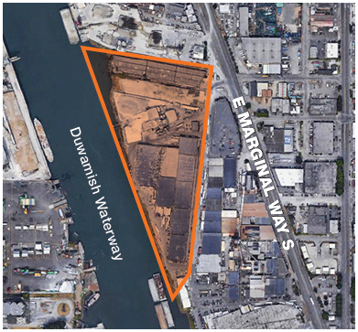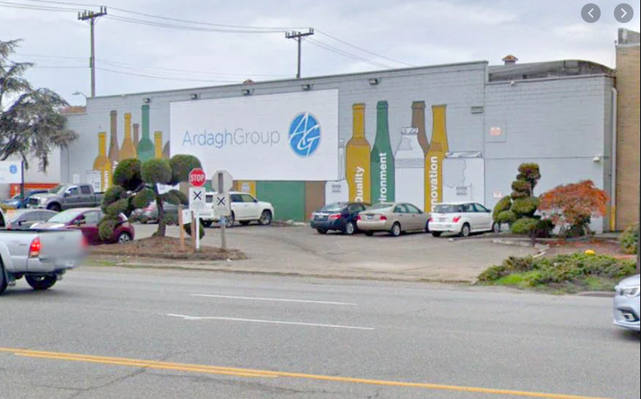

Property Owner: King County Facilities Management Division
Address: Lessee occupies three (3) contiguous parcels
Address | Parcel Number
5245 Ohio Avenue S. | 1924049051
5427 Ohio Avenue S. | 1924049043
5445 Ohio Avenue S. | 1924049002
Rent: $215,000 per month, absolute triple net (NNN) lease with 3% annual rent increases, plus leasehold excise tax of 12.84% ($27,606), rent for the first two (2) months shall be abated.
Operational Costs: Lessee shall incur all costs to operate the property
Term: 10-year term plus a ten-year extension option contingent on environmental upgrades and subject to a code amendment transmitting to Council under separate cover.
Square Footage: Approximately 150,841 square feet of building area situated on an approximate 16.2-acre site (estimated at 14.5 usable acres).
Template: County lease template
Council District: Eight
Funding Source: Facilities Management Division, Long Term Lease Fund.
Previous Location: This is a new lease with an existing tenant for existing use at this location.
Offer Timeline: The lease offer from Ardagh is contingent on simultaneous passage of the Code amendment proposed Ordinance, discussed below. Expedited Council consideration is requested to allow time to finalize permits for select on-site demolition and to activate environmental protections and rent increases negotiated into the lease.
Contingencies: Ardagh Glass, Inc. (Ardagh) has made its offer to lease the premises contingent upon King County Council approval of a code amendment to KCC 4.56.075, transmitting to Council under separate cover, authorizing tenants of certain financial investment properties to enter into leases with King County for a term of longer than ten years if certain conditions are met and without the capital investment required for other County property with a similar term.
Summary:
King County’s Harbor Bond investment properties are comprised of 32 acres of waterfront, industrial/maritime real estate located along the Duwamish River and south of the Port of Seattle. Approximately 16 acres of the property is leased by Ardagh, a multinational corporation, which operates a large glass factory on immediately adjacent property.

Lease Synopsis:
Ardagh intends to extend its lease with King County for 10 years for this location. The lease location (premises) is a raw materials production facility which includes staging and product distribution warehouses, supporting Ardagh’s owned manufacturing facility located directly across Ohio Avenue South, across the street from the premises. The company employs 340 people, including about 300 hourly employees, and operates the plant 24-hours per day, 365 days per year. Ardagh manufactures 1 million bottles per day at the plant. The company recycles all of King County Solid Waste Division's estimated 465 tons of recycled glass generated per day.

Ardagh also has two subtenants on the premises that directly support its manufacturing operations: JA Jack, a limestone producer, and Strategic Materials, Inc., a provider of glass chips known as “cullet”. Each of these subtenants provide key ingredients to the glass manufacturing process. Ardagh does not generate profit from its subleases. Approving the subleases is a condition of the lease.

Under the proposed new lease, Ardagh will also lease an additional contiguous parcel of King County property. The 114,310 SF of land is improved with a 69,000 square foot (SF) warehouse. The warehouse’s former tenant, United Western Supply, vacated the property in July 2021. Ardagh will demolish the warehouse formerly occupied by United Western Supply as a condition of the lease. The structure that was built in 1919, is functionally obsolete, and too costly to maintain or repair. King County will reimburse Ardagh for the costs of demolition following the completion of the work. The reimbursement will be rent credits during the initial term of the lease.

Special Environmental Considerations:

- Glass Furnaces
Ardagh’s manufacturing process requires the 24/7 operation of five glass furnaces that together, produce one million glass bottles each day. In 2020, Ardagh closed its most pollution-prone furnace at the plant, leaving it with four. Another furnace identified with dated technology is furnace #3. As a condition of the lease, Ardagh must notify King County by June 30, 2023, of its intention to either rebuild furnace #3 or permanently cease operation of said furnace. If Ardagh provides notice that it will undertake the furnace #3 rebuild, Ardagh will complete the work no later than December 31, 2025. Furnace #3 is Ardagh’s oldest and most environmentally hazardous furnace of the remaining four furnaces, because of its functionally obsolete technology, resulting in discharge of air pollution. It is expected that Ardagh’s replacement of the furnace and resulting environmental performance improvements would satisfy the requirements of a proposed amendment to King County Code 4.56.075, which would make Ardagh eligible for a ten-year extension of the lease (with a total term of 20 years). The companion legislation to this lease proposal is submitted to the Council under separate cover.

- Stormwater Runoff/Source Tracing
Ardagh is preparing to install new stormwater treatment upgrades and make associated changes to the storm drain system for the premises and Ardagh’s adjacent leased parcel, as corrective actions in accordance with the Washington State Department of Ecology’s Industrial Stormwater General Permit (ISGP). Before making changes to the existing storm drain system, Ardagh will sample storm drain solids from a catch basin, sump, pipe, or other feature that is representative of the sediments deposited into the outfall 2 collection system for polychlorinated biphenyls aka industrial products (PCBs), chemicals or pollutants, in accordance with Ecology’s Stormwater Sampling Manual (Dec. 2015). Within one year after completing the planned changes to the storm drain system and installation of new stormwater treatment system, Ardagh will sample storm drain solids, on Ardagh’s adjacent parcel and the premises, in accordance with conditions S5 (benchmarks) and S6 (discharges) of the ISGP. King County will be provided the opportunity to review and comment on the sampling plan, which shall be designed to facilitate use of the collected data to investigate the source of any PCB concentrations in excess of 120 ug/kg that may be detected. King County must approve the sampling plan before it is implemented. Ardagh is also obligated, at King County's request, to disclose any relevant information and/or documents sought by King County to help determine potential sources of contamination to stormwater at the Premises.

- Environmental Compliance
King County’s extension of a new lease to Ardagh is conditioned on Ardagh coming into and maintaining continuous compliance with any environmental permits it holds now, or in the future, for the manufacturing facility. The term environmental permits include any permit, authorization or approval issued by a federal, state, local, or regional environmental regulatory agency or board (permitting agency) for stormwater or wastewater discharges or air emissions from the Ardagh’s manufacturing facility. Ardagh shall provide King County with a semi-annual environmental compliance report by the fifteenth day of February for the six-month period ending December 31 and by the fifteenth day of August for the six-month period ending June 30, each year during the term. The compliance report shall summarize each instance in which Ardagh exceeded any benchmarks or limitations in its Environmental Permits, or otherwise violated any conditions of any environmental permits, in the preceding six-month period, and whether each such instance constituted a violation of the permit, authorization or approval, in question. For purposes of reporting under this lease, each such incident will be considered an environmental incident.

Within 30 days following receipt of a compliance report that includes any environmental incident(s), King County may, at its sole and absolute discretion, require Ardagh to provide a report detailing how Ardagh plans to remedy the environmental incident(s), and what conditions led to the environmental incident(s) in a Corrective Action Report. Ardagh will provide the Corrective Action Report to King County within 45 days of its request. The Corrective Action Report will include whether any environmental incident(s) are subject to an existing or pending consent decree, order, settlement, corrective, or enforcement action. It will also include Ardagh’s schedule for planned corrective actions, if any, and indicate whether such corrective actions have been approved by the permitting agency that issued the environmental permit. Within 30 days of receipt of Ardagh’s Corrective Action Report, King County shall provide Ardagh with written notice of any objection to a Corrective Action, or to Ardagh’s failure to take or plan a Corrective Action, if Ardagh is not acting in accordance with good pollution controls practices, or if the Environmental Incident(s) reflect an ongoing pattern of material exceedances and/or noncompliance (each, an Objection). Additionally, should a permitting agency terminate any Environmental Permit coverage of the adjacent manufacturing facility for cause, and such termination be finally adjudicated, it shall be at King County’s sole and absolute discretion whether to terminate the lease on that basis. If King County elects to terminate the lease on either basis outlined above, the parties’ rights and obligations under the Lease shall terminate, except those that are explicitly intended to survive expiration or earlier termination, and Ardagh shall waive any and all claims or other recourse it may have against King County related to the termination. The Compliance Reports shall also detail Ardagh’s progress on any ongoing corrective actions and on any infrastructure replacements at the adjacent manufacturing facility which Ardagh was required to perform as a condition of the Lease.

King County Responsibility Ordinance: Ardagh has completed the King County Responsibility Lease Detail and Attestation Form as a requirement of this new lease, a copy of which is attached to this proposed legislation package.

Context
Rationale for transaction: Ardagh’s proposal is grounded in the value proposition that their glass plant provides hundreds of living wage, union jobs, and employee benefits including healthcare and vacation pay. Before engaging with Ardagh on a long-term lease extension, the Facilities Management Division (FMD) considered this information, as well as the fact that Ardagh recycles 100 percent of King County’s 465 daily tonnage of glass. Once the environmental concessions and market rent were successfully negotiated, FMD became satisfied that the extension of Ardagh’s lease is warranted.

Property history: The property was originally acquired by King County from the proceeds of Harbor Bonds that were approved by voters in 1910 for the purpose of improving and enlarging the harbors of King County. The bonds were issued in 1911 and 1912 and among other things, were used to build the Lake Washington Ship Canal and the Duwamish Waterway. The last of the Harbor Bonds was redeemed in 1931 and King County has no remaining indebtedness on the bonds.

Political considerations: Ardagh employs 340 union laborers, and its manufacturing process utilizes 100 percent of King County's recycled glass, 465 tons daily.

Policy considerations: Ardagh will potentially invest millions of dollars into a new glass furnace, which is expected to drastically reduce air pollution generated by the facility. Ardagh will also invest at least $1M into a wastewater treatment system at its facility to capture and filter stormwater runoff before it reaches the Duwamish River.

Community considerations
or partnerships: FMD met with the Georgetown Community Council in October 2019 to hear community concerns related to the glass plant's environmental issues and answer questions related to the County's lease negotiation process. In response to concerns raised by residents of Georgetown, South Park, the Georgetown Community Council, the head of the Duwamish River Cleanup Coalition/Technical Advisory Group, the proposed lease terms include specific environmental requirements, including upgrades to reduce air and water pollution and perpetual compliance with all environmental permits.

Fiscal considerations: Ardagh’s annual rent is escalating significantly, going from $771,468 annually to $2,644,500 in 2022 under the new lease. The blended base rental rate per rentable square foot is $2,580,000 per year ($4.08 SF annually) and an annual increase of 3 percent. If the proposed lease package is approved by Council, there is a provision to collect rent retroactively, at the new rate, back to February 2021. This is an absolute NNN lease, which means that Ardagh pays all costs to operate the property. The negotiated rental rate is a fair market rate and includes 2 months of free rent. Ardagh will demolish the United Western warehouse as a function of this transaction and such demolition costs will be credited back to the Ardagh during the initial lease term. Ardagh will also not be obligated to pay rent on the United Western parcel until the demolition is complete; Ardagh has a maximum of 12-months to complete the demolition work, which King County must approve in advance.

King County Strategic Plan impact: This transaction supports the King County Strategic Plan goal of economic vitality and the goal of efficient, accountable regional and local government.

Equity and Social Justice Impact: In accordance with Real Property Asset Management Plan (RAMP) policy, FMD reviewed this legislation for Equity and Social Justice (ESJ) impacts. This legislation has an improved ESJ benefit due to Ardagh’s obligation to environmental compliance and upgrades that can result in improved air and water quality for neighborhoods located in proximity to the Ardagh site, which have a higher percentage of communities of color and immigrant communities.

Energy Efficiency impact: N/A
Lease Alternatives Analysis
Summary:
FMD marketed the Harbor Bond properties in an open process with the assistance of Kidder Mathews, a commercial brokerage firm based in Seattle. Several bids were received, including from the existing tenant, Ardagh. The competing offers were all from regional or national merchant developers who submitted proposals to demolish the existing structures and redevelop the properties into industrial distribution centers, which, based on the location of the Harbor Bond properties in the SoDo/Georgetown industrial marketplace, would likely be considered the highest and best use. The competitive environment provided leverage for negotiating a fair market transaction with Ardagh resulting in a fair market deal for King County as reflected in the proposal analysis set out below.

Proposal analysis:
Bidder |  | Final Offer  PSF Annually
Trammel Crow |  | $3.48
Dermody Properties |  | $4.20
Bridge Development |  | $3.03
Panattoni Development |  | $4.38
Ardagh |  | $4.08
Average |  | $3.83

Vicinity View Map

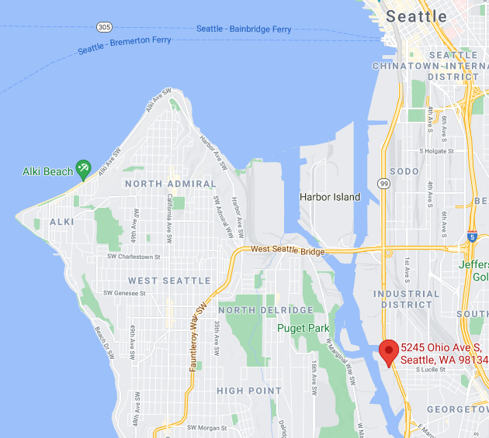

Parcel Map

