PROPERTY SUMMARIES

ATTACHMENT A

TO TRANSMITTAL LETTER

ADVANCE APPROVAL LEGISLATION

PROPERTY SUMMARY
Address: 14256 -100th Avenue, Kirkland Area
Appraised Value: $210,000
Size: House – 1,140 sf.
Lot – 28,050 sf.
Assessor’s Parcel: 202605-9104
Zoning: R-8
Council District: Six (Hague)
Funding Source: Roads Fund, CIP #101791
Declared Surplus: January 30, 2010

Declaration of Surplus: January of 2010

Surplus Date: January __, 2010

Property Synopsis: The subject parcel is located on the east side of 100th Avenue NE in the unincorporated area know as Juanita (Kirkland area). Improvements include a house built in 1910 with a large open carport/storage area. The property was purchased in 1997 for the 139th/145th road-improvement project. However, that project was discontinued due to anticipation that 100th Avenue NE would soon be incorporated into the city of Kirkland. The subject property is not included in Kirkland’s pending annexation of the Juanita area and the City indicates that they are not interested in purchasing the property. In addition, Roads has confirmed that the subject is not required for the pending turn lane project scheduled for 100th Avenue.

The parcel was rejected for possible affordable housing development due to insufficient area for further development caused by a 165-foot setback from the stream on the east side of the lot. The house retains sufficient value to justify sale as a single-family residence.

Interim History: The house has been rented since 1998 at $789.88 per month with no obligation to relocate the tenant.

Appraisal Summary: FMD performed an appraisal in February 2011 which estimated fair market value at $210,000 based on highest and best use as a single family residence. The appraiser noted that the subject neighborhood values are predominantly influenced by distressed sales resulting from short sales, bank-owned property sales, and post-foreclosure sales. The appraiser concluded that the fair market value of the subject as of February 2011 is $210,000. Please see the next page for sale comparables.

Listing Price: The property will be listed for sale at the appraised fair market value of $210,000 and sold for no less than 90% of appraised value ($189,000).

Sale Comparables: 14256 100th Avenue NE, Kirkland Area

Low Sale = $187,650 High Sale = $235,950

VICINITY VIEW

PARCEL VIEW

PROPERTY SUMMARY

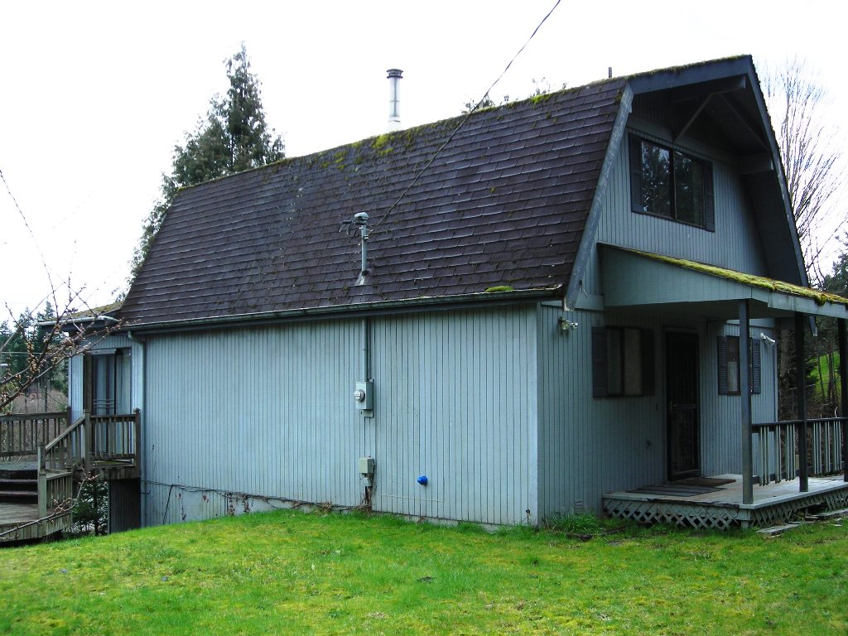
Address: 18219 -140th Avenue SE, Renton Area
Appraised Value: $160,000
Size: House – 1,160 sf.
Lot – 30,672 sf.
Assessor’s Parcel: 342305-9032
Zoning: R-6
Council District: Nine (Reagan Dunn)
Funding Source: Roads Fund; CIP Fund #401195
Declared Surplus: February 2, 2011

Property Synopsis: The subject parcel is located on the west side of 140th Avenue SE just south of SE 180th Street in the Fairwood area of Renton. Improvements include a house built in 1983. The property was purchased in 2001 for Phase I of the 140th / 132nd road expansion project. The frontage area of the subject property was used for road expansion, slope and drainage easements.

The parcel was determined not to be suitable for development for affordable housing, as the lot’s configuration provides limited development potential. The house retains sufficient value to justify sale as a single-family residence.

Interim History: Roads previously utilized the house for its construction office. The property is currently vacant.

Appraisal Summary: FMD performed an appraisal in March 2011 which estimated fair market value at $160,000 based on highest and best as a single family residence. The appraiser noted that the subject neighborhood values are predominantly influenced by distressed sales resulting from short sales, bank-owned property sales, and post-foreclosure sales. The appraiser concluded that the fair market value of the subject as of March 2011 is $160,000. Please see the next page for sale comparables.

Listing Price: The property will be listed at the appraised fair market value of $160,000 and sold for no less than ninety percent (90%) of appraised value ($144,400).

Sale Comparables: 18219 -140th Avenue SE, Renton Area

Low Sale = $149,700 High Sale = $172,350
VICINITY VIEW

PARCEL VIEW
PROPERTY SUMMARY

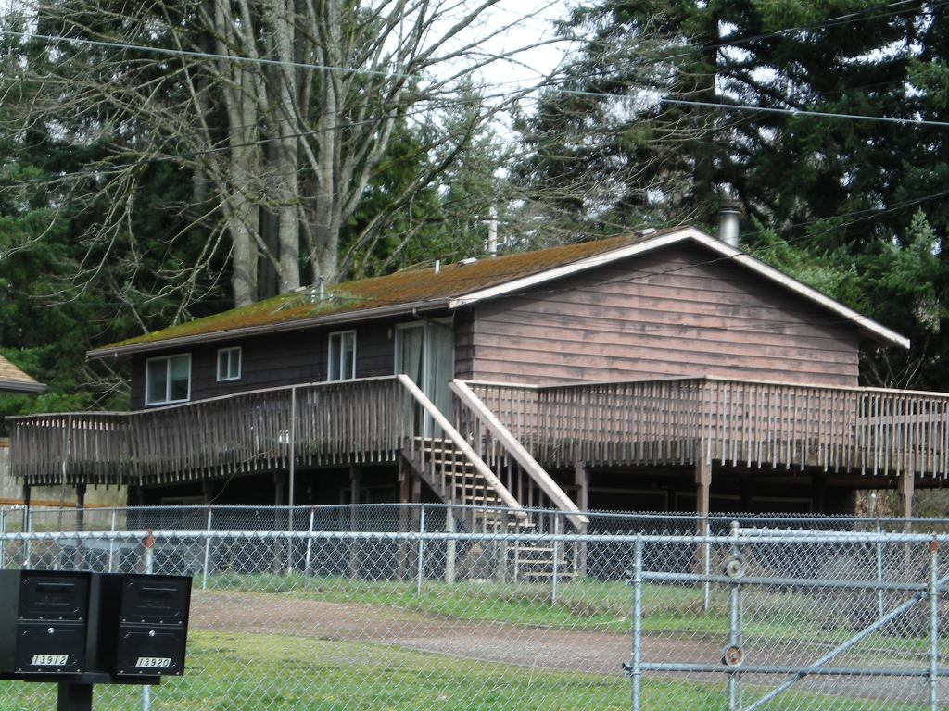
Address: 19851 -140th Avenue SE,
Renton Area

Appraised Value: $135,000
Size: House – 1,020 sf.
Lot – 12,289 sf.

Assessor’s Parcel: 815500-0040
Zoning: R-6
Council District: Nine (Reagan Dunn)
Funding Source: Roads Fund; CIP Fund #401195
Declared Surplus: January 11, 2010

Property Synopsis: The subject parcel sits on the west side of 140th Avenue SE at the corner of SE 200th Street. It was purchased in 1997 for Phase II of the 140th/132nd road-improvement, which project expanded -140th from two to four lanes. A redesign of that project stopped road improvements slightly north of the subject, and the property was never utilized. The site includes a house with built-in garage, constructed in 1967. It has access off both -140th and 200th.

The parcel was determined not to be suitable for development for affordable housing. Its small size provides limited development potential, and the house retains sufficient value to justify sale as a single-family residence.

Interim History: The house has been rented since 1997 for $850 per month with no obligation to relocate the tenant.

Appraisal Information: FMD performed an appraisal in March 2011 which estimated fair market value at $135,000 based on highest and best use as a single family residence. The appraiser noted that the subject neighborhood values are predominantly influenced by distressed sales resulting from short sales, bank-owned property sales, and post-foreclosure sales. The appraiser concluded that the fair market value of the subject as of March 2011 is $135,000. Please see the next page for sale comparables.

Listing Price: The property will be listed at the appraised value of $135,000 and sold for no less than ninety percent (90%) of appraised value, which is $121,500.

Sales Comparables: 19851 -140th Avenue SE, Renton Area

Comparable low = $123,100 Comparable high = 147,850

VICINITY VIEW

PARCEL VIEW

PROPERTY SUMMARY
Address: 13326 -230th Avenue SE, Issaquah area

Appraised Value: $240,000

Size: House – 1,980 sf.
Lot – 44,431 sf.

Assessor’s Parcel: 509040-0020
Zoning: RA-5
Council District: Three (Kathy Lambert)
Funding Source: Roads Fund;
CIP Fund #200208

Declared Surplus: February 2, 2011

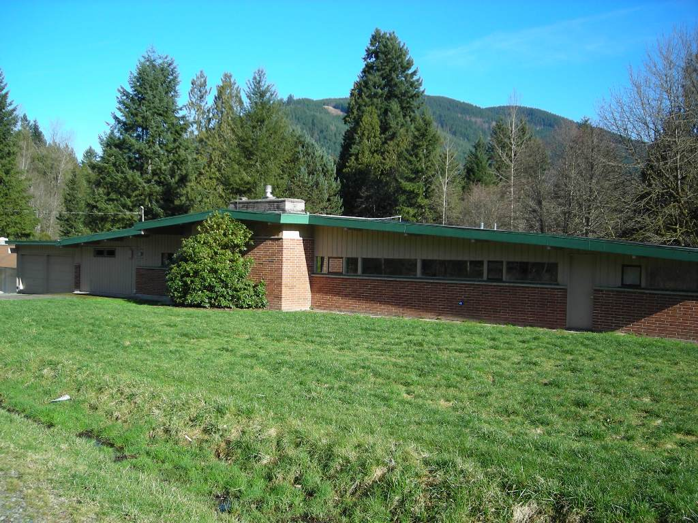

Property Synopsis: The subject parcel sits on the north side of SE May Valley Road at the corner of 230th Avenue SE. Issaquah Creek runs along its eastern boundary. It was purchased in 2006 for use in the reconstruction of Bandaret Bridge which crosses Issaquah Creek. As part of the project, a 19,315 square foot conservation area was established on the parcel, providing for unobstructed fish passage and fencing off access to the creek near the north side of the bridge. This easement will be reserved upon conveyance.

The subject property has no potential for subdivision and is not suitable for affordable housing.

Recent History: The property was used a project construction office and was subsequently rented for a short period of time on a month-to-month basis. It is currently vacant.

Appraisal Information: FMD performed an appraisal in February 2011 which estimated fair market value at $240,000 based on highest and best use of the property as a single family residence. The appraiser noted that the subject neighborhood values are predominantly influenced by distressed sales resulting from short sales, bank-owned property sales, and post-foreclosure sales. The appraiser concluded that the fair market value of the subject as of February 2011 is $240,000. Please see the next page for sale comparables.

Listing Price: The property will be listed at the appraised value of $240,000 and sold for no less than ninety percent (90%) of appraised value, which is $216,000.

Sales Comparables: 13326 -230th Avenue SE, Issaquah Area

Low Sale = $226,175 High Sale = $252,600
VICINITY VIEW

PARCEL VIEW
PROPERTY SUMMARY
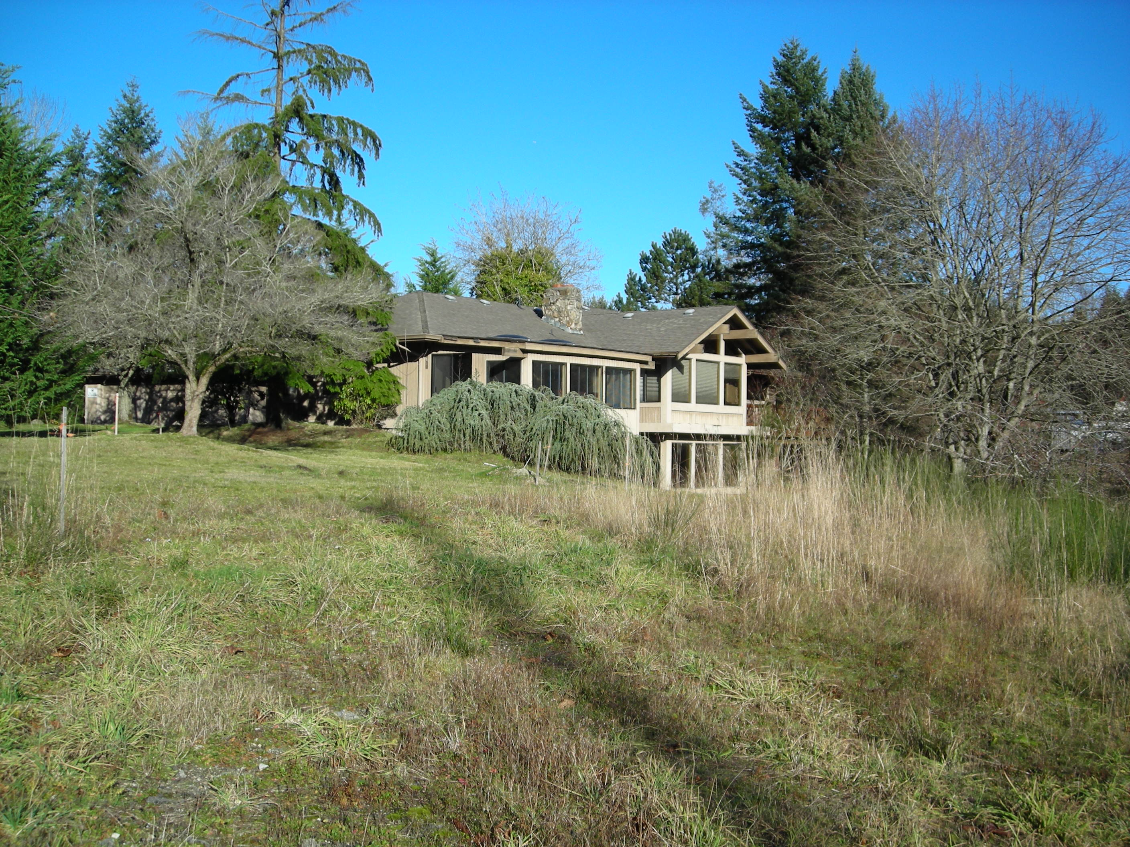
Address: 10332 -208th Court NE, Redmond area

Appraised Value: $525,000
Size: House – 4,280 sf.
Lot – 123,170 sf.

Assessor’s Parcel: 805350-0300
Zoning: RA-5P
Council District: Three (Kathy Lambert)
Funding Source: Roads Fund;
CIP Fund #100992

Declared Surplus: February 15, 2010

Property Synopsis: The subject property is a sloping 2.83-acre parcel located on a small cul-de-sac off Novelty Hill Road at 208th Avenue NE. Roads purchased the property in 1999 for use in the construction of the stoplight at the adjacent intersection. For the current Novelty Hill project, areas will be reserved from the parcel for wetland mitigation, expansion of ROW, and rerouting of driveway access from the expanded ROW. FMD has worked diligently with Roads in the last year to assure anticipated ROW development planning for this property prior to listing.

Property Rights Reserved Upon Conveyance: The following areas are noted on the 95% completed ROW for the Phase II construction planning level and will be reserved upon conveyance to a new owner:

Natural Resource Protection Easement 51,792 square feet (1.19 acres)
Storm and Driveway Easement 31,955 square feet (0.73 acre)
Area for contribution to ROW 6,830 square feet (0.16 acre)

Interim History: FMD has maintained the property’s improvements and is currently installing a new septic system as the original system was crushed when the detention pond was constructed.

Appraisal Information: FMD performed an appraisal in December 2010 which estimated fair market value at $525,000 based on highest and best use as a single family residence. The appraiser noted that the subject neighborhood values are predominantly influenced by distressed sales resulting from short sales, bank-owned property sales, and post-foreclosure sales. The appraiser concluded that the fair market value of the subject as of December 2010 is $525.000.

Listing Price: The property will be listed at the appraised value of $525,000 and sold for no less than ninety percent (90%) of appraised value, which is $472,500.

Sale Comparables: 10332 -208th Court NE

Low Sale = $467,900 High Sale = $569,200

VICINITY VIEW

PARCEL VIEW

