Attachment 2
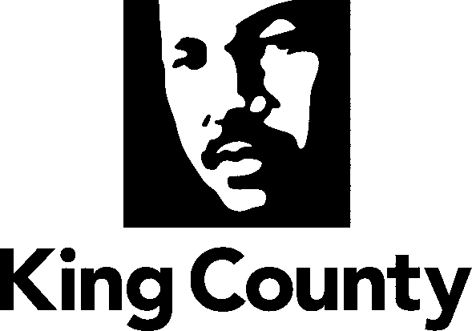

King County
Citizens’ Elections Oversight Committee

The Honorable Larry Gossett, Chair
Metropolitan King County Council
516 Third Avenue, Suite 1200
Seattle WA 98104

February 3, 2012

Dear Chair Gossett:

On behalf of the members of the Citizens’ Elections Oversight Committee I am pleased to transmit this “Annual Report on King County Elections – January 2012”.

The mission you assigned us is “…to help King County restore and maintain public confidence in elections.” (Ordinance 15453) The Citizens' Election Oversight Committee embraces this mission and observes that the King County Elections Department has largely restored public confidence in elections. It is worth noting that last year King County was visited by elections officials from four states as well as from China, Russia and Yemen, to see what is regarded as a model process for the administration of elections.

Over this last year the CEOC held seven formal committee meetings, spent significant time observing all elections and canvassing board meetings, and served as a resource to the Department and the Council.

We commend the County Council for its leadership in addressing elections issues and we look forward to serving you and the voters of King County in 2012.

Sincerely,
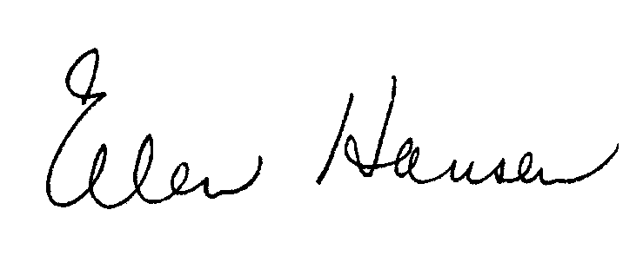
Ellen Hansen, Chair, King County Citizens’ Elections Oversight Committee

cc: Metropolitan King County Councilmembers
Dow Constantine, Executive, King County
Sherril Huff, Director, Department of Elections
Members, Citizens' Elections Oversight Committee

