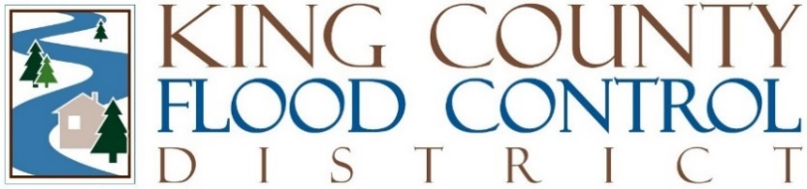

STAFF REPORT

Agenda Item: | 9 | Name: | Steven Schauer
Proposed Legislation: | FCD25-03 | Date: | July 8, 2025

Proposed FCD Motion FCD25-03: A MOTION declaring the King County Flood Control District's commitment to integrated floodplain management and multibenefit projects and to the principles of environmental stewardship, equity and social justice and environmental justice; and establishing how the District prioritizes capital projects utilizing a “worst-first” paradigm arranging flood risk reduction projects based on an assessment of risk, severity, and consequence.

Proposed Motion FCD 25-03 does four things:
- Declares the King County Flood Control District's (District) commitment to Integrated Floodplain Management and multibenefit projects;
- Declares the District's commitment to the principles of environmental stewardship, equity and social justice, and environmental justice;
- Establishes how the District prioritizes capital projects utilizing a “worst-first” paradigm arranging flood risk reduction projects based on an assessment of risk, severity, and consequence; and
- Establishes a glossary to enhance clarity, consistency, and efficiency in communication, providing a centralized resource defining key terms related to Integrated Floodplain Management for the District and its service providers, partners, constituents, and other interested parties.

Proposed Motion FCD 25-03 has been developed in accordance with the guidance provided by the District Board of Supervisor as established in the District’s 2025 Work Program, which is Attachment A in the 2025 budget adopted on November 19, 2024, by Resolution FCD2024-12. The 2025 Priorities include, among other issues:
- Policy development for a review of the District’s 6-year Capital Investment Program (CIP) to prioritize projects and align expenditures with District revenue; and
- Direction to align capital projects in the District’s budget with actual expenditures for service providers.

If approved, proposed Motion FCD 25-03 will be utilized by the District to review and prioritize the District’s 6-year CIP, in collaboration with its service providers, providing to the District’s Board of Supervisors a revised and updated 6-year CIP for consideration as part of the 2026 budget deliberation.

