BEHAVIORAL HEALTH
Analyst: Sam Porter

 |  | Expenditures |  | Revenues |  | FTEs |  | TLTs
2025 Revised Budget Biennialized |  | $1,001,036,794 |  | $879,252,532 |  | 190.6 |  | 0.0
2026-2027 Base Budget Adjust. |  | ($156,223,882) |  | ($21,212,062) |  | (1.7) |  | 0.0
2026-2027 Decision Packages |  | ($36,945,381) |  | ($28,679,764) |  | (64.8) |  | 1.0
2026-2027 Proposed Budget |  | $807,868,000 |  | $829,361,000 |  | 124.0 |  | 1.0
% Change from prior biennium, biennialized |  | (12.8%)
Dec. Pkg. as % of prior biennium, biennialized |  | (0.03%)
Major Revenue Sources: Medicaid, interfund transfers from Mental Illness and Drug Dependency (MIDD) and Health Through Housing funds, direct federal revenues; local and philanthropic revenues. State non-Medicaid money for crisis behavioral health system (including involuntary treatment), federal block grants formerly received in this fund are proposed to be transferred to a new fund in the proposed budget.

Description

In the 2026-2027 Biennial Budget, the Behavioral Health Fund primarily accounts for the King County Integrated Care Network (KCICN) managed by the Behavioral Health and Recovery Division (BHRD) in the Department of Community and Human Services (DCHS). The KCICN is the Medicaid-funded network of integrated physical and behavioral health providers. While Medicaid is the largest revenue source in the Behavioral Health Fund at $748 million for the biennium, Executive staff indicate that the Fund also contains $5.7 million in direct federal revenues; $25 million in local and philanthropic revenues, $46.7 million in transfers from other County funds, and $3 million in estimated investment earnings.

While BHRD continues to serve as the Behavioral Health Administrative Services Organization (BHASO) to administer the State-funded crisis behavioral health system and other non-Medicaid-funded behavioral health services in King County, the BHASO is proposed to have its own fund through Proposed Ordinance 2025-0303, which was transmitted with the Budget. That appropriation unit and the funds that account for the Mental Illness & Drug Dependency (MIDD) sales tax and the Crisis Care Centers (CCC) Levy are discussed elsewhere in this staff report.

BHRD provides oversight and management of the publicly funded mental health and substance use disorder (behavioral health) service system for eligible County residents. Since 2016, the behavioral health system in Washington has gone through a State-mandated transformation culminating in what is known as fully integrated managed care (FIMC) for the Medicaid healthcare system. The goal of FIMC is whole person coordinated care for both physical and behavioral health. As such, BHRD now contracts with five Managed Care Organizations (MCOs) that operate in the county to administer the King County Integrated Care Network (KCICN). Figure 1 provided by Executive staff outlines the funding structure in BHRD with the BHASO highlighted at the top of the chart.

Figure 1. Behavioral Health Funding Structure
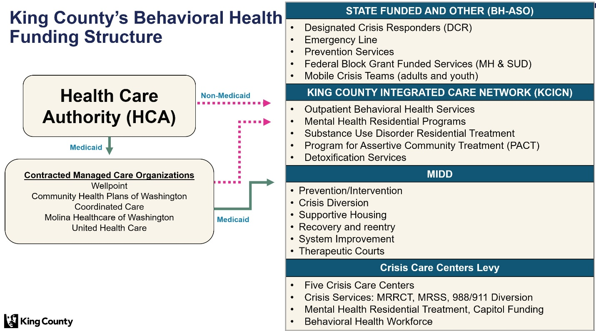

Summary of Proposed Budget and Changes

The Executive's proposed budget would appropriate $807.8 million to the Behavioral Health Fund. This is a decrease of approximately $193.1 million from the 2025 biennialized appropriation. Of this decrease, $156.2 million is base budget adjustments, followed by $36.9 million in decision package adjustments. The largest decision package is a disappropriation of all State non-Medicaid funding to support the BHASO which is proposed to be accounted for in a new BHASO Fund discussed elsewhere in this staff report packet.

Decision packages of note are further summarized below.

Trueblood Grant [$6.3 million, revenue-backed]: Allocate $6.29 million of a grant from the State Health Care Authority passed through the Seattle Foundation to pay for supportive housing and enhanced clinical care services for Trueblood class members. The appropriation includes funding for 1.0 TLT position to provide system navigation, training, and care coordination and support for housing providers and class members. This appropriation will allow BHRD to procure temporary "high support" housing including Transitional Supportive Housing, where individuals generally stay for around six months although sometimes stays are shorter or longer depending on individual needs. The grant runs from July 1, 2025 through June 30, 2030.

BHASO Fund Creation [($141.4 million) and (70.8 FTEs)]: Disappropriate $141.4 million and 70.8 FTEs and reappropriate to the new BHASO Fund proposed to be created through Proposed Ordinance 2025-0303. Executive staff indicate this decision package has a net zero fiscal impact, as funds are simply shifting from the Behavioral Health Fund to the BHASO Fund. There is a request for an additional Business Finance Officer IV FTE to serve as Fund Manager and ensure BHASO financial oversight, management, and compliance. The related decision packages are discussed in more detail in the BHASO Fund appropriation unit.

BHRD Fiscal Structure Update [$1.2 million and 4.0 FTEs]: The proposed budget requests $1.17 million to convert 4.0 TLT finance positions to FTEs. Eighty percent of these positions would be paid for with Medicaid and 20% would be non-Medicaid. Executive staff indicate that BHRD has grown significantly since implementing Fully Integrated Managed Care in 2018. The BHRD fiscal team is responsible for the division’s accounting, audit, accounts payable and receivable, budgeting, fund management, and financial reporting and processing more than 14,000 invoices per year. In 2025, BHRD also began billing private medical insurance in response to HB 1688, enacted in 2022, requiring private insurance to cover certain behavioral health services.

As a result of this increasing complexity, BHRD implemented a pilot implemented in 2023 using TLT and Special Duty positions to restructure the Fiscal unit by creating:
- A centralized Accounts Payable unit with an Accounts Payable lead;
- An Accounting and Revenue unit with an Accounting Manager; and
- A Budget section to lead budget development and financial monitoring.

Executive staff indicate that these changes created clear, functional accountability, streamlined financial processes, and provided more responsive fiscal support to BHRD programs. Therefore, the proposed budget proposes making the fiscal restructure permanent.

Allocated costs in the Behavioral Health Fund for internal controls and audit response [$976,356] and office space needs [$1,012,220], correspond with proposed decision packages in the DCHS Administration appropriation unit.

The proposed budget includes $979,000 of salary savings from employee turnover without decreasing the FTE authority.

Key Issues

Staff have not identified any key issues for this appropriation unit.

The term "behavioral health" encompasses both mental illness and substance use disorders.
The Trueblood et al. v. Washington State DSHS lawsuit filed in 2014 challenged unconstitutional delays in competency evaluation and restoration services for people detained in jails. King County implemented Trueblood Settlement programs June 30, 2023. https://www.dshs.wa.gov/bha/trueblood-et-al-v-washington-state-dshs
In 2025, BHRD's budget consisted of three funds totaling more than $1.3 billion in biennial expenditures.
As a result, BHRD is not only administering the BHASO, CCC Levy, MIDD funds, and contracting with the MCOs as part of the KCICN, but also now with commercial insurance plans for Medication for Opiate Use Disorder and crisis services, such as crisis stabilization.

