Additional Information from WTD on Required FTEs for Capital Projects

Capital Expenditure Delivery Capacity Analysis
In 2022, the Wastewater Treatment Division (WTD) conducted an initial analysis to understand the relationship between capital expenditures and staffing levels as part of the sewer rate development process. This analysis helps estimate how many Full-Time Equivalents (FTEs) will be required to meet planned capital spending, targeting alignment of resources with strategic priorities.
Historical Analysis
We analyzed data from 2012 to 2021, comparing the number of WTD FTEs allocated to delivering and supporting the capital program to the amount spent annually on capital delivery. This provided a baseline to understand how staffing levels influence our ability to deliver projects. While this historical relationship isn’t perfectly predictive, it offers a reasonable and simple metric to forecast how much of the capital program priorities can be delivered in any given year of the forecast, as WTD scales up its capital delivery in the next ten years.

Capital FTE Allocation
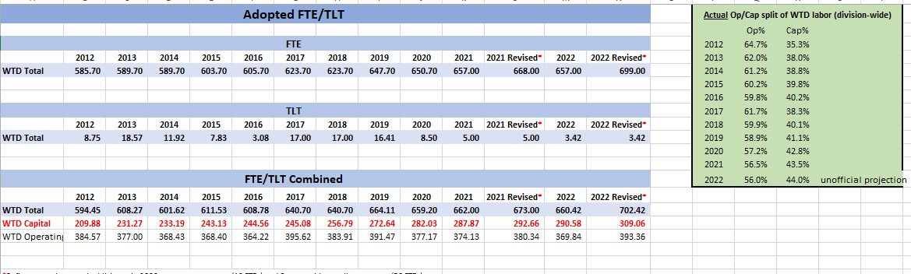
We then graphed the capital FTEs against the historical actual capital expenditures to see if there was a relationship between staffing and capital expenditures that could be useful for forecasting purposes.
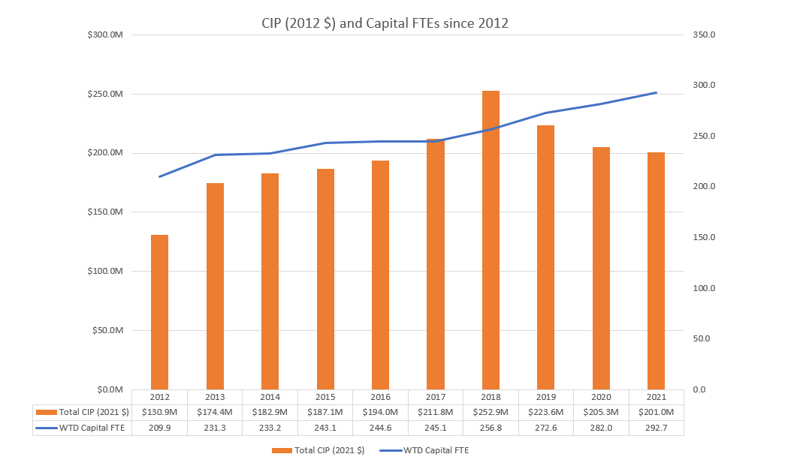
There was a rough correlation between the two, when adjusting for the exception of the West Point flood event and pandemic related slowdown in capital delivery. We used this correlation to develop an expected capital expenditure per capital FTE incorporating the following assumptions:
Onboarding Time:

New staff typically require approximately two years to manage workloads similar to seasoned staff. This requires recognizing new capital FTEs when they are productive in line with the historical delivery relationship so as not to overstate forecasted delivery capacity.
In-House vs. Consultant Labor:
Historically, for every $1 spent on in-house staff, $1.30 is spent on consultant support. We expect this ratio to continue for future capital projects. This assumption is based on WTD’s historical approach to delivery and does not incorporate recent delivery strategies such as collaborative delivery.
Forecasting Future Needs
This historical data and assumptions were first used in 2022 in calculations to inform the 2023 Sewer Rate setting. The forecast assumed that each capital FTE contributed to roughly $944,140 in capital expenditures annually (adjusted to 2023 dollars). This model estimates the capital FTE resource demand for a portfolio of WTD projects based on averages since 2012 and the assumptions above. We applied this model to estimate how much capital delivery capacity is available to respond to WTD non-Combined Sewer Overflow consent decree capital investment priorities in any given year.
Special Case: CSO Projects
Large-scale projects required for Combined Sewer Overflow (CSO) consent decree compliance need a different staffing model. For these large-scale projects, we anticipate a much higher reliance on consultants, similar to past large-scale efforts such as the Brightwater Treatment Plant. Brightwater utilized on average around $5.40 in consultant contracts for every $1 in in-house staff labor. The larger a project grows, the ratio of non-construction costs like design engineering also goes down compared to the construction cost. So, large-scale projects also require proportionally less staff labor when compared to their size overall.
In 2022, using the Brightwater staff delivery to consultant expenditures metric, we modeled expenditures for large-scale CSO projects recognizing the portion of capital expenditures delivered by consultants outside of the capital FTE metric described above. For purposes of the Sewer Rate calculations, we assume that large-scale CSO projects are unconstrained by internal staff resources. Now that the Mouth of the Duwamish program has started and the consent decree is finalized, we will continue to refine our assumptions about how the large-scale CSO Consent Decree projects will be resourced as the timeline and delivery strategy evolve.
Bringing it All Together
To project the total anticipated capital FTEs, we assume that the non-CSO projects are constrained by internal staff labor and that the staffing need is driven by these projects. We assume that to deliver the large-scale CSO projects, we will rely primarily on consultant staff labor and are unconstrained by internal staff resources. Large-scale CSO project FTE requirements are not included in this high-level calculation.
To meet key program goals—including asset management, population growth demand, climate action, and regulatory compliance—WTD must increase its capital delivery capacity. As part of the 2025 Sewer Rate process, WTD estimated capital investment needs to be over $1 billion annually by the end of the decade (before application of the 85% accomplishment rate). In the 2025 Sewer Rate capital expenditure projection, 2032 was the peak year of expenditures, so we can use it as a way to demonstrate the total capital FTEs needed.
In 2032, the total projected capital expenditure was estimated to be $1.2 billion (2032$). Of that, roughly $700M would be for non-CSO projects, and $500M would be for large-scale CSO projects. Using all the assumptions noted above, and dollars escalated to the year of resource calculation (i.e. expenditures per capital FTE are escalated to $1.2M in 2032$), the graphic below shows the steps to calculate the capital FTE resources needed to deliver the 2032 projected CIP expenditures.
To meet key program goals—including asset management, population growth demand, climate action, and regulatory compliance—WTD must increase its capital delivery capacity. As part of the 2025 Sewer Rate process, WTD estimated capital investment needs to be over $1 billion annually by the end of the decade (before application of the 85% accomplishment rate). In the 2025 Sewer Rate capital expenditure projection, 2032 was the peak year of expenditures, so we can use it as a way to demonstrate the total capital FTEs needed.
In 2032, the total projected capital expenditure was estimated to be $1.2 billion (2032$). Of that, roughly $700M would be for non-CSO projects, and $500M would be for large-scale CSO projects. Using all the assumptions noted above, and dollars escalated to the year of resource calculation (i.e. expenditures per capital FTE are escalated to $1.2M in 2032$), the graphic below shows the steps to calculate needed to deliver the 2032 projected CIP expenditures.
583 Capital FTEs Needed to produce 2032 Non-CSO Project Expenditures
$1.2M (2032 $) expected expenditure per Capital FTE Equivalent
Total 2032 Projected Capital Expenditures: $1.2b (2032 $)
2032 Projected Capital Expenditures for non-CSO Projects: $700M (2032 $)
Constrained by Staff Resources

2032 Projected Capital Expenditures for CSO Projects: $500M (2032 $)
Unconstrained by Staff Resources

2032 Projected Capital Expenditures for non-CSO Projects: $700M (2032 $)
Constrained by Staff Resources

Capacity-Adjusted Forecast
In 2022, WTD had about 309 Capital FTEs. Hiring and onboarding around 300 new staff to arrive at the total above would take multiple years. The estimate of 50 additional Capital FTEs annually was developed as a high-level assumption, serving as a practical recruiting limit. The phase-in forecast anticipates completing FTE additions by 2029, with WTD fully resourced to meet projected expenditures in 2032. This resource model was developed to achieve this specific goal of forecasting reasonable and conservative capital delivery resource constraints in a ten-year context for purposes of sewer rate setting. It serves as a starting place for the FTE budget request rather than prescriptive to any given year.
Since this 2022 calculation, WTD has increased the amount of Capital FTEs. In 2023, the number of Capital FTEs was 371, the projected number for 2024 is 466. We will continue to refine the assumptions and estimates of FTEs required to deliver the capital program as we get more information and understand how new delivery strategies such as the use of collaborative delivery impact staffing assumptions.
Calculating FTE Requests for Budget
The high-level analysis outlined above was developed to support sewer rate projections and capital program FTE needs. However, translating this into FTE requests for budget purposes requires additional detail.
The Capital FTE reflects all labor charged directly or indirectly to capital projects. This includes Project Planning and Delivery (PPD) staff like project managers and engineers, Environmental Compliance and Sustainability (ECSS) staff such as real property agents and environmental planners, and Operations & Maintenance (O&M) staff who provide critical input into project design. It also includes support staff from Finance and other administrative roles who contribute to capital project oversight. Staff charge a percentage of their time to capital work, ranging from as little as 5% (e.g., O&M staff reviewing design specs) to over 95% (e.g., capital project managers). This variance complicates FTE budgeting since not all roles are primarily capital focused. Therefore, the assumed limit of 50 Capital FTEs hired annually can be considered a starting point for the total FTEs requested in a year.
During the budget process, this model is refined at the section level. Instead of focusing solely on overall capital FTEs, we assess the specific staffing needs for PPD, ECSS, O&M, Finance, and other supporting sections. For each section, we project staffing needs based on anticipated project timelines and workloads. Decision Packages (DP) are proposed from each section for new FTEs, including the unit (i.e. Planning, Engineering, Project Management, Portfolio Planning and Analysis, Construction Management, Project Control, etc.) and the classification of the FTE (i.e. Water Quality Planner, Wastewater Capital Project Manager, Project Control Engineer, etc.)
When all sections have submitted their proposed DPs, division leadership then meets to authorize submission to the Department and Executive’s Office based on criteria and alignment to division strategies and commitments.
Council Staff Question: Ongoing Process for Justifying FTEs: What are WTD’s thoughts on how to document/justify additional FTEs moving forward? What is WTD’s feedback on the method of using a project management type software to develop a resource loaded (FTE) list of planned capital project expenditures for the budget year that lists the FTE equivalent needed for each project in the proposed budget.
WTD Response: Leveraging Project Information System (PRISM) Data for the Future Staffing Forecasts
WTD uses PRISM to manage capital project forecasts. With over a decade of labor cost data, PRISM provides valuable insights for estimating future labor demand based on historical trends. These data-driven models inform our FTE requests and help forecast labor needs for future projects based on high-level assumptions.
Looking ahead, there are several potential approaches to further refine our staffing forecasts, including leveraging PRISM’s capabilities, developing alternative Excel-based models, or exploring other analytical tools. These options will be considered and evaluated in preparation for future sewer rate and budget submittals including the 2026 submittals, as we work to refine our staffing needs.
Balancing Models with Qualitative Approach
While forecasting models are valuable tools, WTD utilizes a qualitative process that includes model outputs, judgement and experience. Given the uncertainty inherent in capital projects — where scope, timeline, and delivery methods can change — FTE requests must be refined through expert evaluation and experience. Each project has unique resource demands, making it essential to balance model outputs with informed decision-making.

